**Topic- 1. Spring Core demo: -**

**1.Hello world Program**

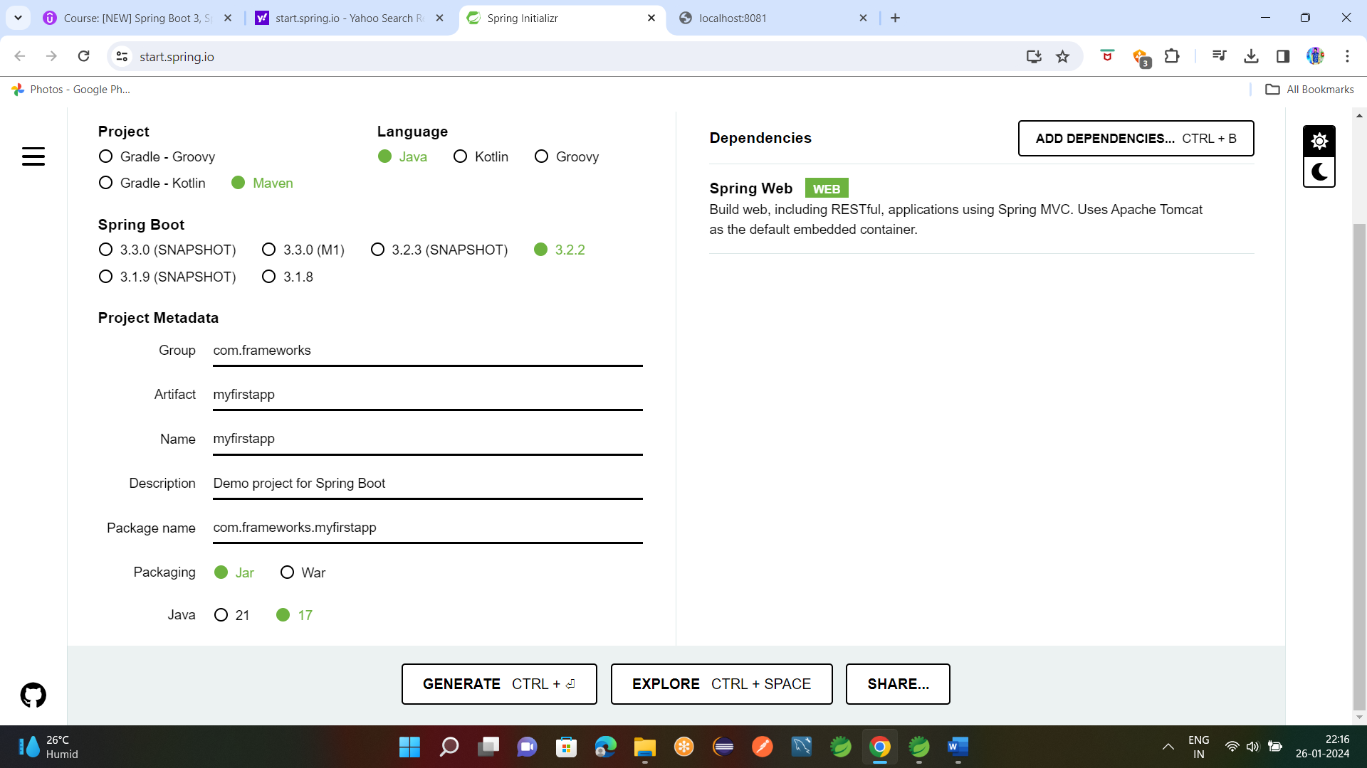

After create package rest and create class FirstRestController.java

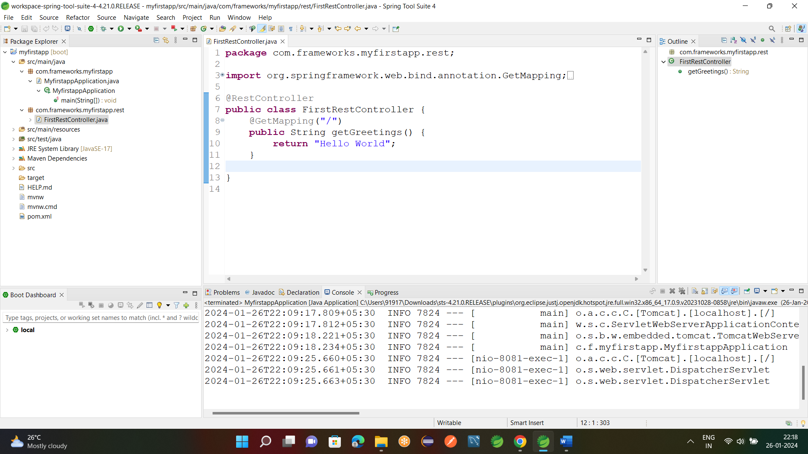

**Browser Link:-** <http://localhost:8081/>

**2.Dev tools:-**

If we add dev tools Appn will automatically reloads without user involvement.

Add dev starter in dependencies

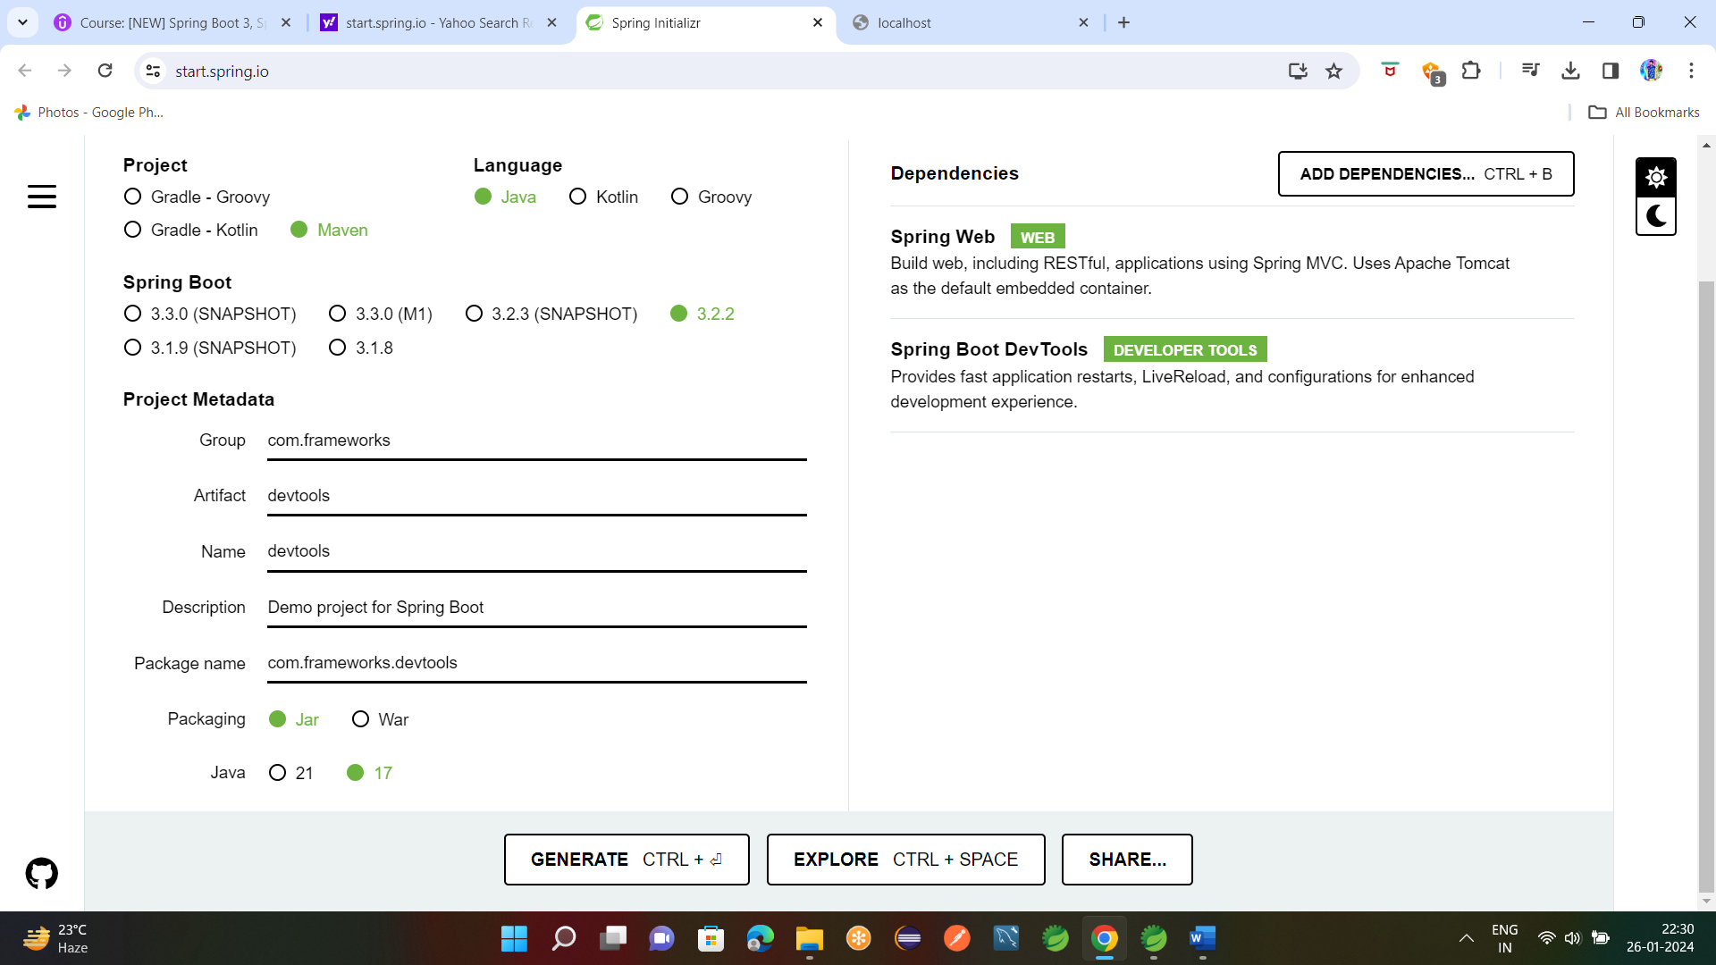

Add **DevRestController.java** under rest Package.

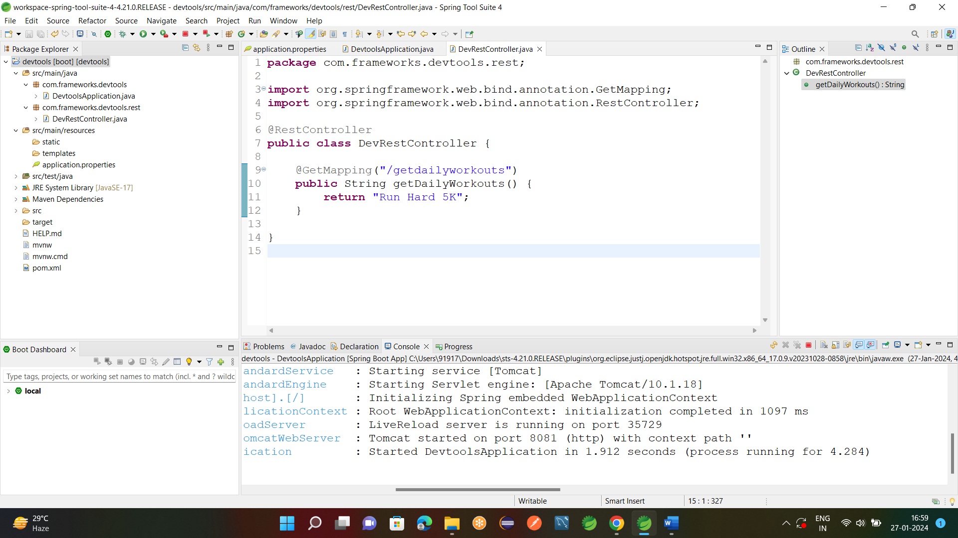

**Browser Link:-** [**http://localhost:8081/getdailyworkouts**](http://localhost:8081/getdailyworkouts)



If we are changing any code we no need to re Run the appn it automatically loads code.



**3.Actuator:-**

Add actuator dependency.

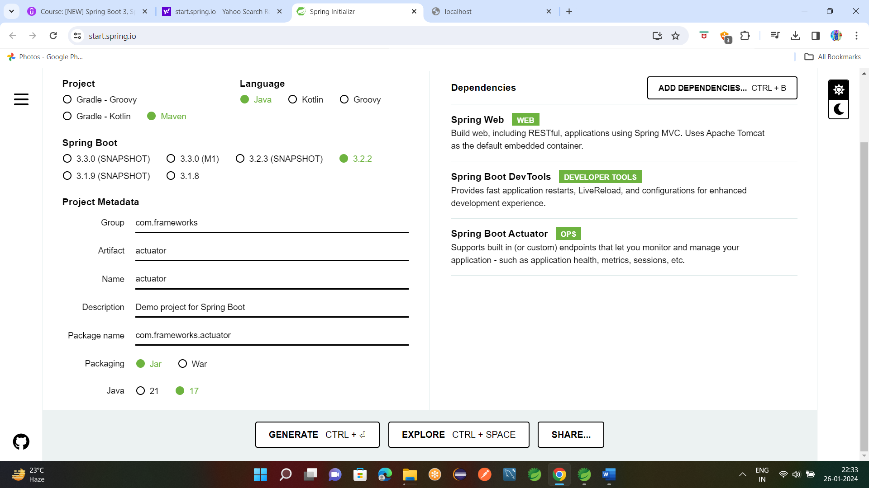

Add Actuator data in **application.properties**

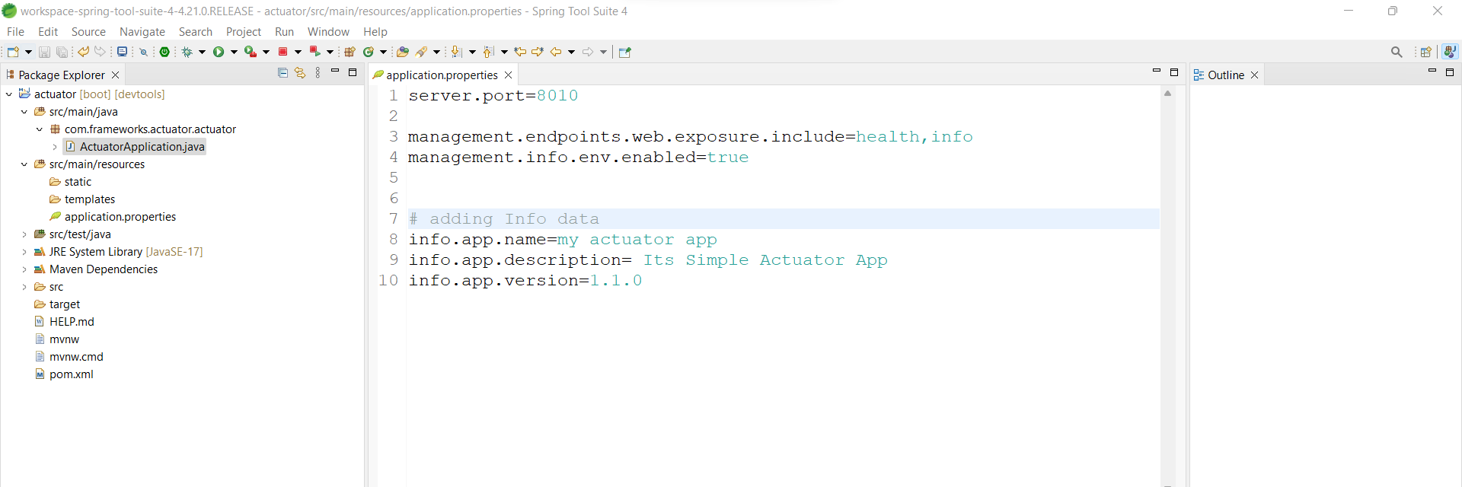

**Browser** Link:- <http://localhost:8010/actuator/health>

<http://localhost:8010/actuator/info>

but here info data is empty so will add info data.



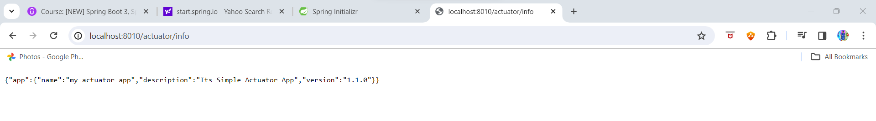

To Expose all end points add in appn.prop

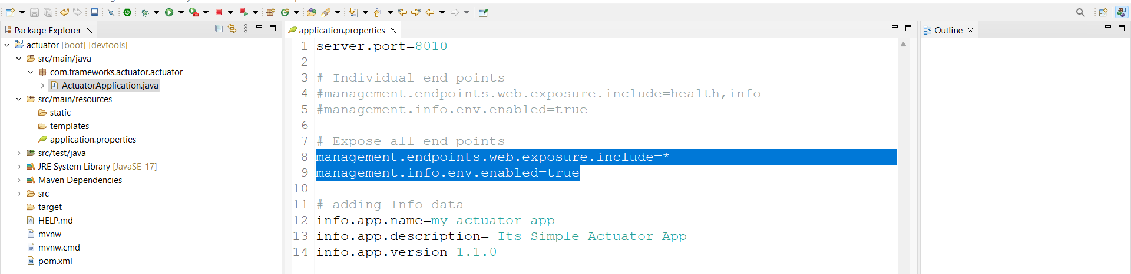

<http://localhost:8010/actuator/beans> it gives all bean data

<http://localhost:8010/actuator/threaddump> it gives all threads running for our appn.

<http://localhost:8010/actuator/mappings> it gives all req mappings.

**4.Actuator Security:-**

Add security dependency

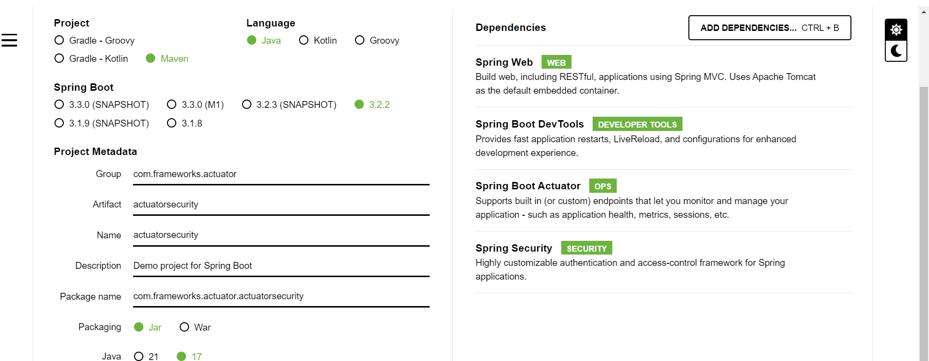

Now if we run appn we need user and pwd to see actuator data.default user id is user and pwd is coming in log

**Browser** Link:- http://localhost:8010/actuator/threaddump

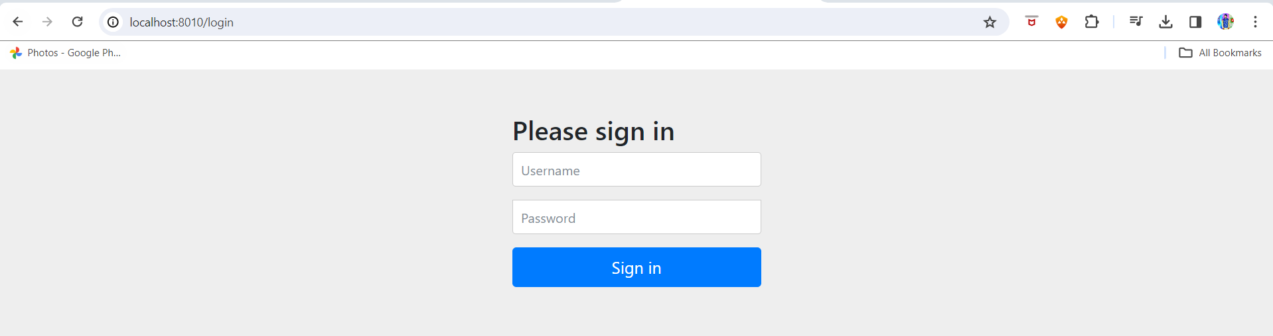

**5.Custom Properties:-**

Create project add custom properties in app.props as follows.

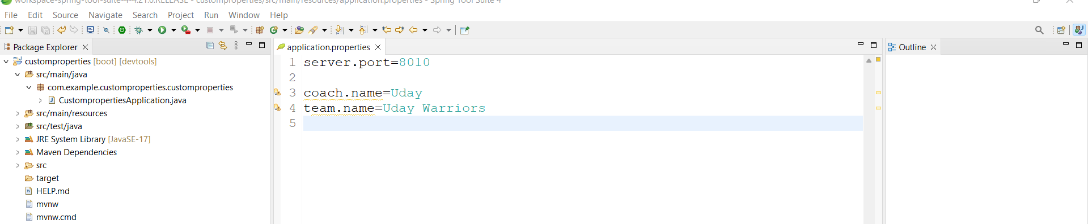

Create **CustomPropRestController.java**

Create private fields for custom props and use @Value for get the values into appn.

Create @GetMapping for our appn.

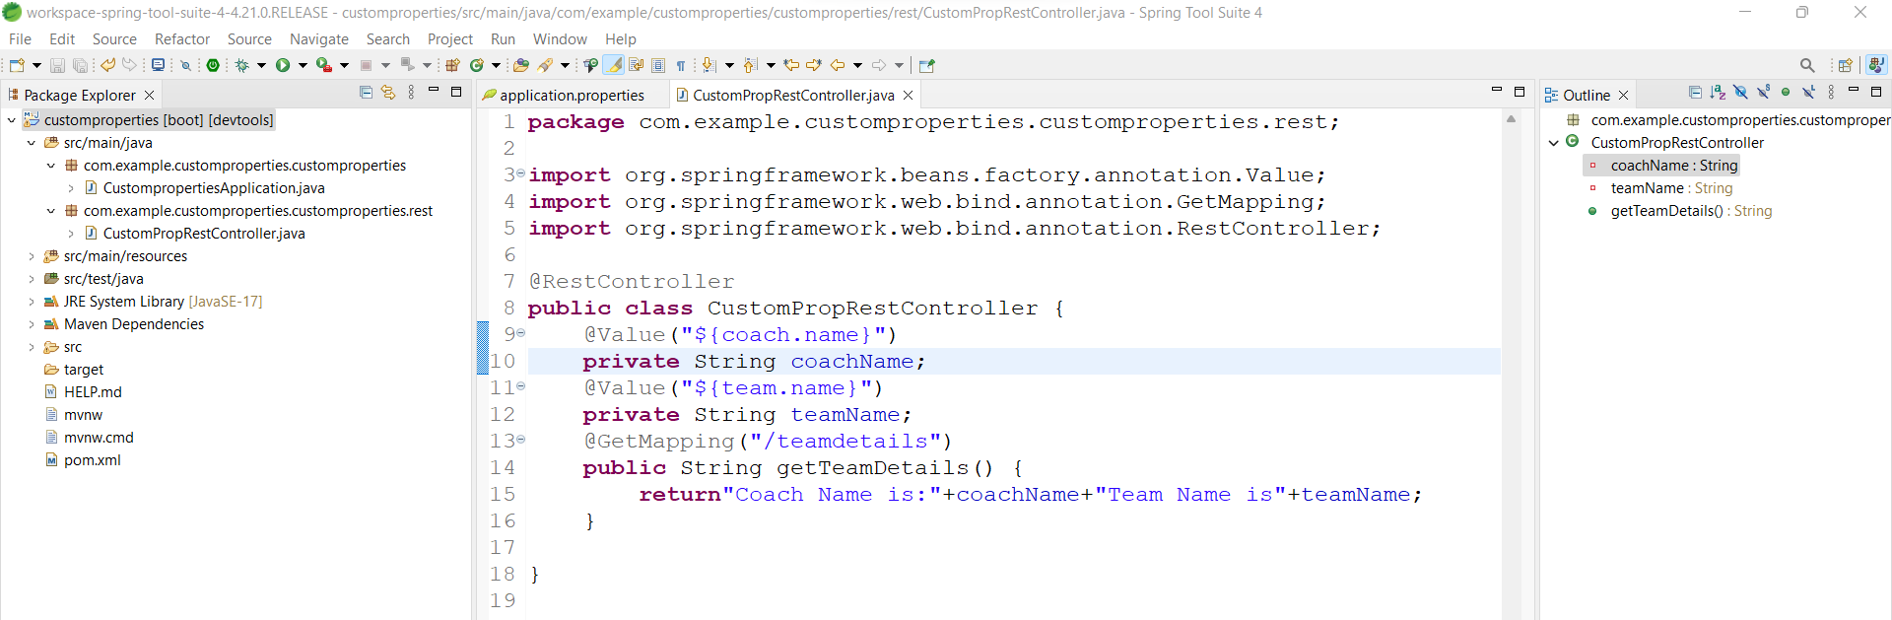

**Browser** Link:- <http://localhost:8010/teamdetails>

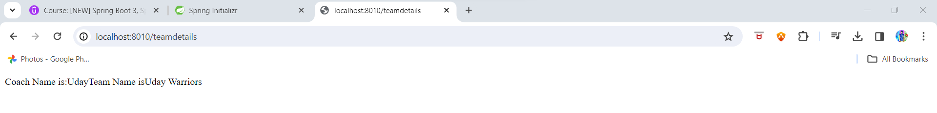

**Topic-2. Spring Core**

**1.constructor-injection**

Create project and load in STS.

Create new Interface **Coach** and create new class implemented from this coach interface i.e **CricketCoach.java**

**@Component** is apply to **CricketCoach.java**

**Coach.java**

**package** com.example.constructorinjection.constructorinjection;

**public** **interface** Coach {

String getDailyWorkouts();

}

**==========================================================================**

**CricketCoach.java**

**package** com.example.constructorinjection.constructorinjection;

**import** org.springframework.stereotype.Component;

**import** org.springframework.stereotype.Component;

**import** org.springframework.stereotype.Component;

@Component

**public** **class** CricketCoach **implements** Coach {

@Override

**public** String getDailyWorkouts() {

**return** "Practice Bating for 1h Every day";

// **TODO** Auto-generated method stub

}

}

**===========================================================================**

Now create **ConstructorRestController.java**

Here create Constructor for dependency injection and apply @Autowired on constructor.

Write @GetMapping for our appn.

**ConstructorRestController.java**

**package** com.example.constructorinjection.constructorinjection;

**import** org.springframework.beans.factory.annotation.Autowired;

**import** org.springframework.web.bind.annotation.GetMapping;

**import** org.springframework.web.bind.annotation.RestController;

@RestController

**public** **class** ConstructorRestController {

**private** Coach theCoach;

@Autowired

**public** ConstructorRestController(Coach theCoach) {

**super**();

**this**.theCoach = theCoach;

}

@GetMapping("/getDailyWorkouts")

**public** String getWorkouts() {

**return** theCoach.getDailyWorkouts();

}

}

**==============================================================**

**Browser** Link: - <http://localhost:8011/getDailyWorkouts>

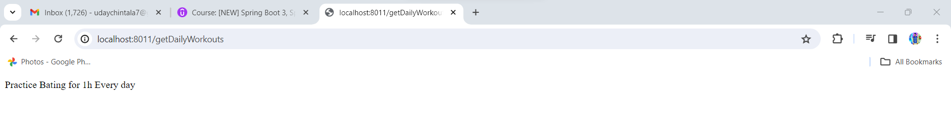

**Folder Structure: -**

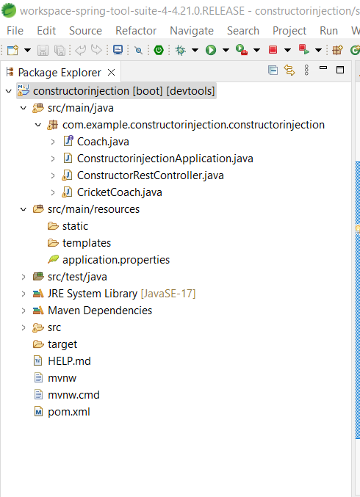

**2.Component Scanning: -**

Use same above code

Create Rest package and move **ConstructorRestController**

And create common package and move Coach and CricketCoach into that.

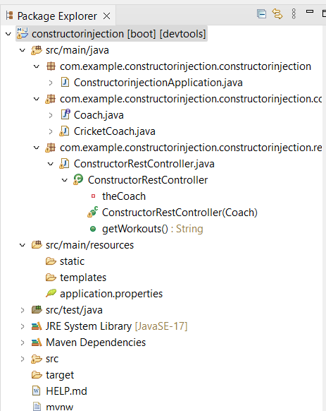

**3.Setter Injection: -**

Copy same above project

Open **ConstructorRestController.java** and change code comment @Autowired code

Define setter method to your variable as follows

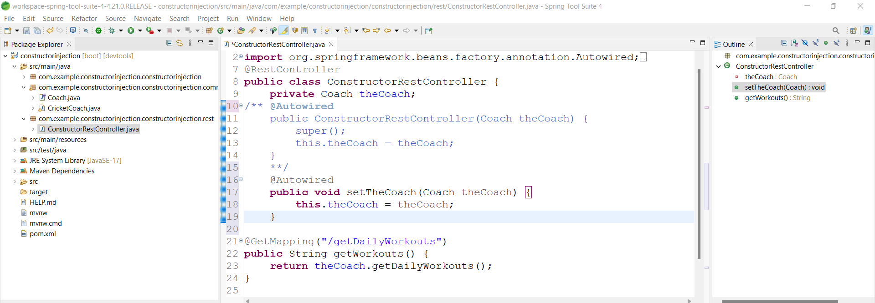

Run the appn

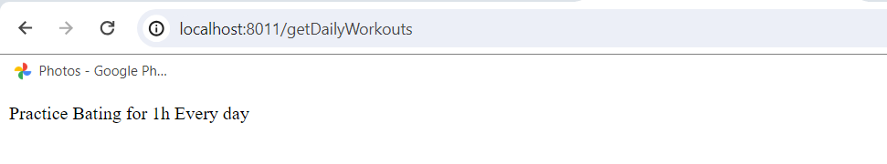

**4.Qualifiers:-**

**Copy above project**

And create diff classes under common package and implement from coach class

Classes are **BaseballCoach,TennisCoach**

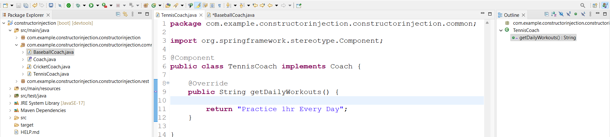

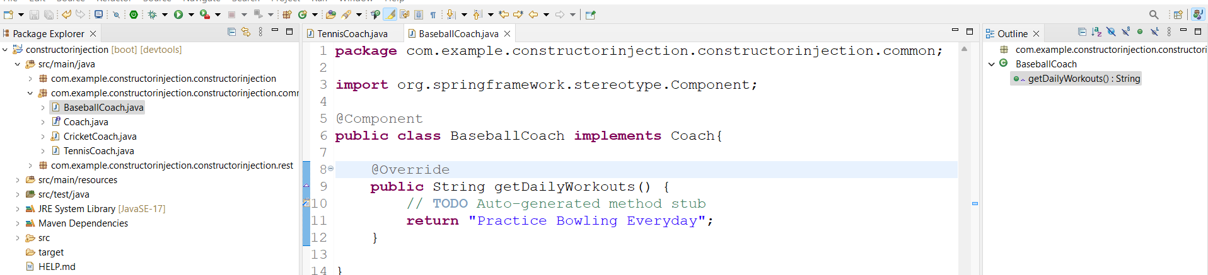

comment Setter injection code and uncomment constructor injection

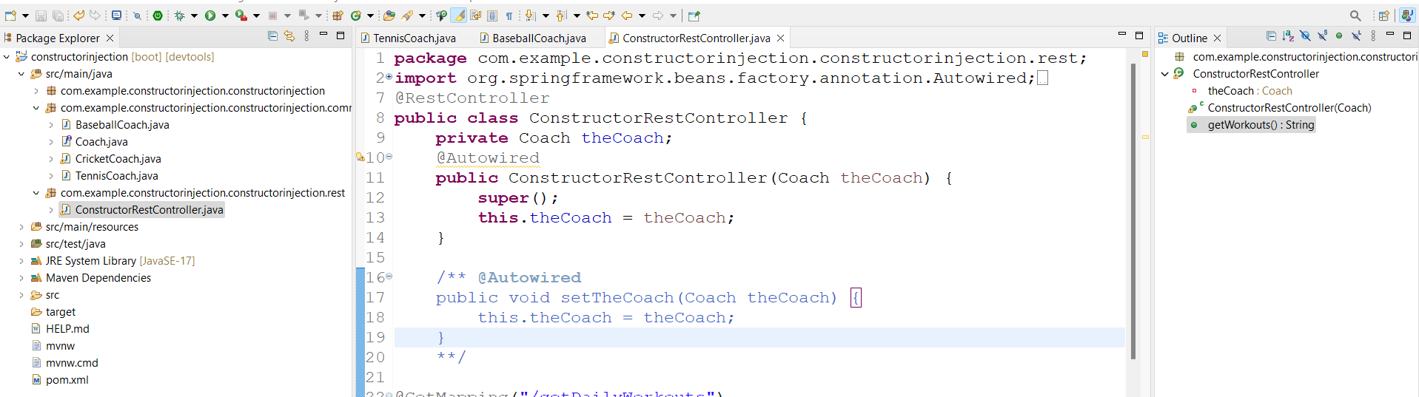

Now run the program will get error bcz we had 3 implemented classes so there is ambiguity issue in constructor injection. Here we have to use @Qualifier to overcome this.Remember in @Qualifier we need to use particular class name with starting letter small.

Ex:- @Qualifier(“**tennisCoach**”) and run appn.

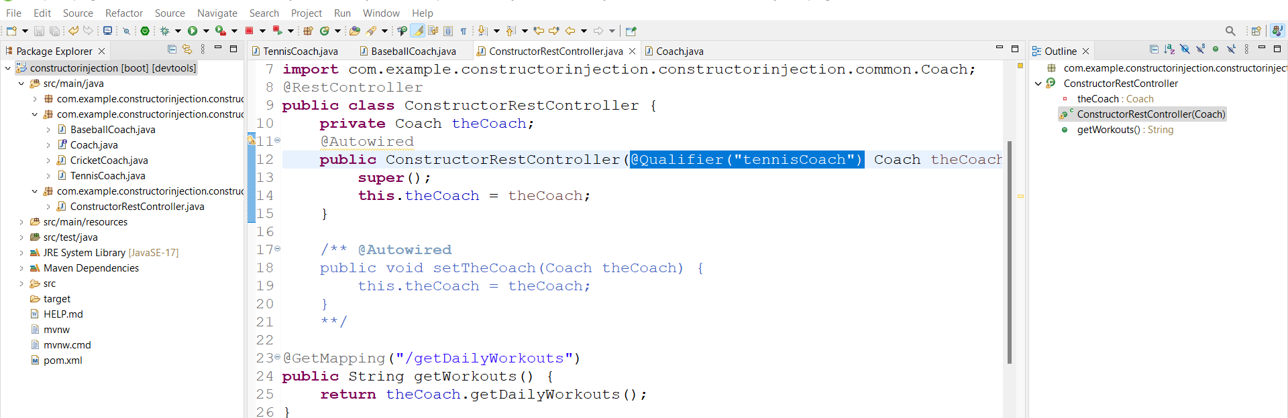

**Browser** Link: - <http://localhost:8011/getDailyWorkouts>

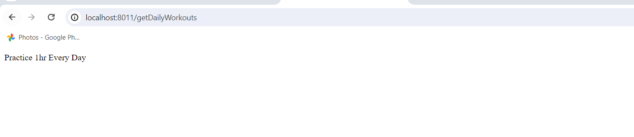

**5.Primary:-**

Copy same code open controller file remove @Qualifier code first

Then open anyone implemented class and add @Primary on top of class

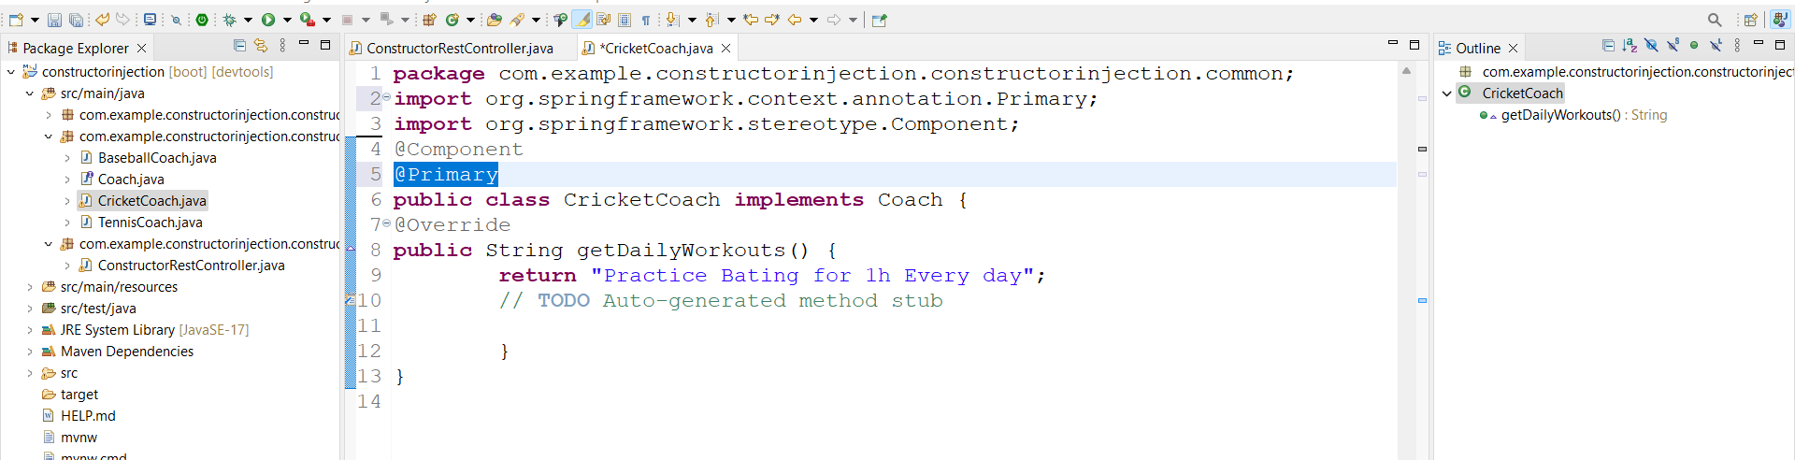

Run appn

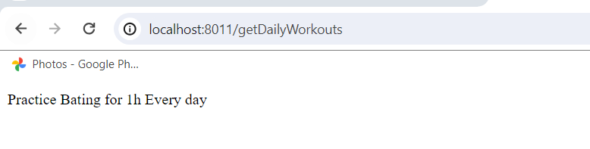

**6.Lazy-Initialization: -**

Copy same and change code to @Qualifier annotation and remove @Primary from CricketCoach

Add println to all constructors of implemented classes and control .

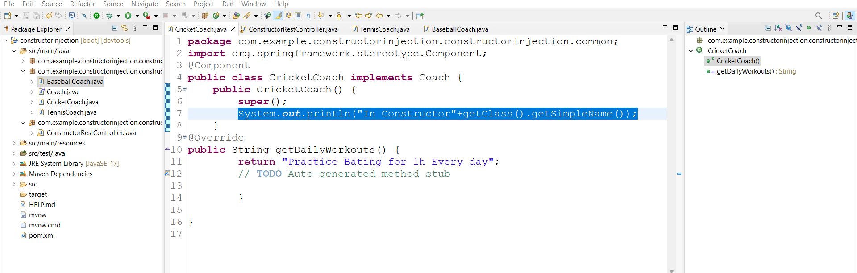

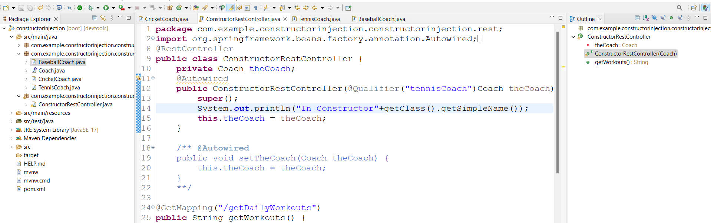

Run appn and check in log bean created for all implemented classes.

Then add @Lazy to any one implemented class then that class bean not initialized.

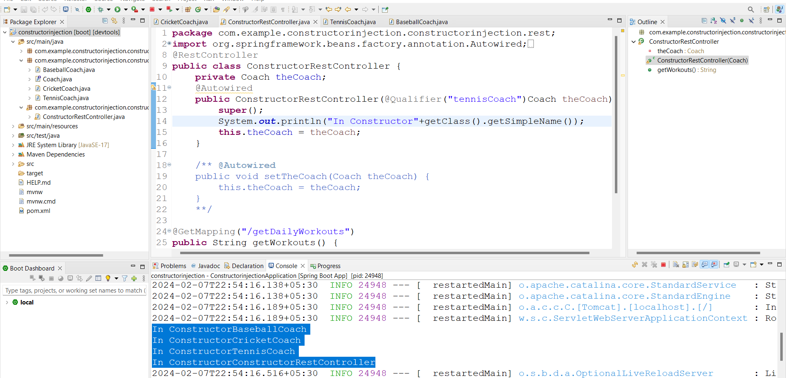

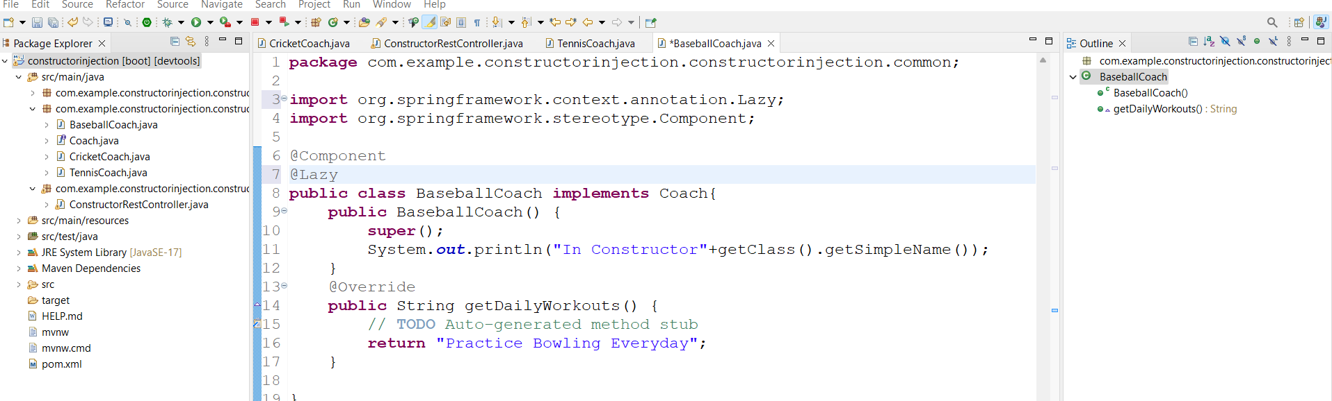

After adding @Lazy

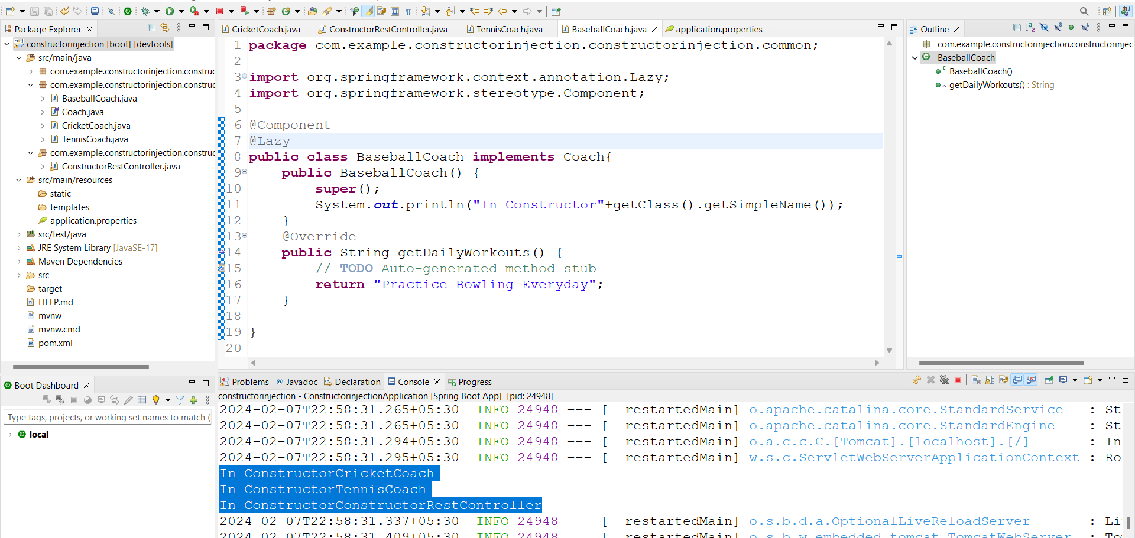

Setting lazy initialization globally by adding in appn.prop as follows

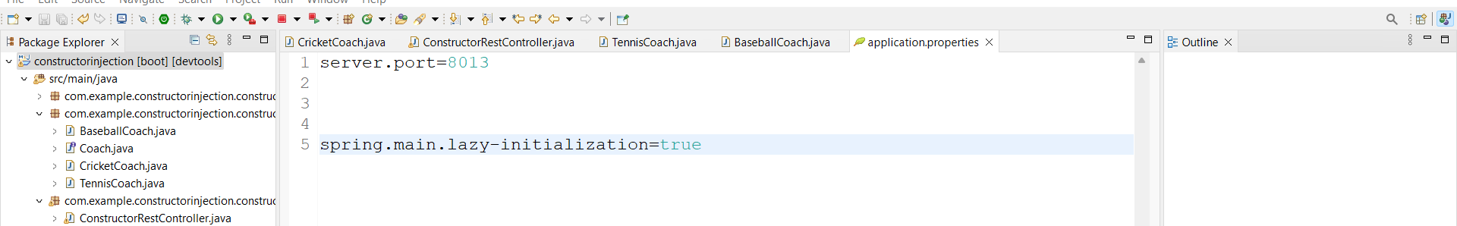

Then all beans are not created at a time they will creates whenever they required.

Run appn and check.

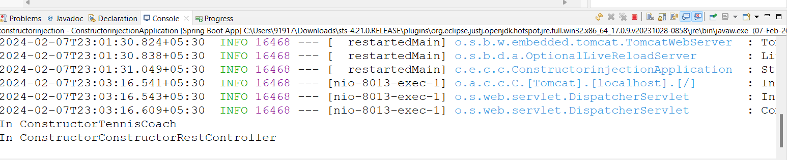

**7.Bean-Scope:-**

Copy same and remove @Lazy and global Lazy from appn.prop

Add @Qualifier for other class

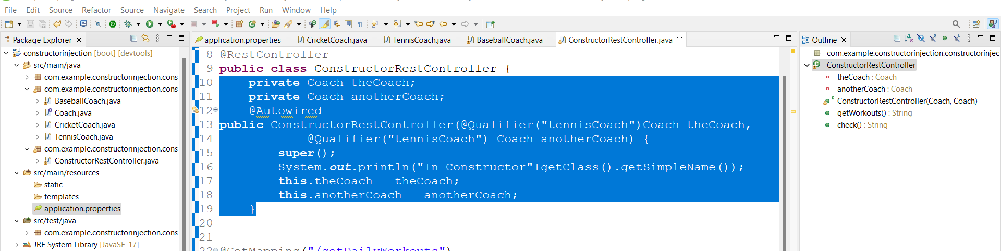

Then add new @GetMapping in controller class

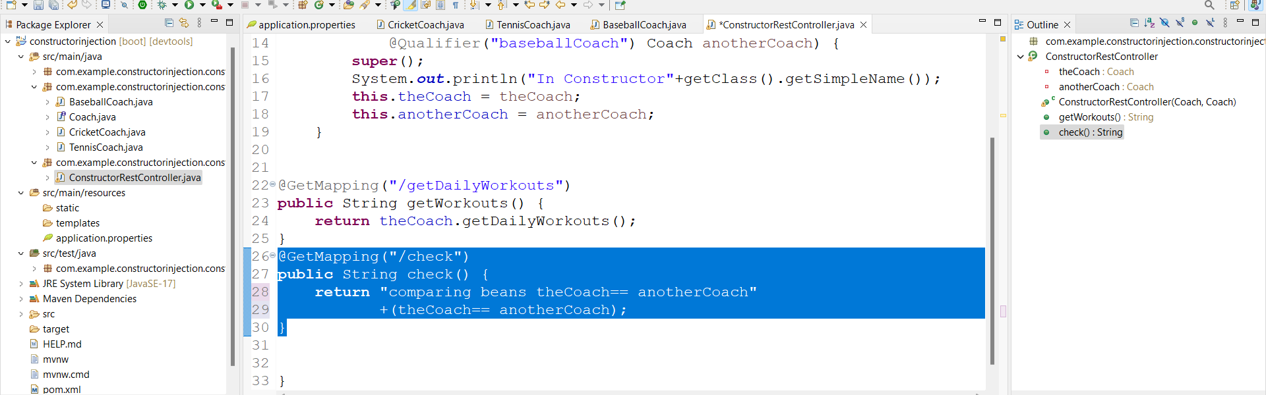

Run appn with link <http://localhost:8013/check>

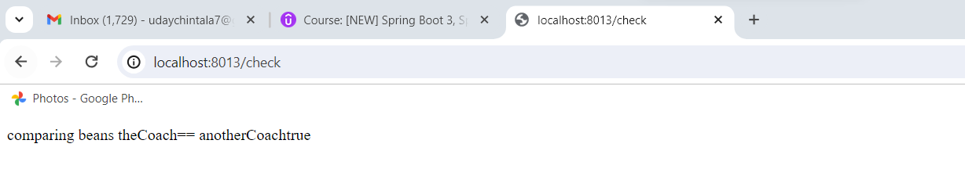

Now add @Scope to **Tennies.java** here @Scope(ConfigurableBeanFactory.***SCOPE_PROTOTYPE***) will create new obj for each bean

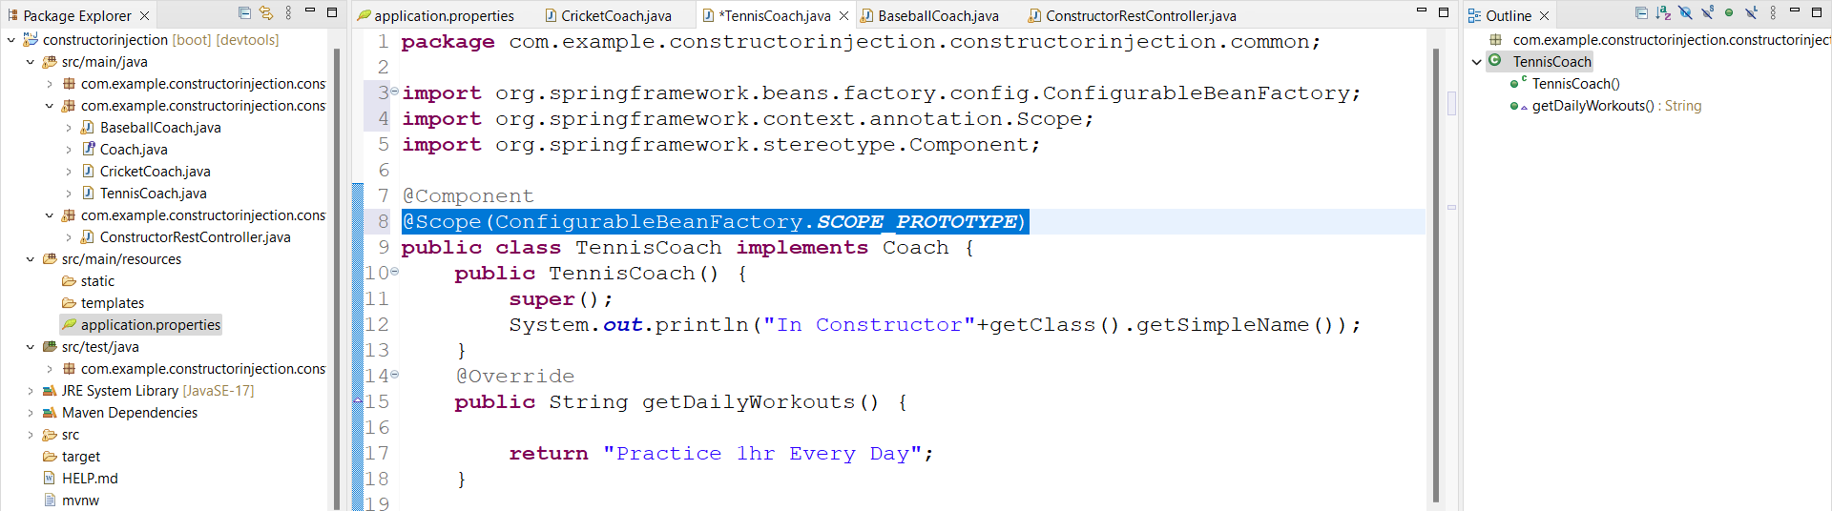

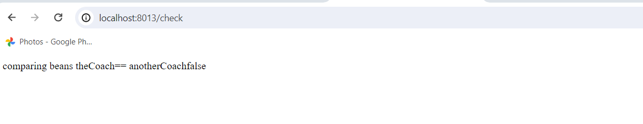

**8.Bean Life Cycle Methods:-**

Copy code and remove code for Lazy initialization. In controller and **TenniesCoach.java**

**Open TenniesCoach.java add @PostConstruct and @Predestroy**

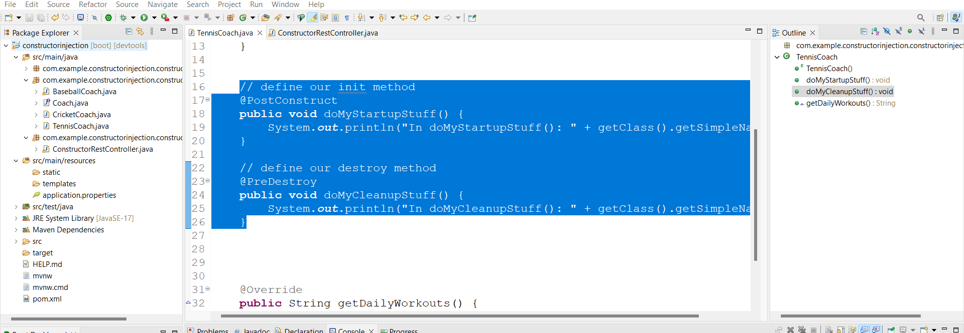

Check in log init and destroy methods are running.if we run appn then init got started

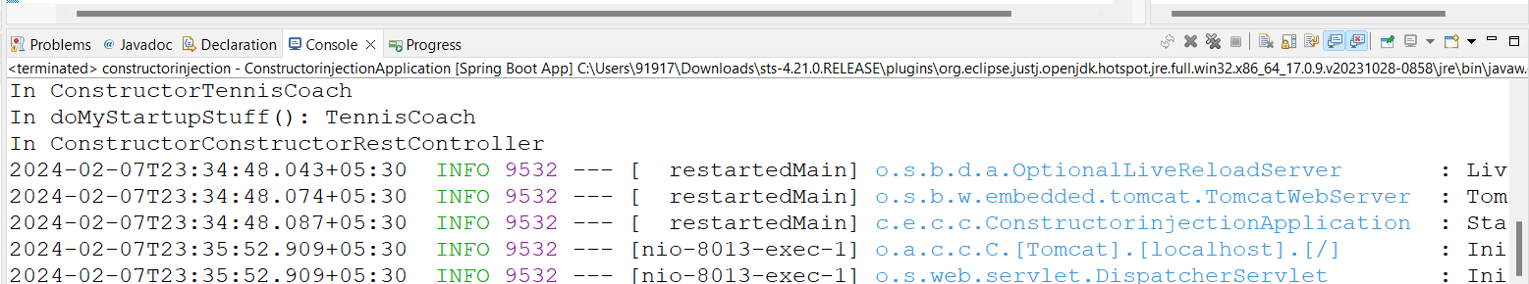

After closing appn destroy got started

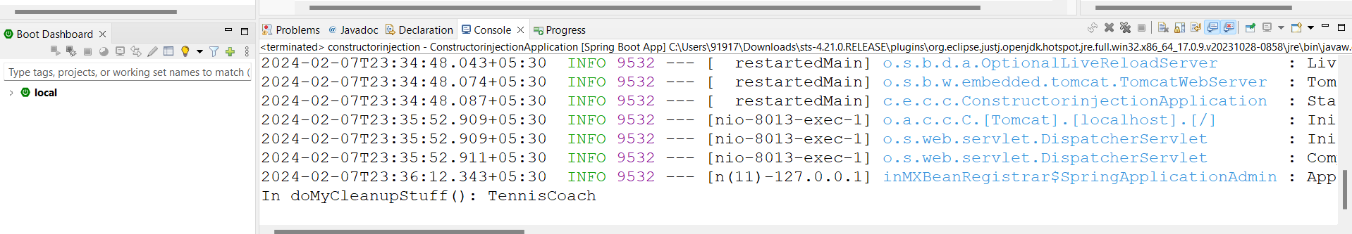

**9.Java Config Bean: -**

Copy code and create new class **SwimCoach.java** under common.

Here we are not defined @Component on **SwimCoach.java**

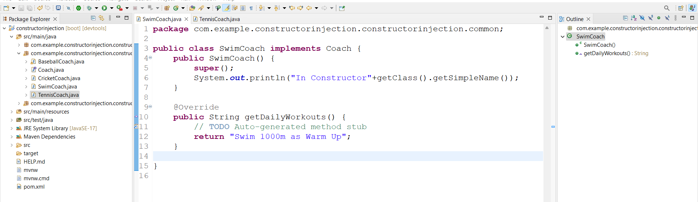

If we run appn will get error because we are not defined **@Component** on class.

Now to resolve this issue create new Class **SportConfig.java** under new Package **config**.

Here Write a method which returns **SwimCoach** obj

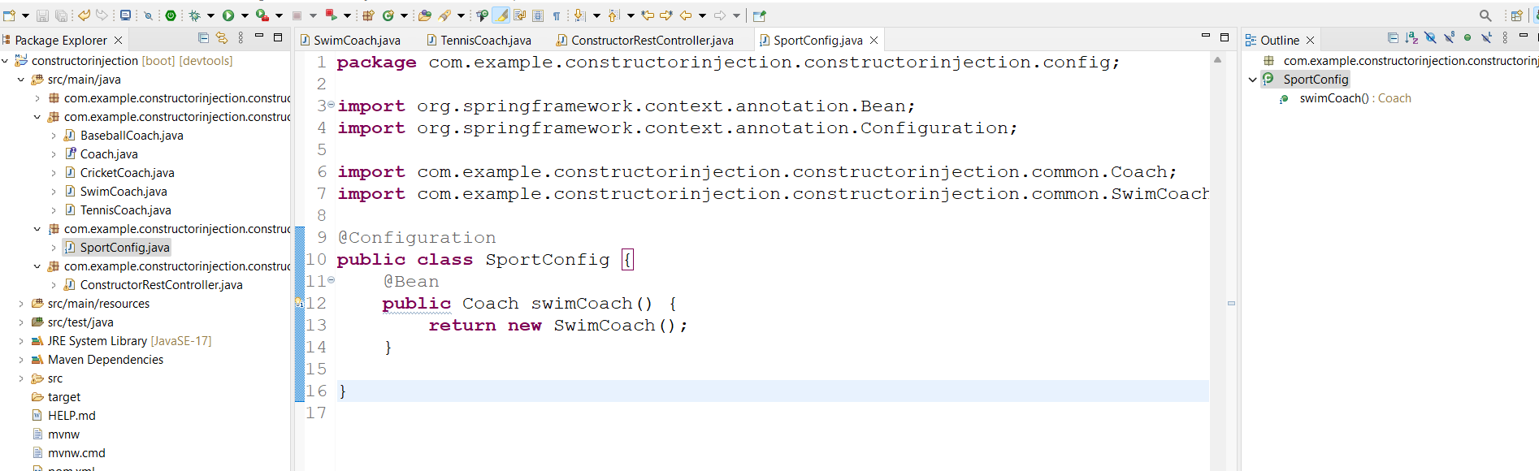

Now run code it creates beans for all classes.

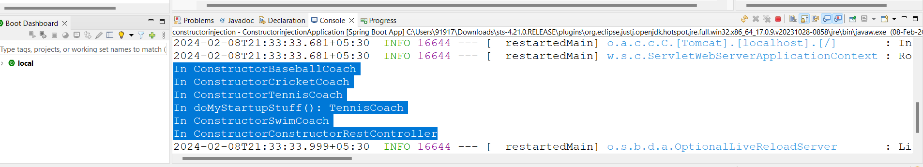

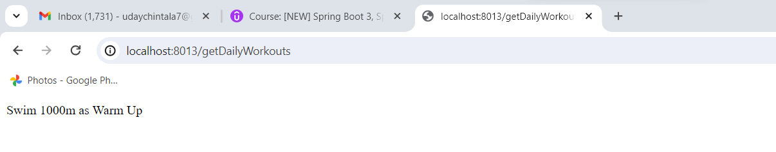

Another way give name to @Bean and change that in **Controller** class

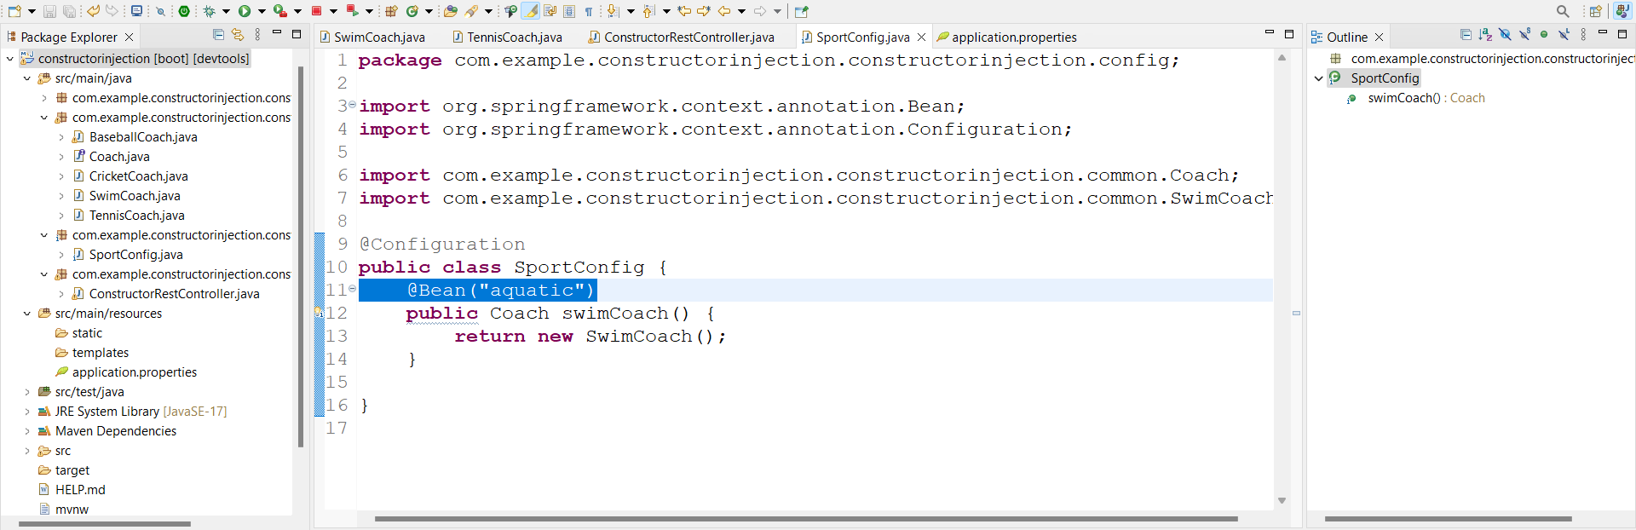

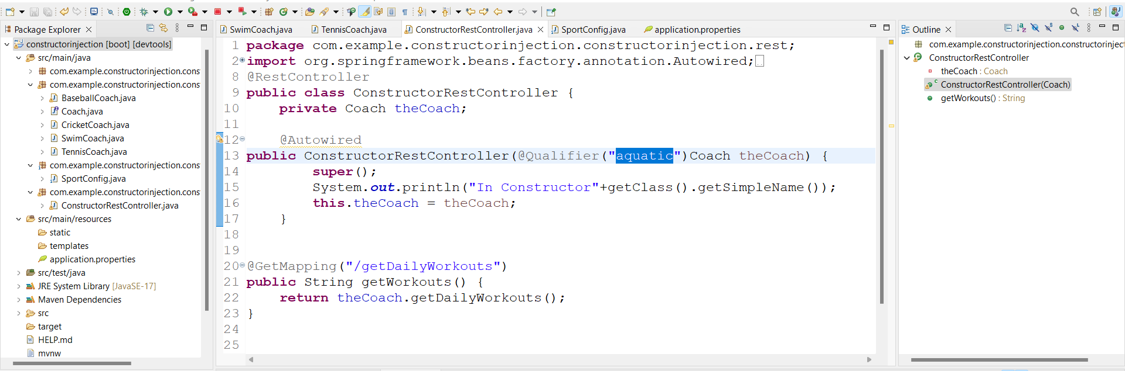

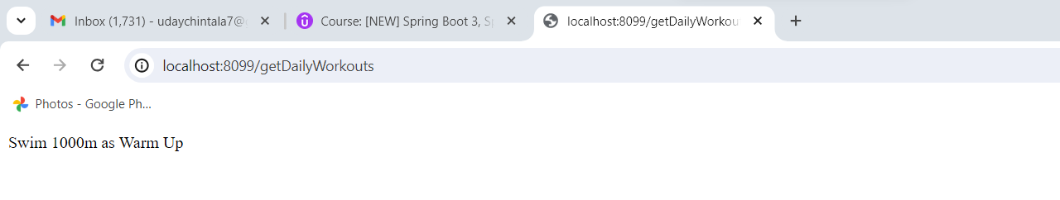

**Topic- 3. Hibernate JPA Crud: -**

Open MySQL server then open database files from folder and execute them path **File 🡪open SQL Script**

**User = springstudent**

**PWD =** **springstudent**

Execute 1st SQL script from folder then click on Home will move to home screen there click on plus symbol then add our user there by giving connection name and user as **springstudent** then click on test connection give pwd **springstudent**.

In **springstudent** user execute 2nd SQL script

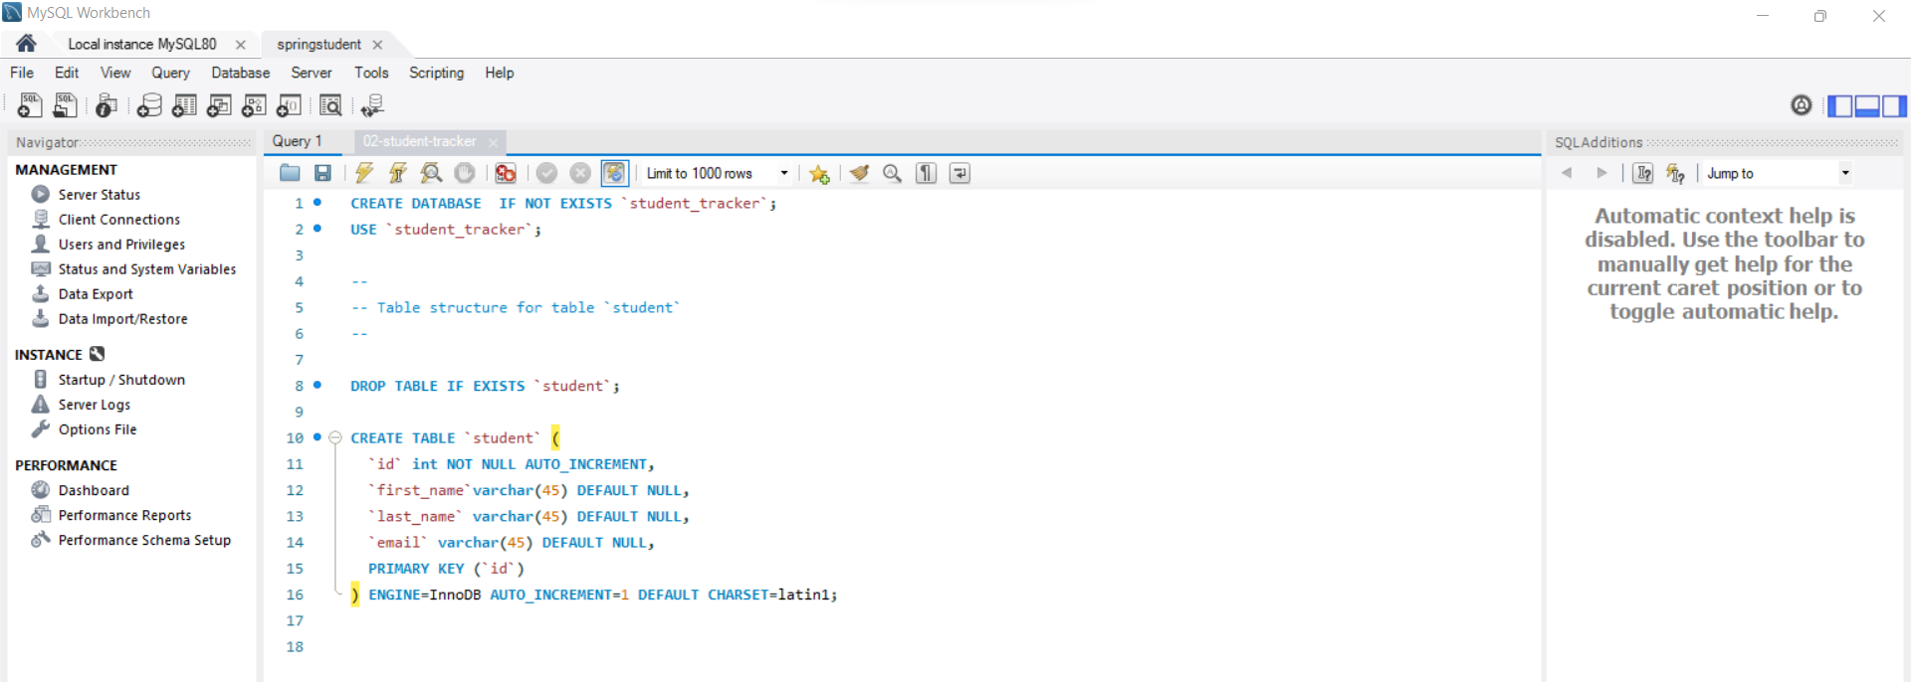

**Crud Appn: -**

Create new project with mysql and jpa dependencies.

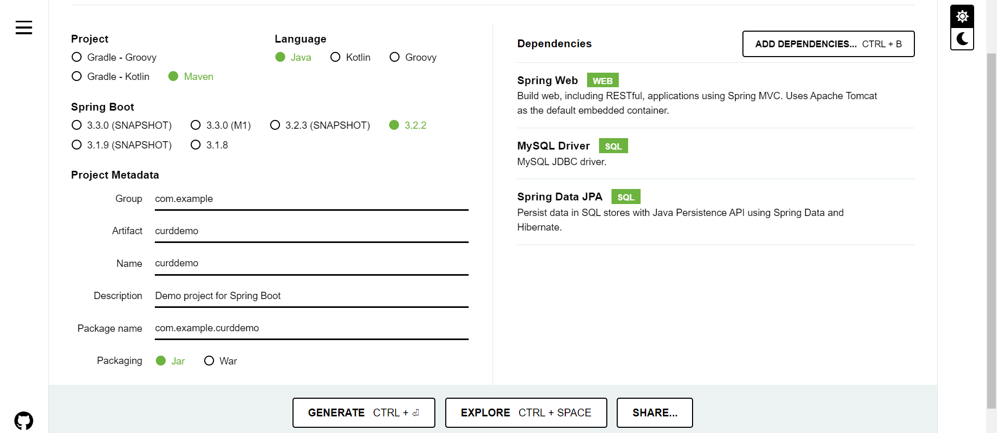

Open **CurdDemoApplication.java** and start write code we need **CommandLineRunner** for doing curd operations.

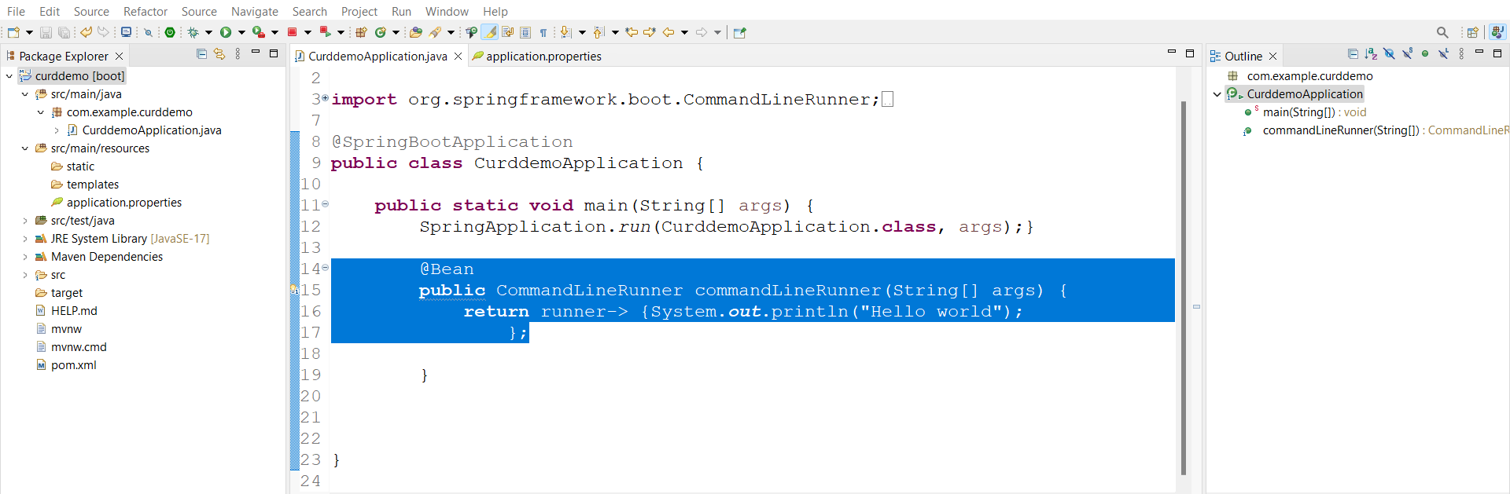

Here runner is interface we are using Lambda expressions to call runner interface. **CommandLineRunner** will execute after all beans are loading

Now add database properties in appn.props.

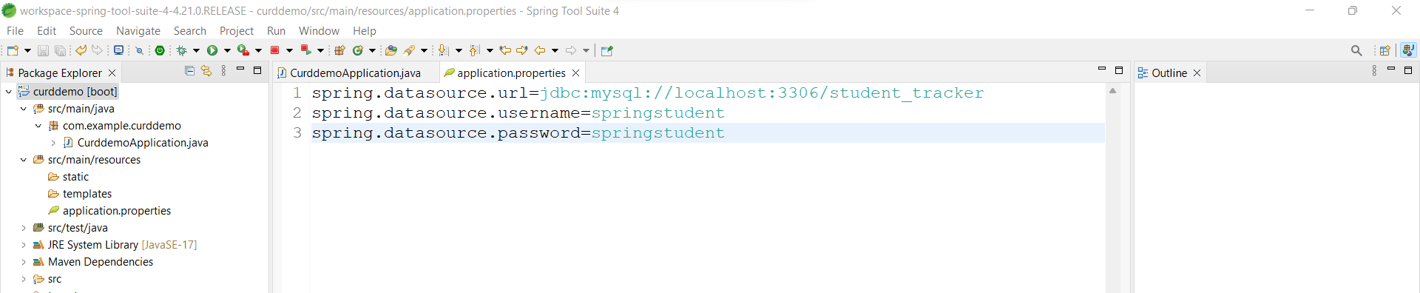

Now run the appn then check in log weather connection happened successfully or not

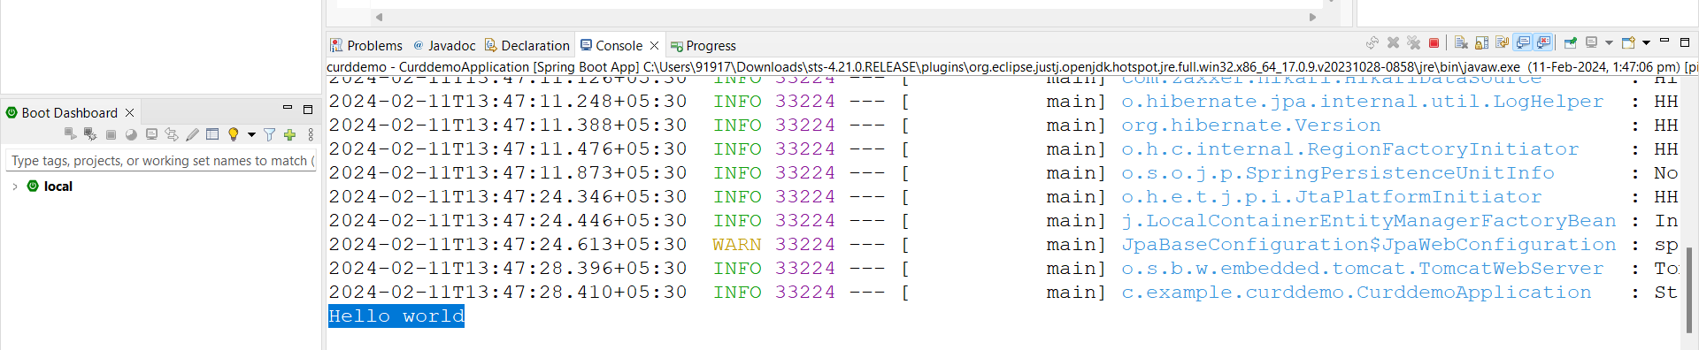

In log if we want to turnoff Spring boot banner then add following in appn.prop

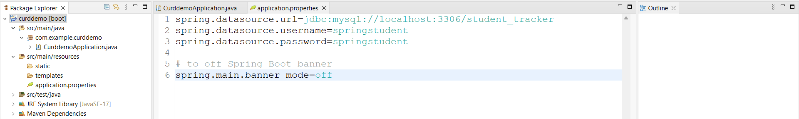

To reduce logging level add following

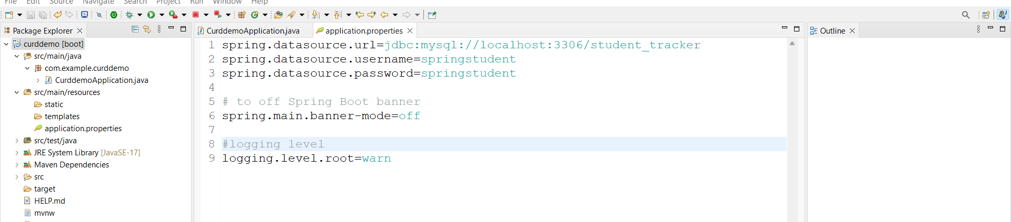

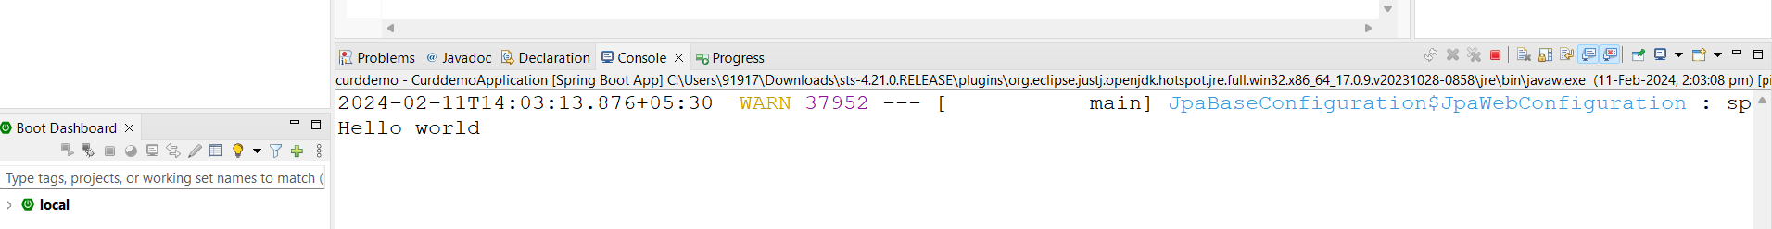

**Inserting single Student: -**

Now create new package entity and create new class **Student.java**

Create fields which reflect database Student and map them with help of @Table and @Column

**@Id** is tells field is primary key in database table column.

**@GeneratedValue(strategy.GenerationType.IDENTITY)** this will auto increment the field value in table.

Import all Annotations from **Jakarta.persistence** packages

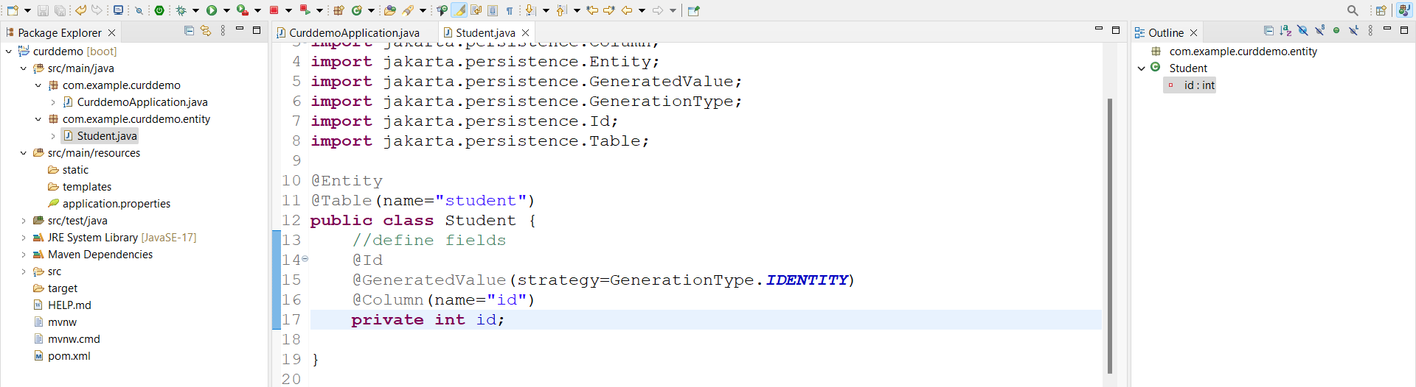

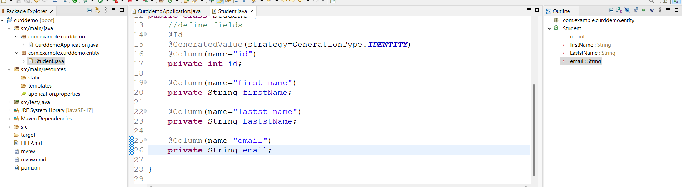

Create default constructor and parameterized constructors and setter and getters and toString method

Ceare new package dao and new interface StudentDAo

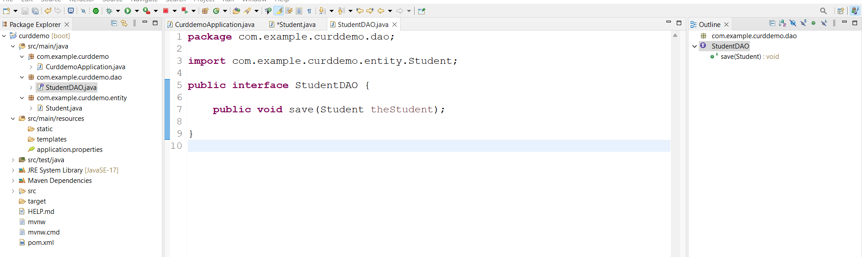

Create **StudentDAOImpl.java** under dao package with @Repository Annotation this annotation helps to component Scanning and Jdbc exceptions

**@Transactional** this will used when we are doing transactions in DB

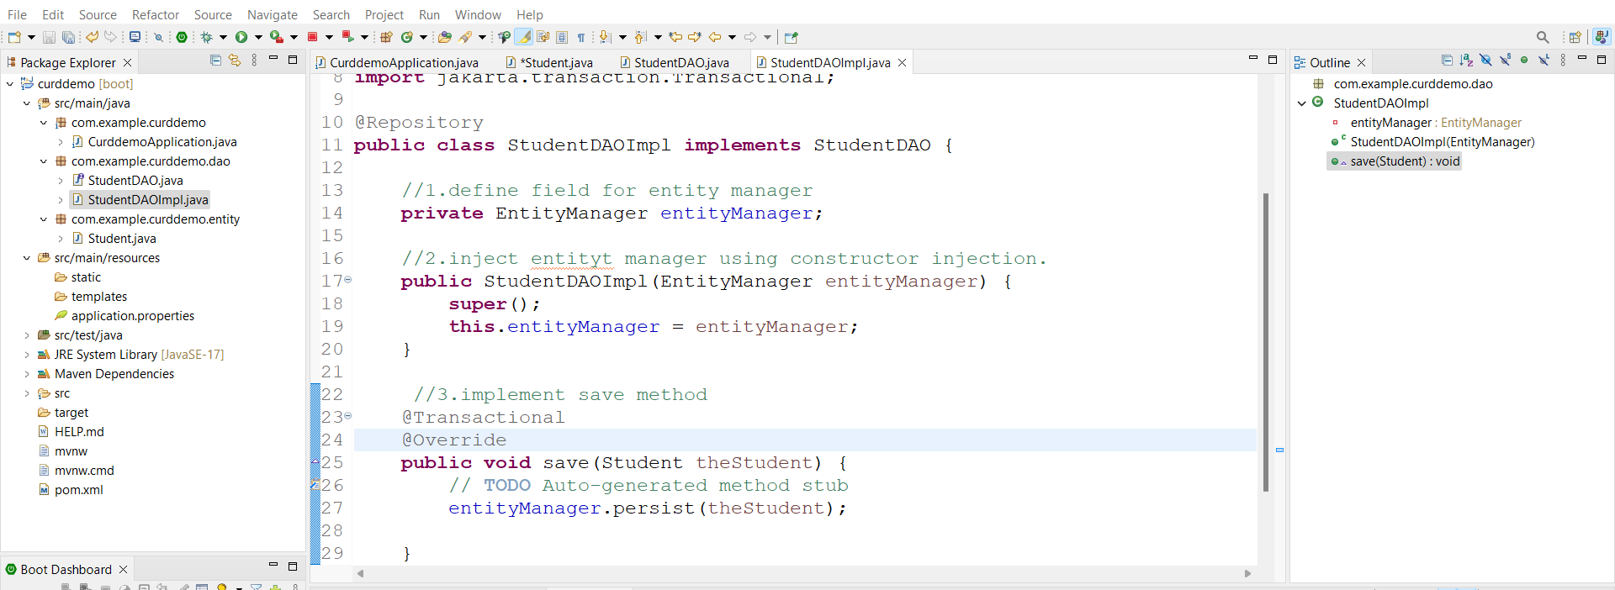

Then open main appnthat is **CurdDemoApplication.java** change CommandLine code as follows

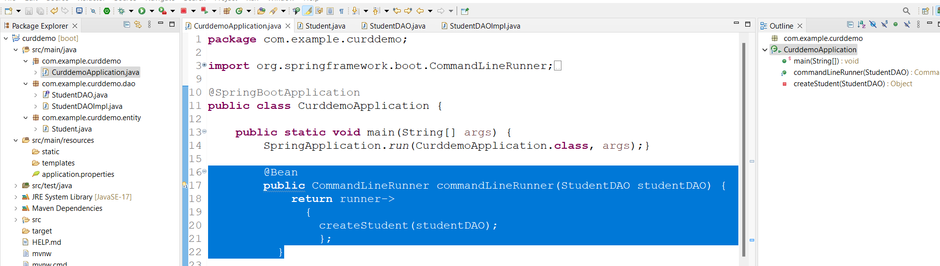

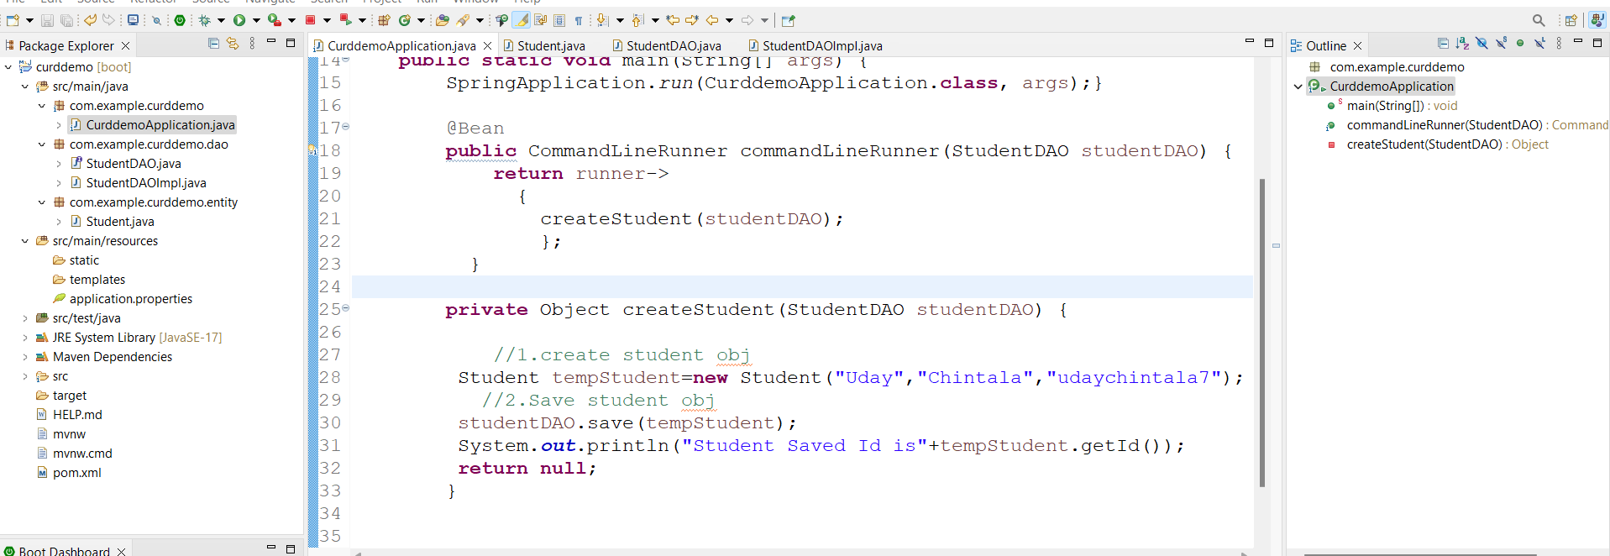

Run the appn then student got saved before run DB

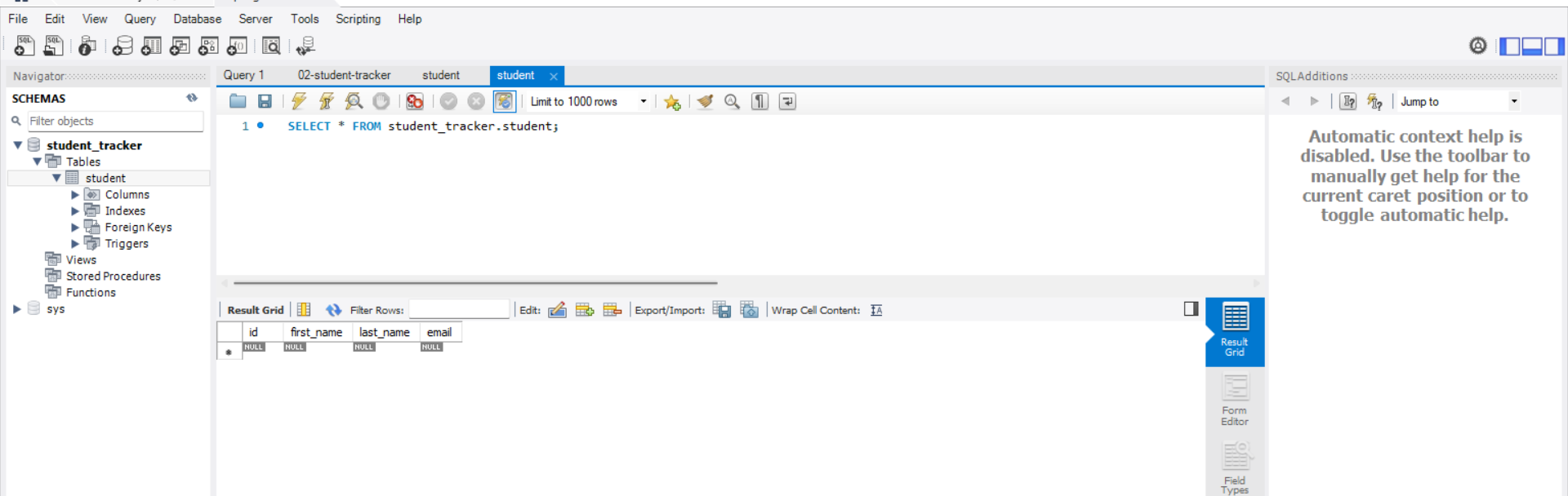

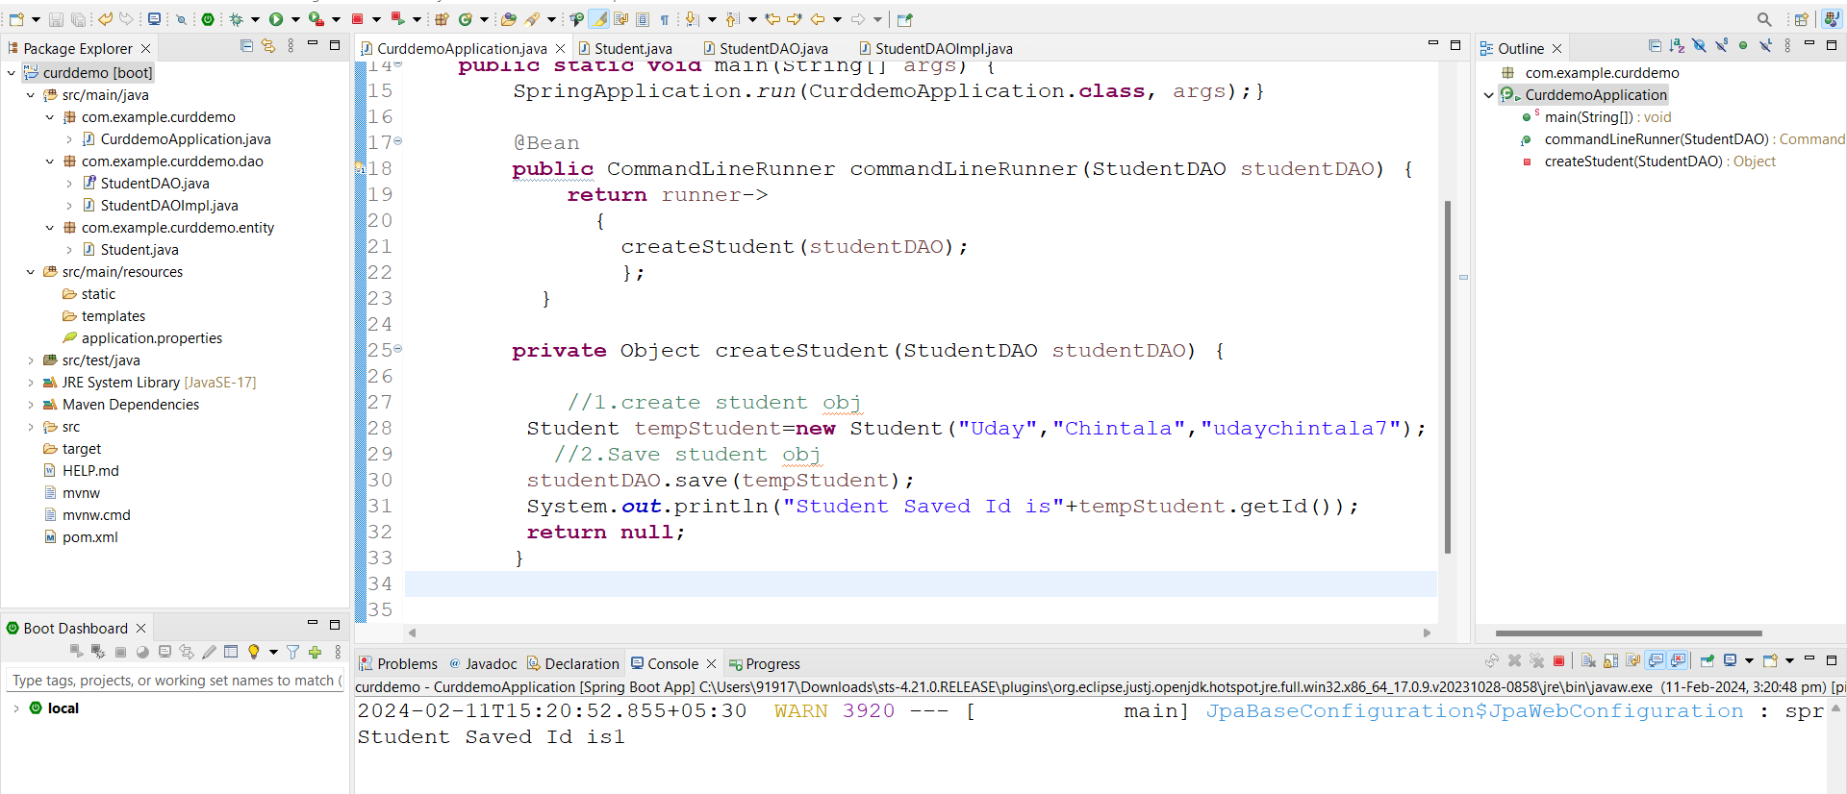

After run

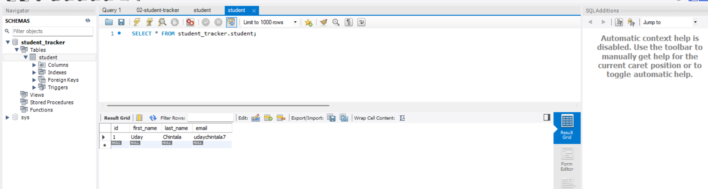

**Inserting Multiple Student: -**

**Go to CurdDemoApplication.java** comment method for single student write new method to save multiple students

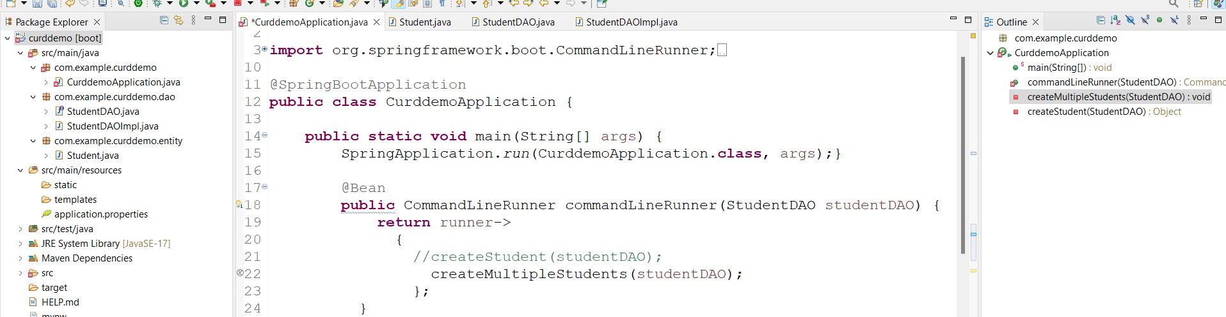

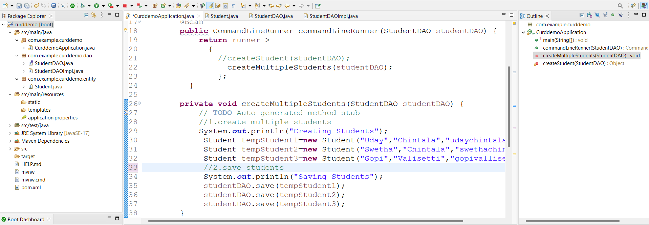

**Run appn**

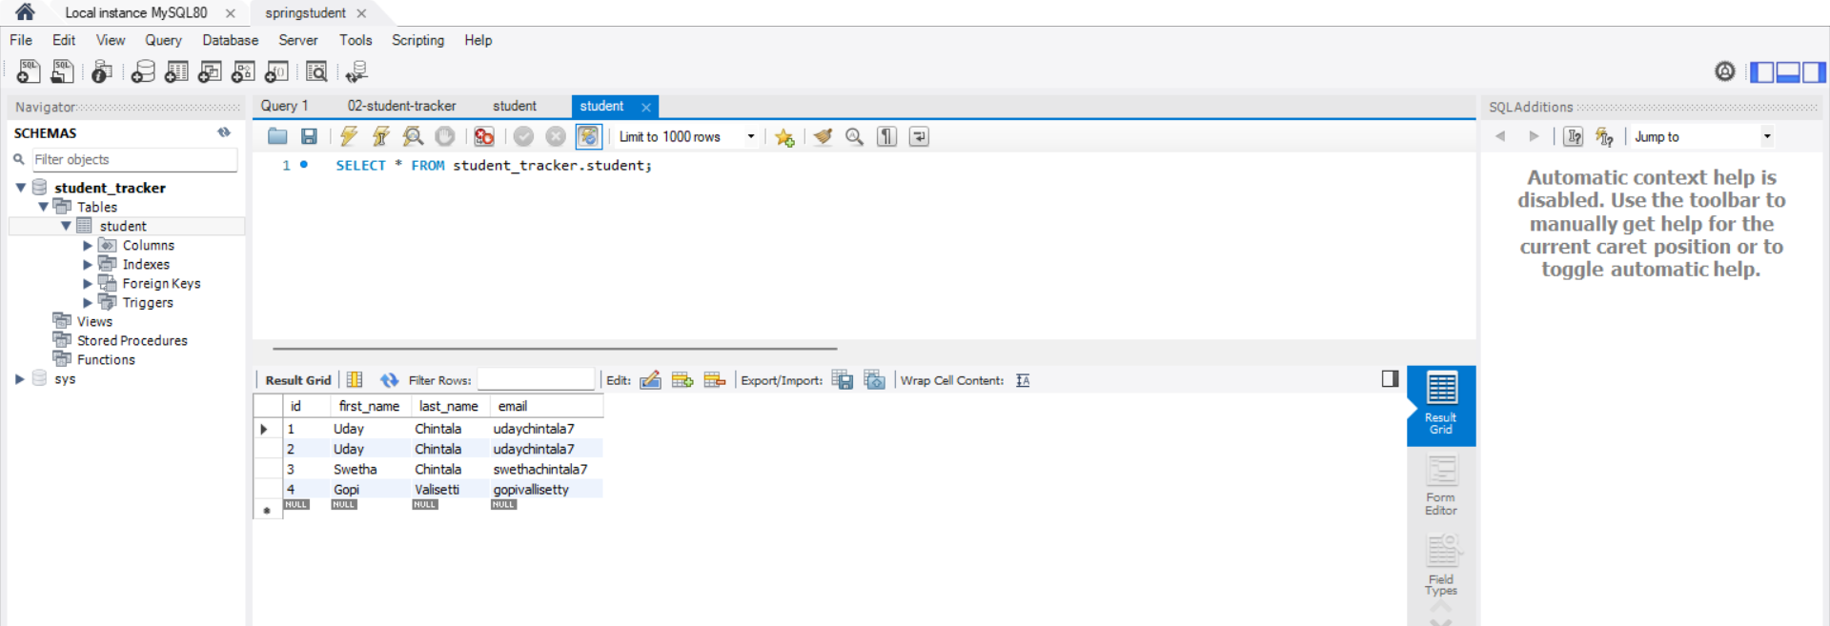

Here id got auto incrementing from 1 if we wants to change that to our wish do as follows in Db

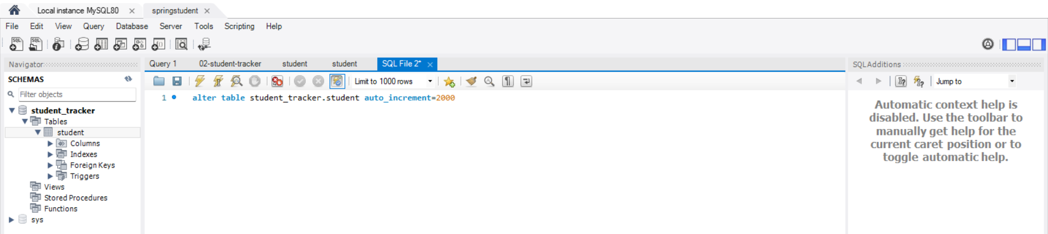

Now run appn check in Db

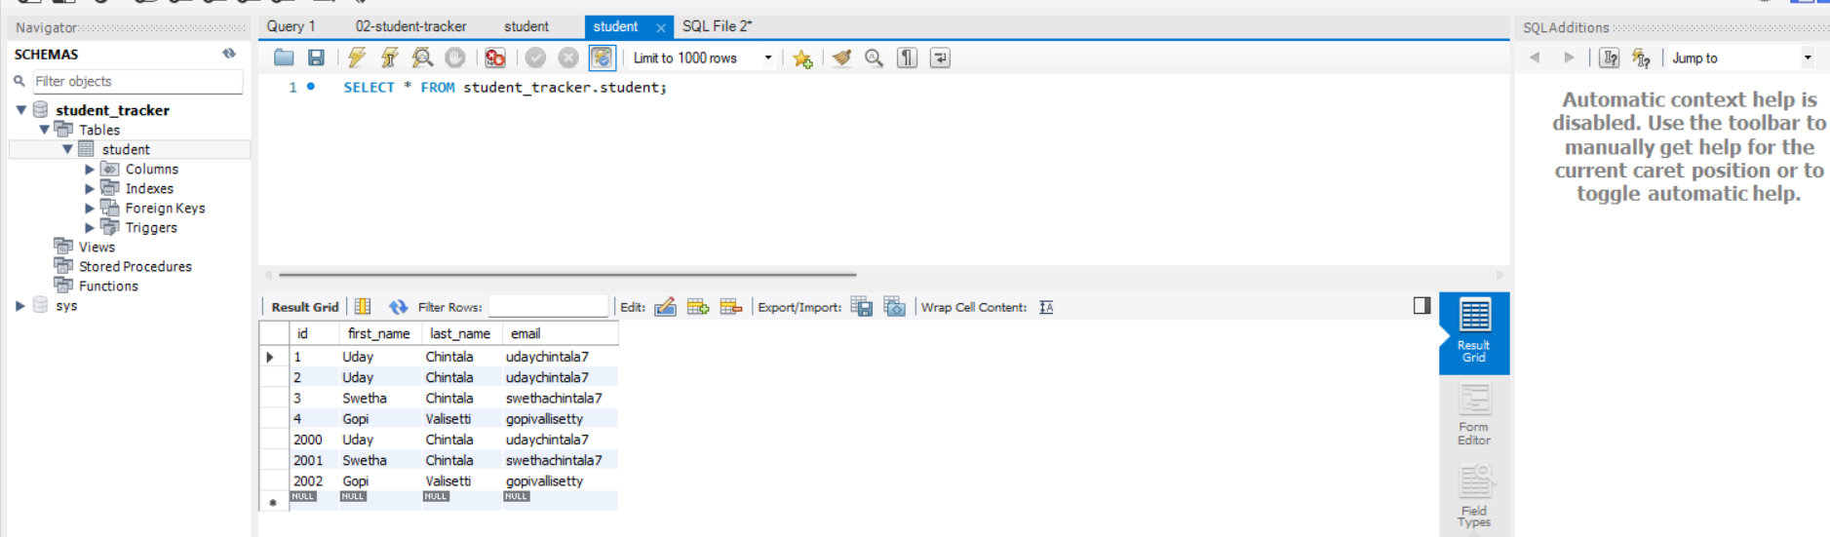

**Read Student: -**

1.Add new method in DAO interface

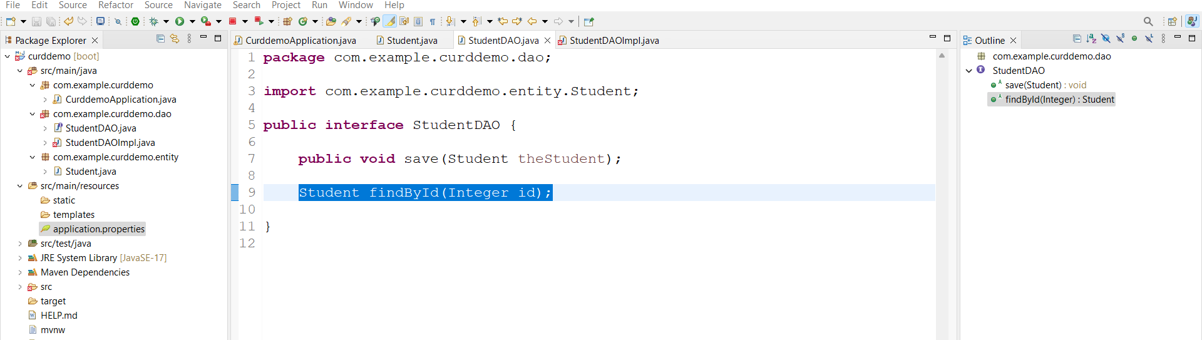

2.Add this method in **StudentDAOImpl.java**

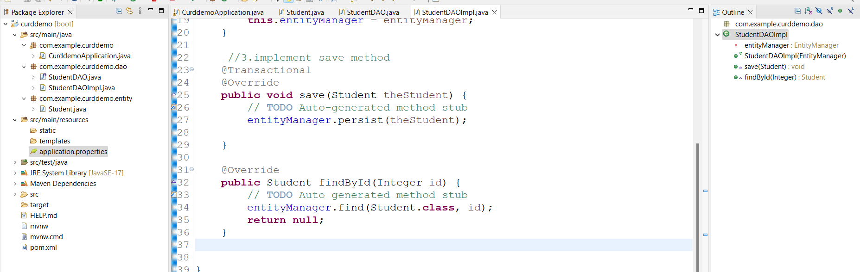

3.add in main appn

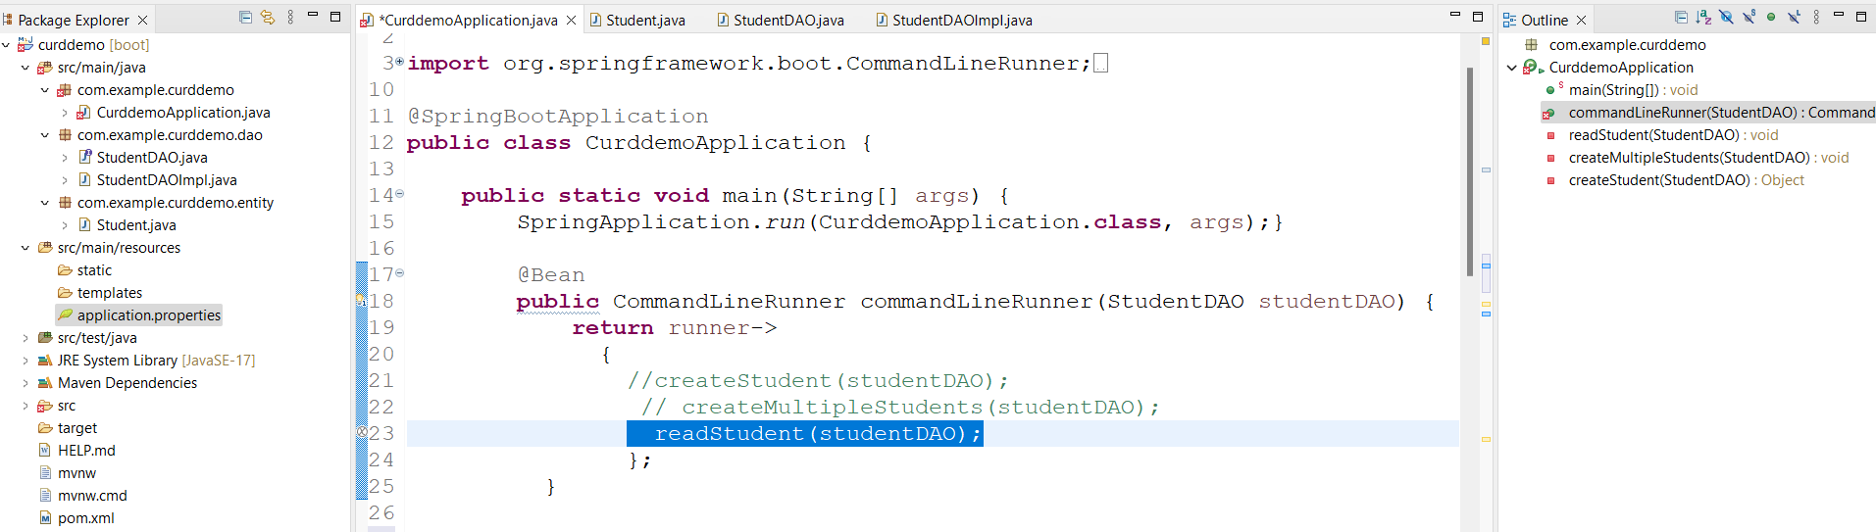

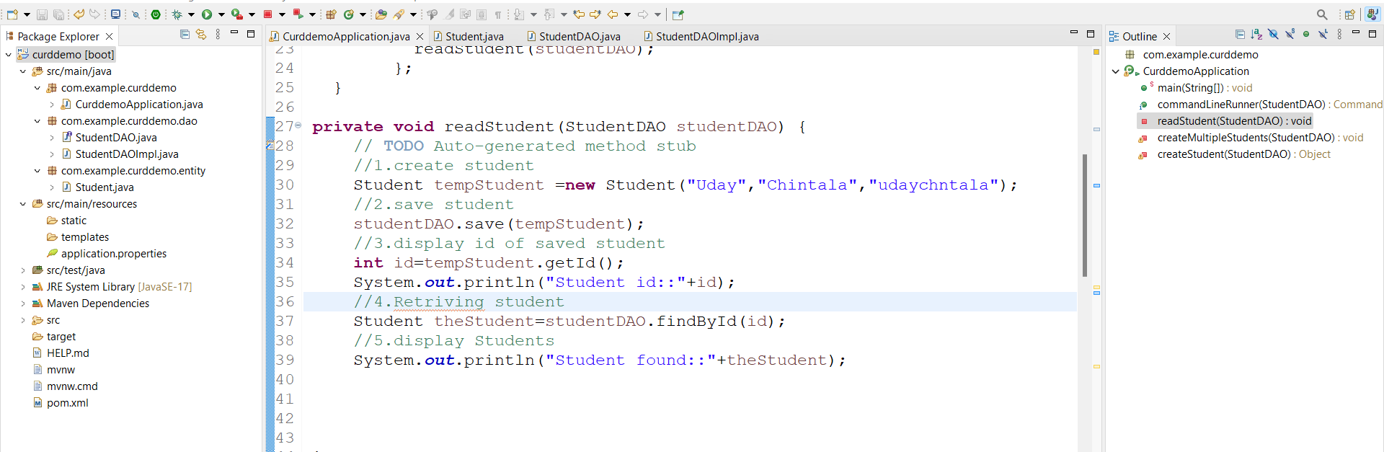

Run appn

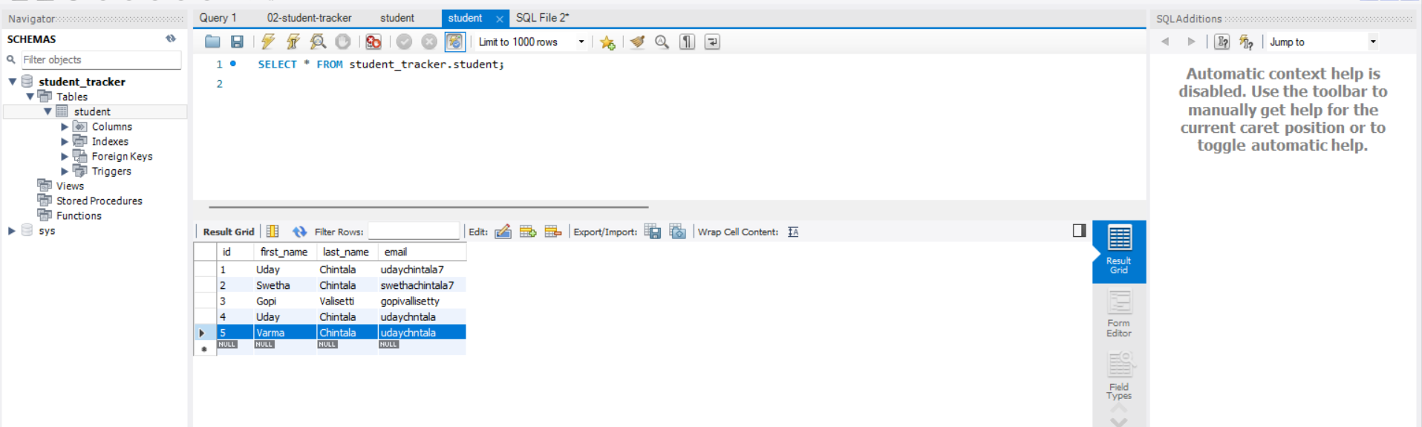

**Querying data: -**

Add method in interface

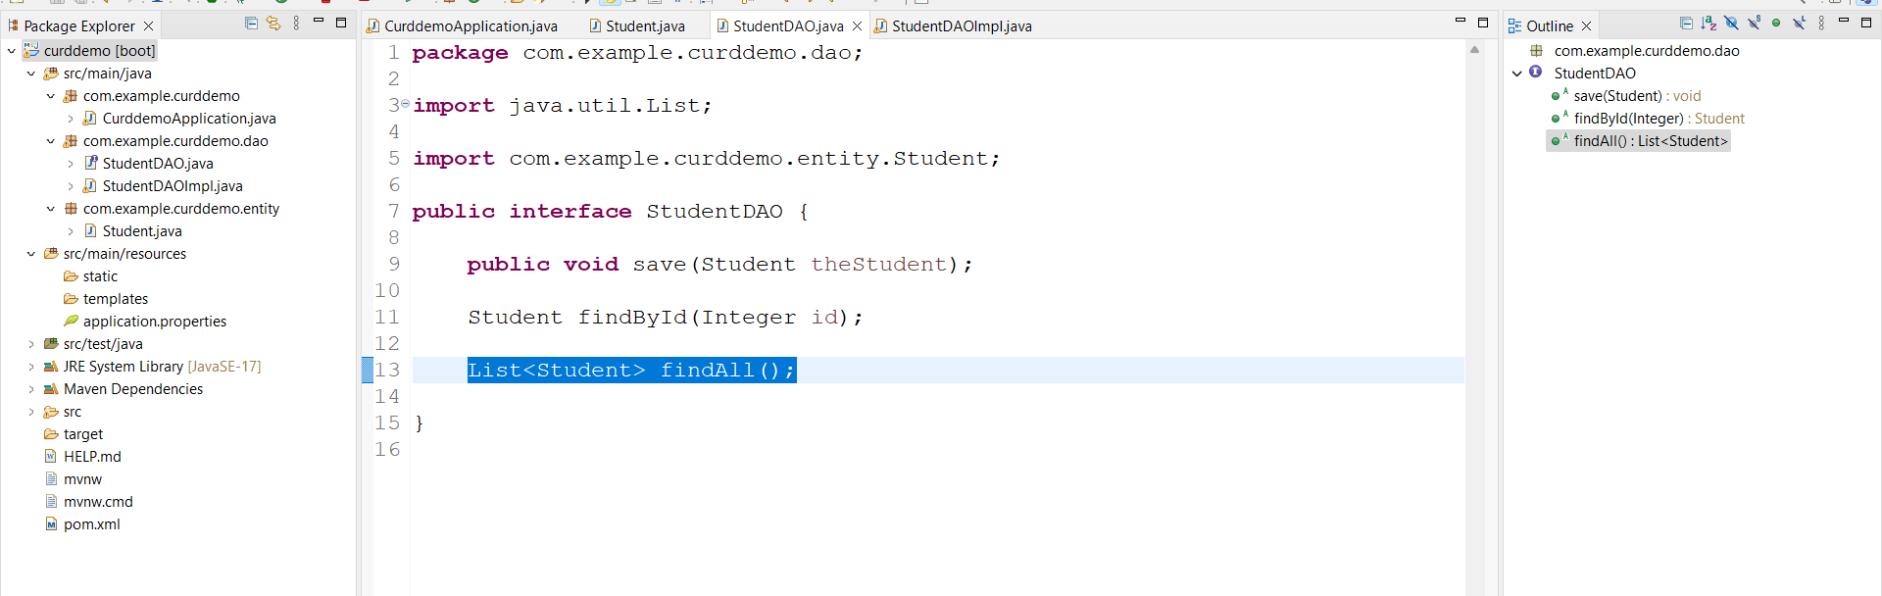

Implement method in DAOImpl class

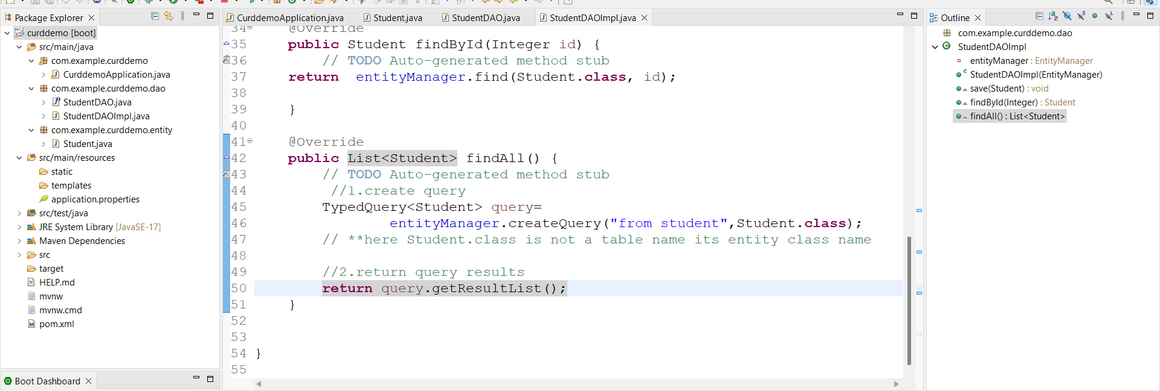

Update in main appn

Add method in runner

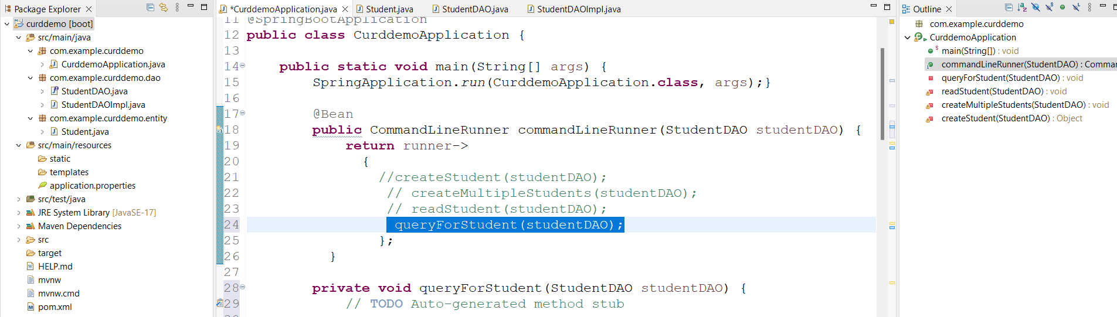

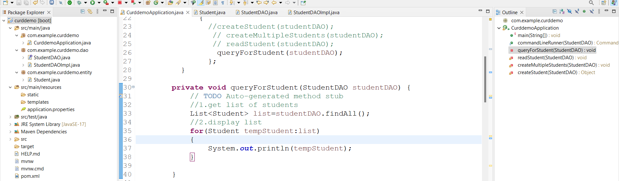

Run appn

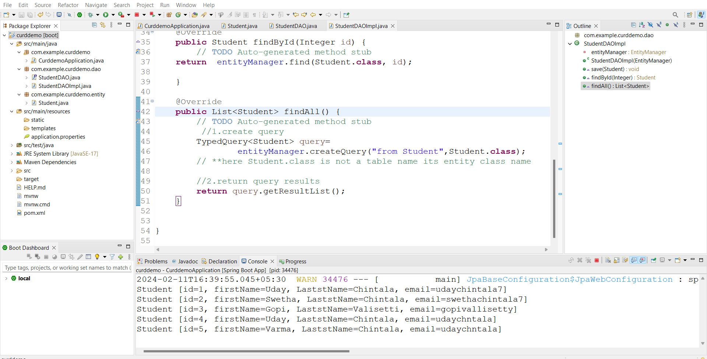

**Sorting Student based on last name: -**

Open DAOImple class and write like this

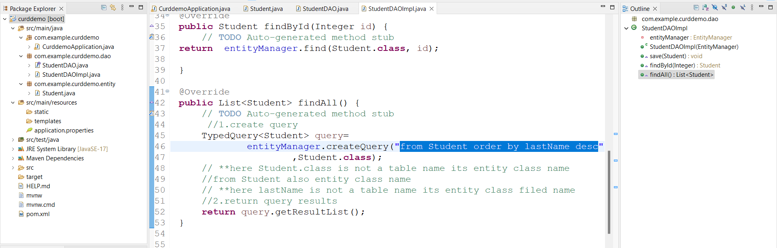

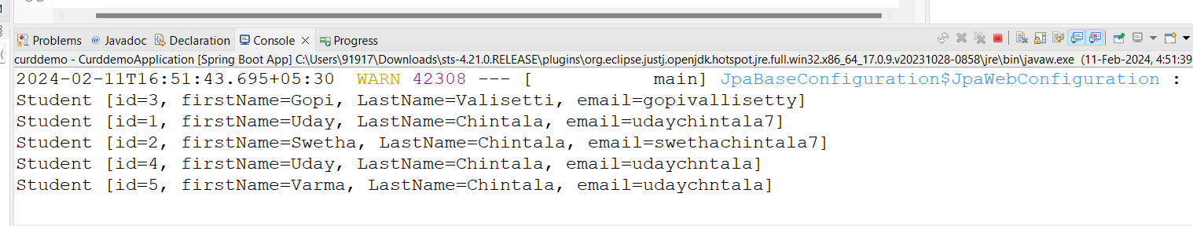

**Find Student by Last Name: -**

Add method in DAO interface

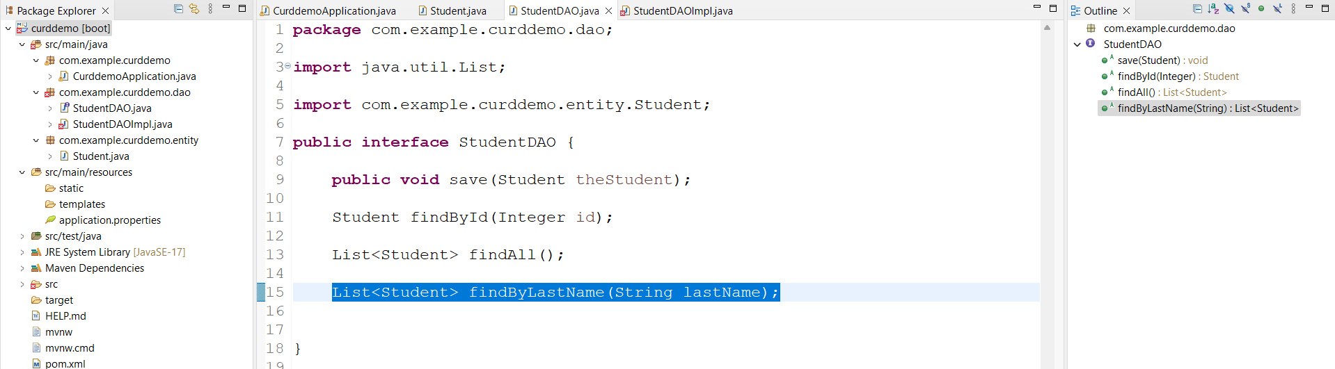

Implement in DAOImpl class

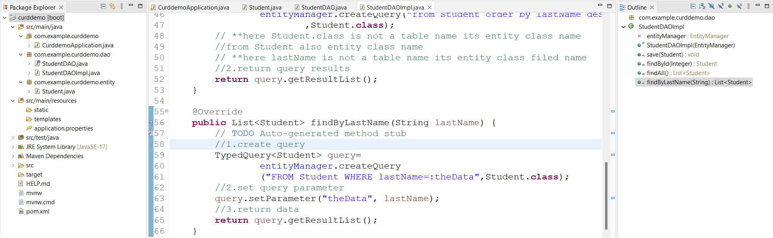

Go to main appn

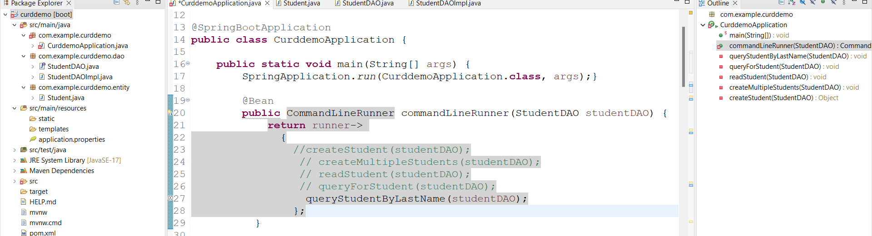

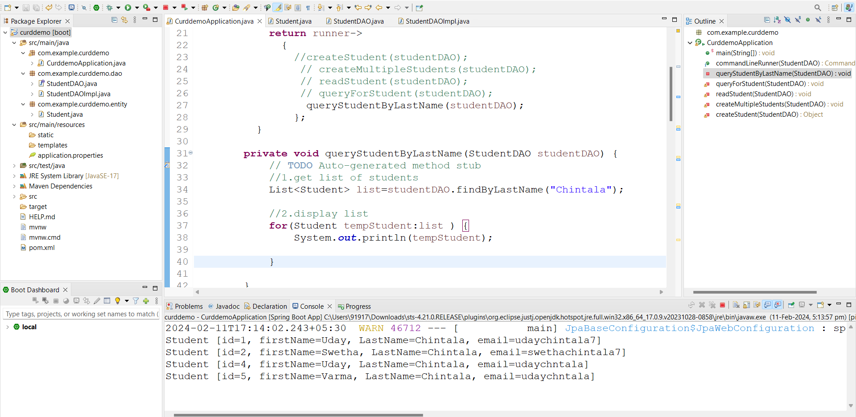

**Updating Student: -**

**Add new method in interface**

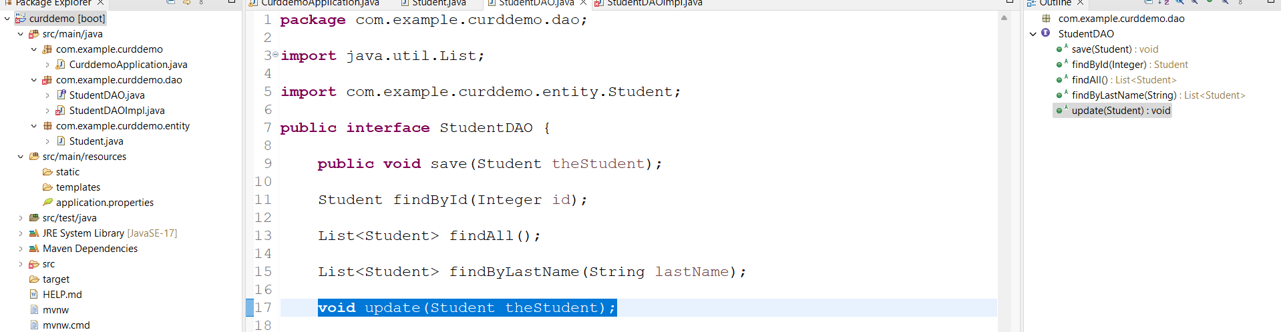

Implent in DAOImpl class

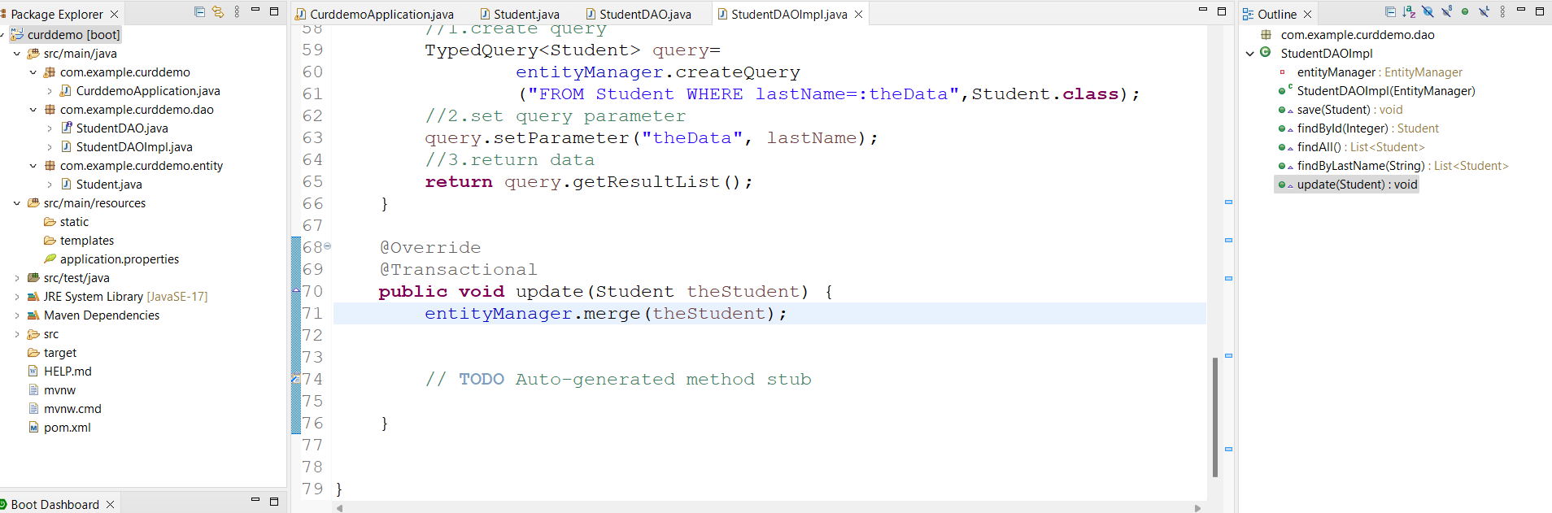

Update main appn

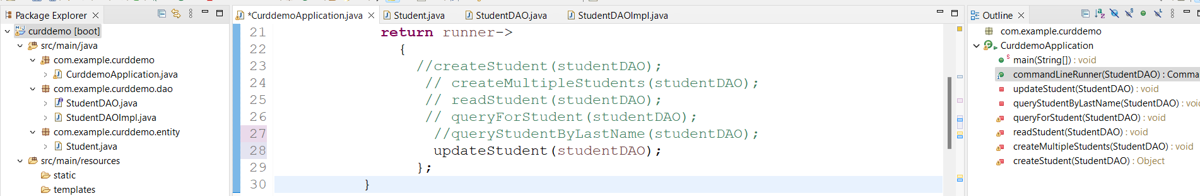

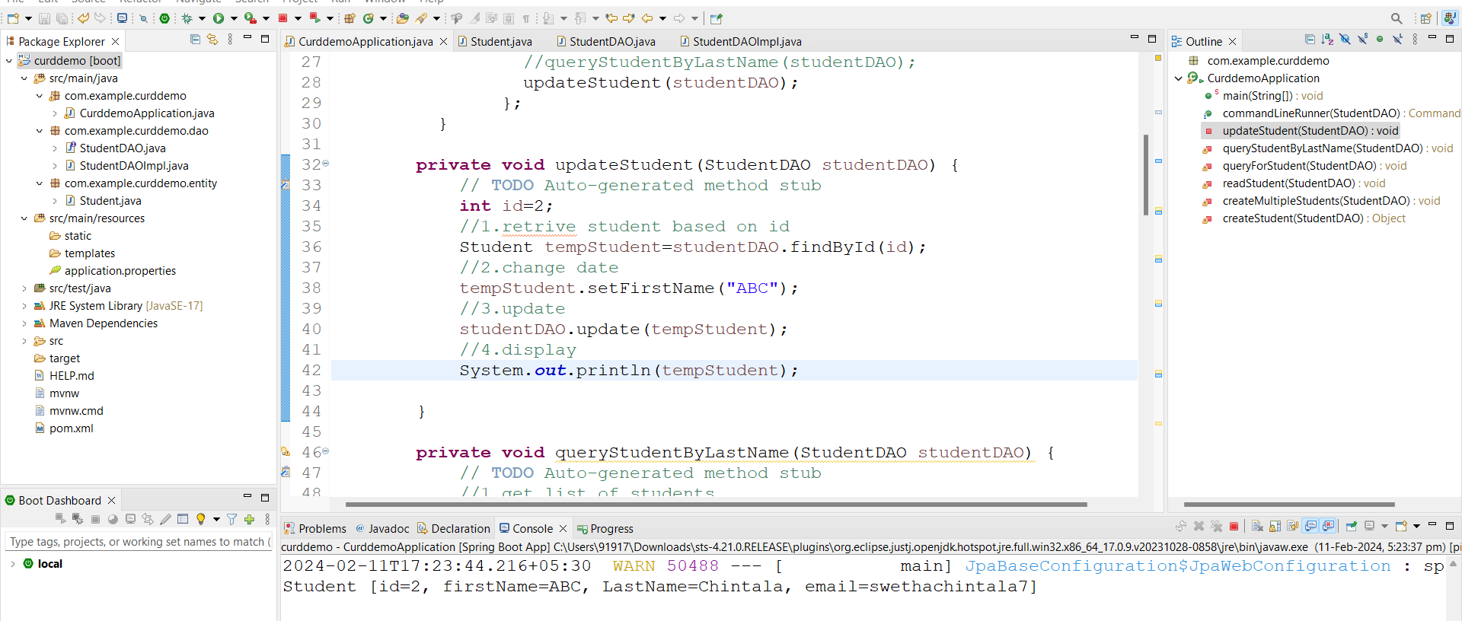

**Delete Student: -**

Add method in interface

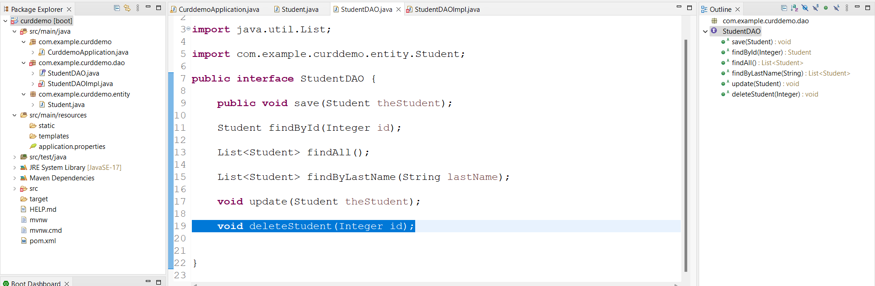

Add in DAOImpl class

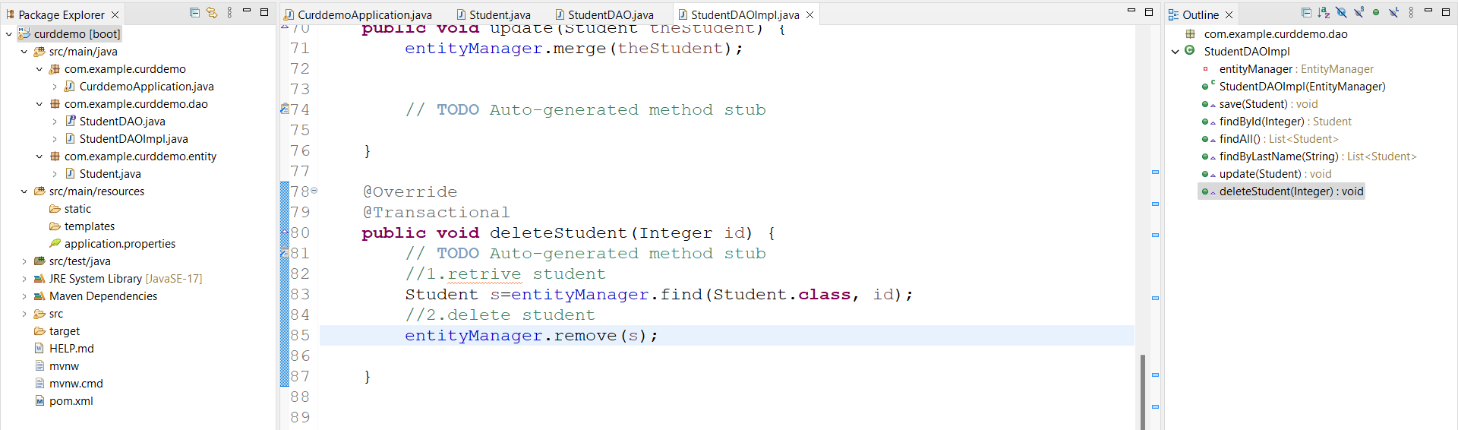

In main app

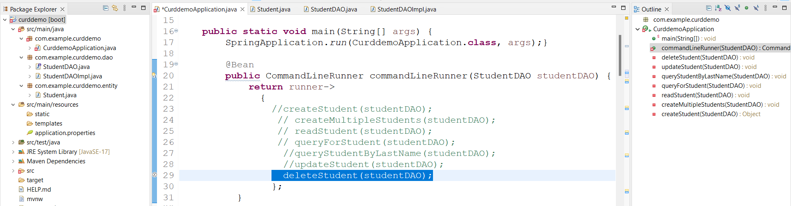

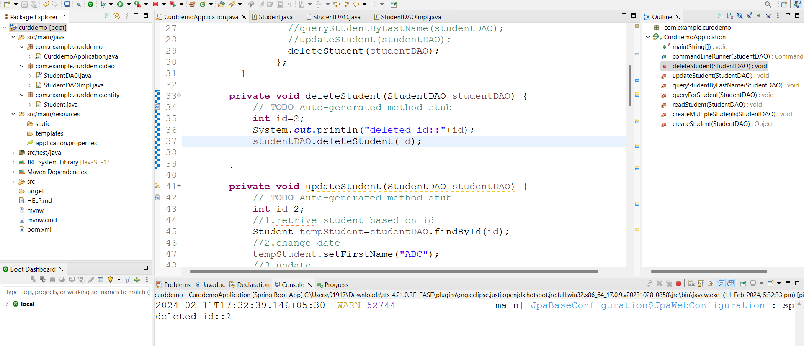

**Delete all Students: -**

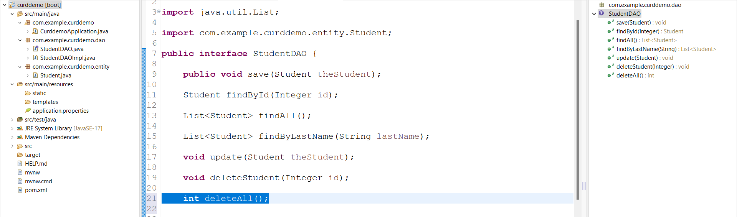

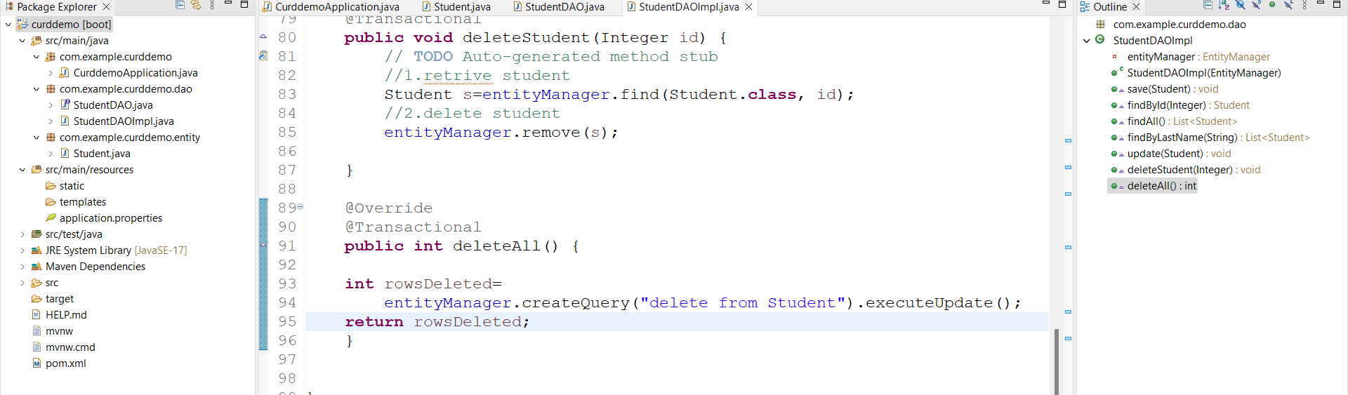

Main app

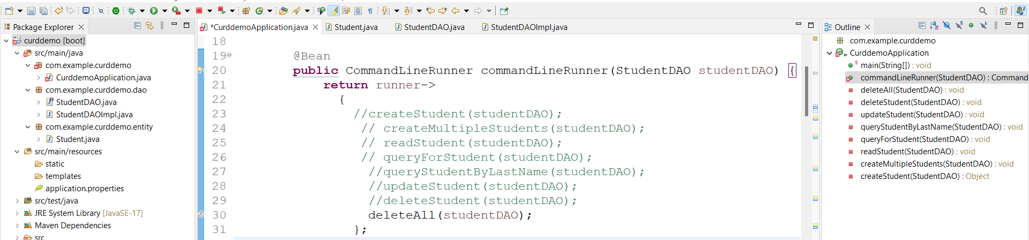

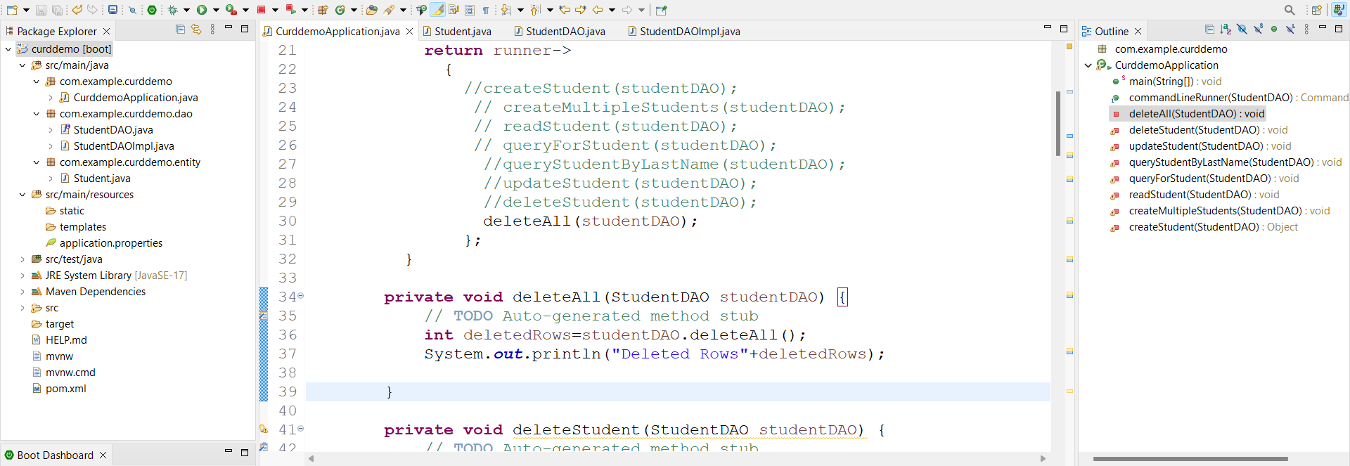

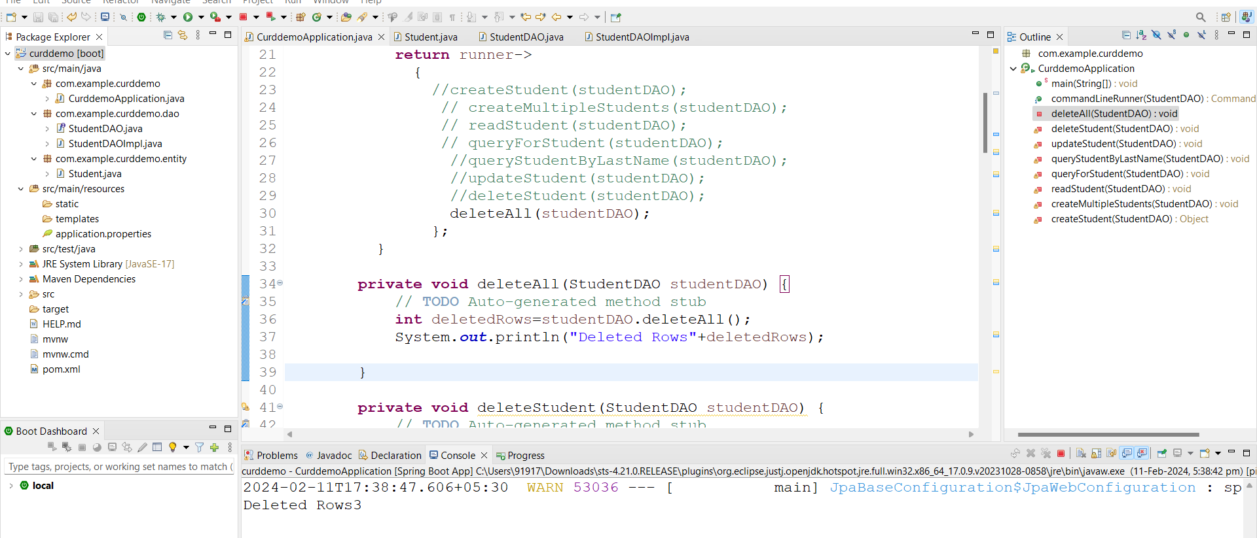

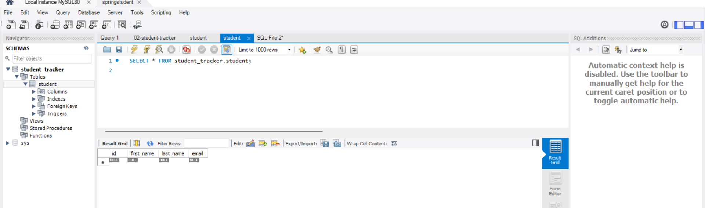

**Create Table: -**

Adding looging level to show SQL queries 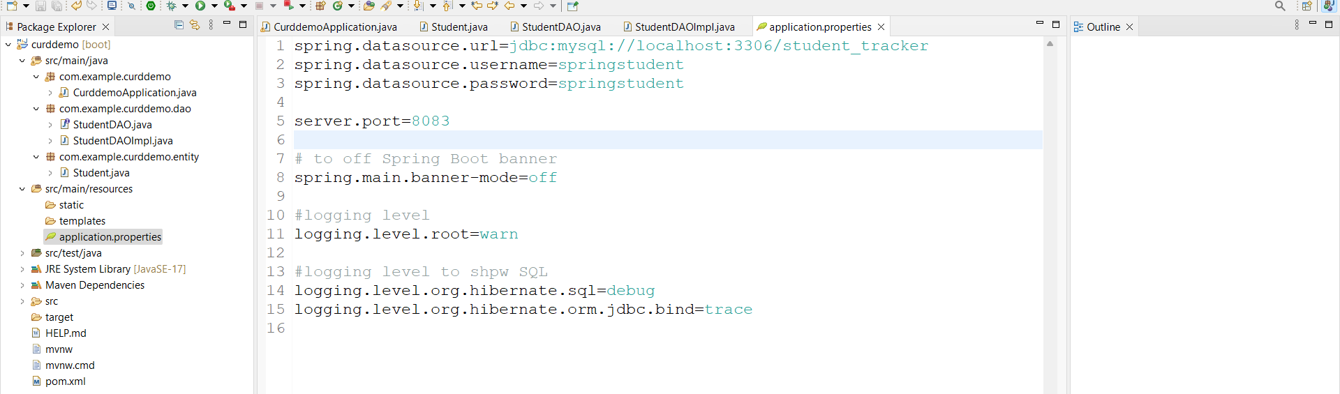

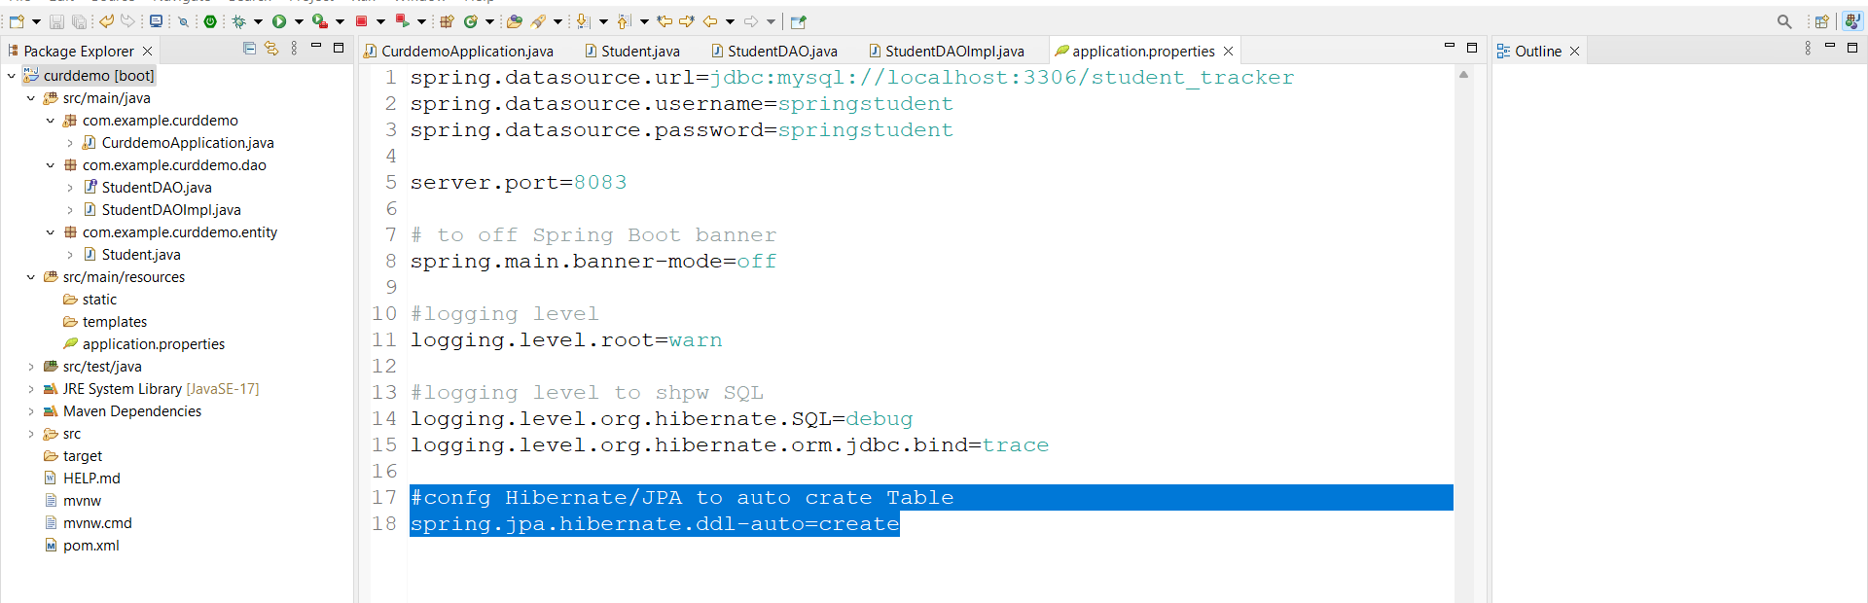

If we write this in appn.prop if table not exist also spring will drop table and create it again with data

spring.jpa.hibernate.ddl-auto=create this will drops table and newly cretes data

spring.jpa.hibernate.ddl-auto=update this is will keep data asusal and update data

**Topic- 4. RESTful Api’s: -**

**Hello world:-**

Create new project with web dependency

Create **DemoRestController.java** under rest package.

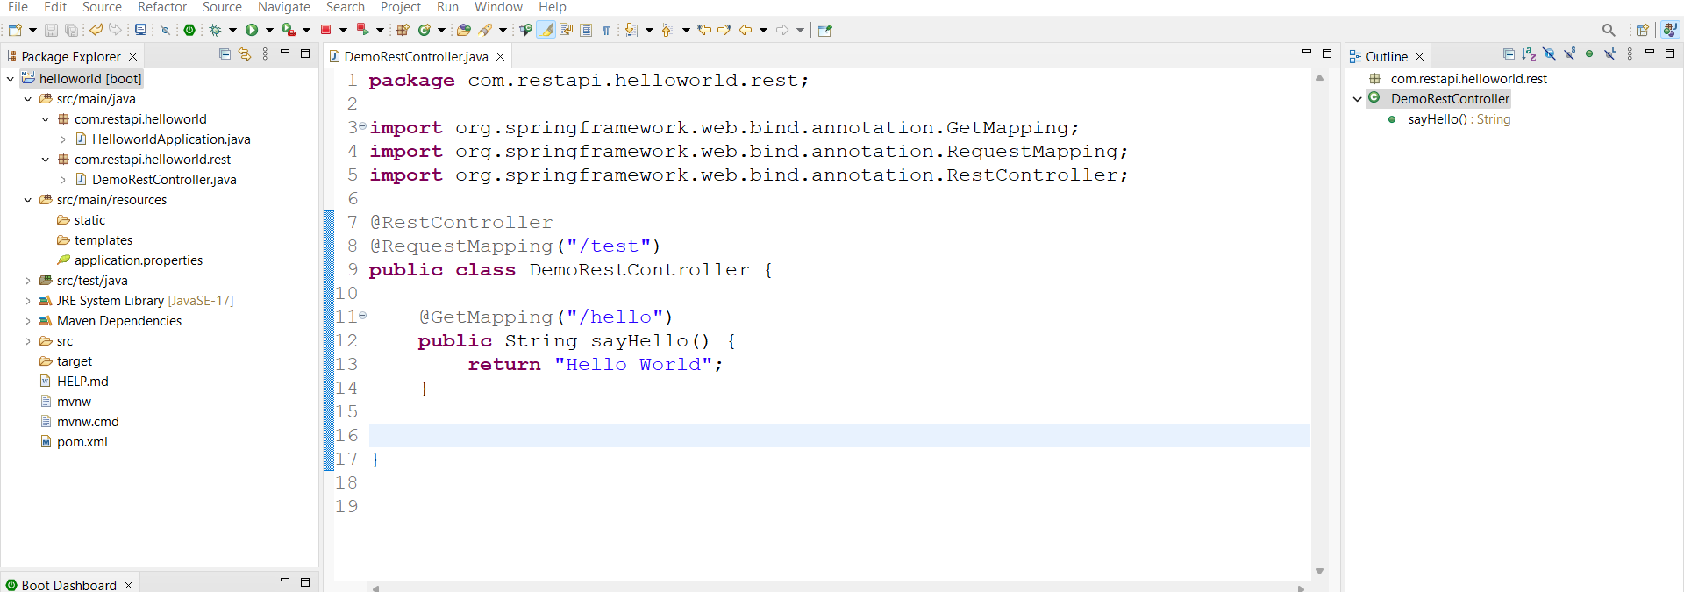

Link:- <http://localhost:8080/test/hello>

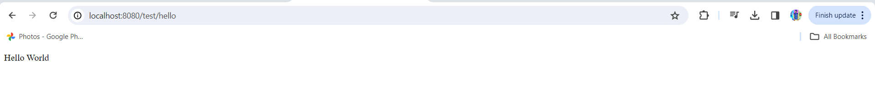

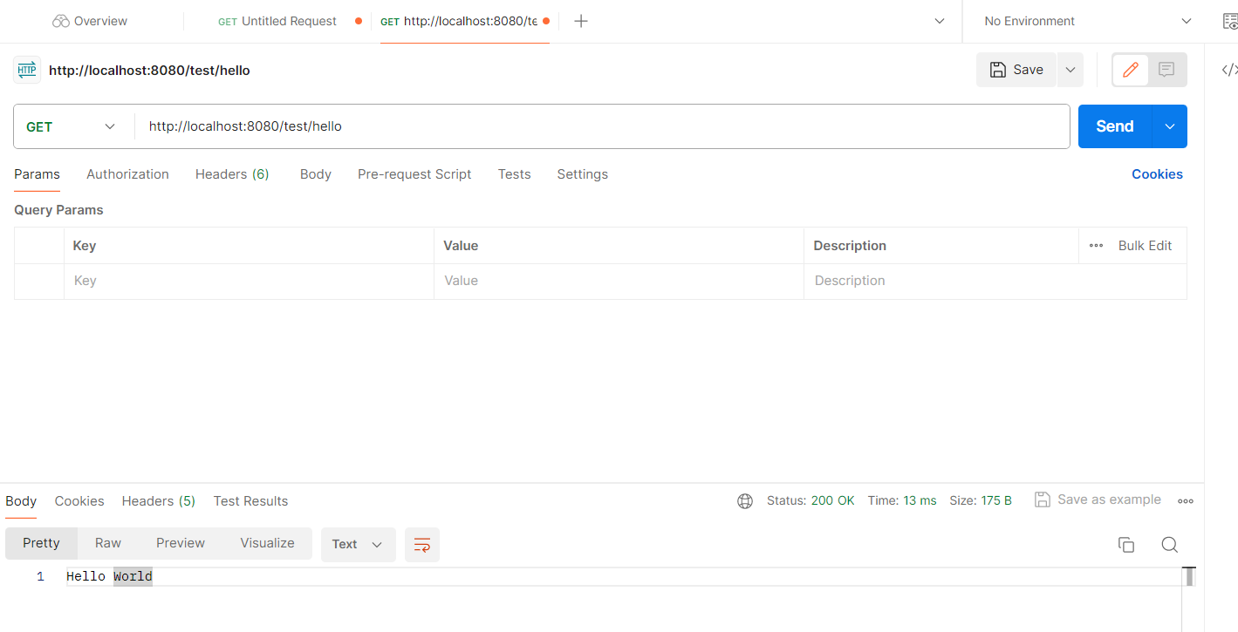

**Crud Operations: -**

Create **Student.java** under entity package with firstName and lastname and setters and getters and both constructors.

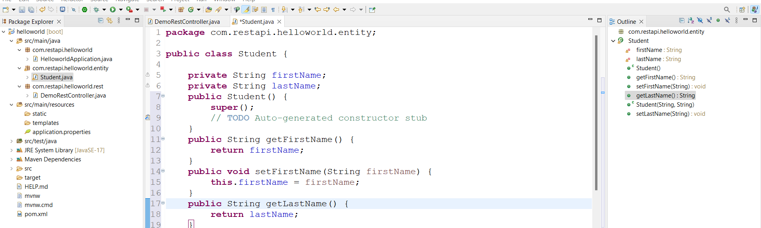

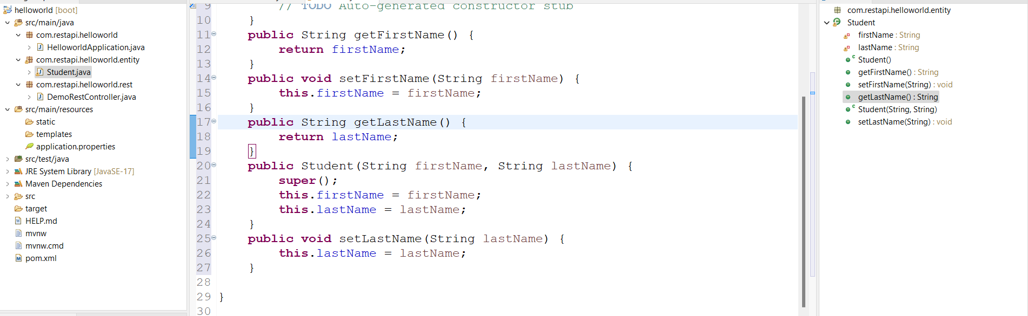

Create **StudentRestController.java** under rest package.

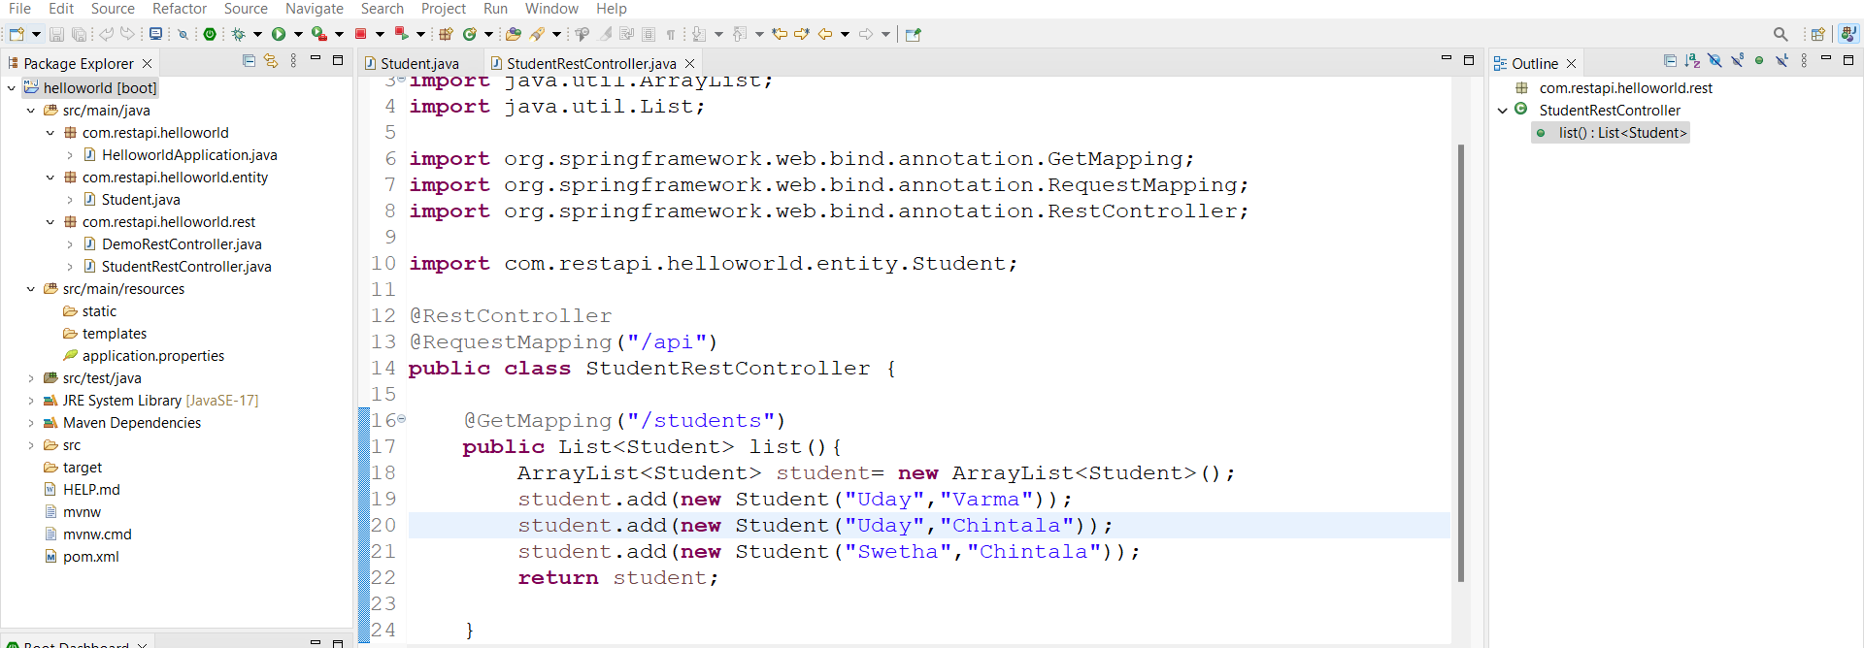

Run appn

Link: - http://localhost:8080/api/students

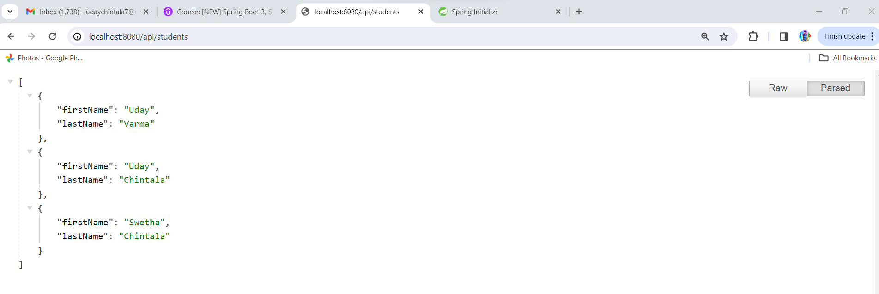

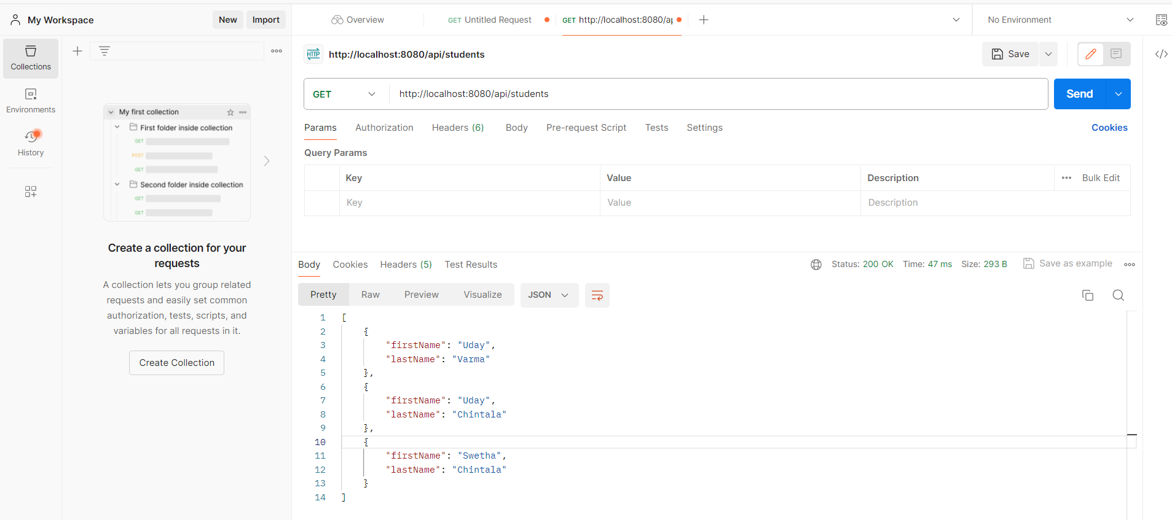

**Path variable: -** printing student basing on ID

Here we are going to use @PostConstruct to load data at one time instead of loading data for all requests as follows.

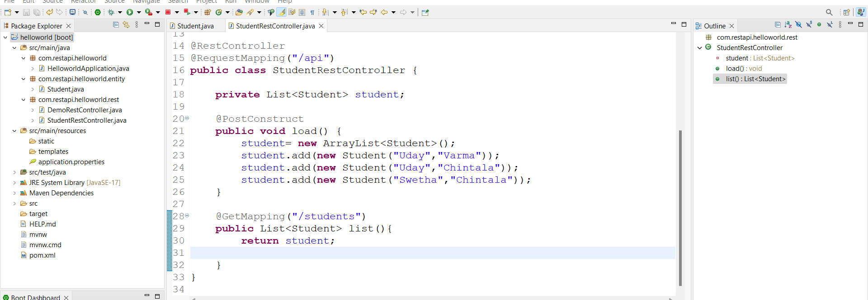

Same o/p will got

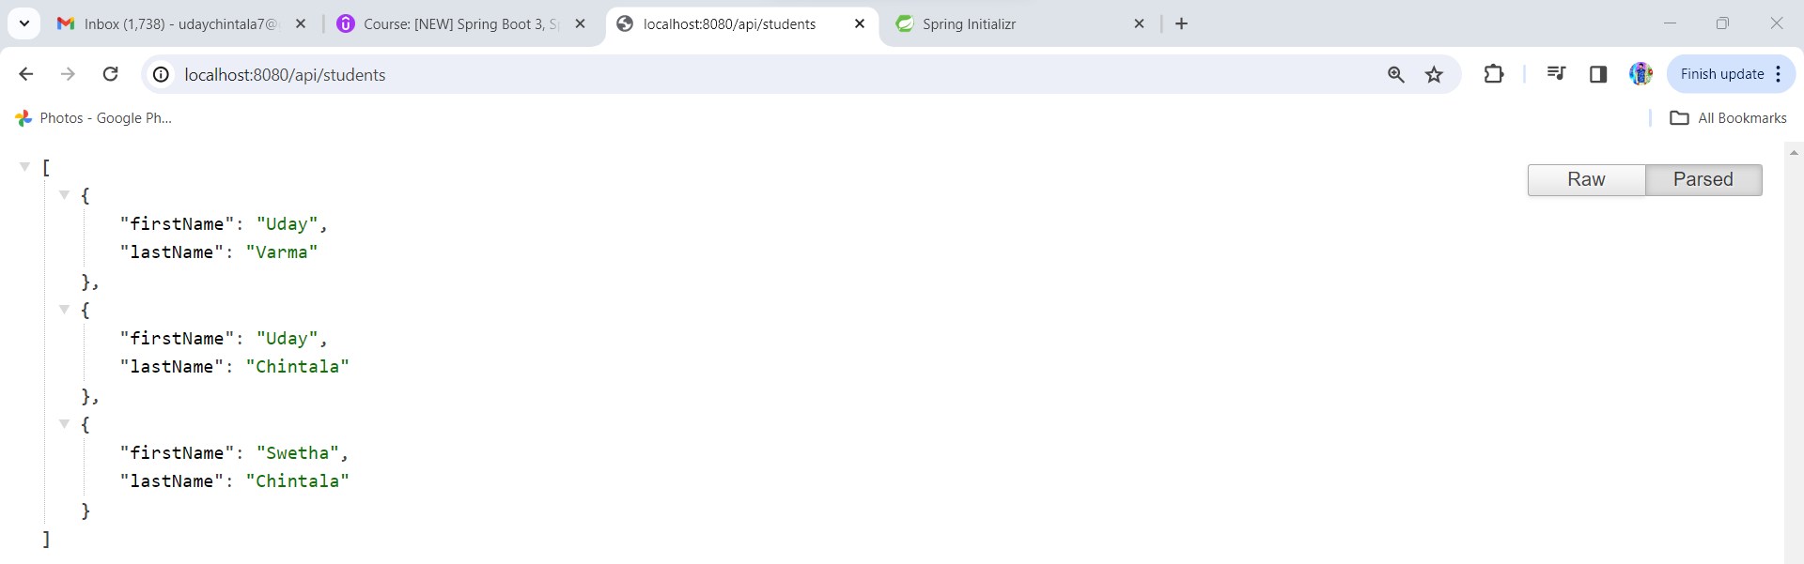

Create another getmapping for this request

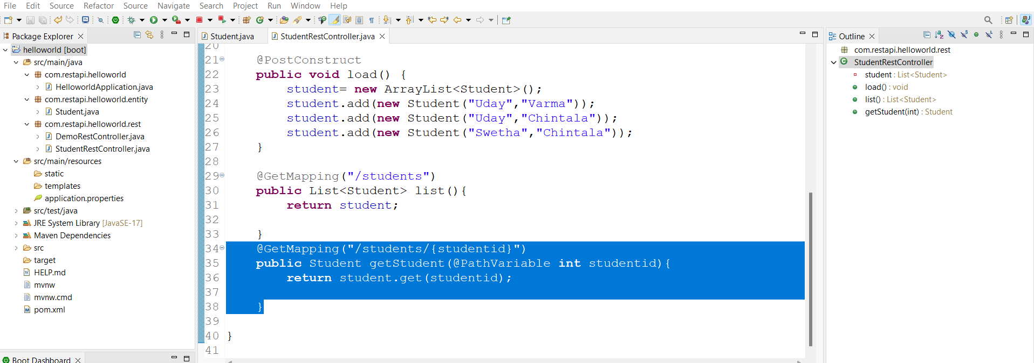

**Here @GetMapping studentid should be same as @PathVariable studentid**

**Link:** [**http://localhost:8080/api/students/0**](http://localhost:8080/api/students/0)

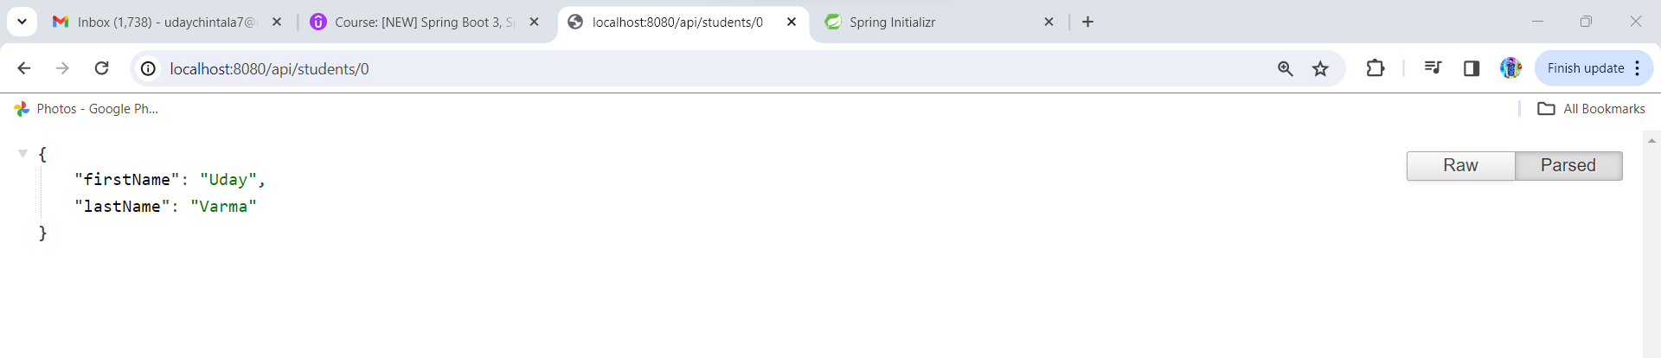

**Exception Handling: -**

In above example if we run with index id out of id then will get exception as follows.

Link: - <http://localhost:8080/api/students/999>

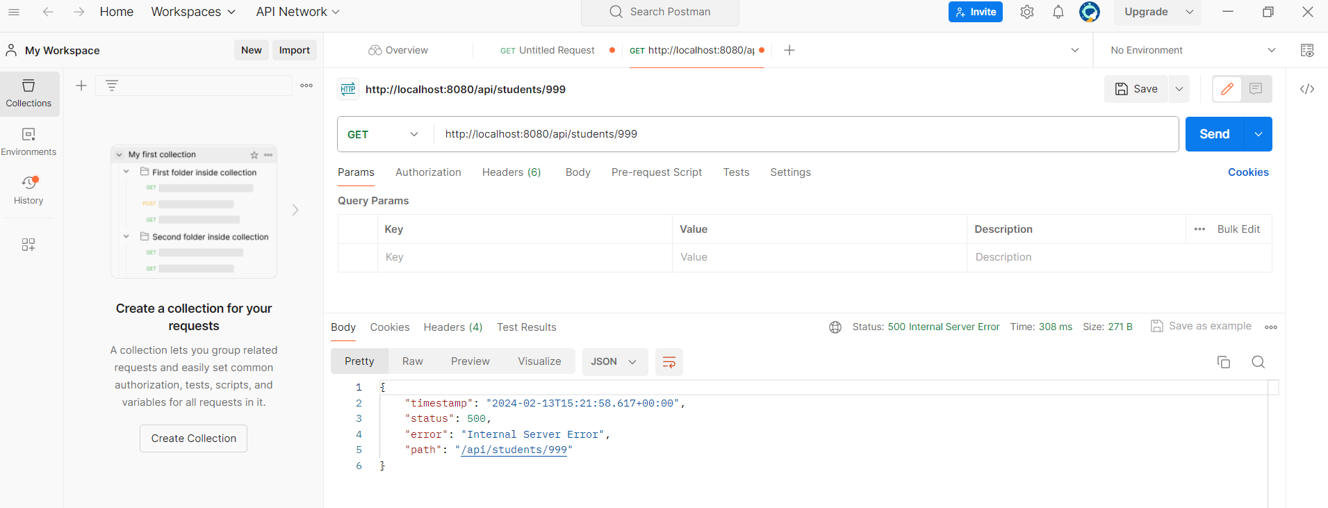

**Step:1** create error response class under rest package **StudentErrorResponse.java** with fields and create setters and getters and parameterized constructor.

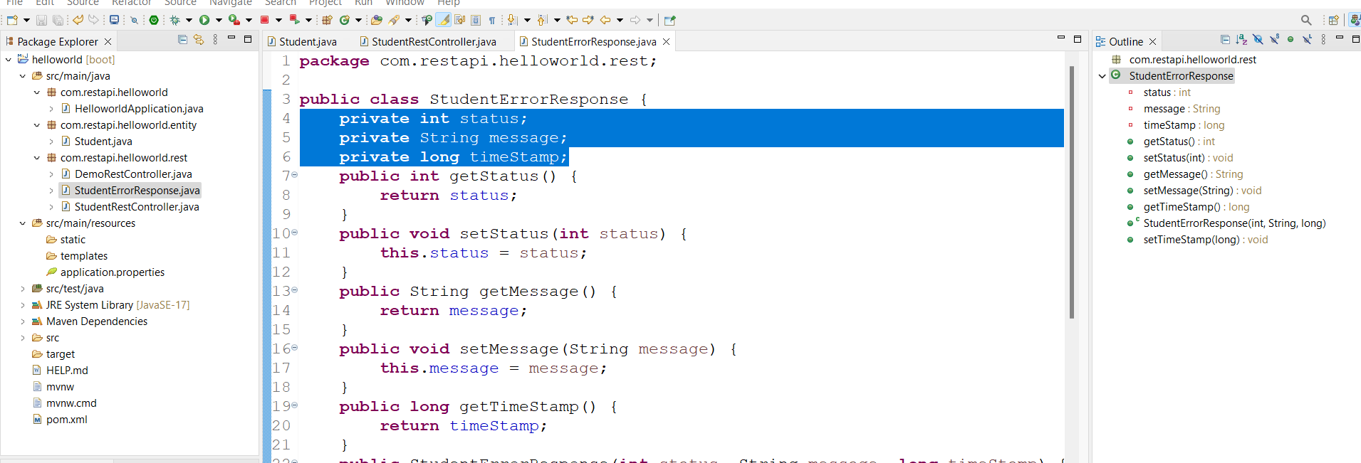

**Step: -2** create custom exception class under rest package **StudentNotFoundException.java** and generate constructors from super class

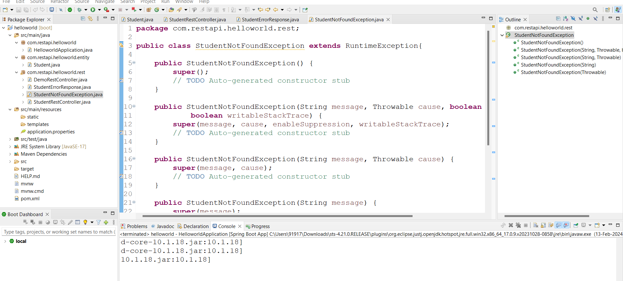

**Step: -3** update Rest controller throw exception.

Add logic at @GetMapping("/students/{studentid}")

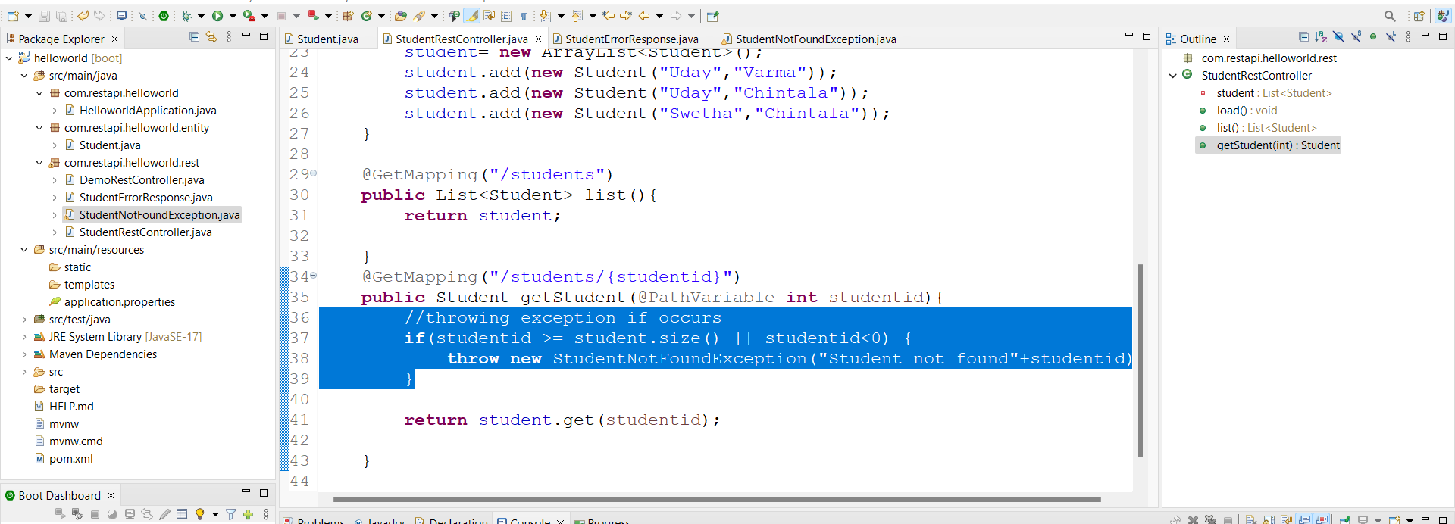

**Step: -4 Adding** exception handler using @ExceptionHandler in **StudentRestController.java**

@ExceptionHandler

**public** ResponseEntity<StudentErrorResponse> getRespone(StudentNotFoundException exec){

//create error response

StudentErrorResponse error = **new** StudentErrorResponse();

error.setStatus(HttpStatus.***NOT_FOUND***.value());

error.setMessage(exec.getMessage());

error.setTimeStamp(System.*currentTimeMillis*());

//return response

**return** **new** ResponseEntity<>(error,HttpStatus.***NOT_FOUND***);

}

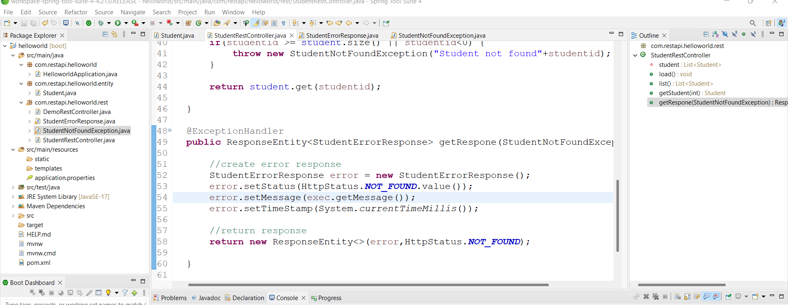

**Run appn**

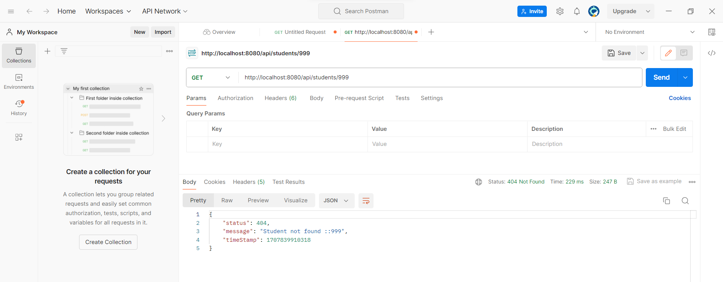

**Now try to give character in link will get error again**

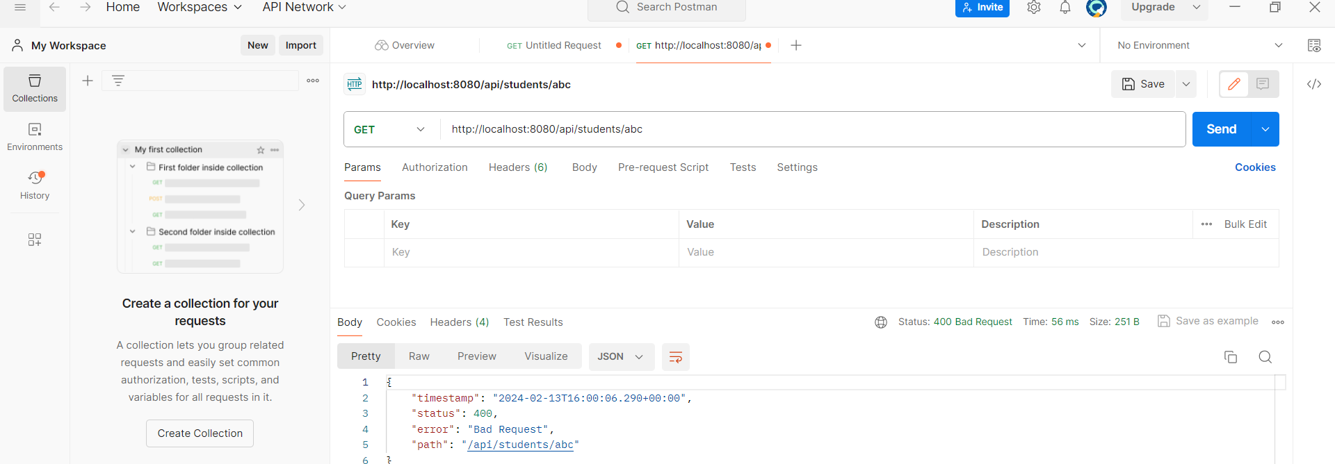

**Add another exception handler add generic exception handler**

@ExceptionHandler

**public** ResponseEntity<StudentErrorResponse> handleException(Exception exec){

//create error response

StudentErrorResponse error = **new** StudentErrorResponse();

error.setStatus(HttpStatus.***BAD_REQUEST***.value());

error.setMessage(exec.getMessage());

error.setTimeStamp(System.*currentTimeMillis*());

//return response

**return** **new** ResponseEntity<>(error,HttpStatus.***BAD_REQUEST***);

}

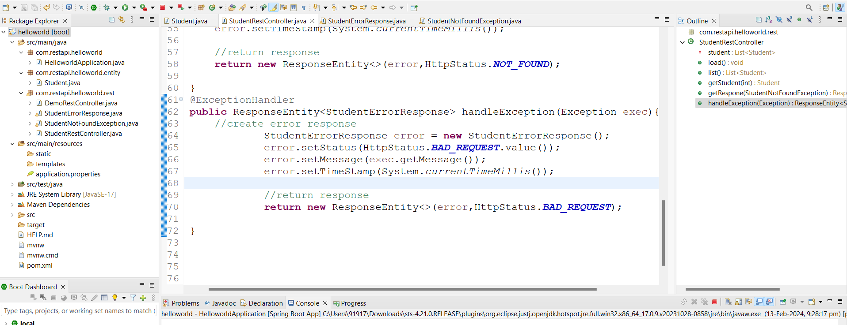

Run code

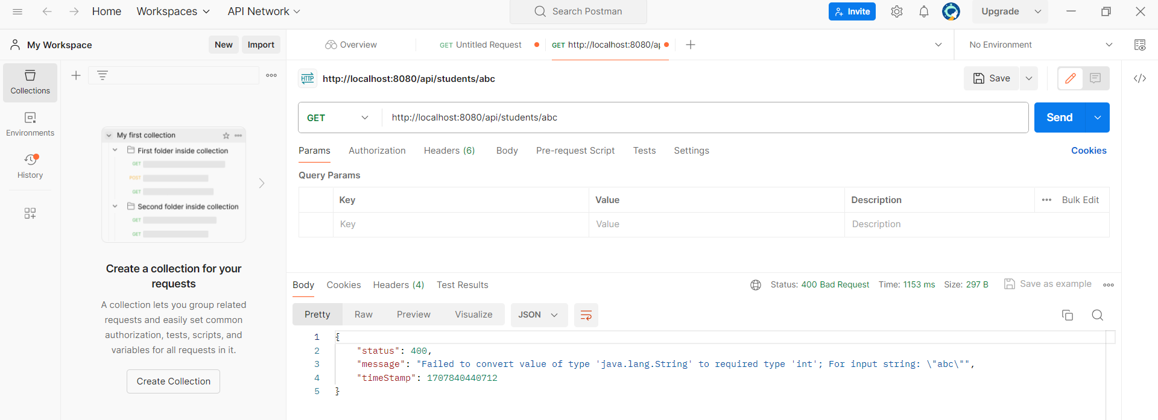

**Global Exception: -**

**Step: -1** create **StudentRestExceptional.java** for **@ControllerAdvice** under rest package cut and paste Exceptionalhandler code into this class

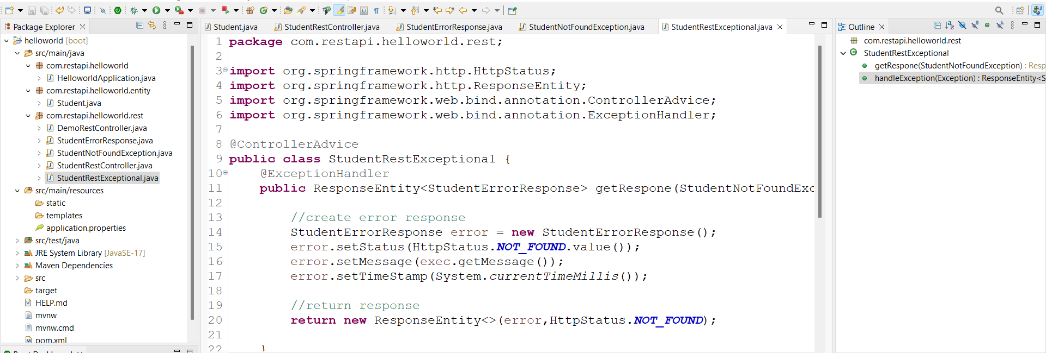

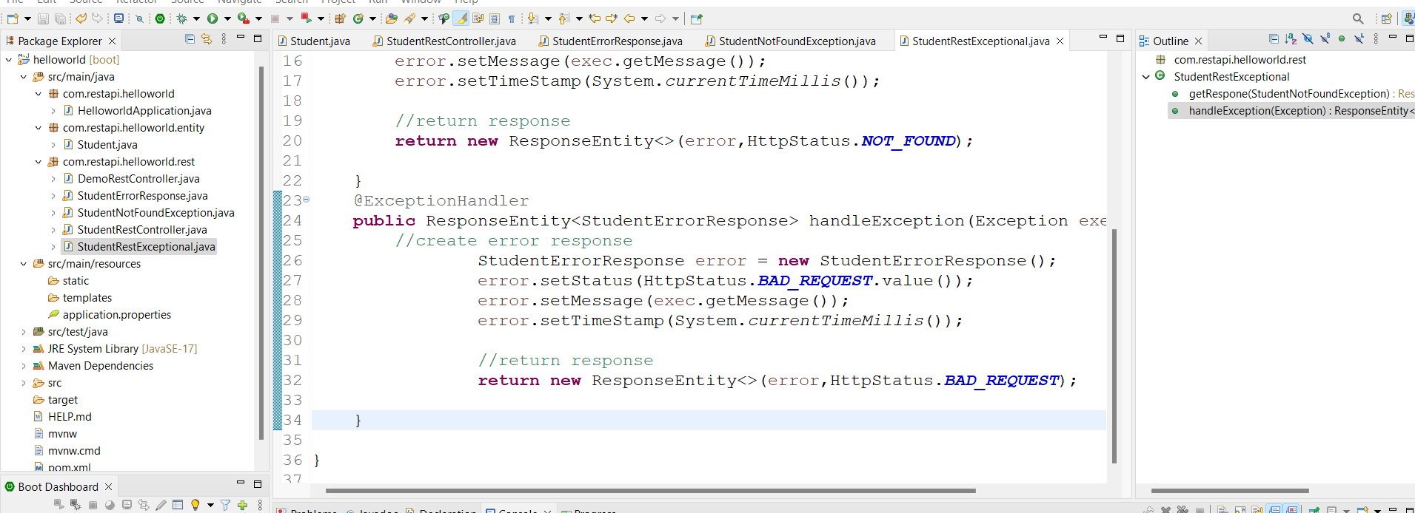

**Step: -2** go to Controller class and remove Exceptionalhandler code

Run the code

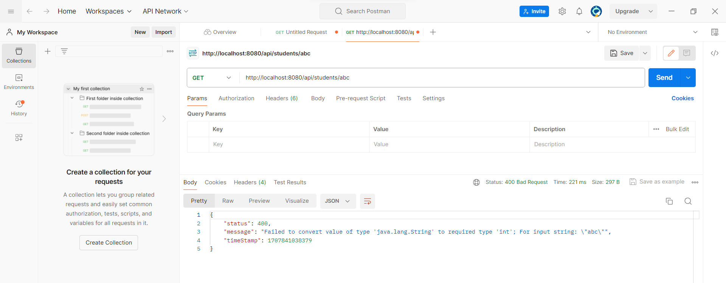

**CRUD Operations:-**

**Run sql script first for Data Base data**

Create new project with web,jpa,dev tools,mysql driver dependencies.

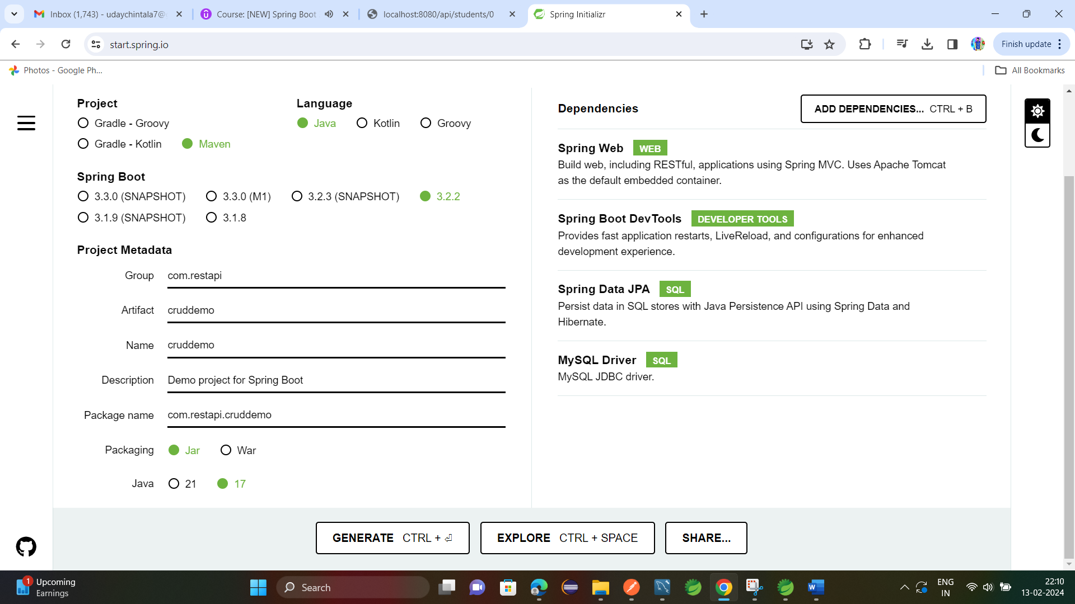

Add database properties in appn.prop

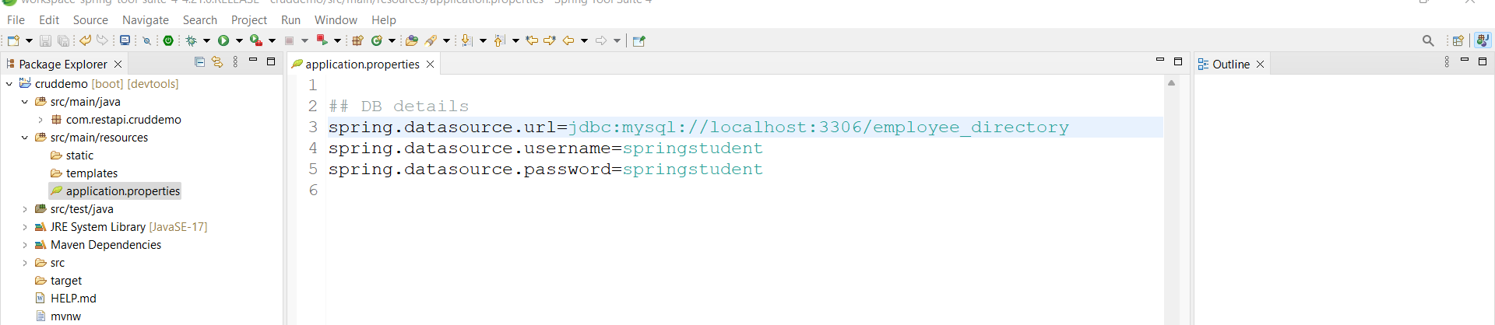

Create **Employee.java** under entity package with fields matching with DB create constructor and getter and setter and parameterized constructor and toString method.

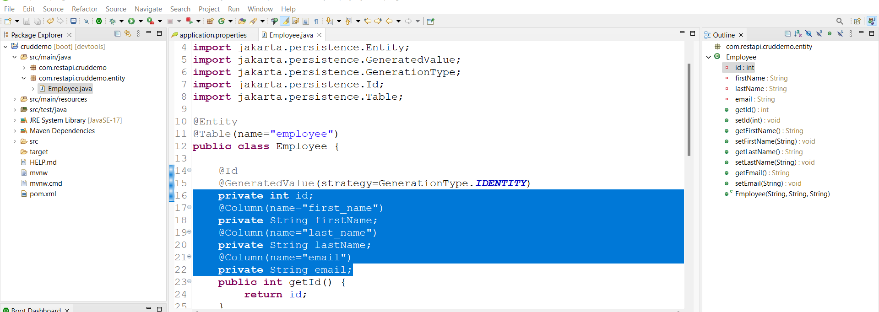

Create DAO interface and implemented class under DAO package.

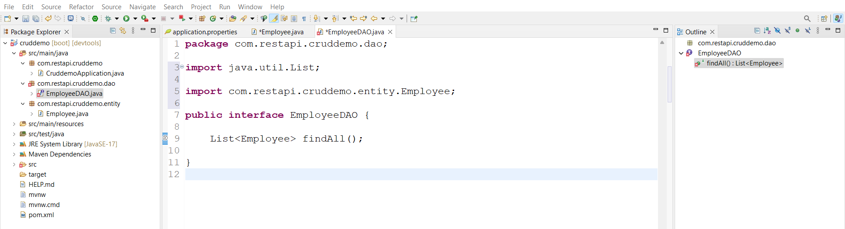

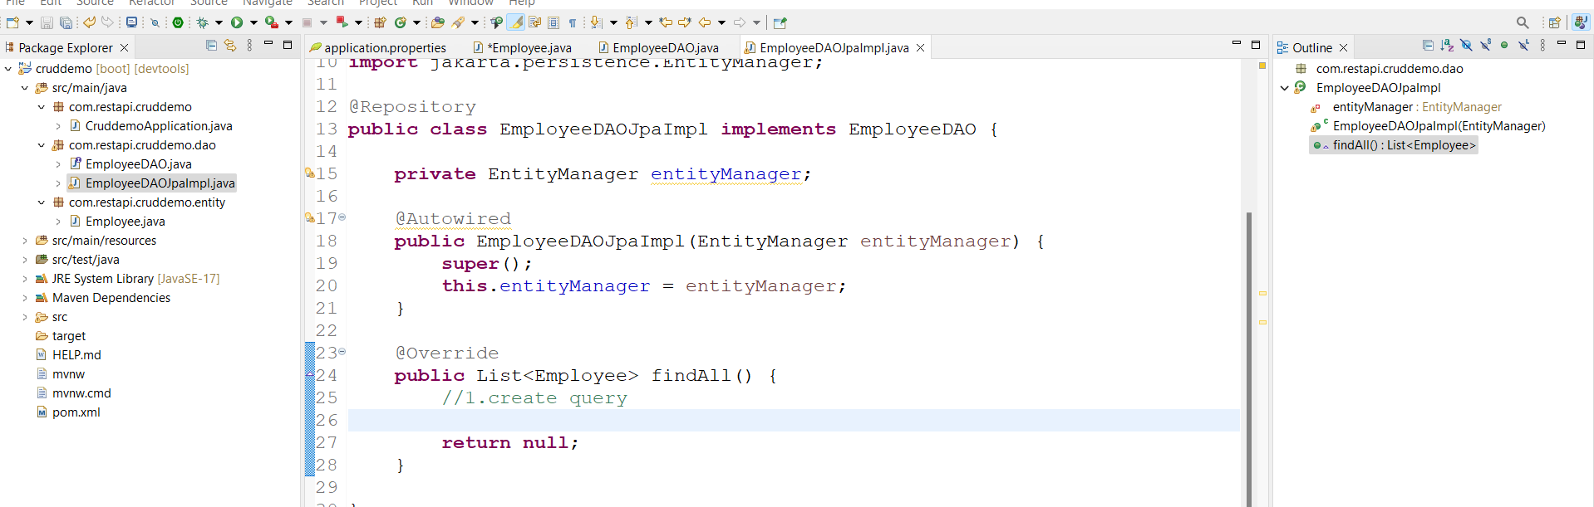

Start code for findAll()

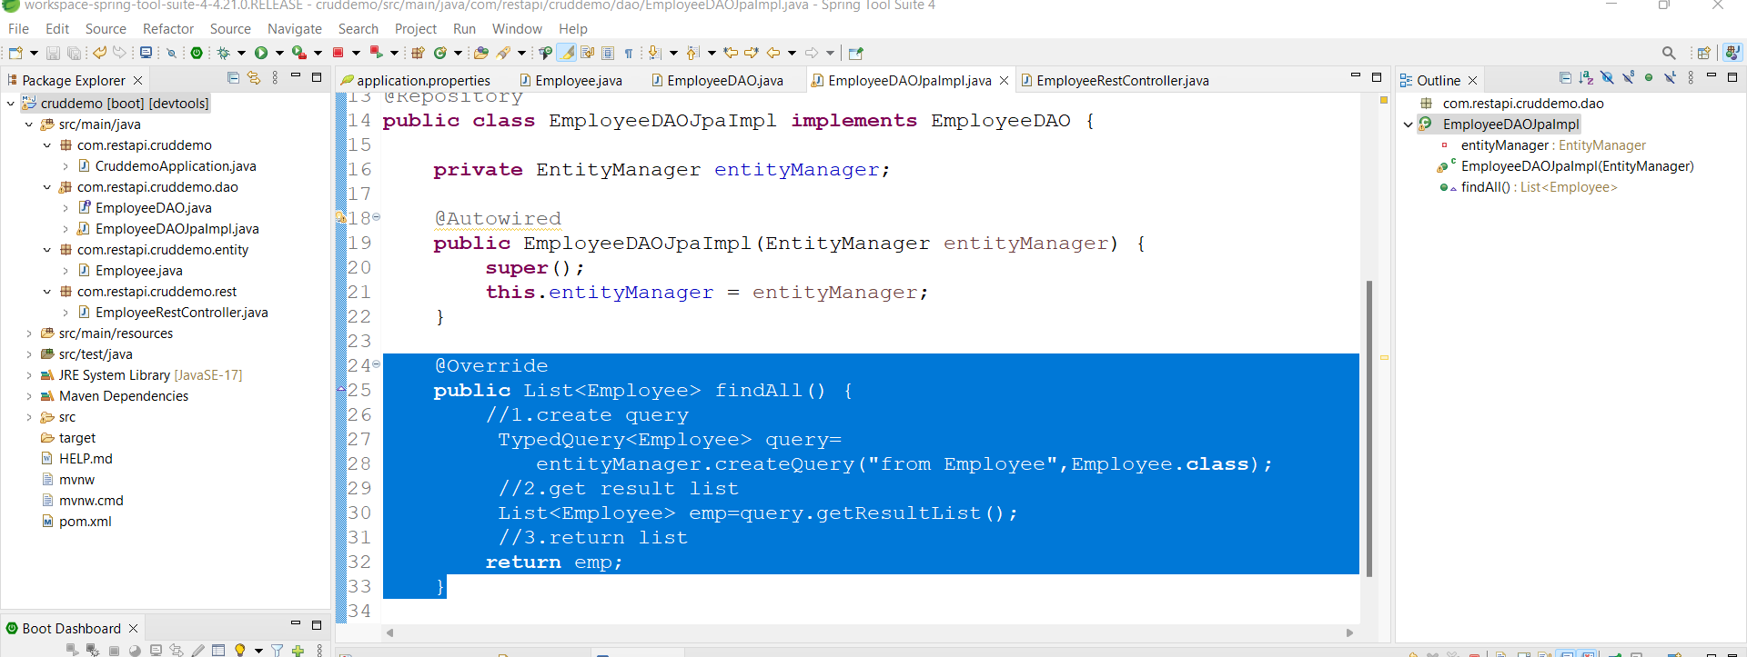

Create **EmployeeRestController.java** under rest package

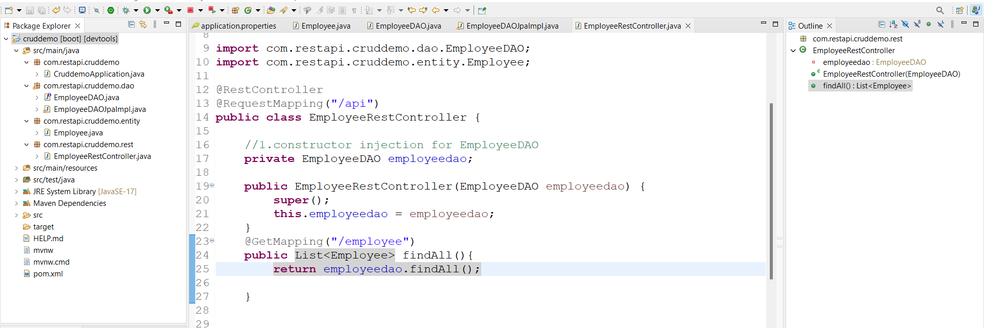

Run appn

Link:- <http://localhost:8080/api/employee>

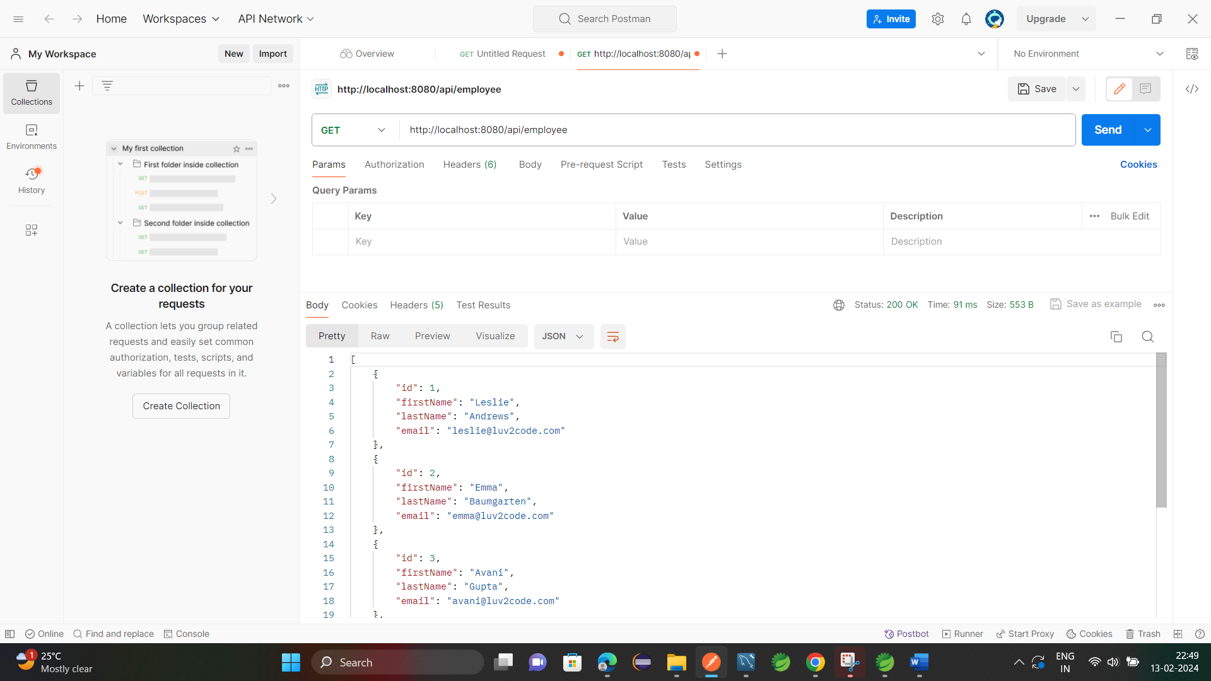

**Creating Service layer: -**

Create **EmployeeService** interface and **EmployeeServiceImpl.java** under service

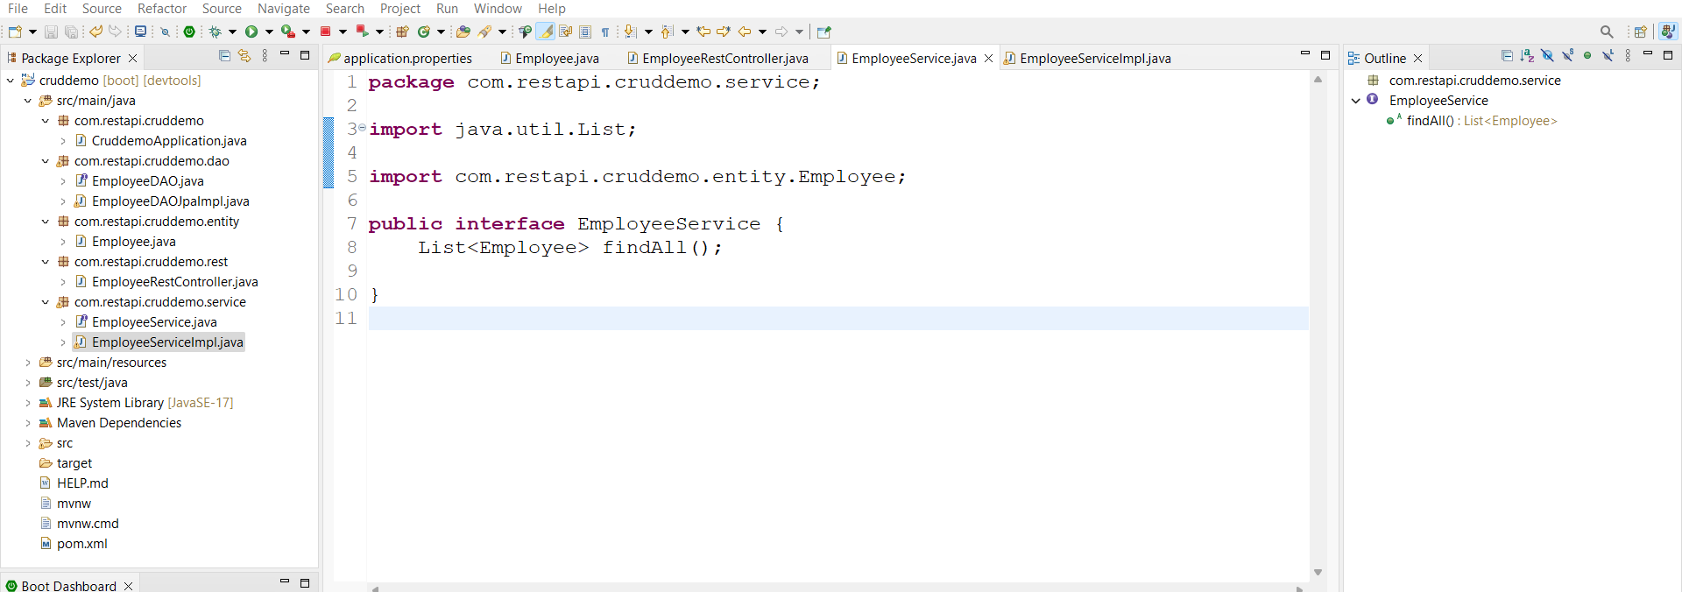

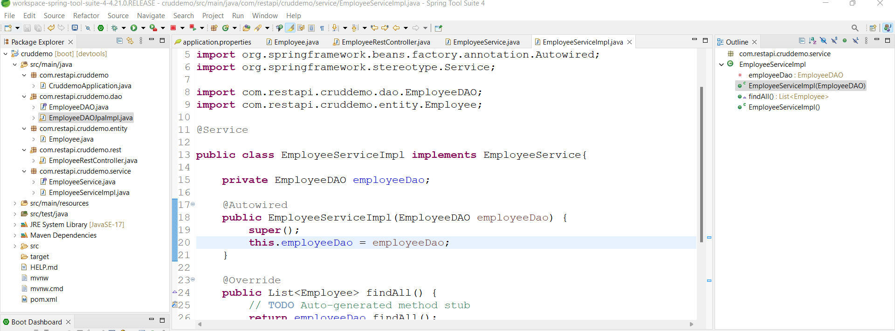

Goto controller class add make changes

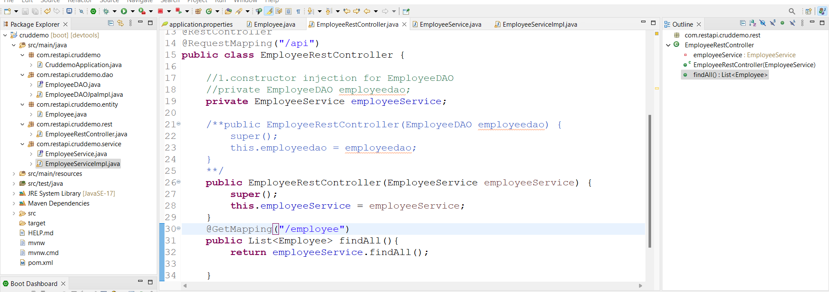

Run appn got same response

**Getting single Employee: -**

Add following methods to EmployeeDAO interface

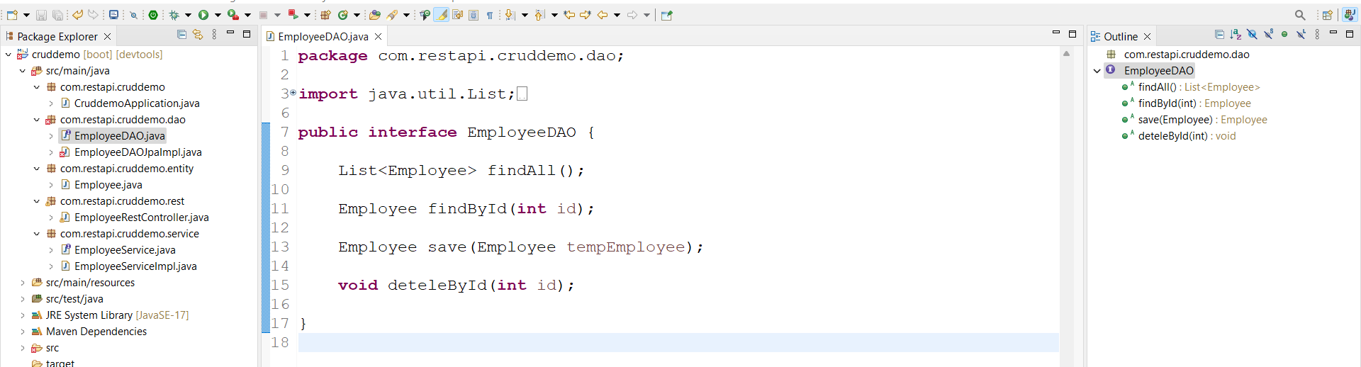

And write code in **EmployeeDaoJpaImpl.java** as follows

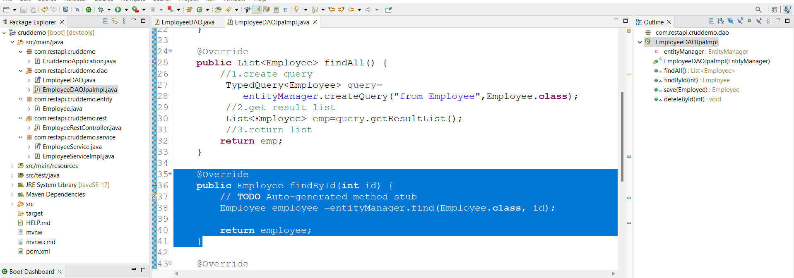

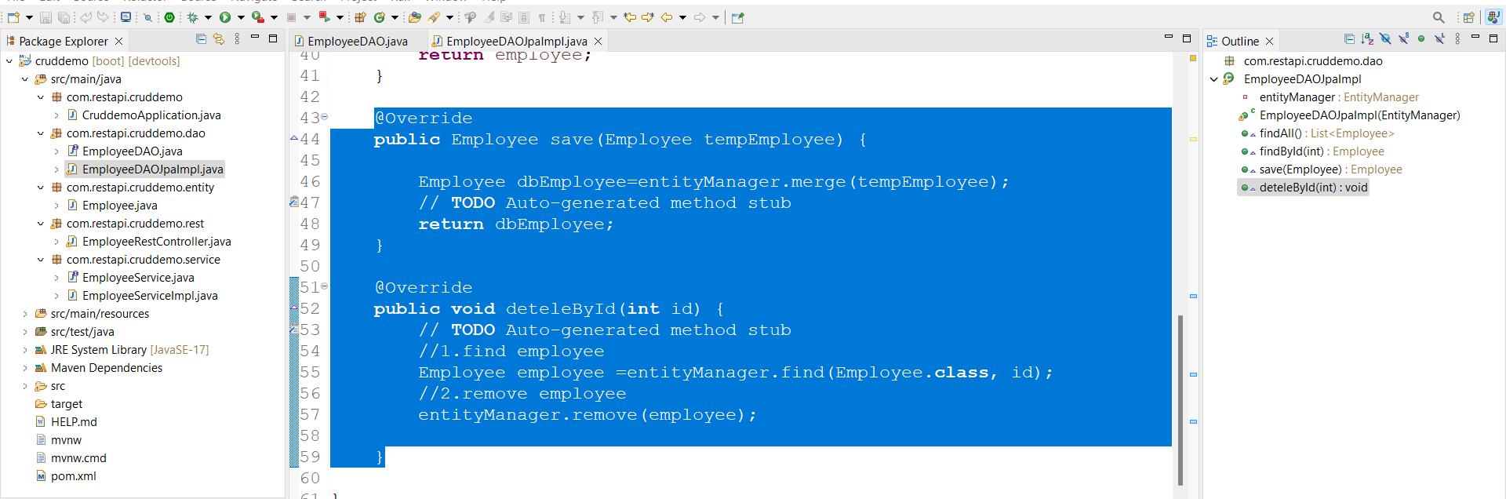

Now add new methods from EmployeeDAO to EmployeeService interface by copy paste.

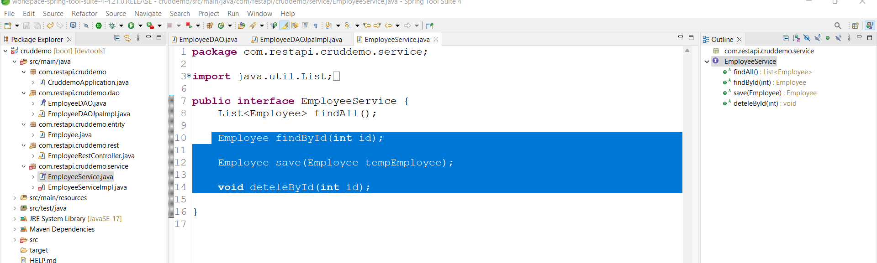

Implements all methods in **EmployeeServiceImpl.java**

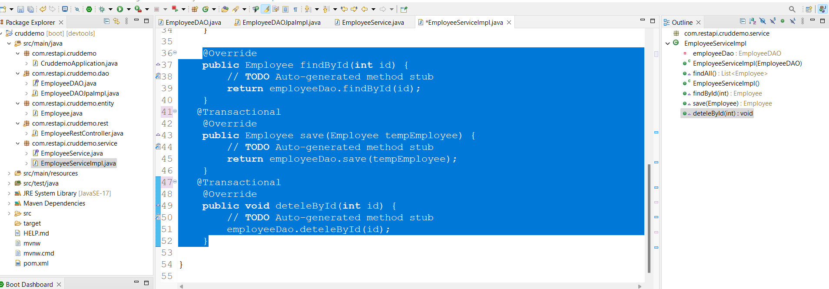

Add RestController methods to **EmployeeRestController.java**

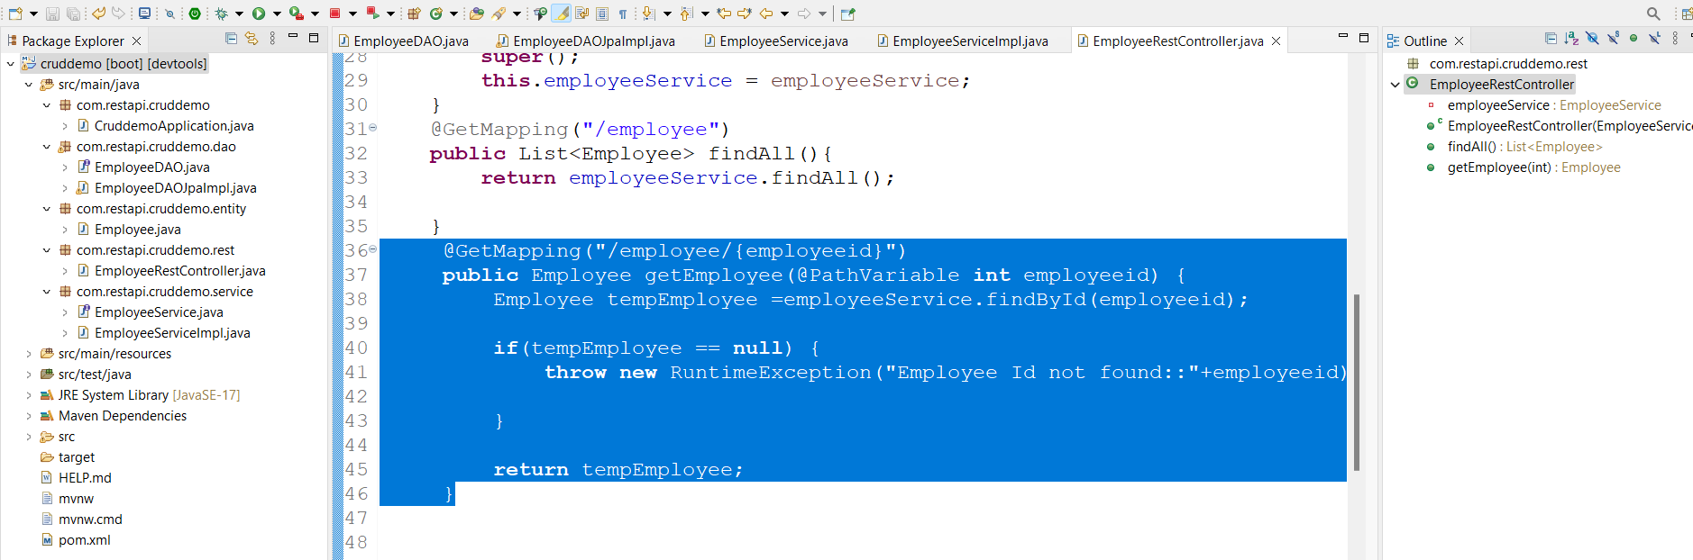

Run appn and check in postman

Link:- <http://localhost:8080/api/employee/1>

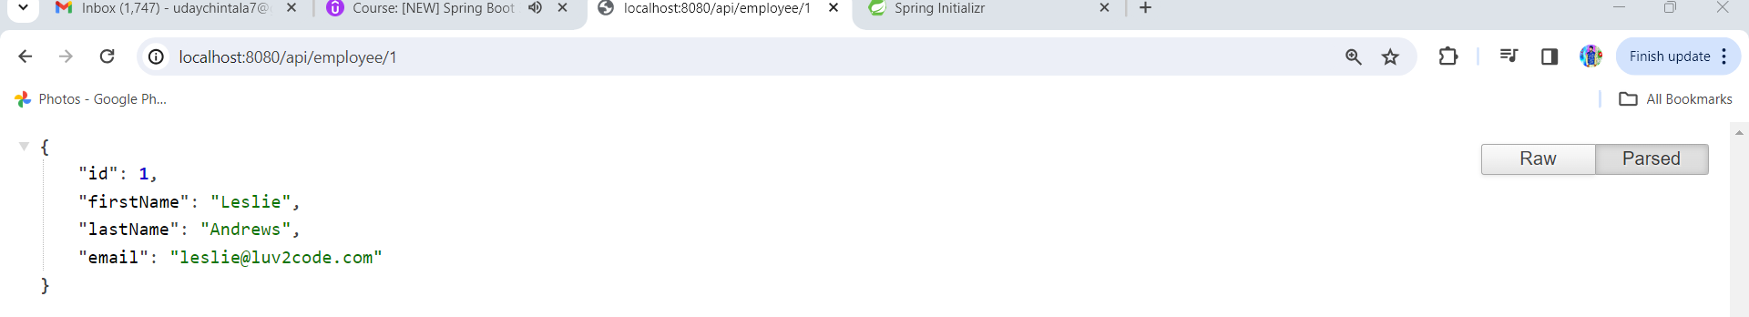

Add new Employee for this add getmapping in control class

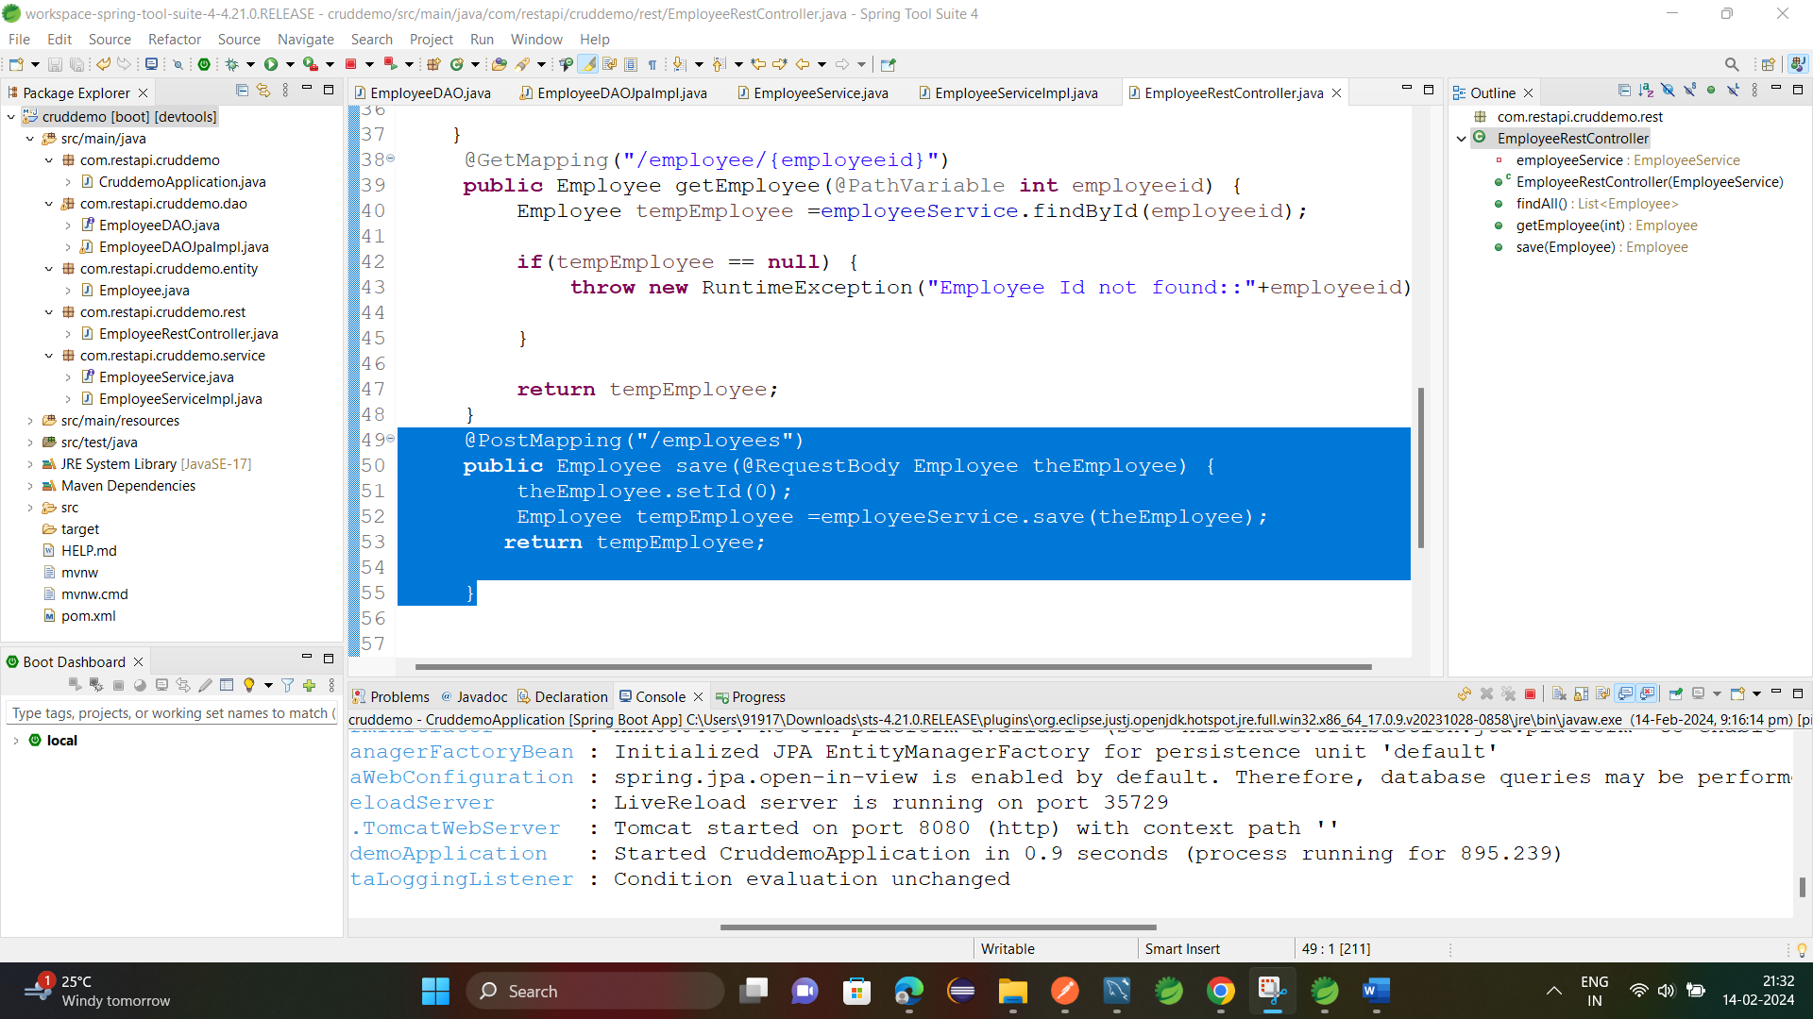

Run appn and try to insert data from postman

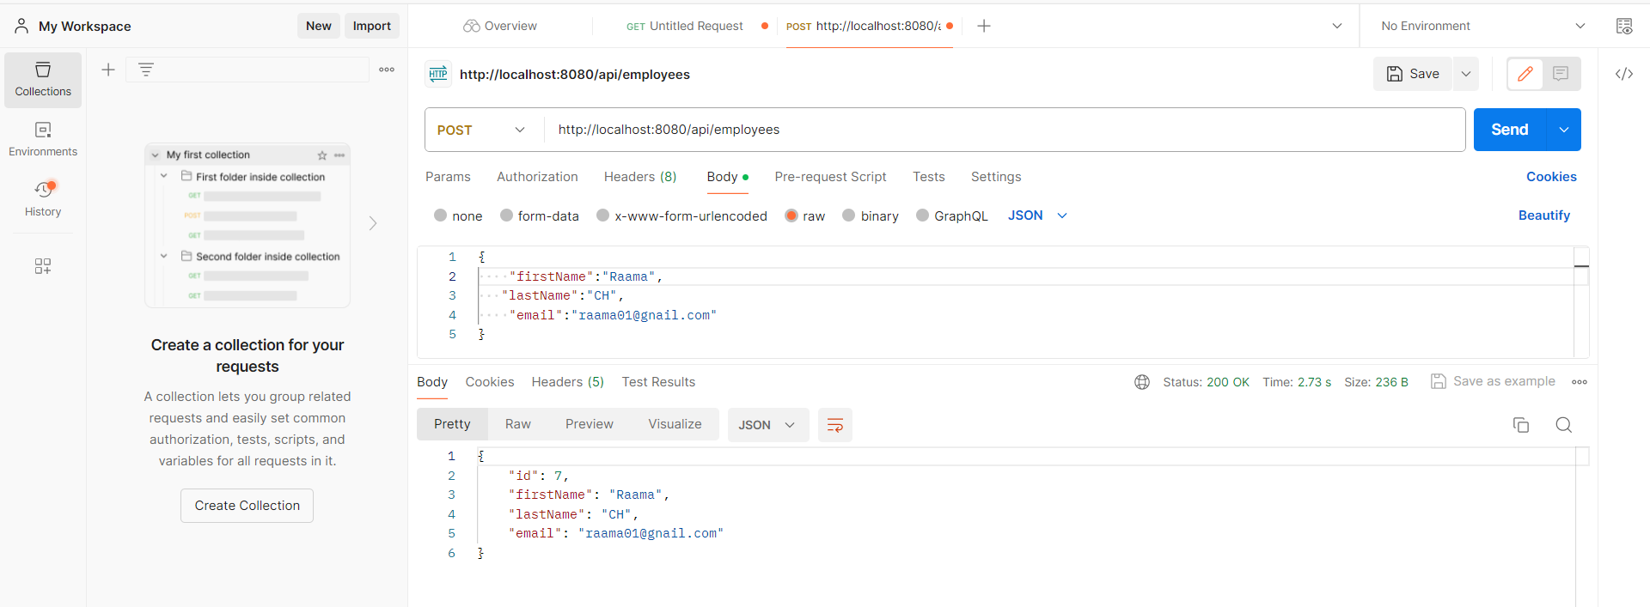

Data inserted in database

Update Employee for this new controller mapping in controller class.

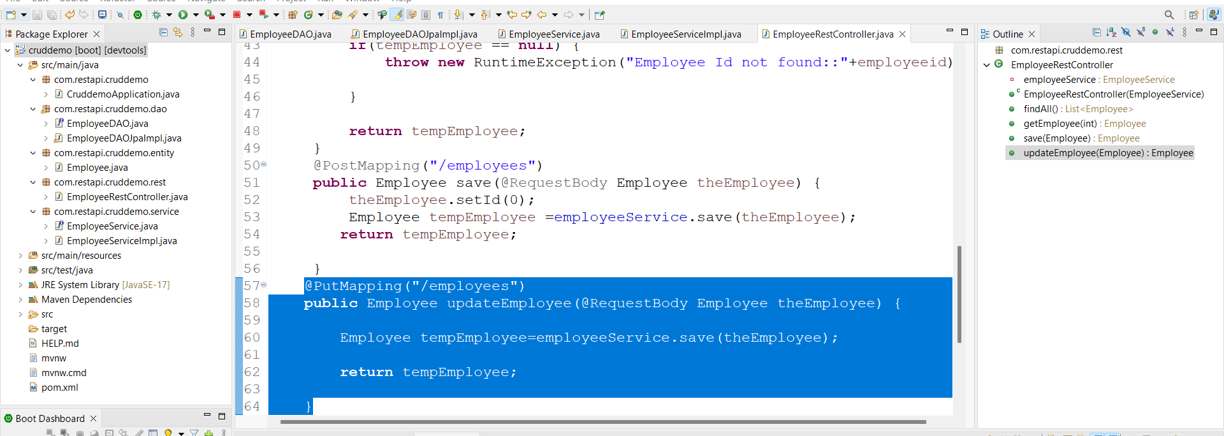

Run appn and test through postm

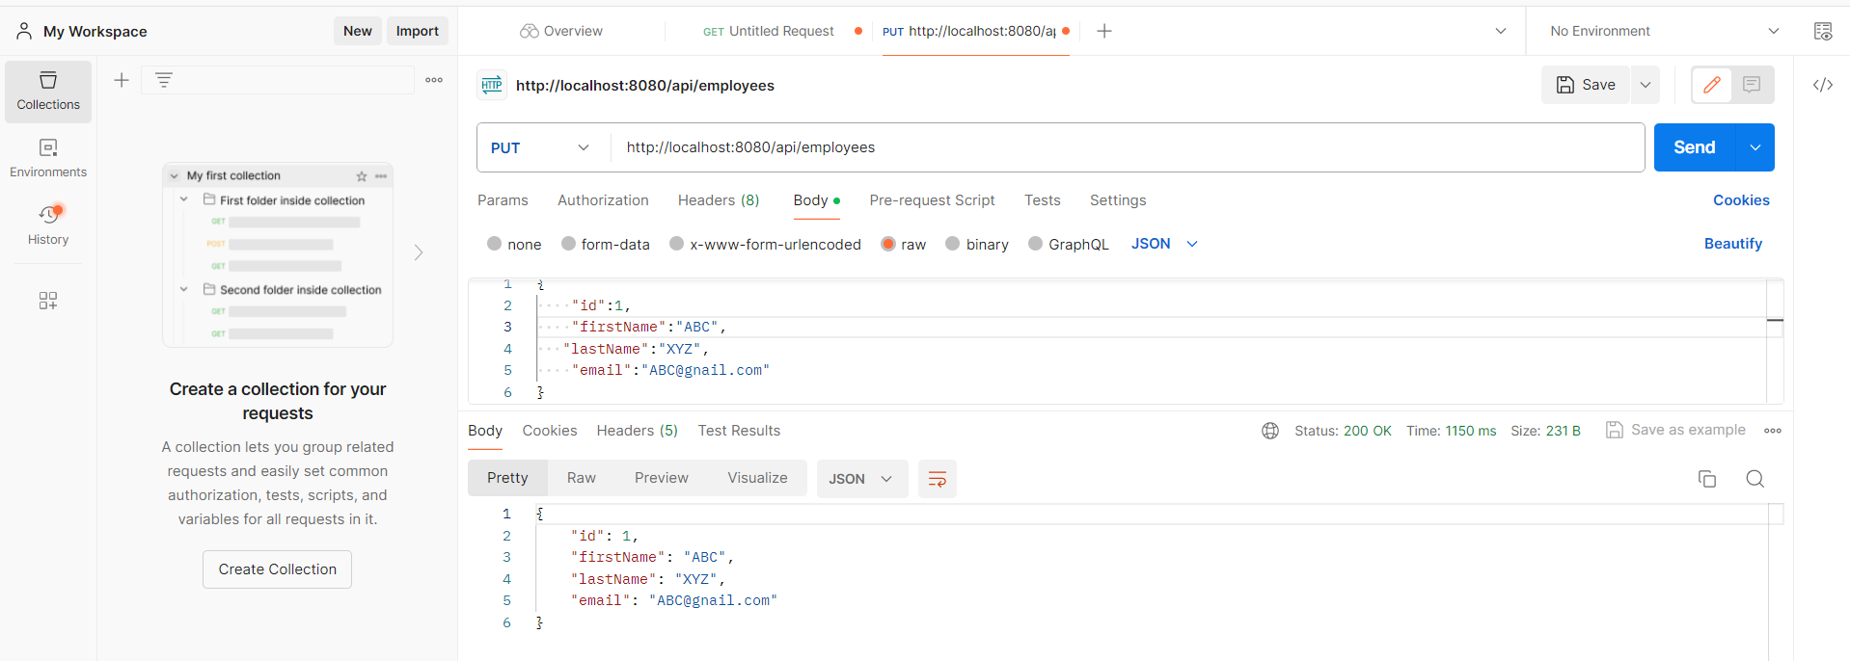

Record got updated

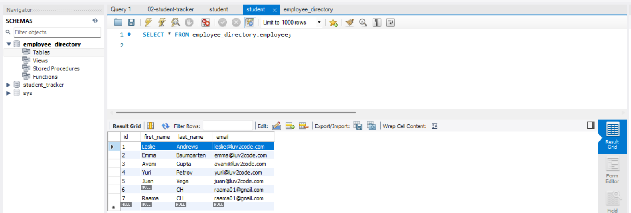

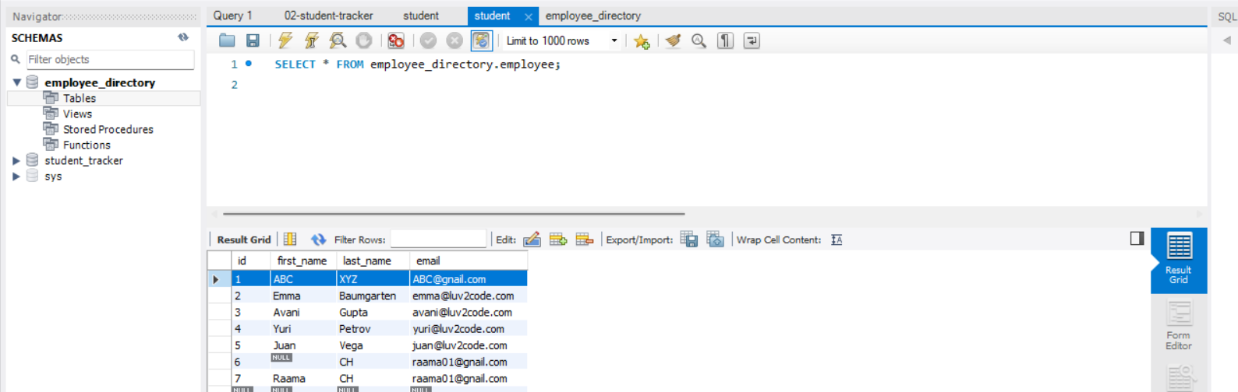

Deleting Employee:-

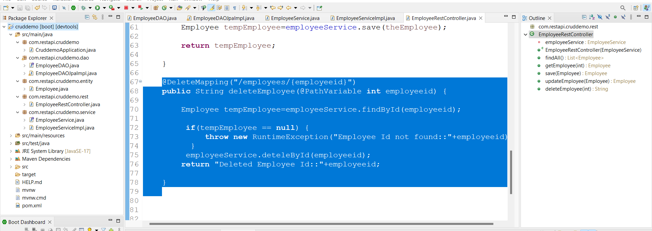

Link:- <http://localhost:8080/api/employees/1>

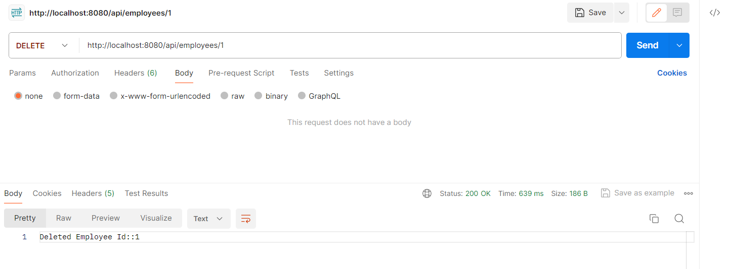

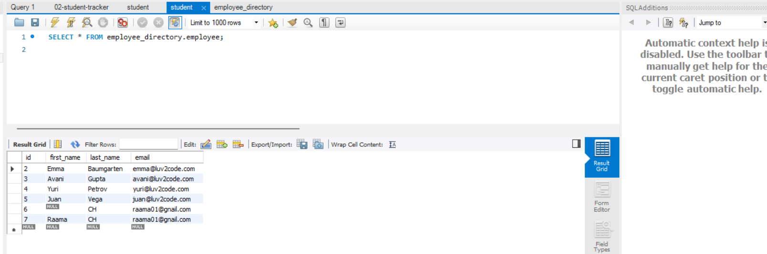

**Crud With Spring data jpa:-**

**Copy same code**

Remove DAO interface and implemented class from DAO package

And create **EmployeeRepository** interface under dao package

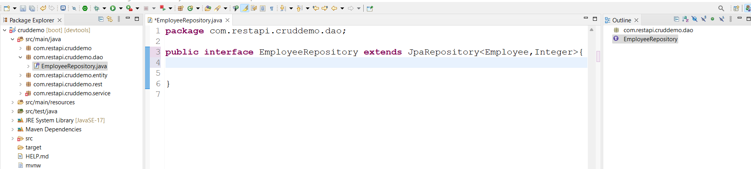

And made changes in **EmployeeServiceImpl.java**

Replace EmployeeDao with EmployeeRepository

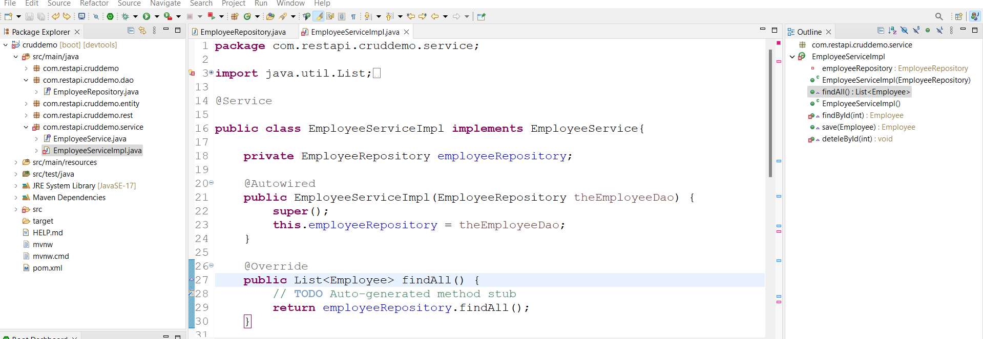

Here we have to comment @Transactional bcz jpa automatically handles this annotation.

For findById we have to use Java 8 Option feature

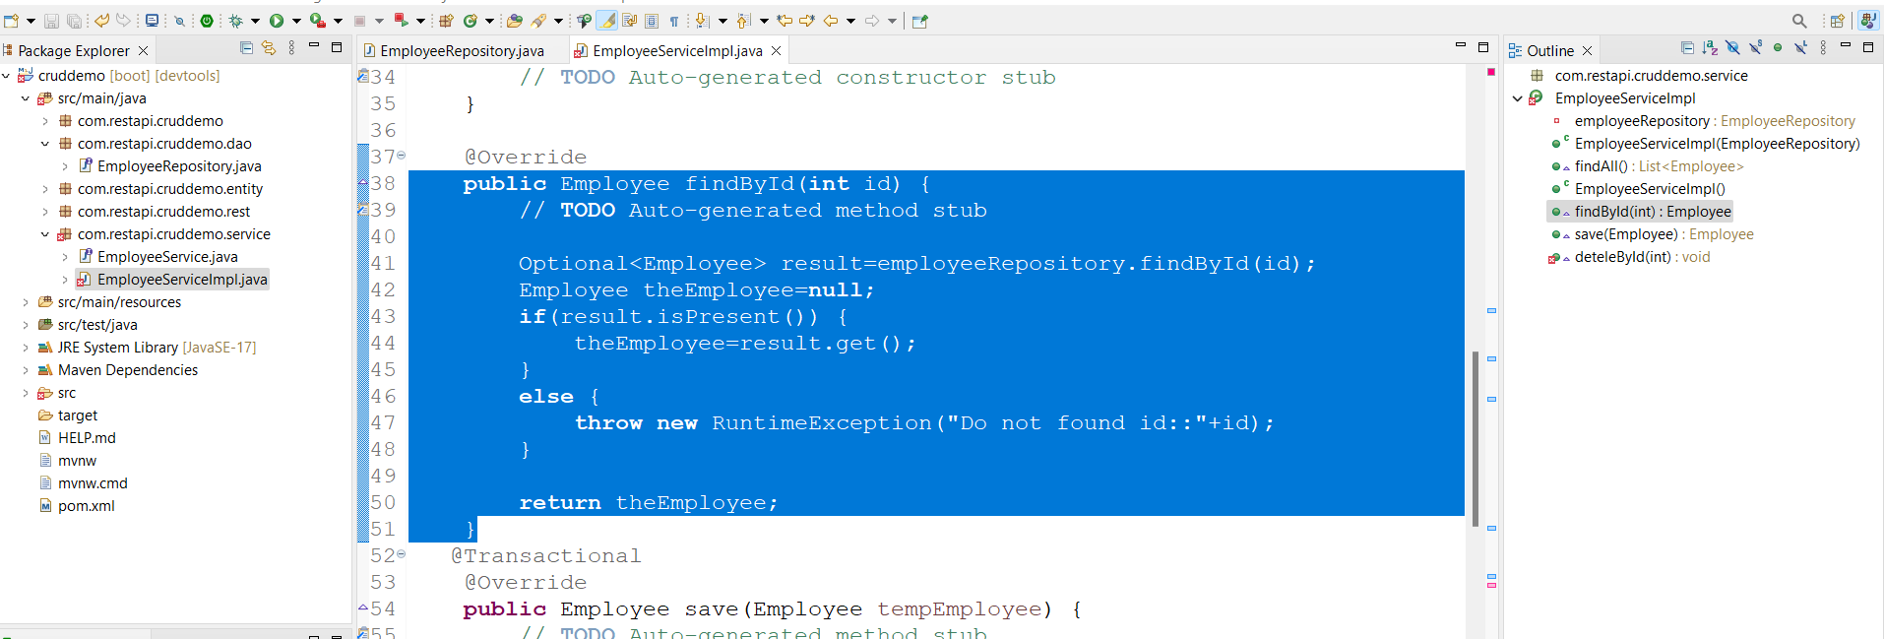

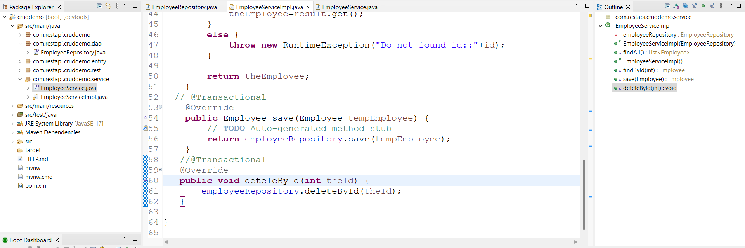

Run appn it works as same as before

**Crud with spring jpa Rest:-**

Copy same and add rest dependency in pom.xml

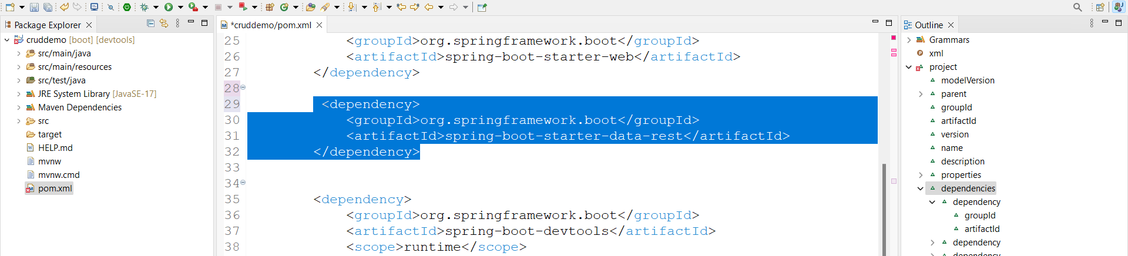

Then delete rest and service packages

Run appn it works as same before

Link:- <http://localhost:8080/employees>

**Topic- 5. RESTful Security: -**

Download project from resources 141 video.

Add Security dependency in pom.xml

Run appn and check in browser

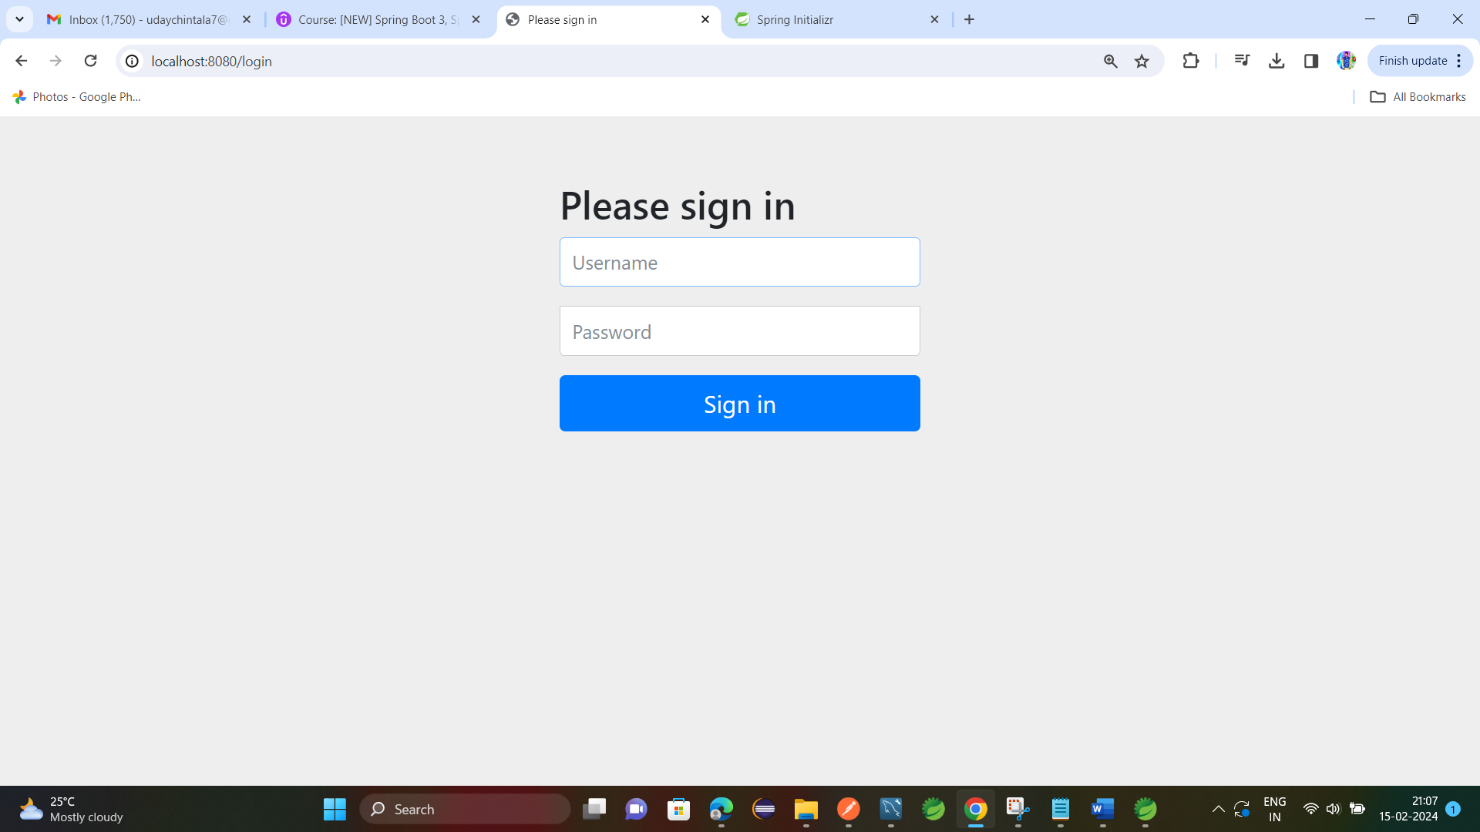

**Topic- 6. Spring Boot MVC: -**

**Thymleaf Demo:-**

Create project with web, devtools, thymleaf dependencies.

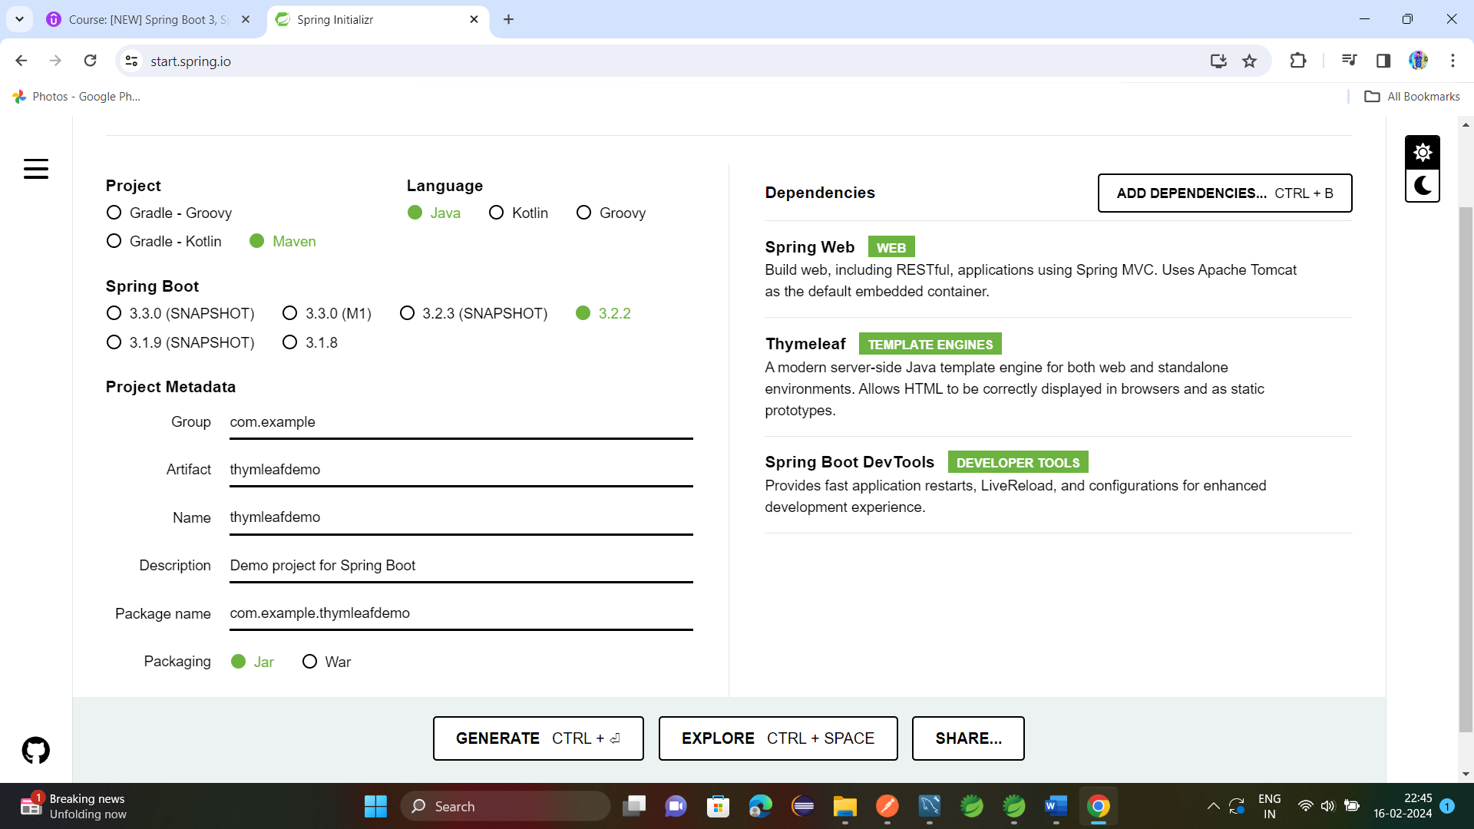

Create DemoController.java under controller package.

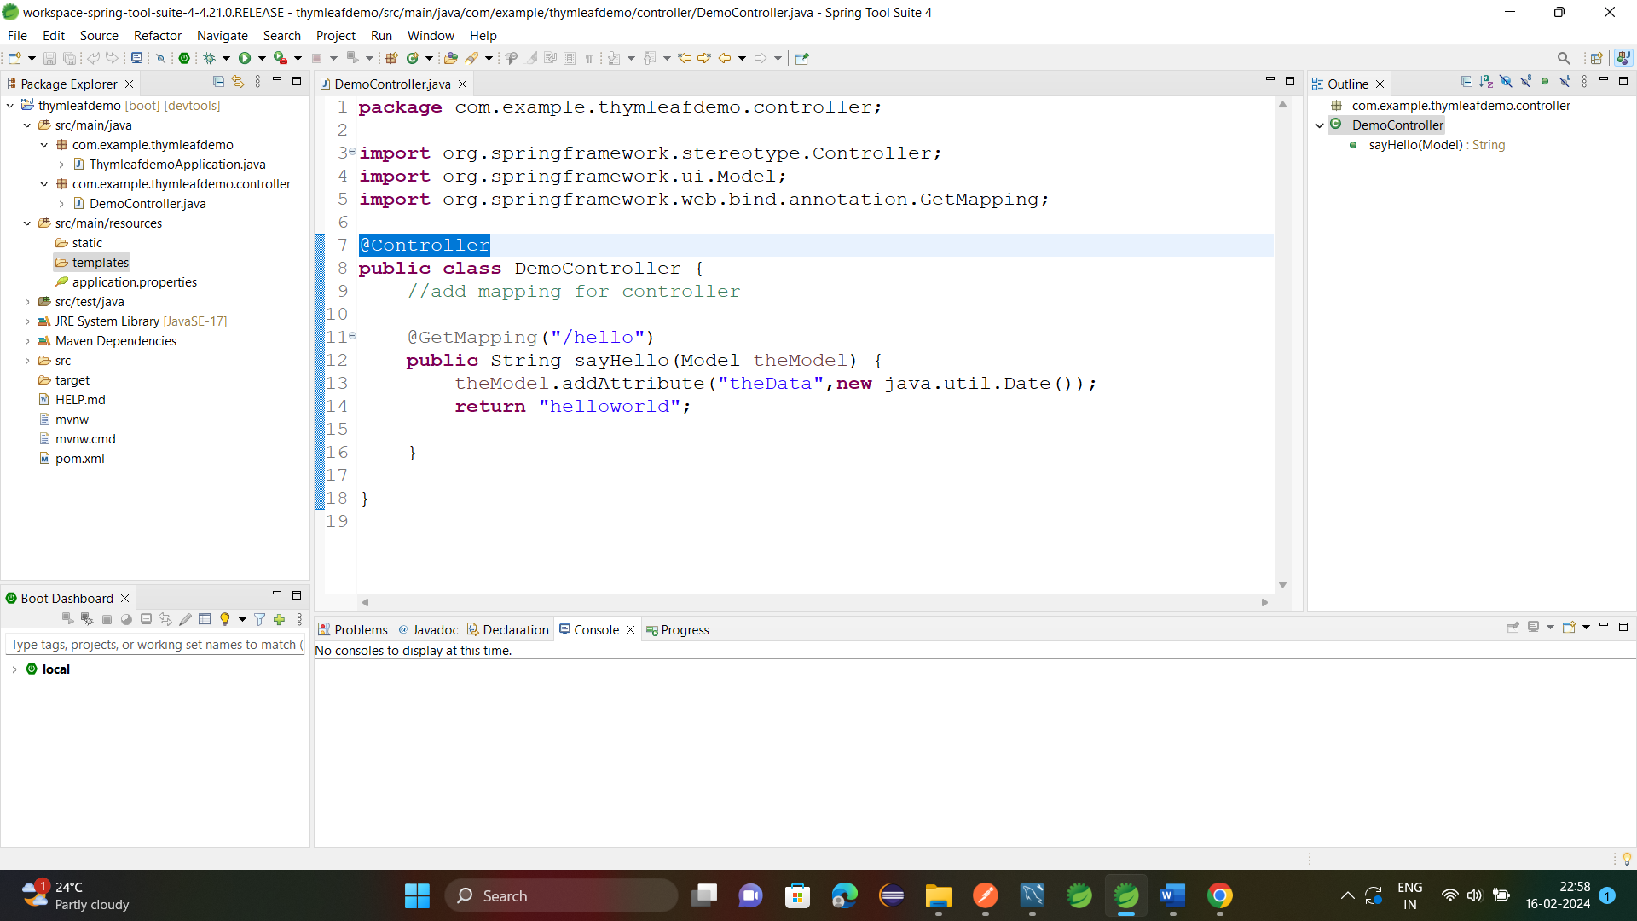

Now create templet helloworld.html under src/main/resources/templets

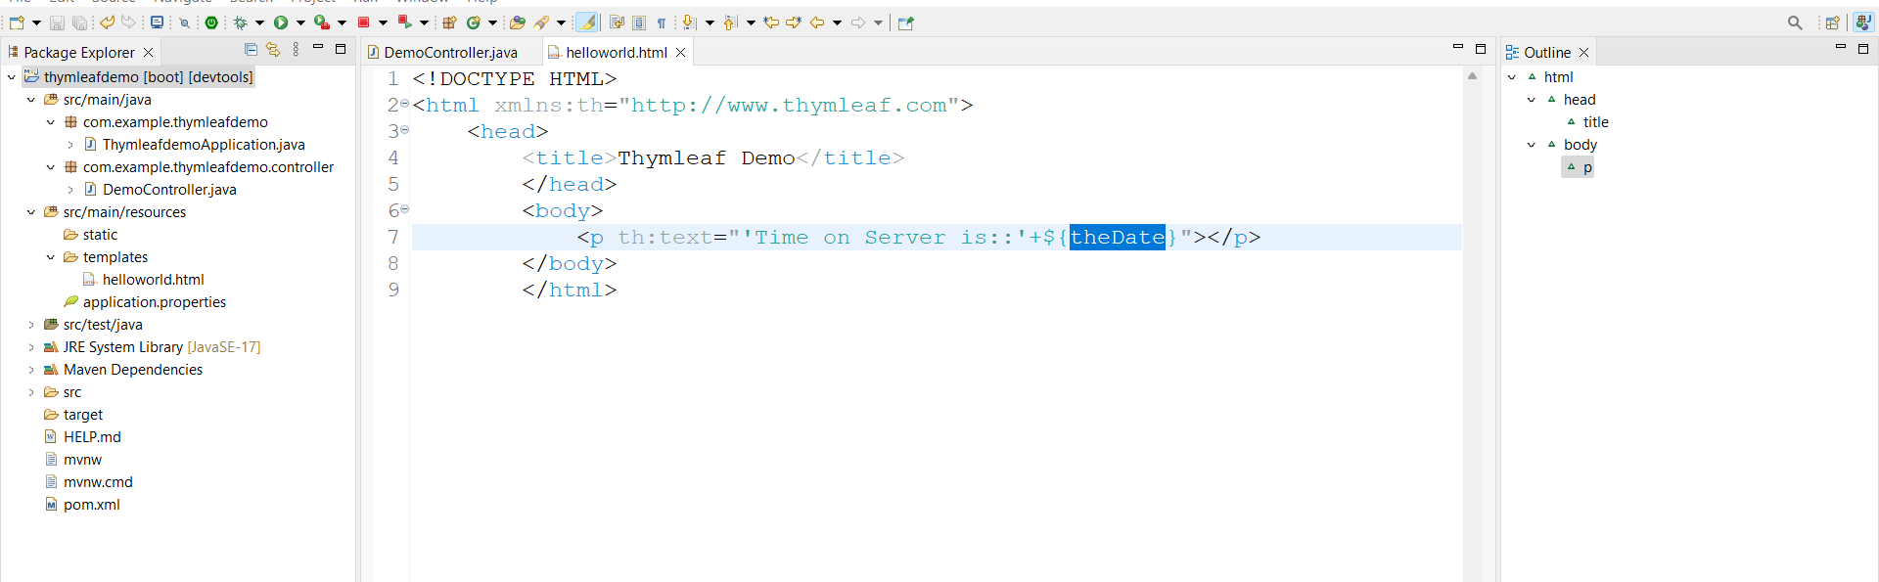

Run appn Link:- <http://localhost:8080/hello>

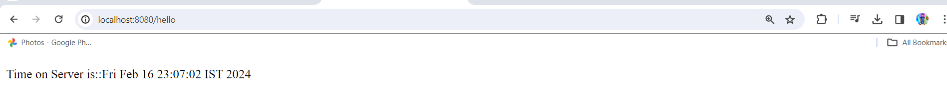

Adding css to appn src/main/resources/static/ under static folder create css folder under this create Demo.css file

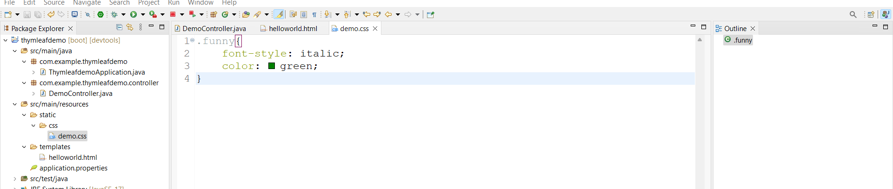

Add css file to thymleaf templet

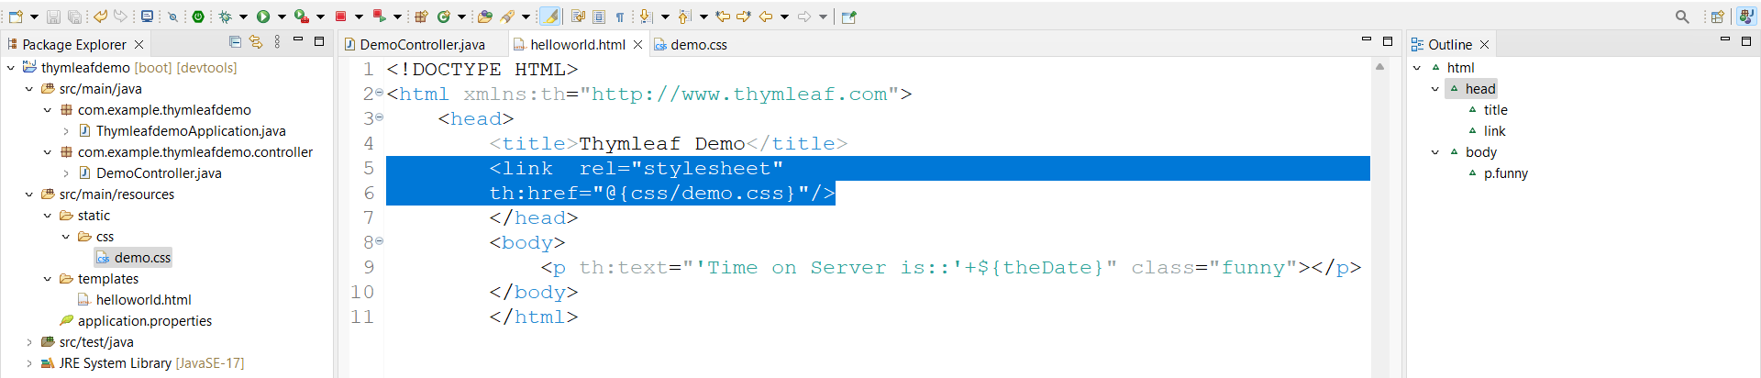

Apply style to display

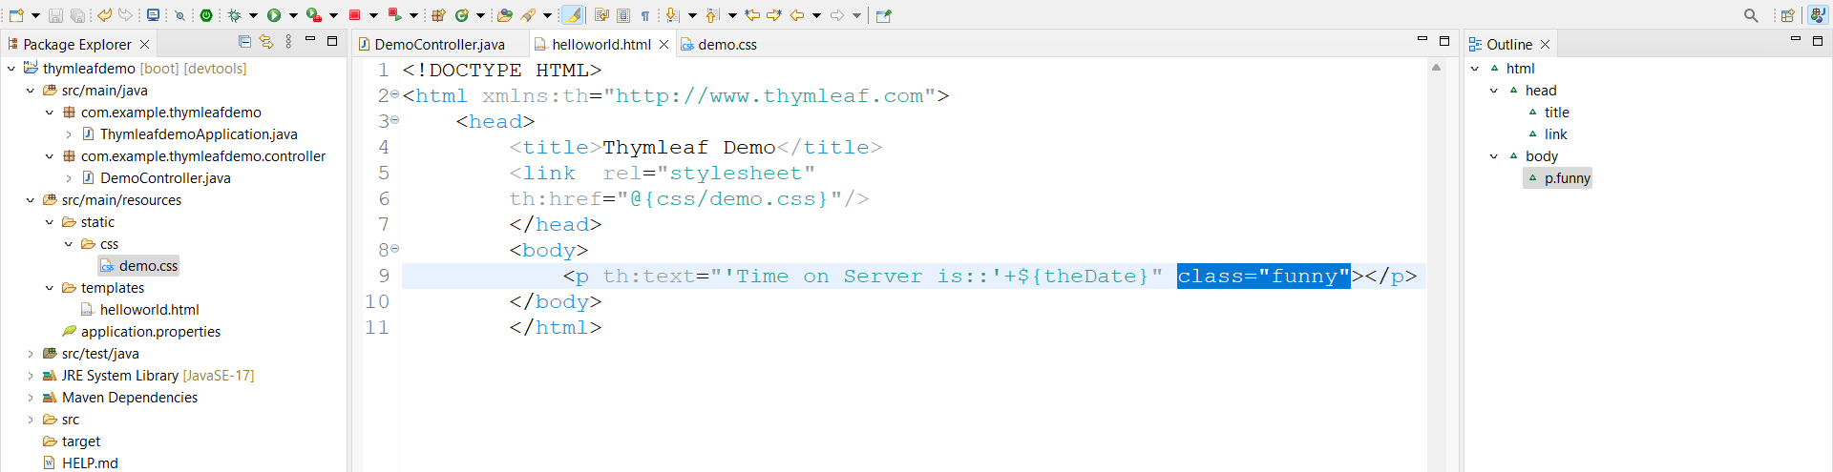

Run appn

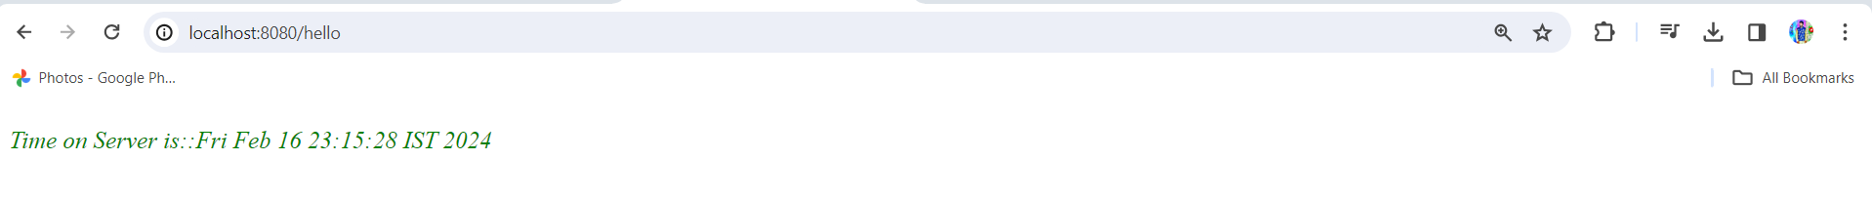

**Hello world:-**

Create **HelloworldController.java** under controller

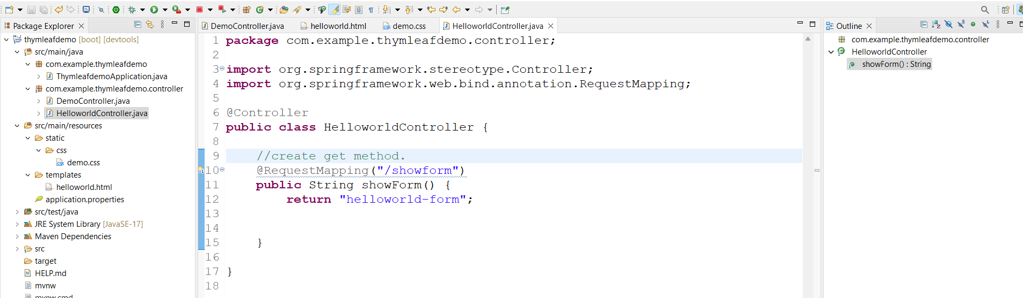

Create helloworld-form.html under templets

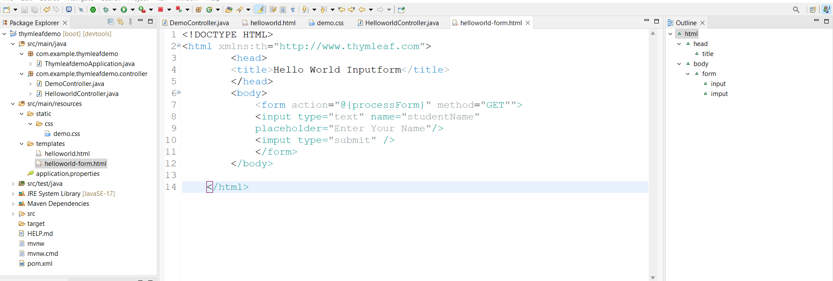

Open HelloworldController.java and write code for process form.

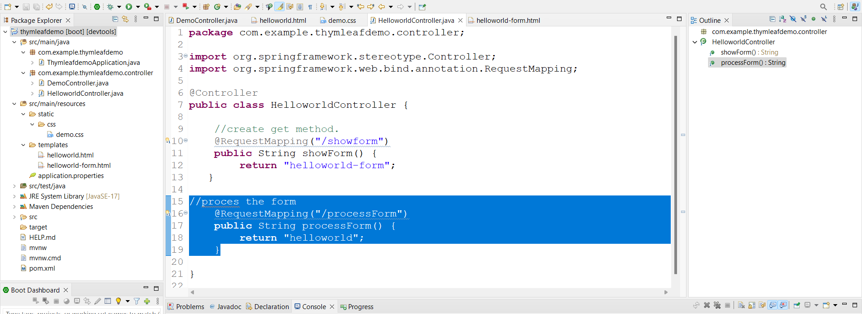

Write code for helloworld.html

Here previously helloworld.html is there change name of that file

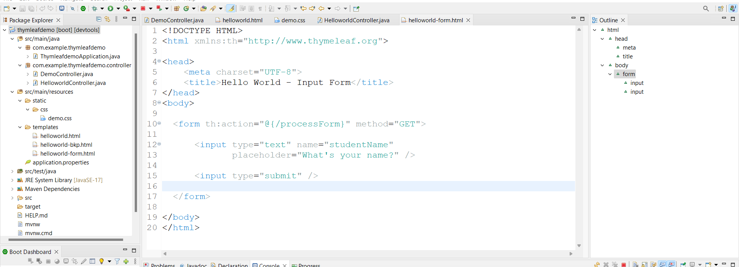

Now run appn Link:- <http://localhost:8080/showform>

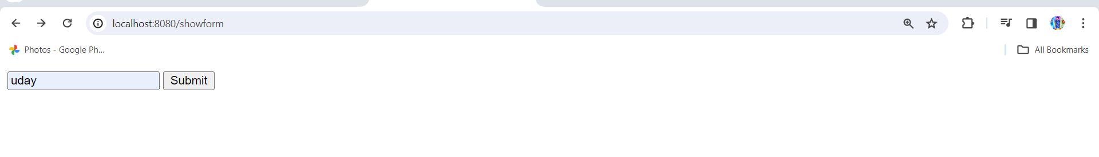

Click on submit

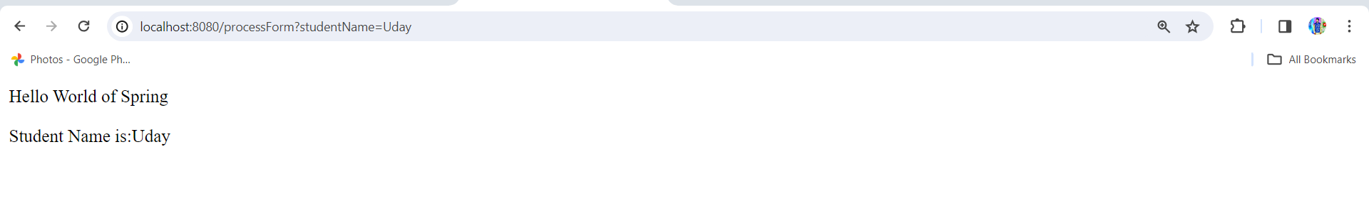

Adding data to MVC model: -

Add data to **HelloWorldController.java**

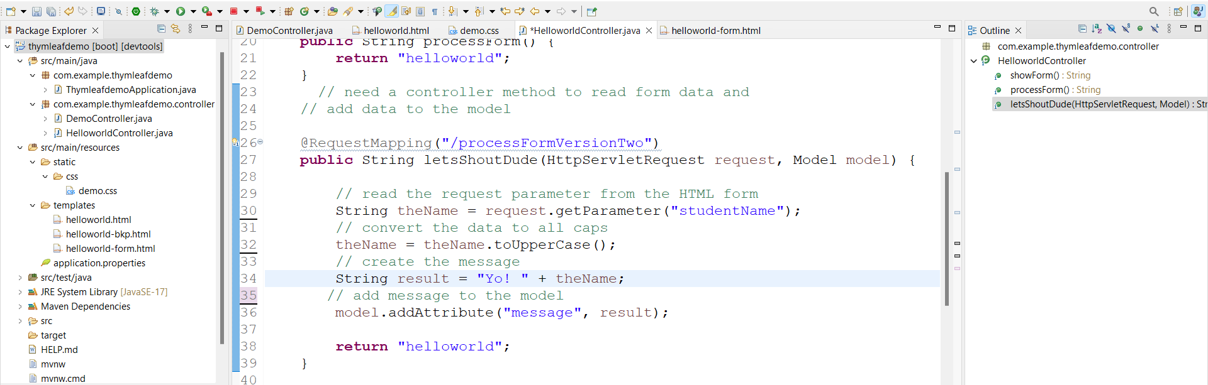

Open helloworld.html write code

Here model.addAttribute(“message”,result)

The parameter message should be same in **helloworld.html**

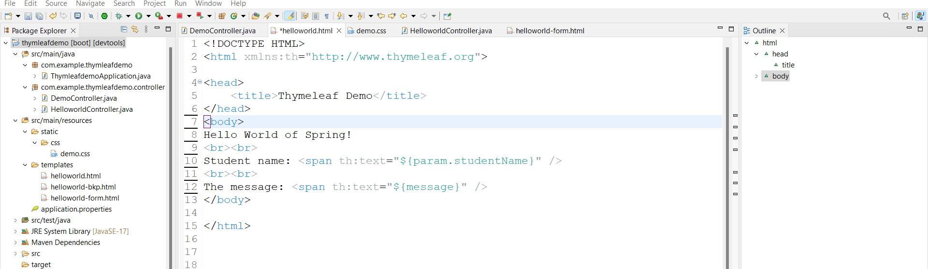

Now change form action in **hwlloworld-form.html** processForm to processFormVersionTwo

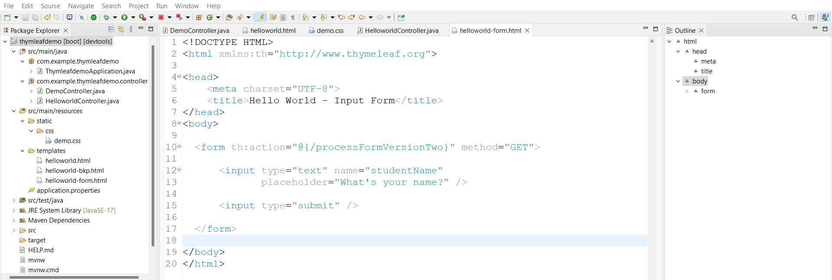

Run appn



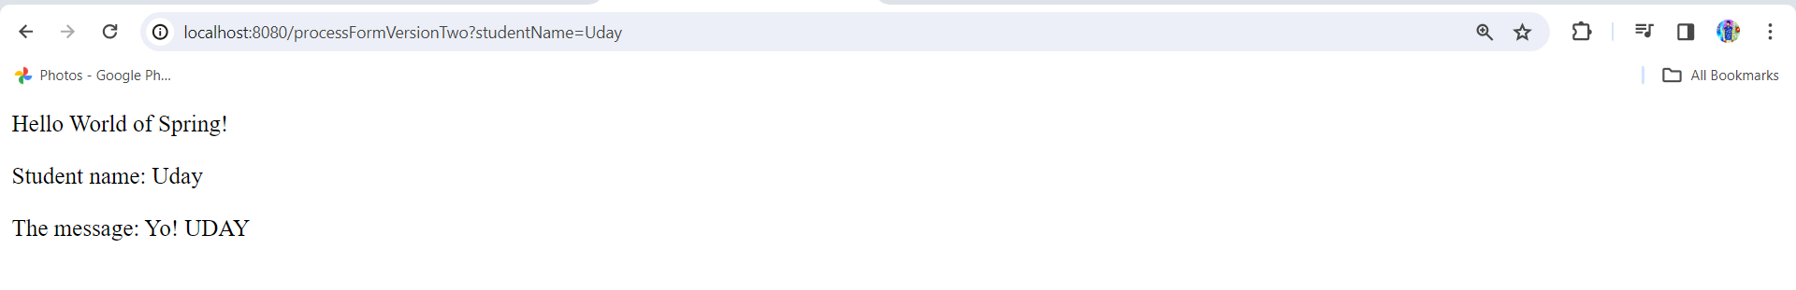

Binding Request Param: -

Open **HelloWorldController.java** write another request mapping here we are going to use **@RequestParam** instead of **HttpServletRequest** and remove code related to HttpServletRequest

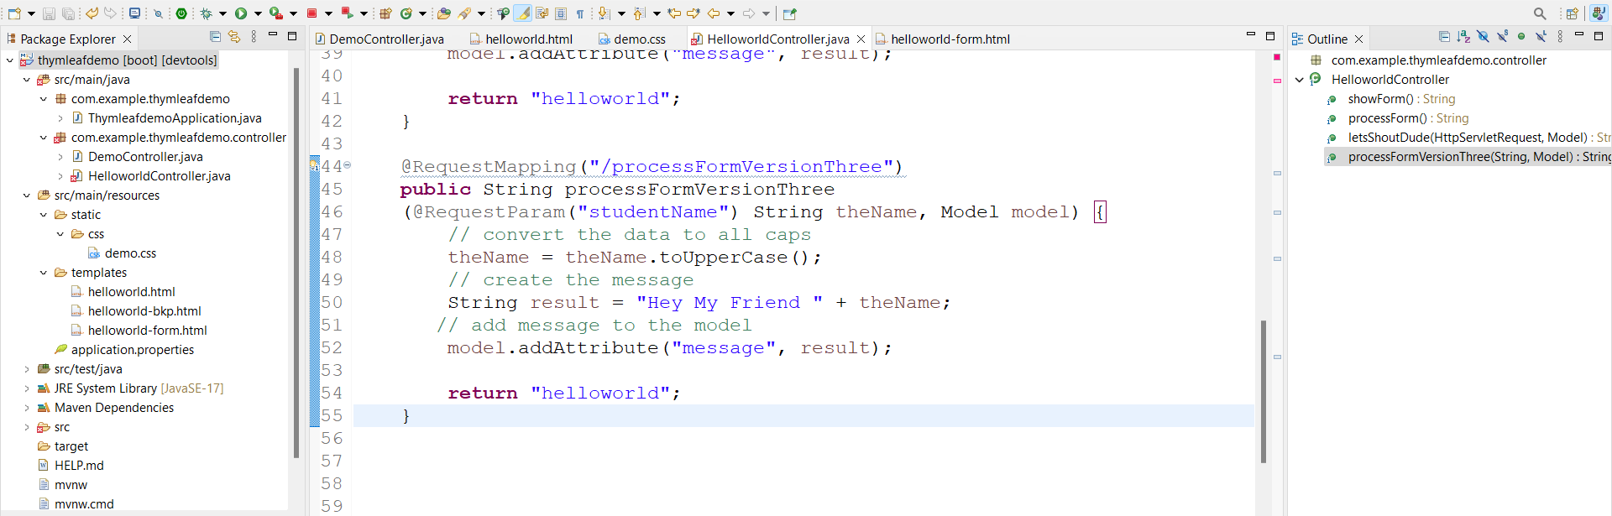

Change form action in **helloworld-form.html**

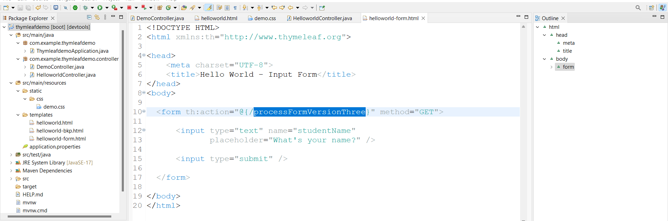

**Run appn**

**Link:-** [**http://localhost:8080/showform**](http://localhost:8080/showform)

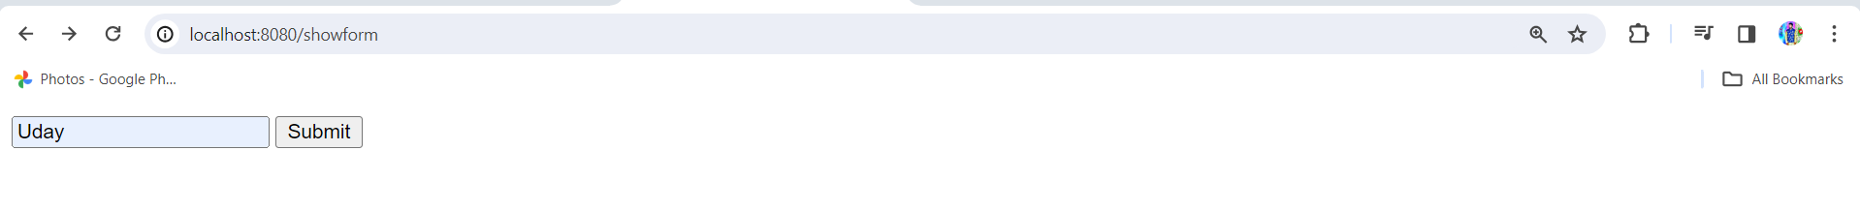

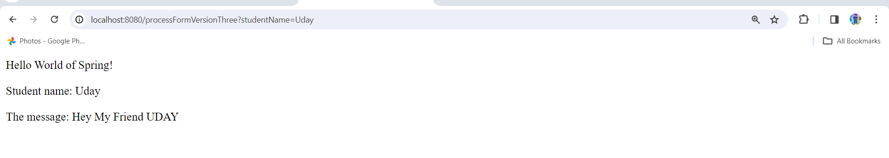

**@GetMapping:-**

For this go to **HelloWorldController.java** and change /showform request method from @RequestMapping to @GetMapping

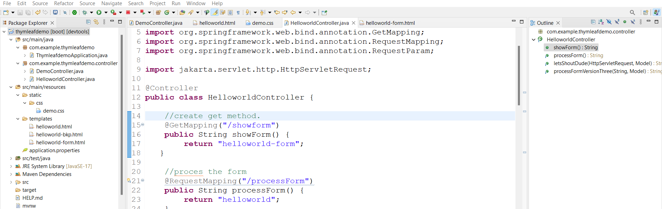

**Run appn**

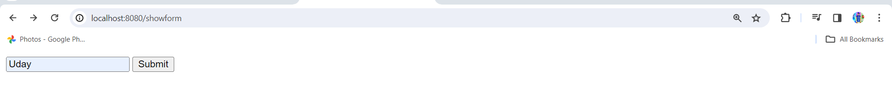

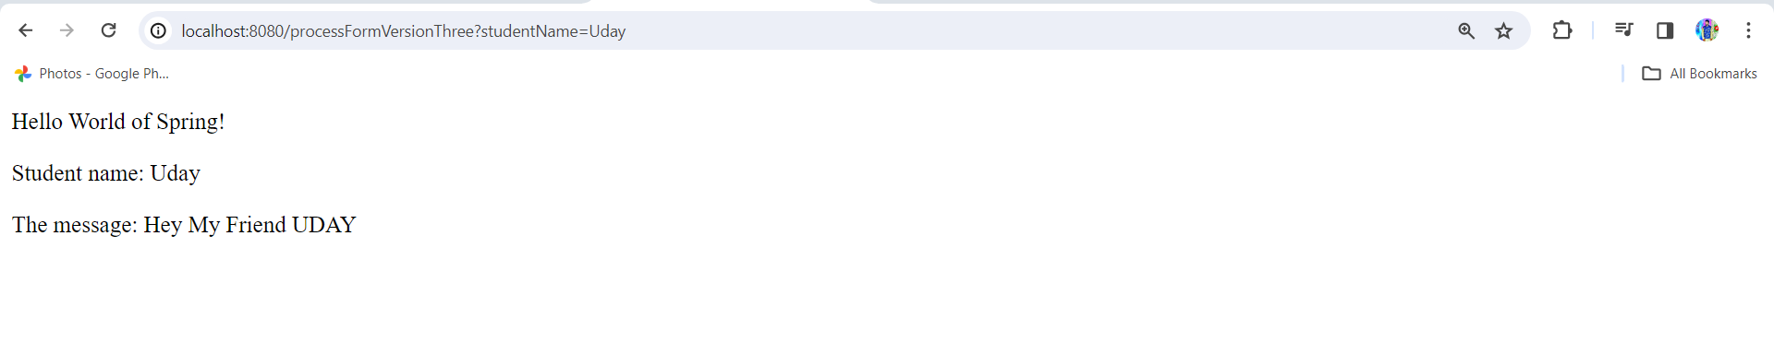

Its working fine

@PostMapping:-

Now change @GetMapping to @PostMapping now then its not works

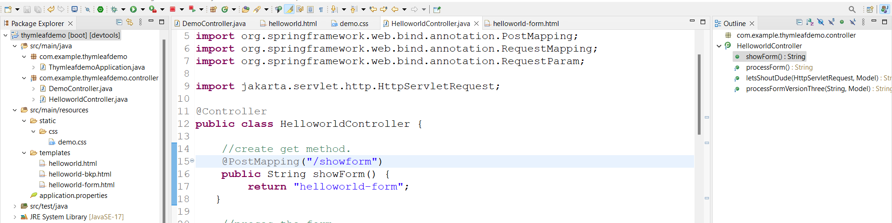

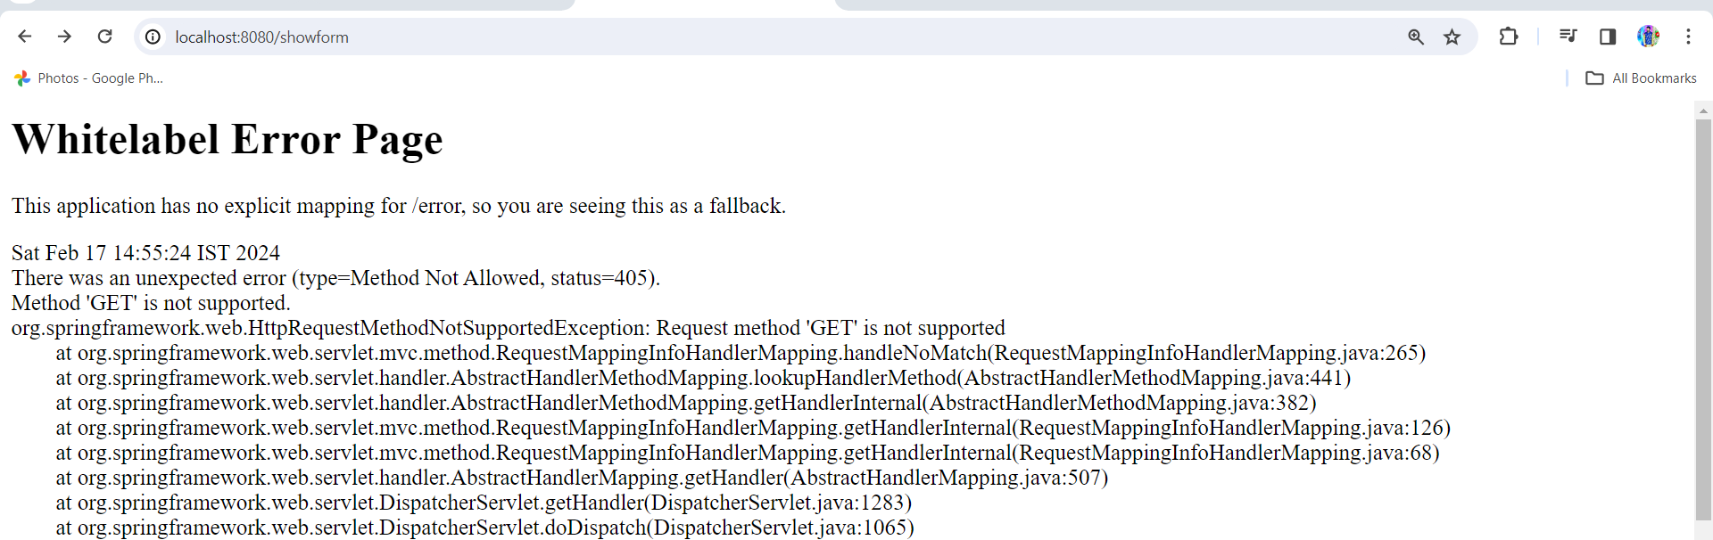

Here issue is browser is always supports @GetMapping only now change /showform to @GetMapping run appn its works fine

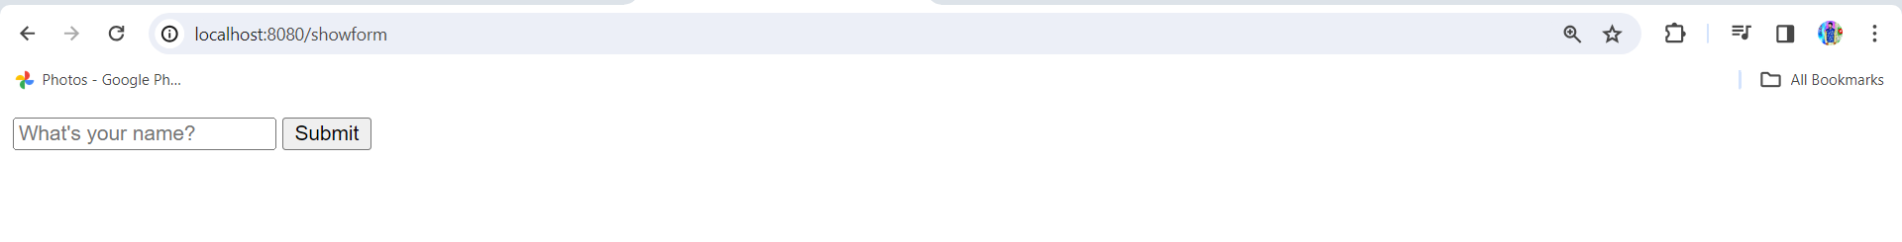 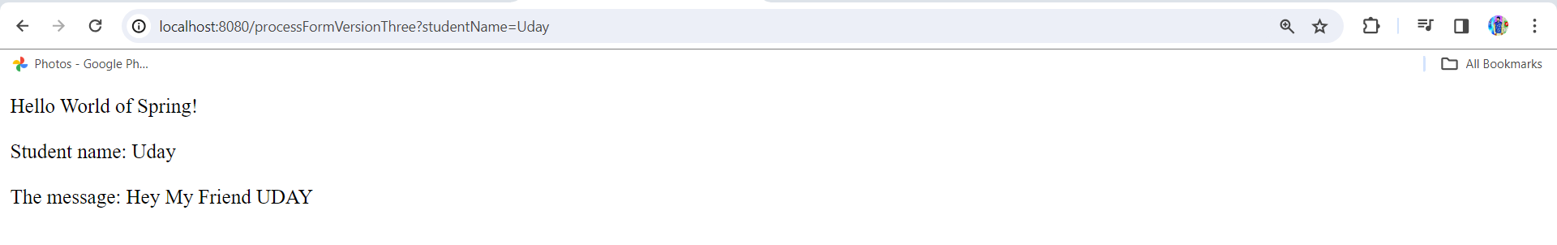

Here one issue if request type is @GetMapping then request params are showing in browser search this is not good way so we have to do one thing change form method in **helloworld-form.html** from GET to POST

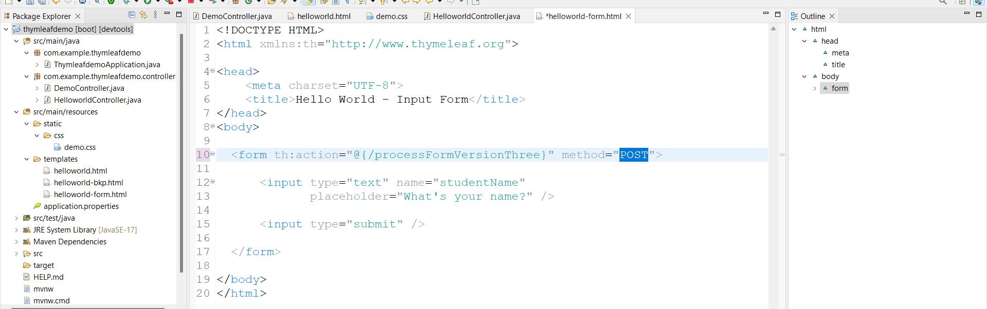

And change @RequestMapping to @PostMapping in **HelloWorldController.java** forprocessFormVersionThree

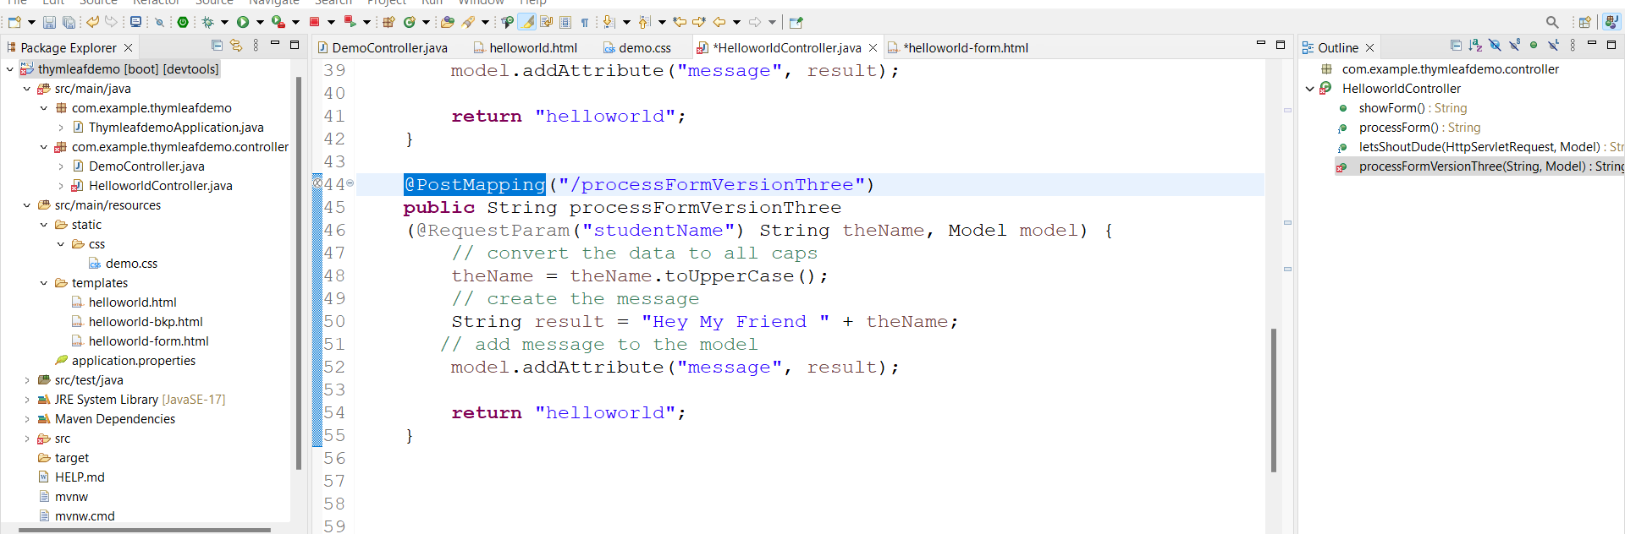

Now run appn its works fine

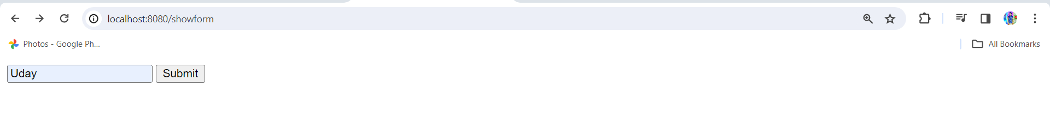

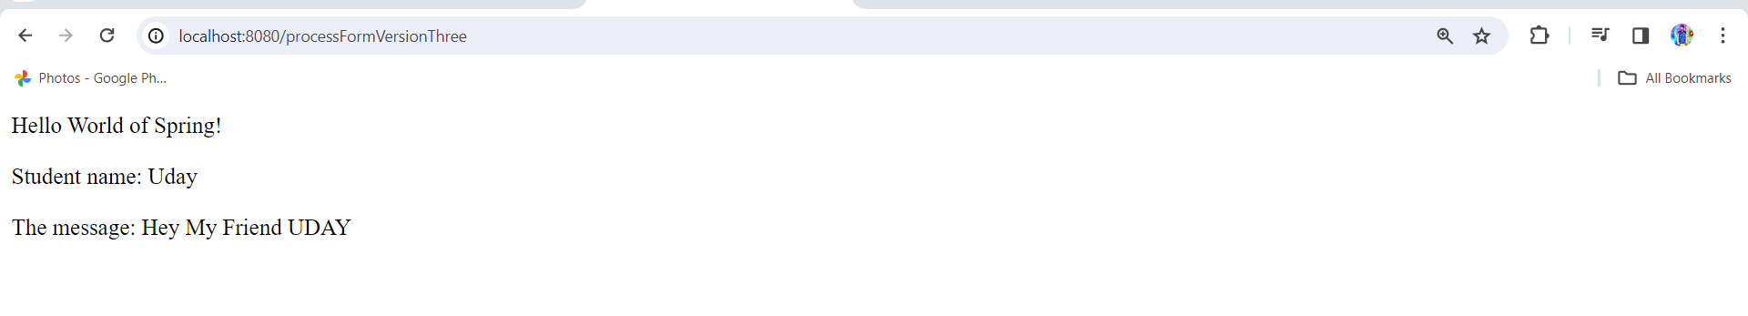

Here you see data not showing in browser search

Data Binding: -

Text Fields: -

1.create **Student.java** under model package with fields, constructors and getters and setters

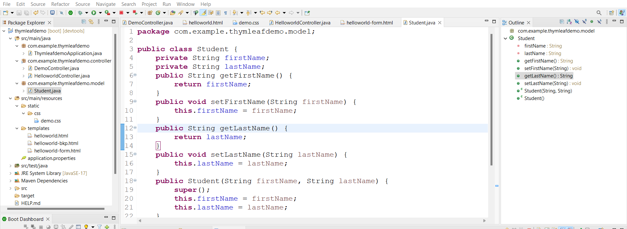

2.create **StudentController.java** under controller package.

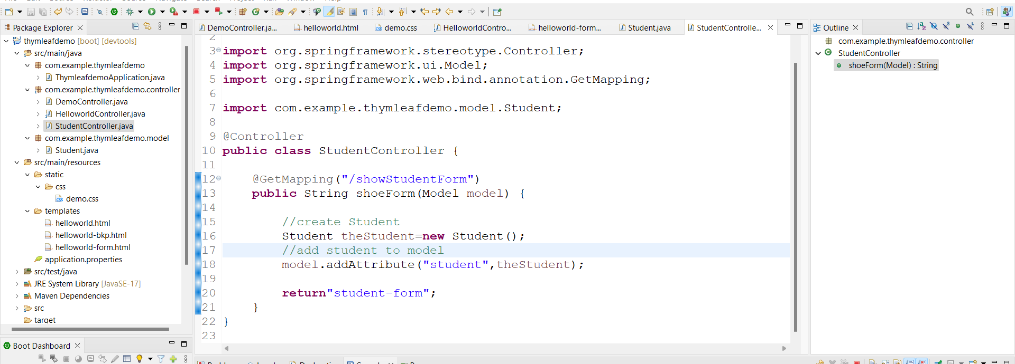

3.create **student-form.html** under templet

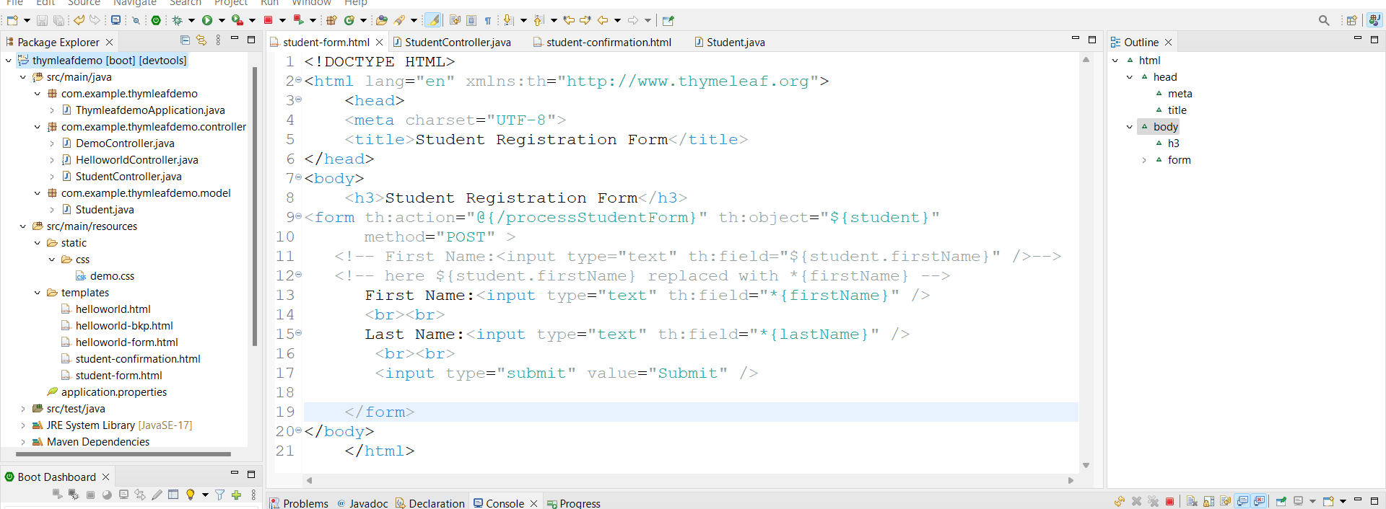

4.create code for form processing in **StudentController.java**

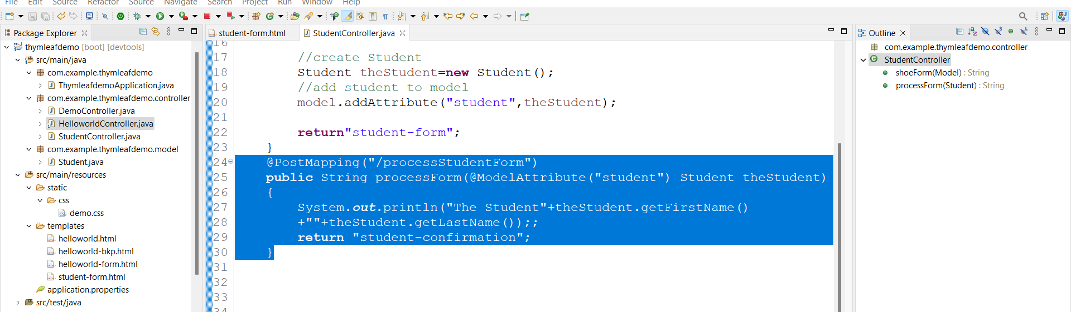

5.create student-confirmation.html under templets

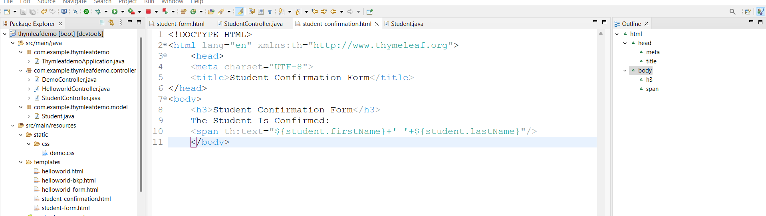

Run appn

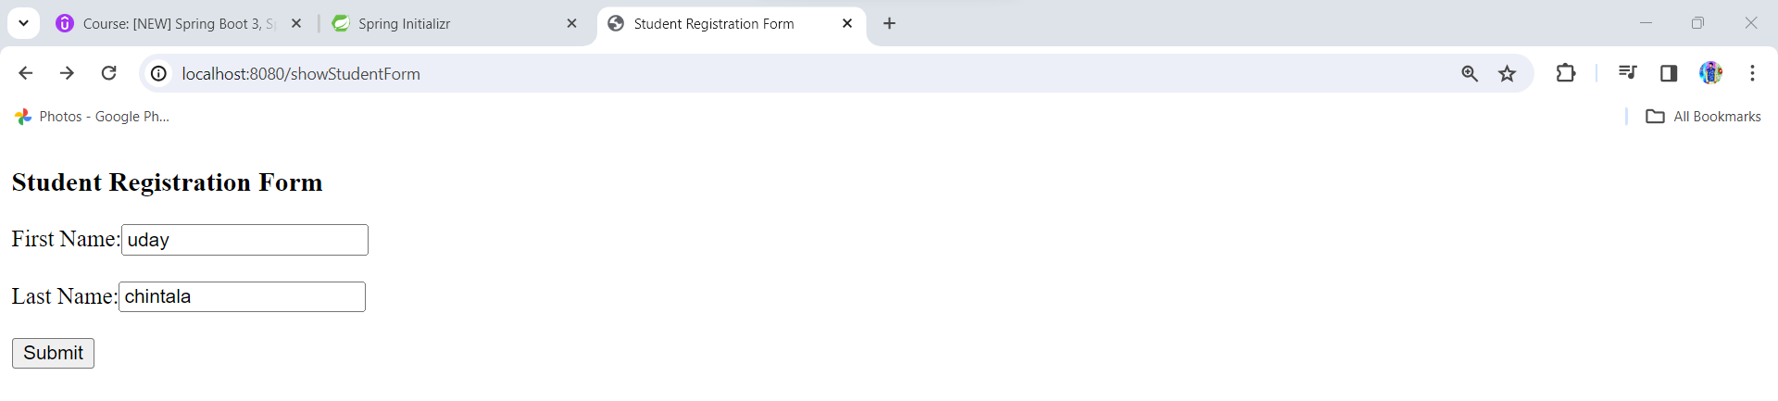

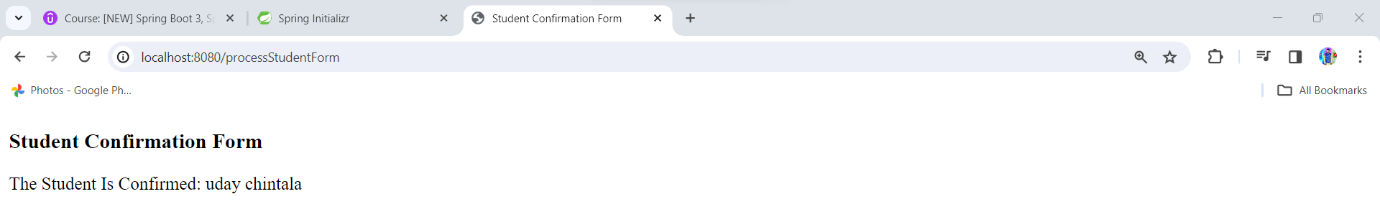

Drop Down List: -

1.student-form.html

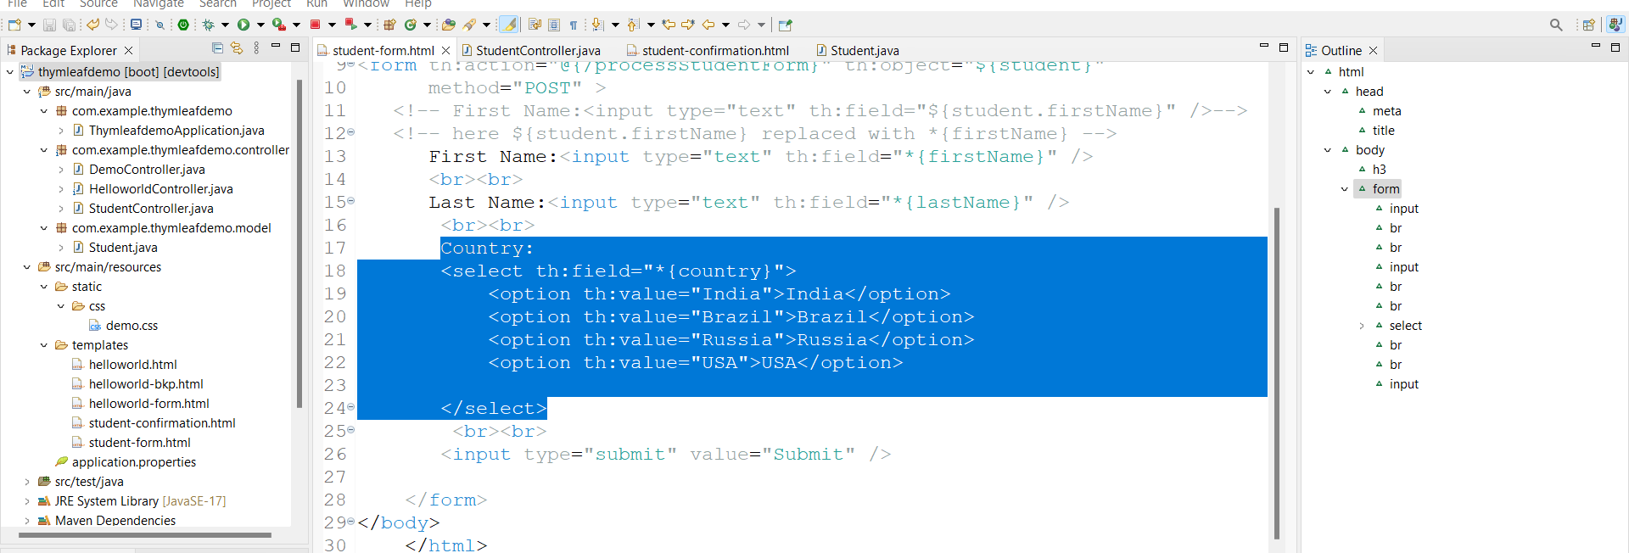

2.Add Country field into **Student.java** and add getters and setters

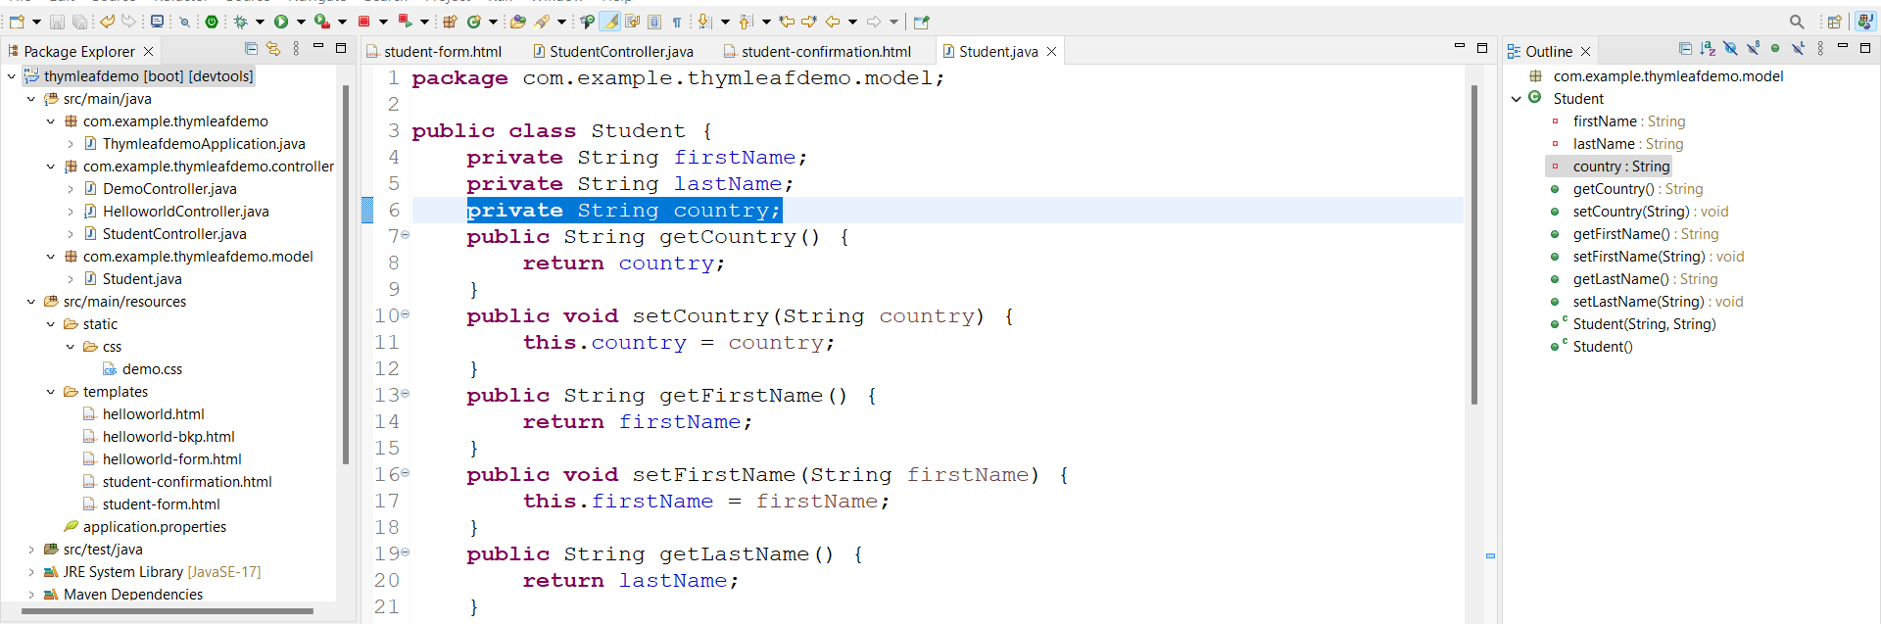

3.student-confirmation.html

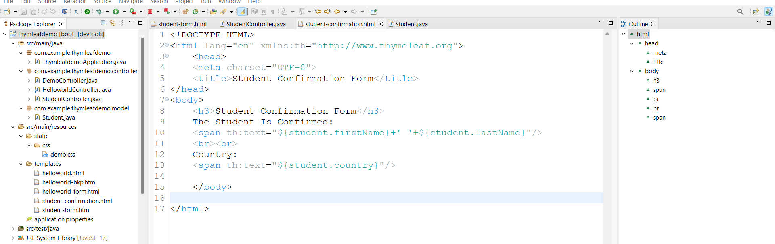

Run appn

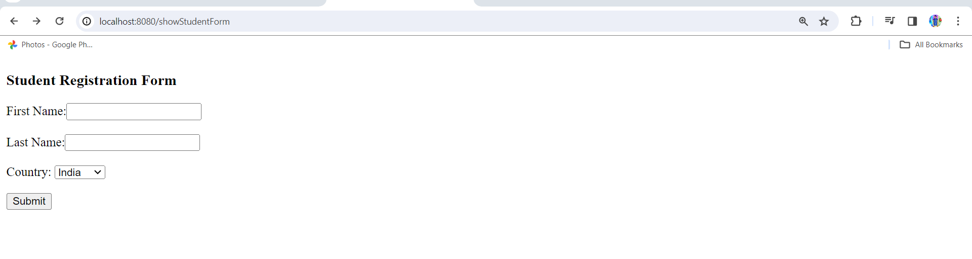

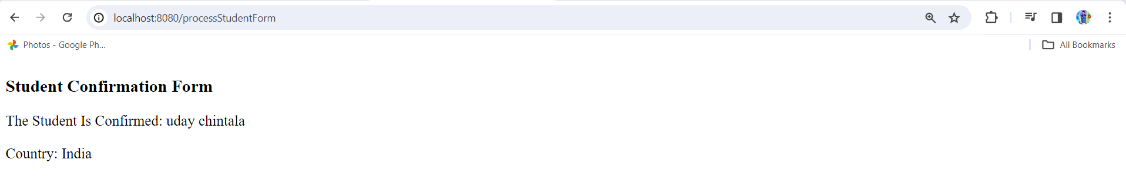

Here country values are hard coded so will go with properties file as appn.prop

1.application.properties

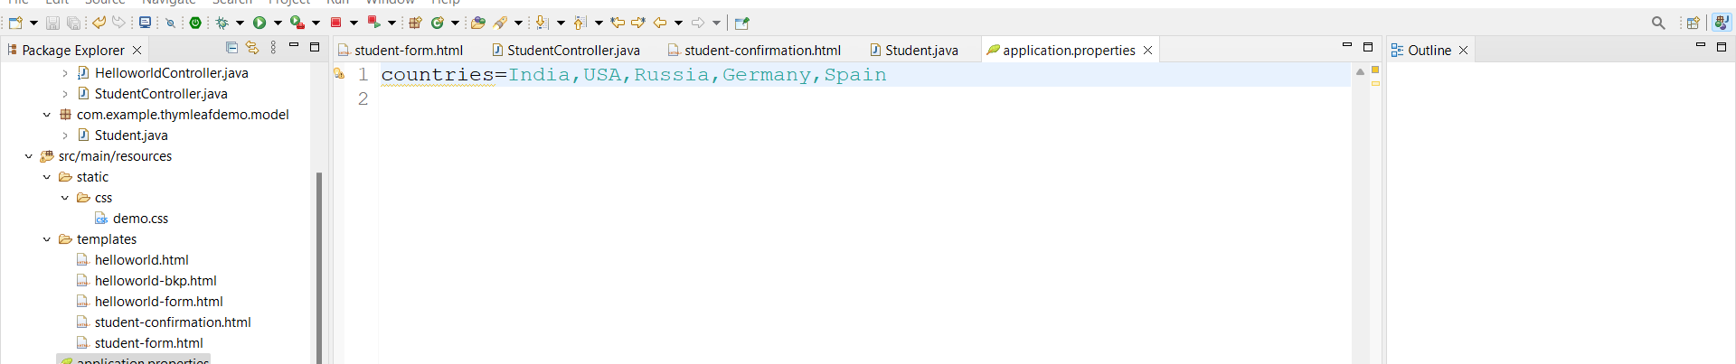

2.inject values into **StudentController.java** using @Value

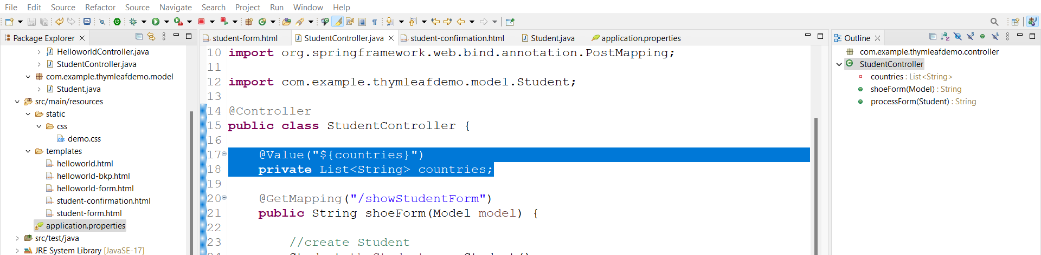

3.add countries to model in **StudentController.java**

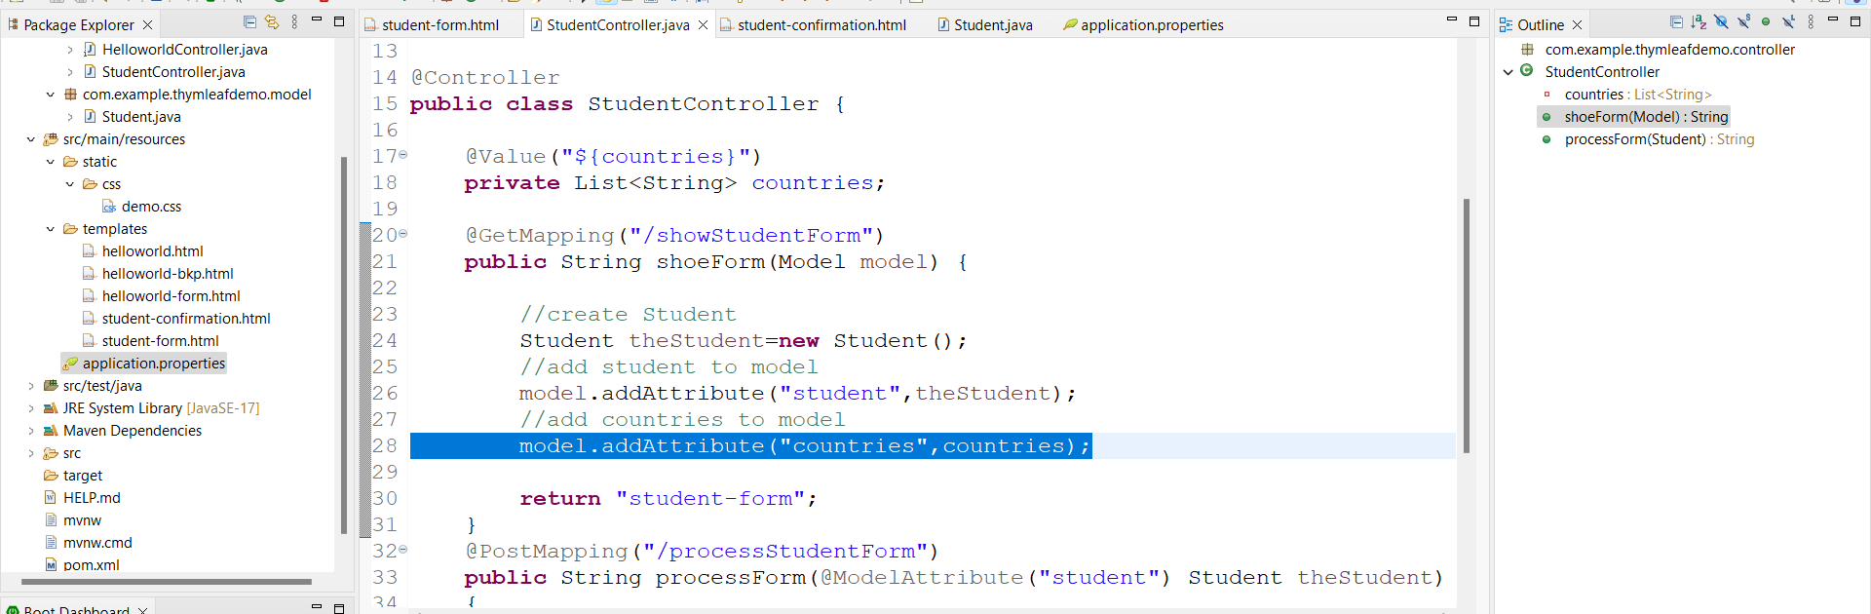

4.student-form.html

Remove existing code add new one

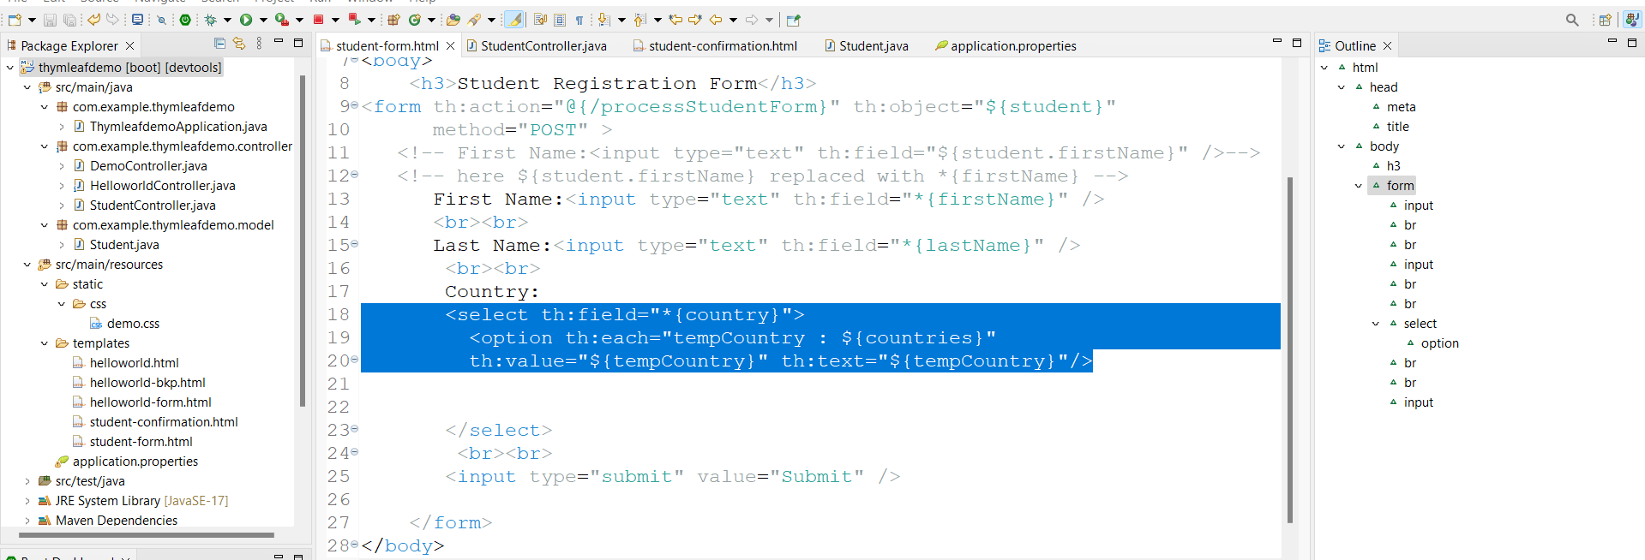

Run appn

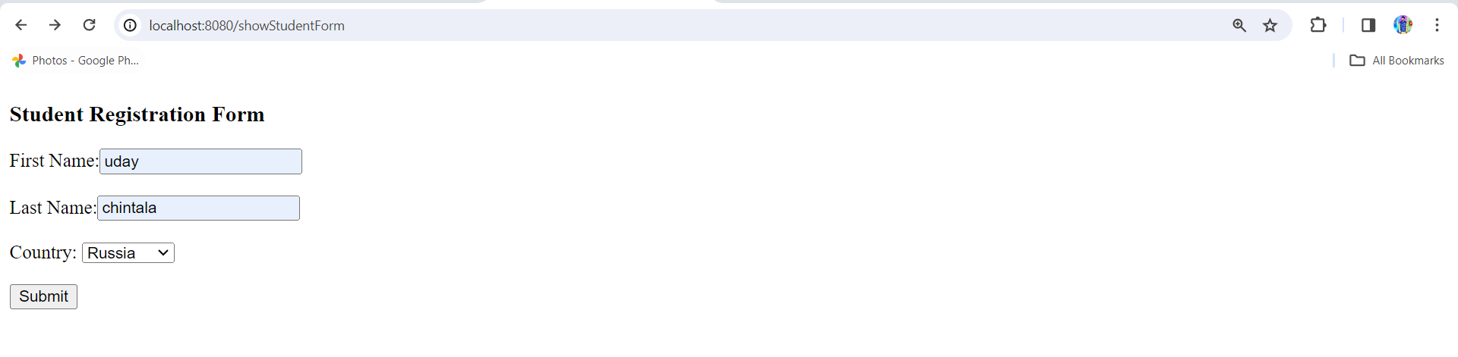

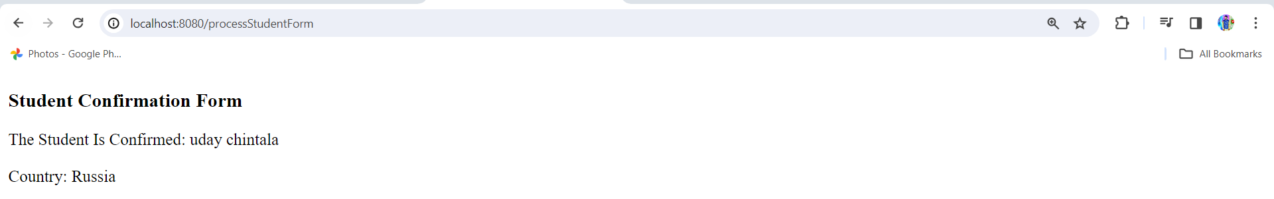

Radio Button: -

1.student-form.html

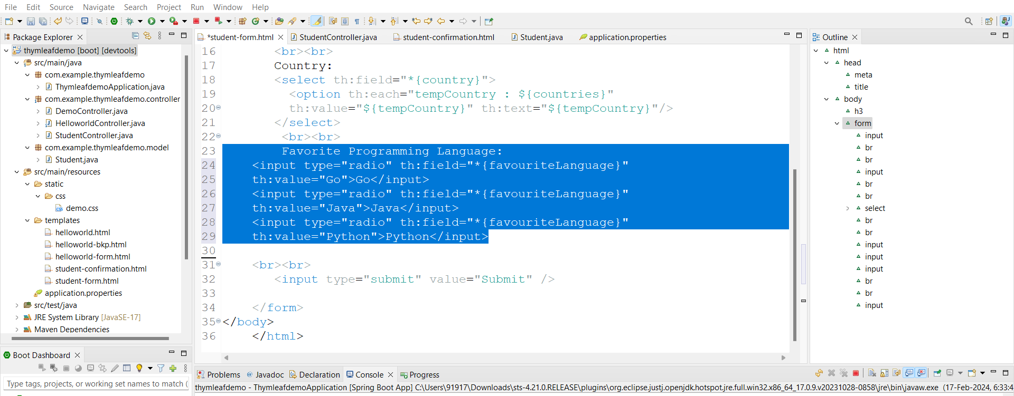

2.Student.java

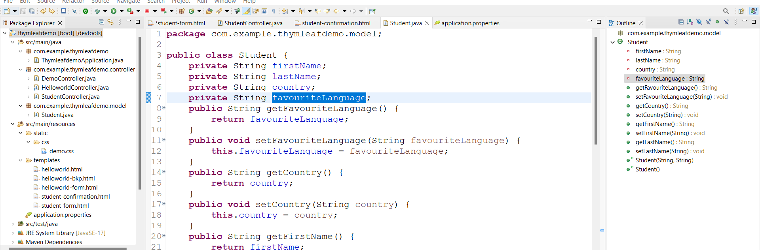

3.student-confirmation.html

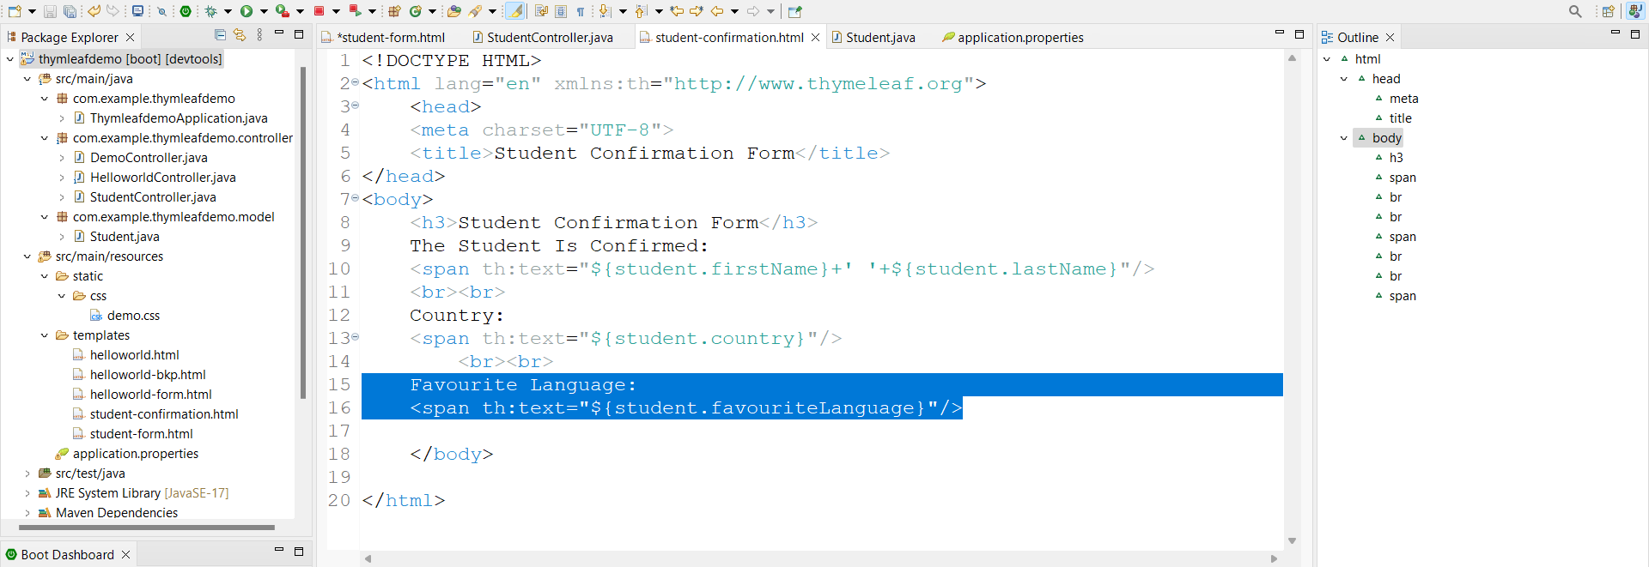

Run appn link:- <http://localhost:8080/showStudentForm>

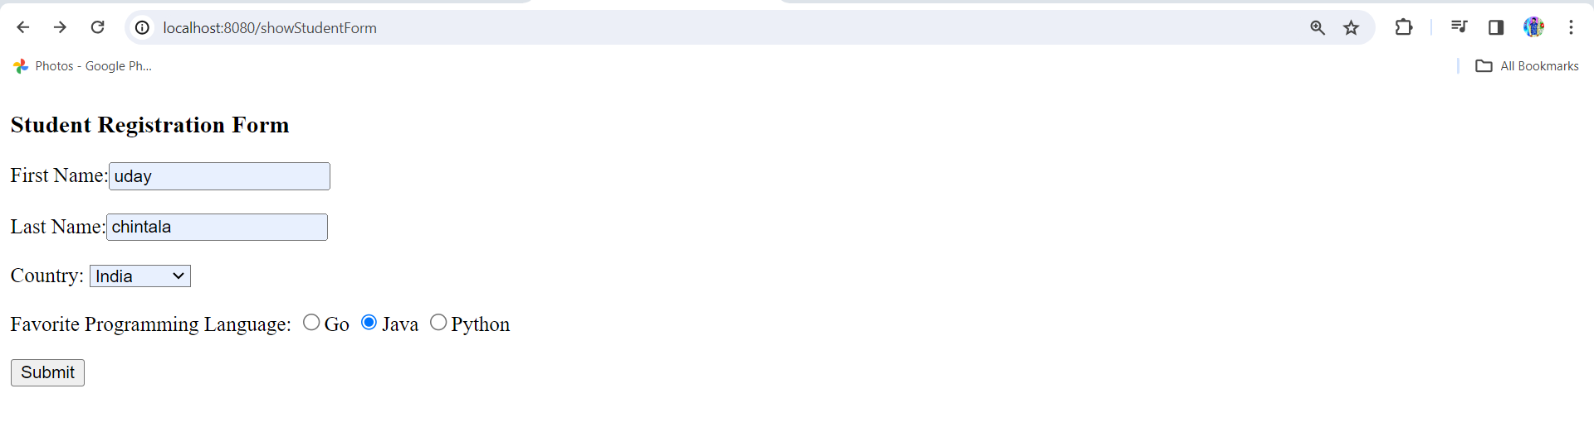

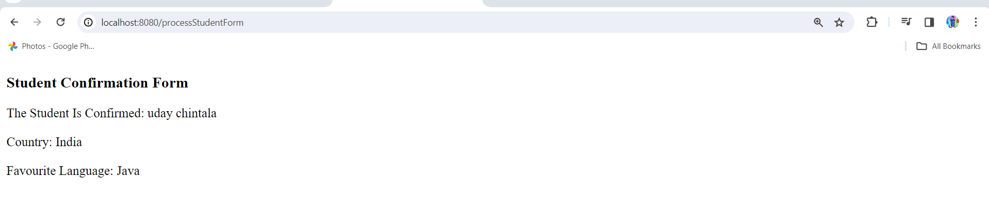

Here languages are hard coded so will add them in appn.prop

1.application.properties

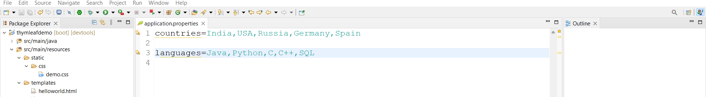

2.StudentController.java

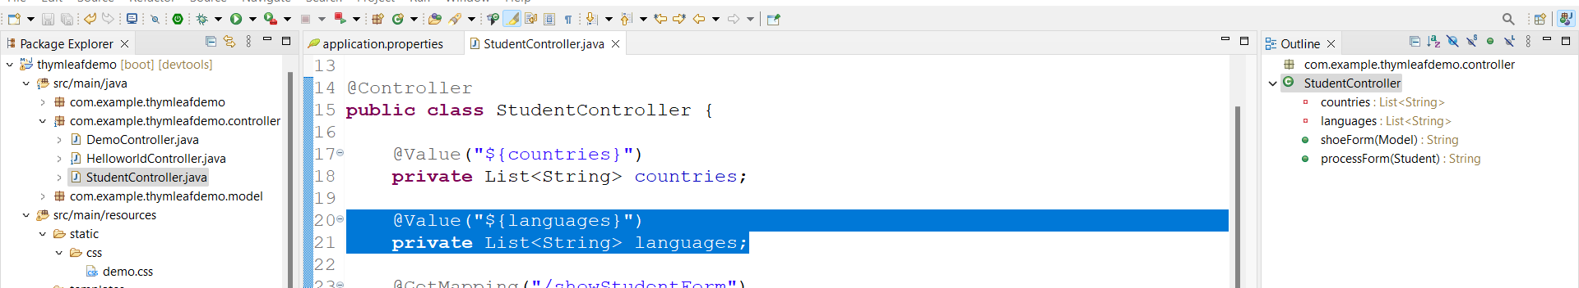

Add to model

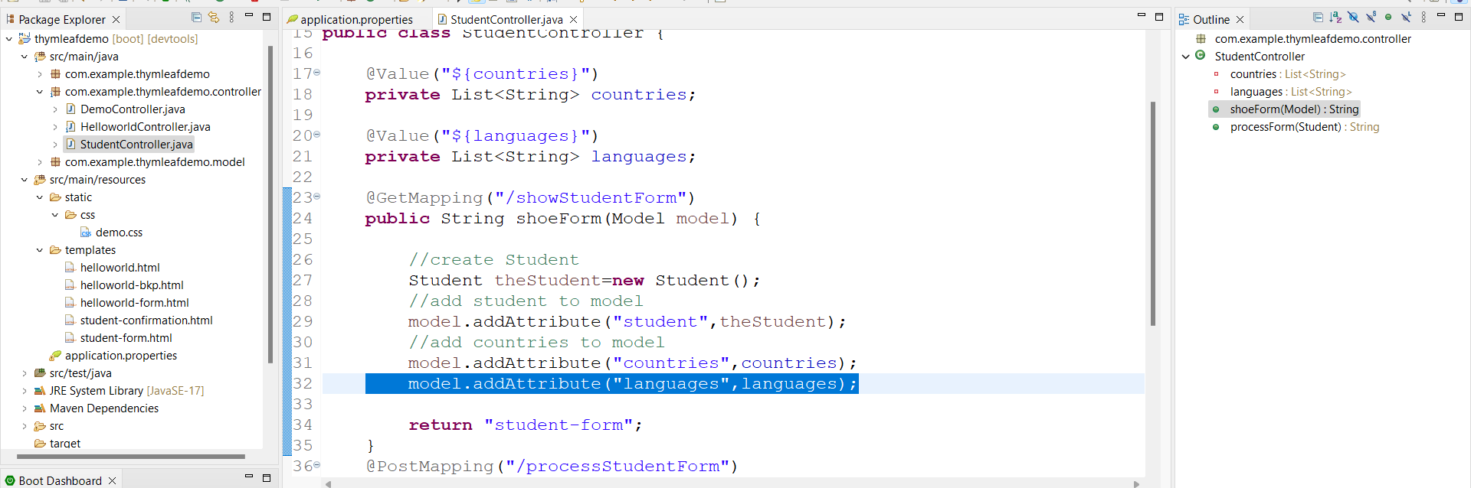

3.student-form.html

Delete hard coded data and add following

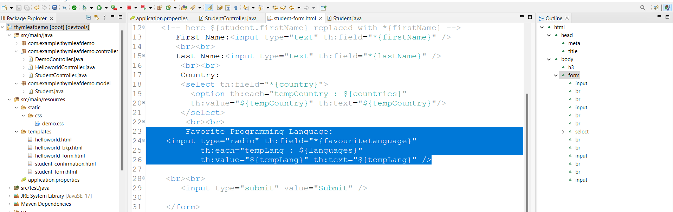

Run appn its working fine

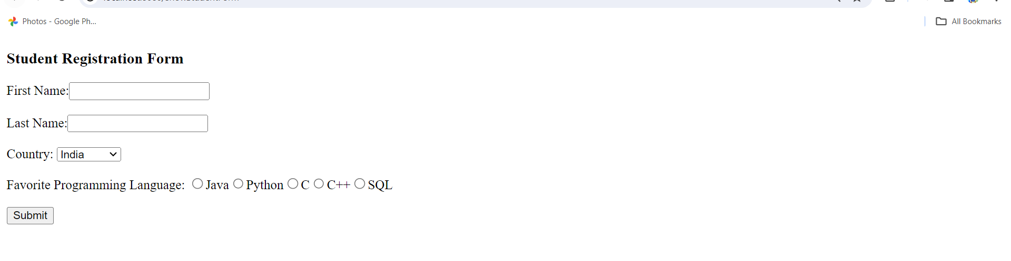

Check Boxes:-

1.student-form.html

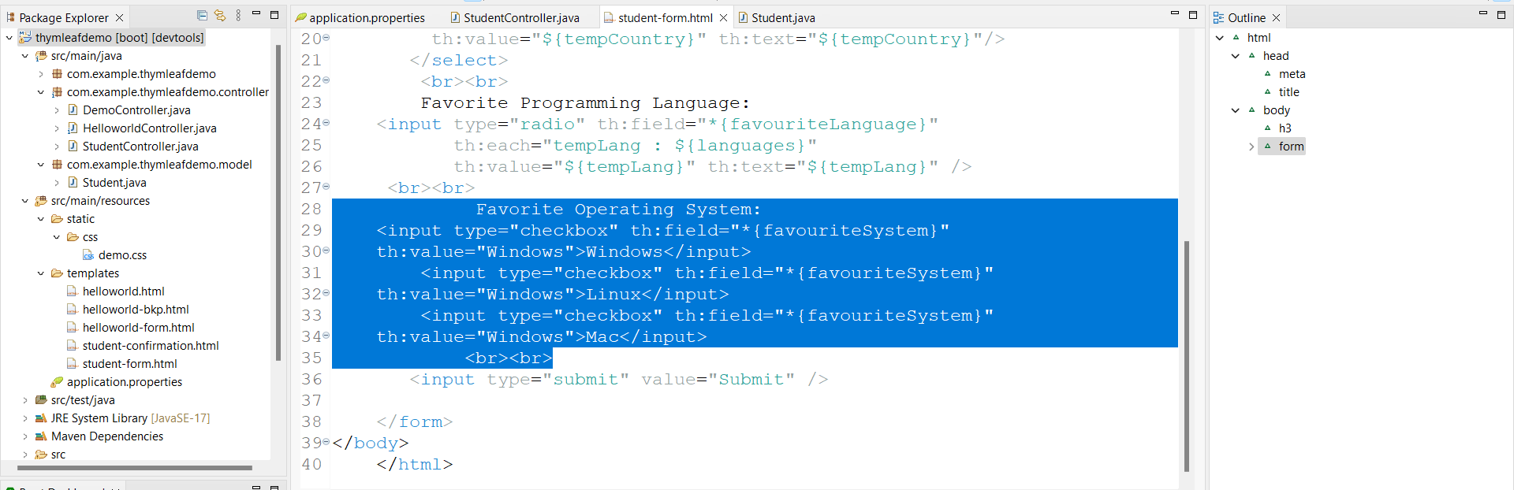

2.Student.java add favouritrSystem and add getter and setter

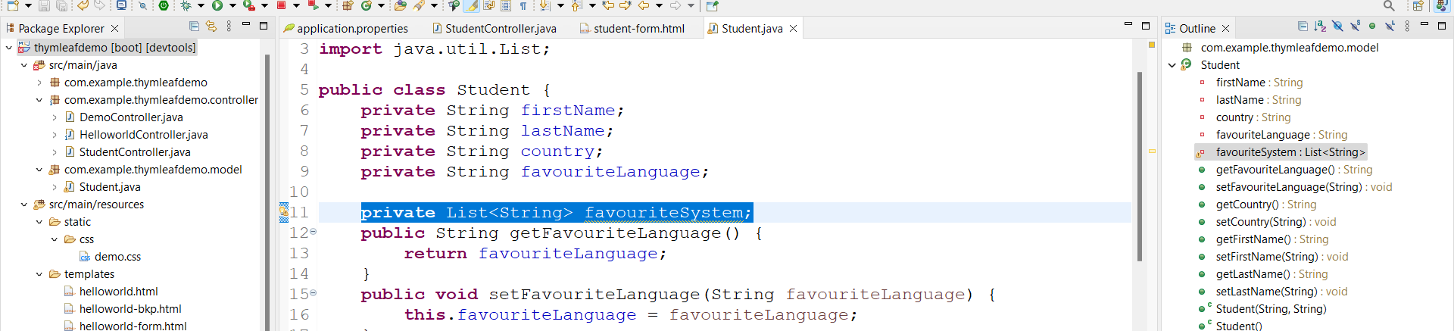

3.student-confirmation.html

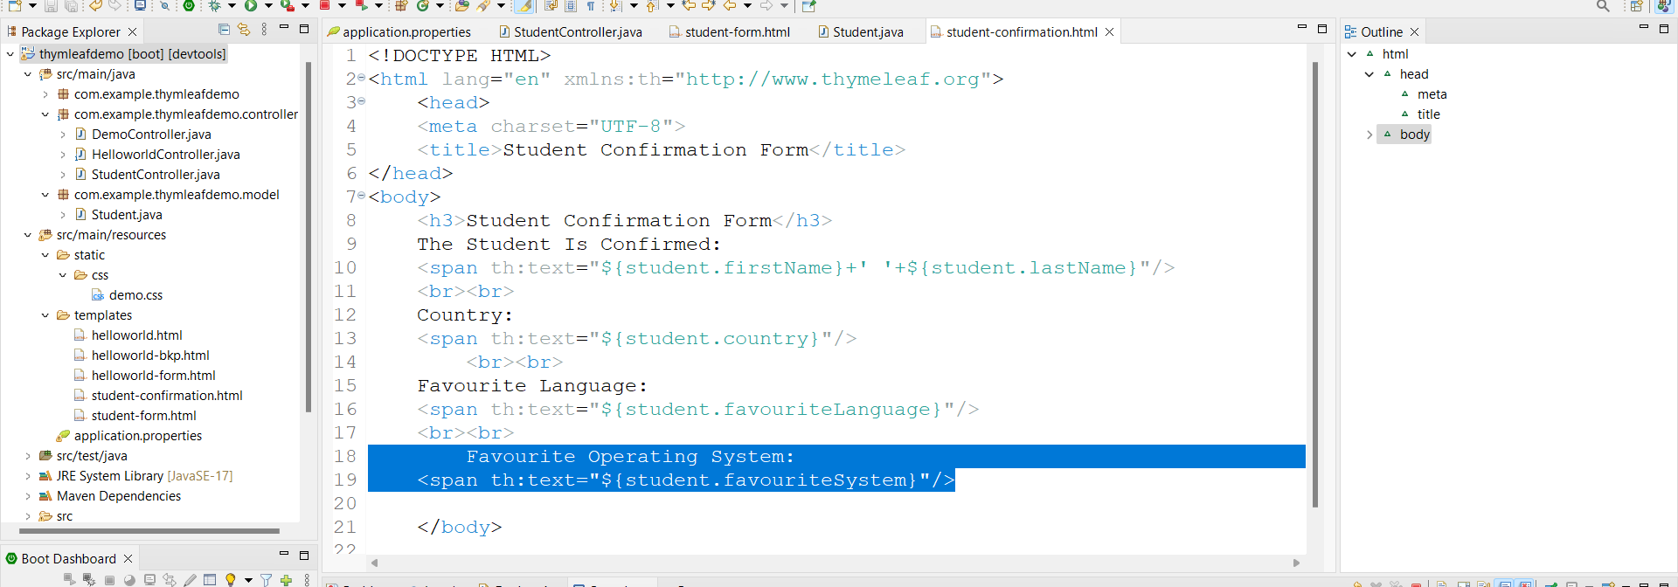

Run appn link:- <http://localhost:8080/showStudentForm>

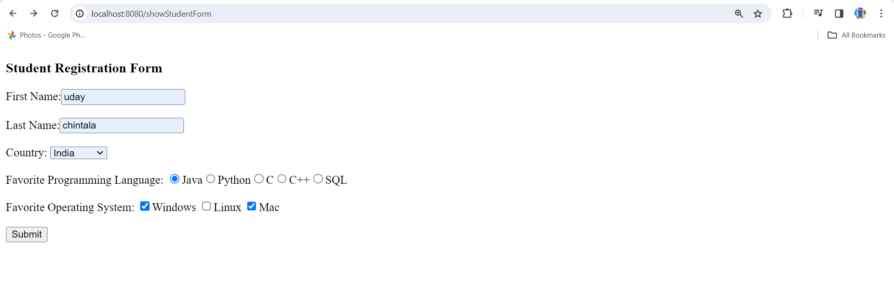

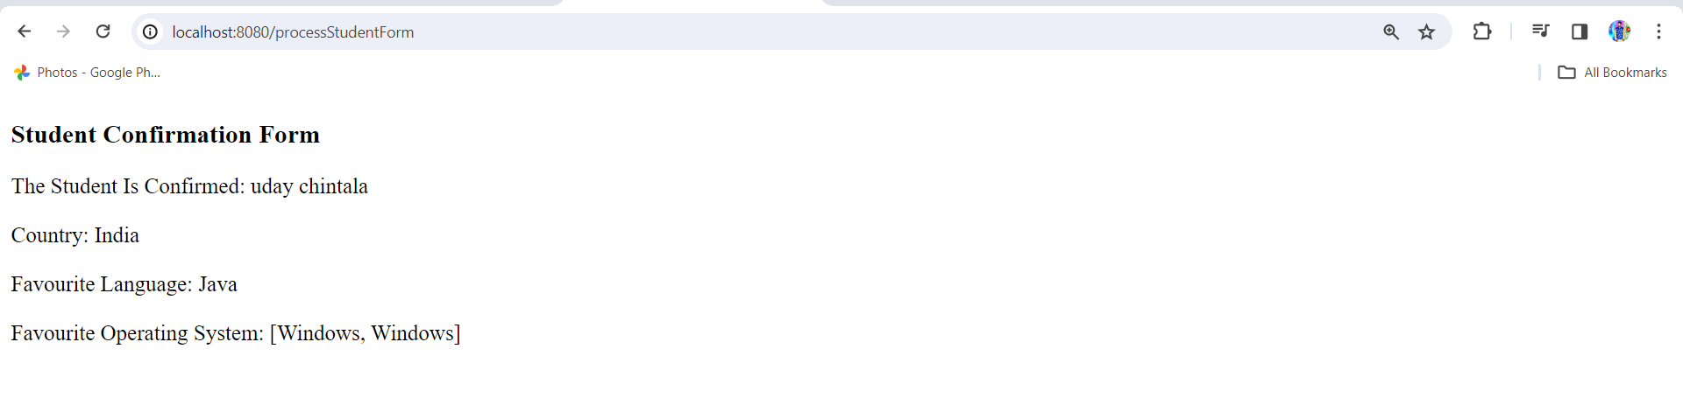

Here operating system coming inside brackets but will print as bullet points for this

student-confirmation.html add following.

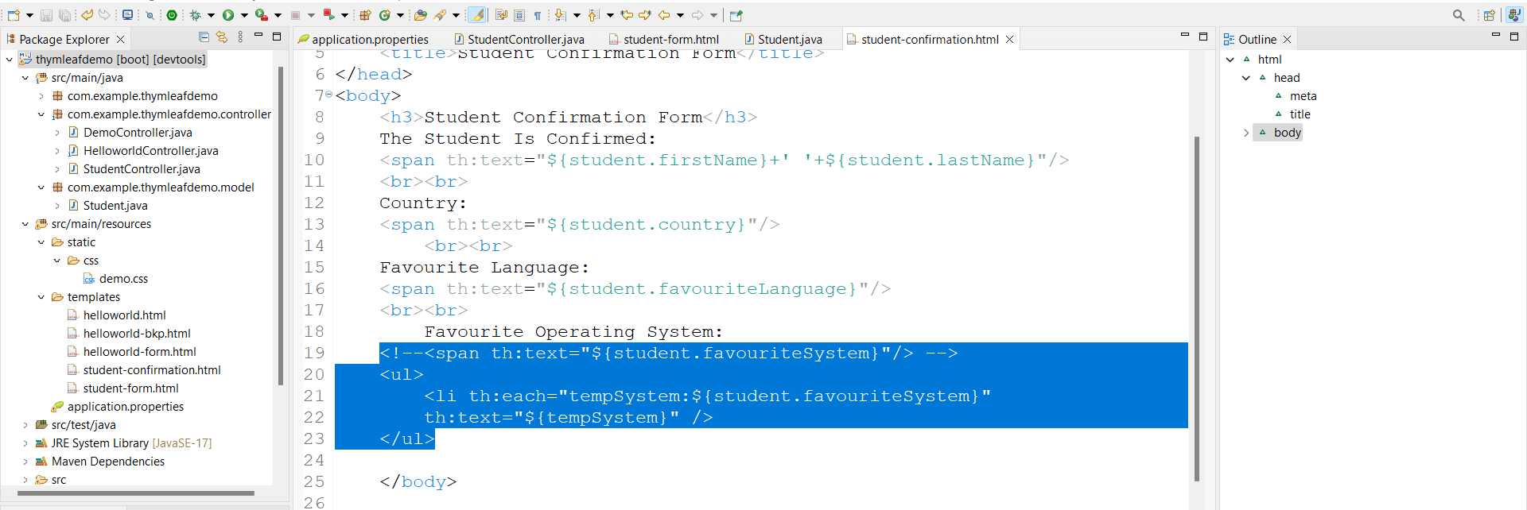

Run appn

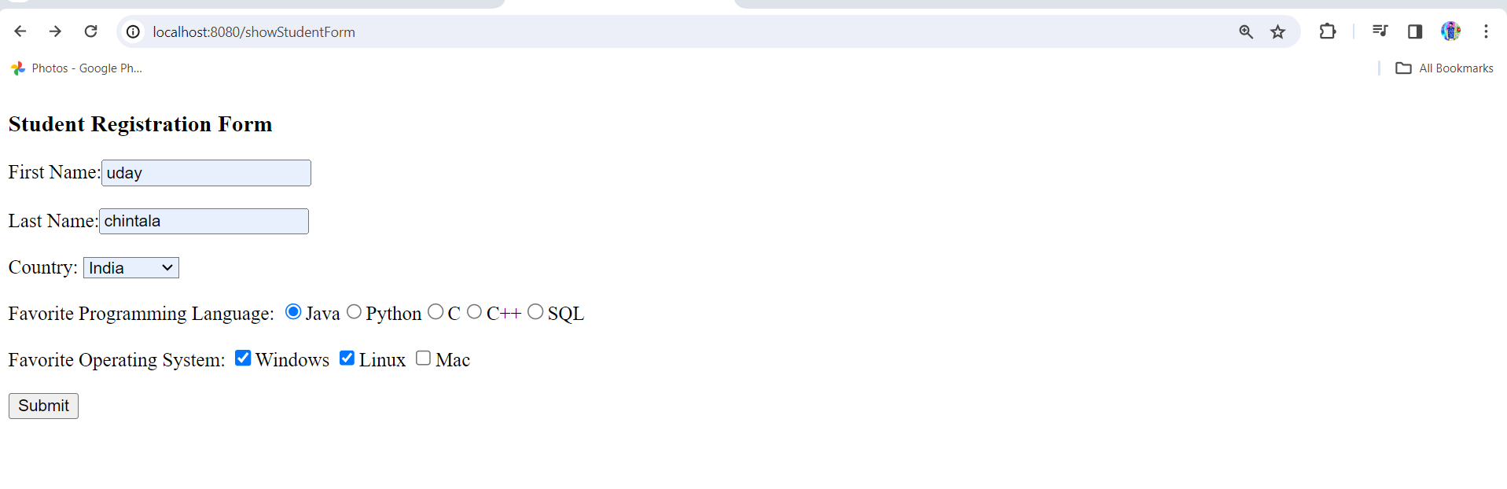 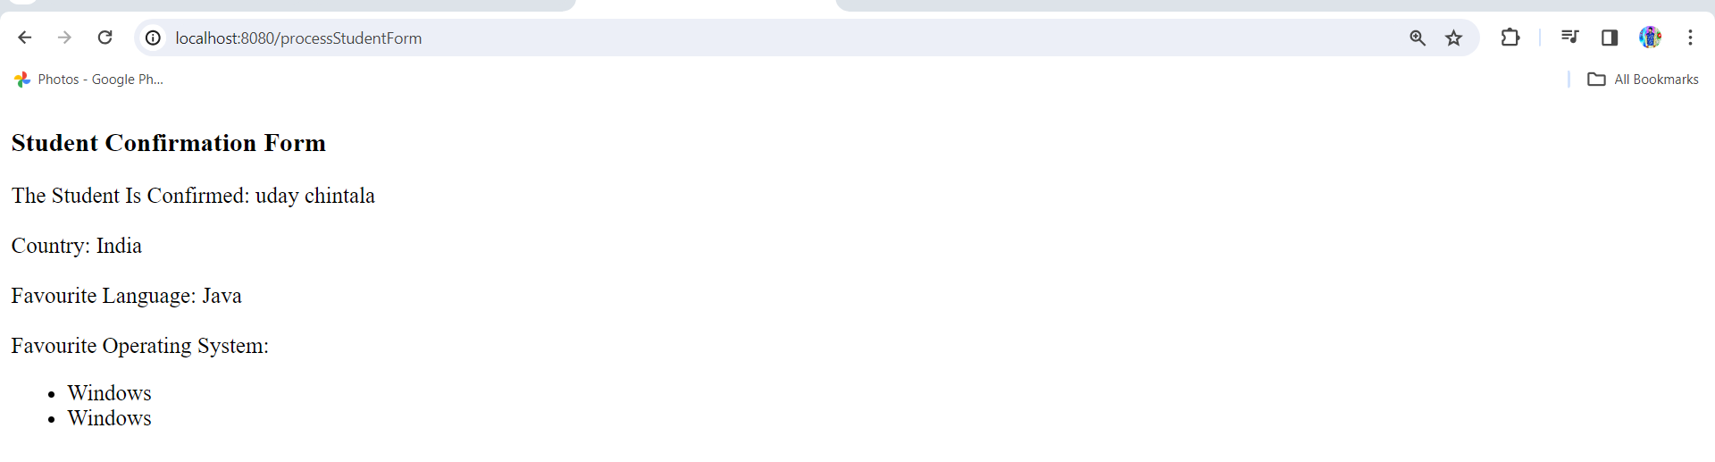

Adding data in appn.prop

1.application.properties

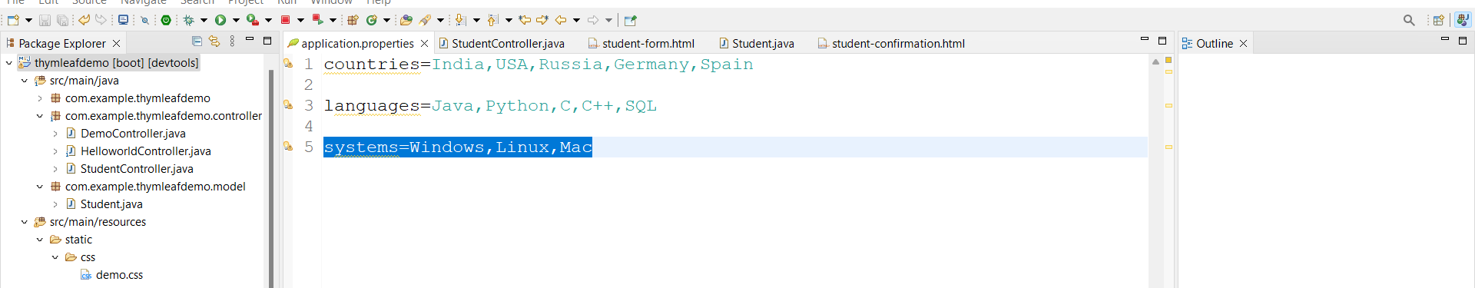

2.StudentController.java

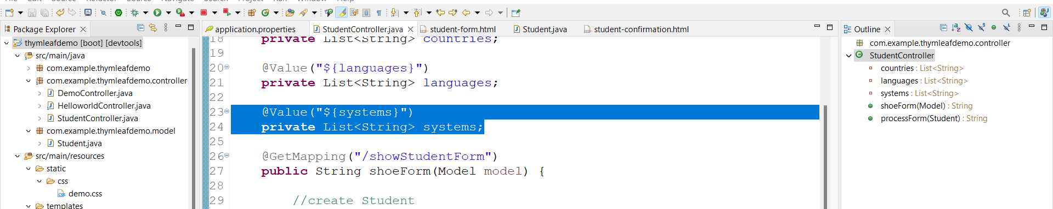

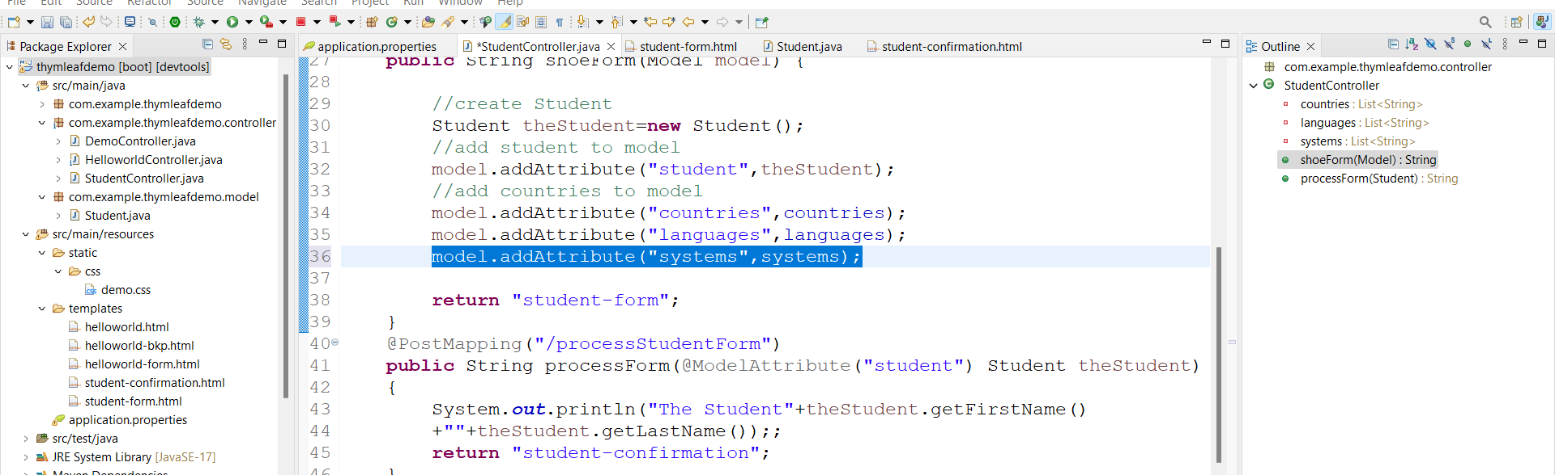

3.student-form.html

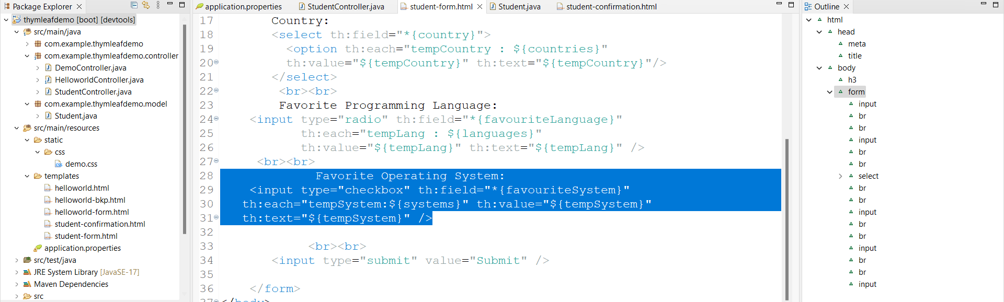

Run appn working fine

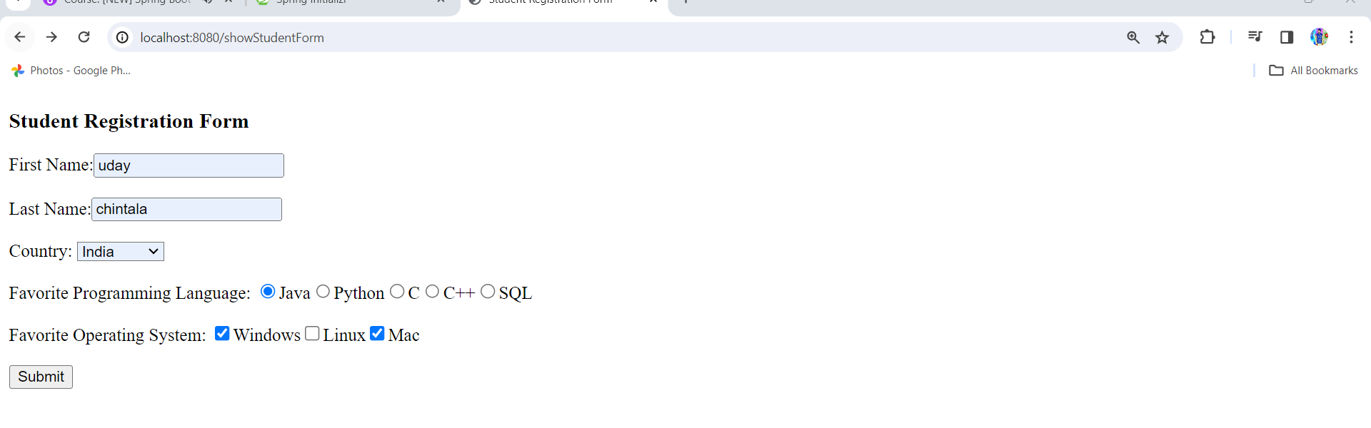

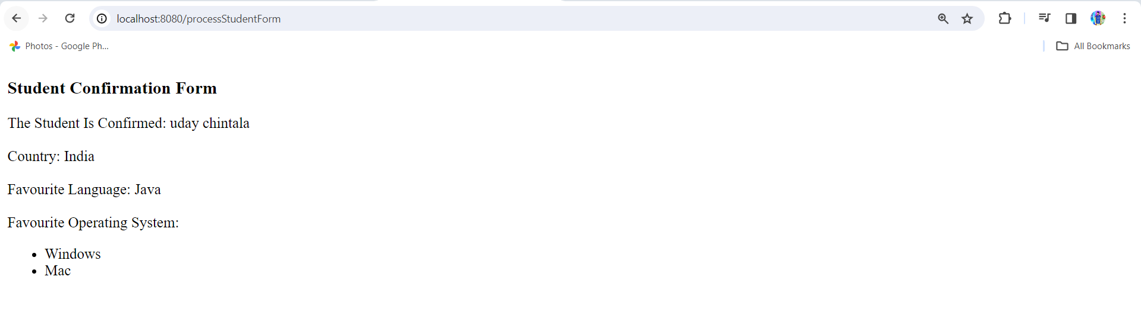

**MVC Validations: -**

**Create new projrct with web,validation,devtools,thymleaf dependencies**

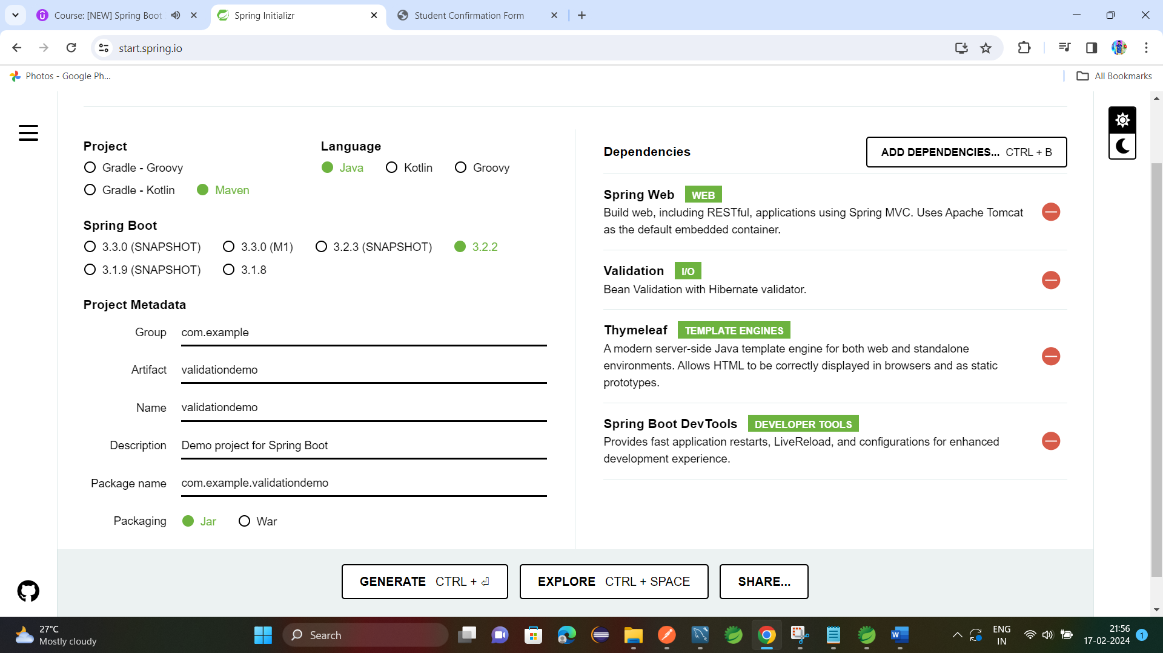

1.Create new class **Customer.java** with fields and getters and setters

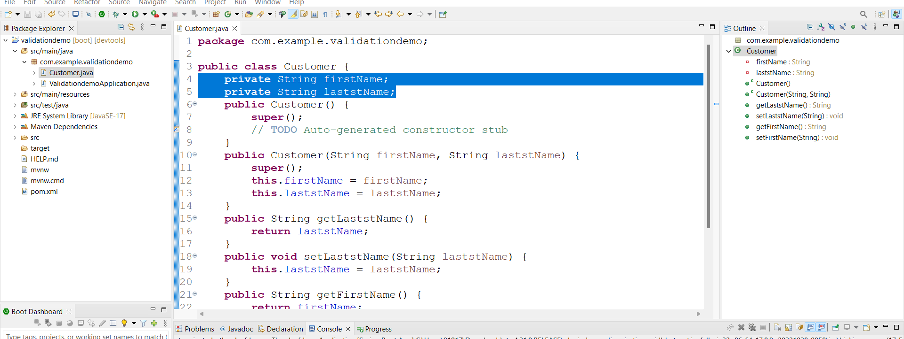

2.adding validation to fields

Here we are going to make lastName to mandatory field as follows

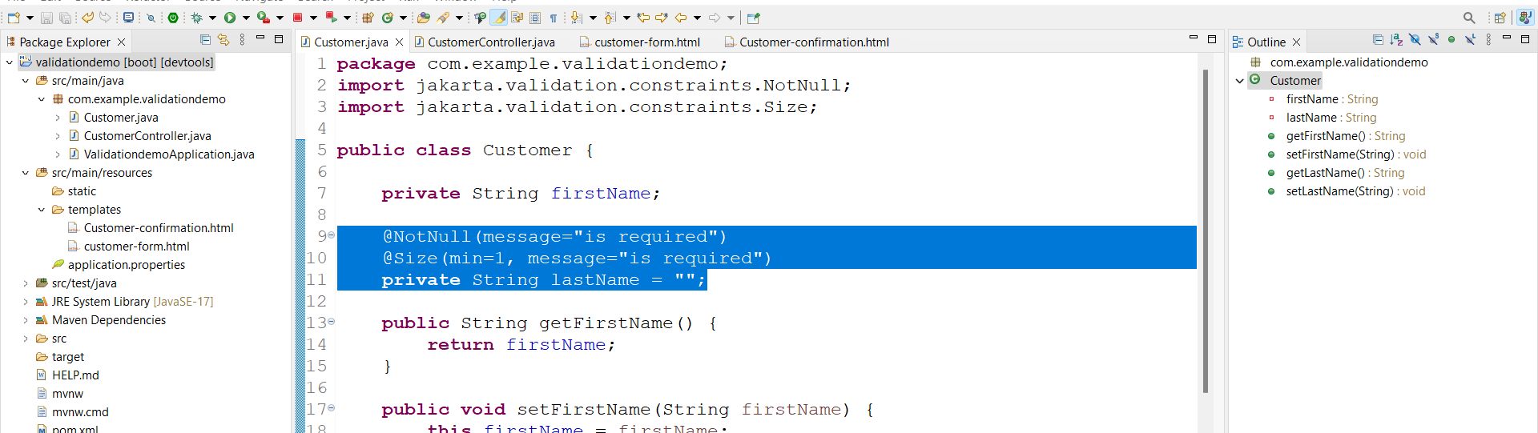

3.adding controller to show html form

Create **CustomerController.java**

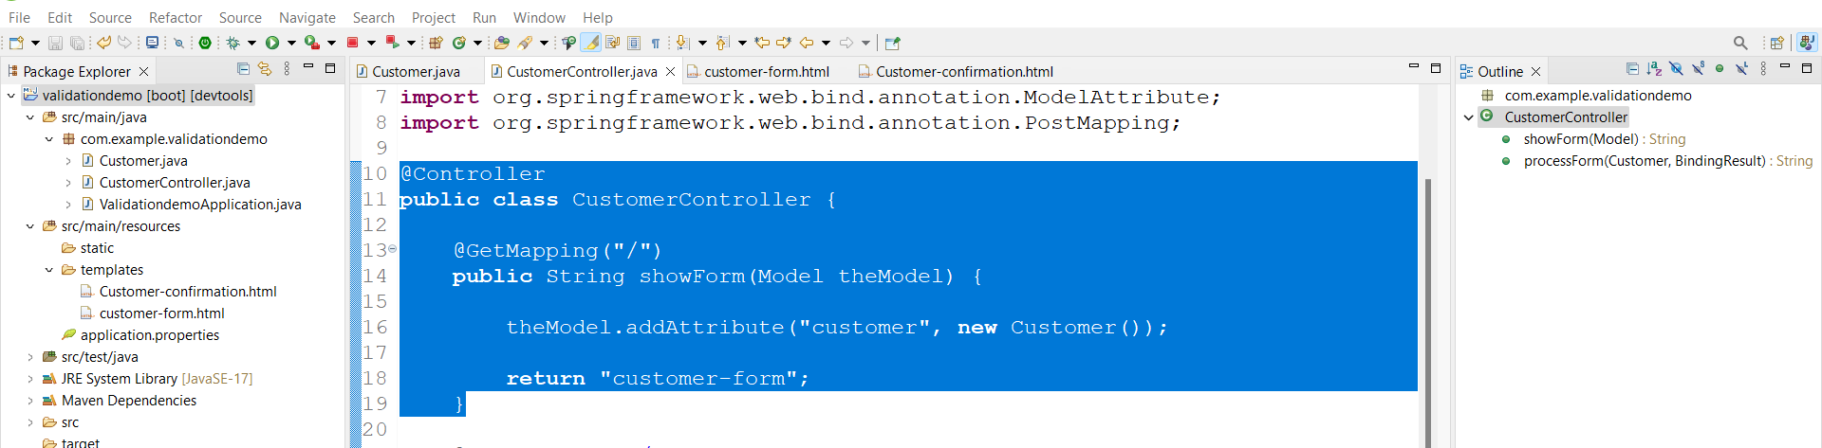

4.developing html form for validation **customer-form.html** under templates

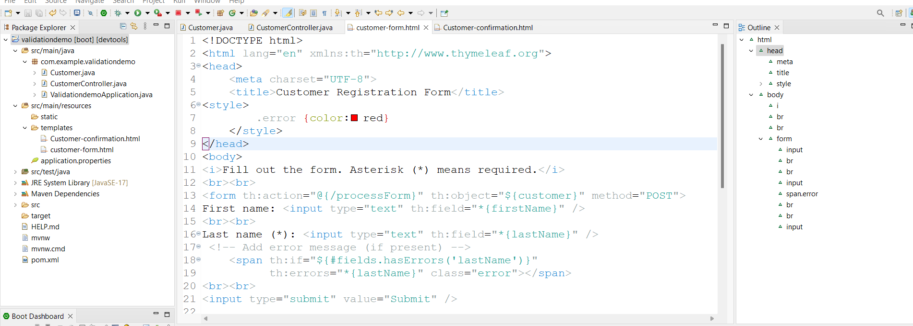

5.perform validation in controller class CustomerController.java

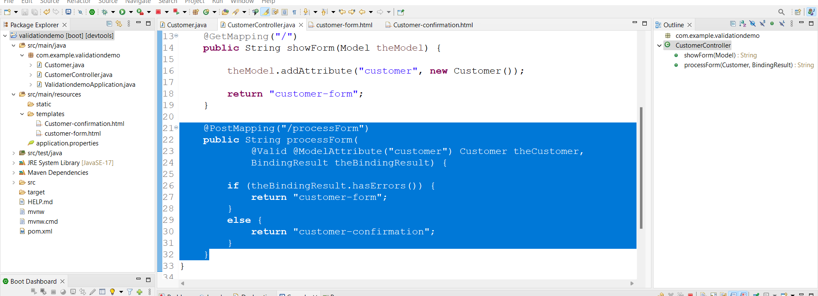

Here @Valid tells do validation and **BindingResult** holds error from html file

6.confirm customer **Customer-confirmation.html** under templates

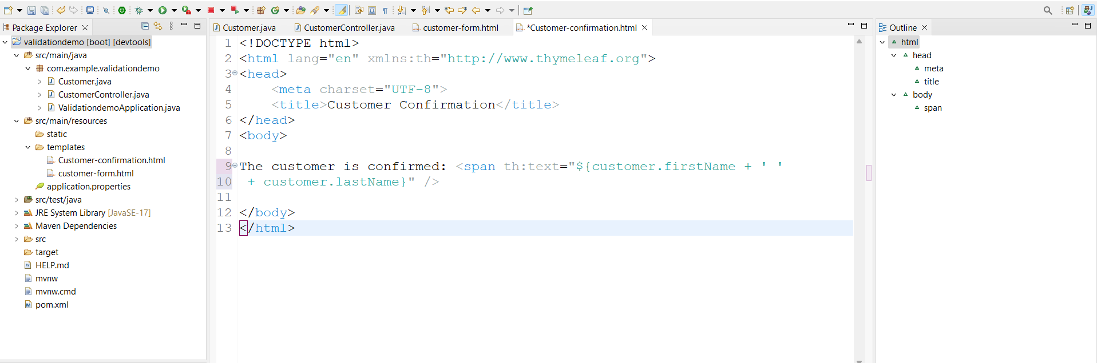

Run appn link:- <http://localhost:8080/>

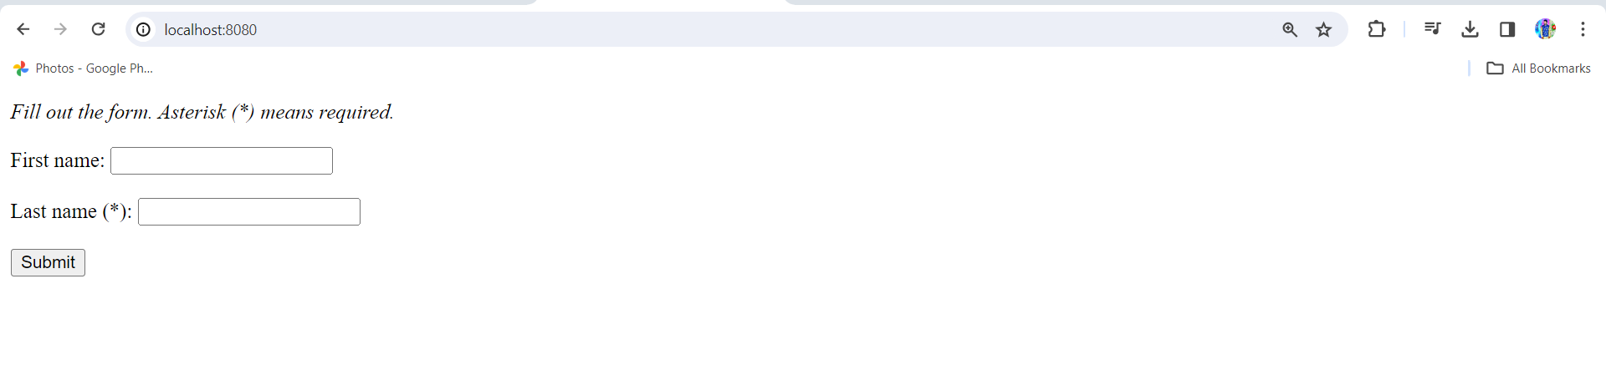

If you don’t give last name and click on submit will get required message

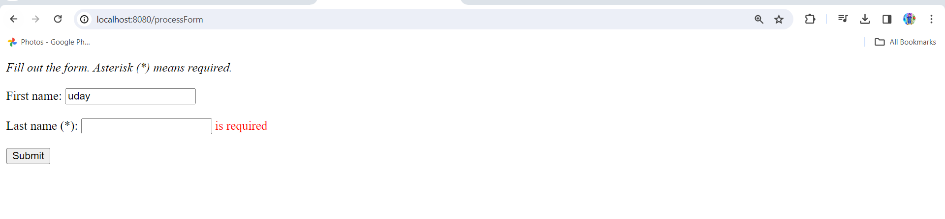

If give correct values it works

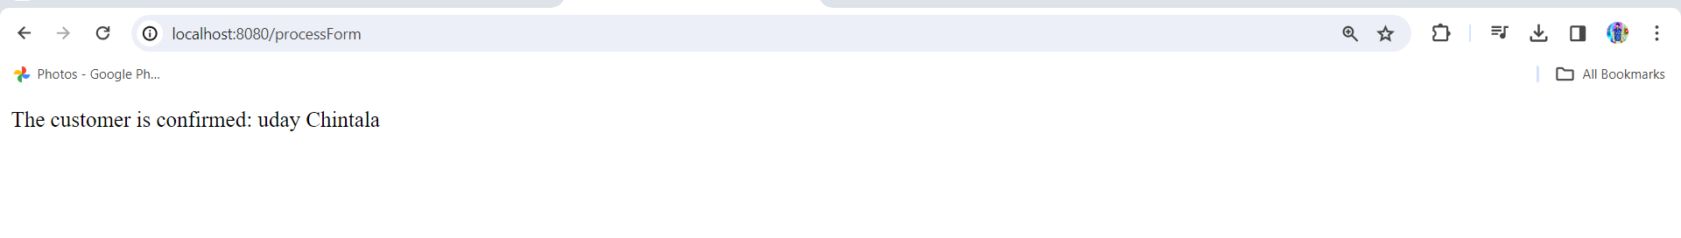

If you give all spaces in last name it will allow you to submit to overcome this will add following coda 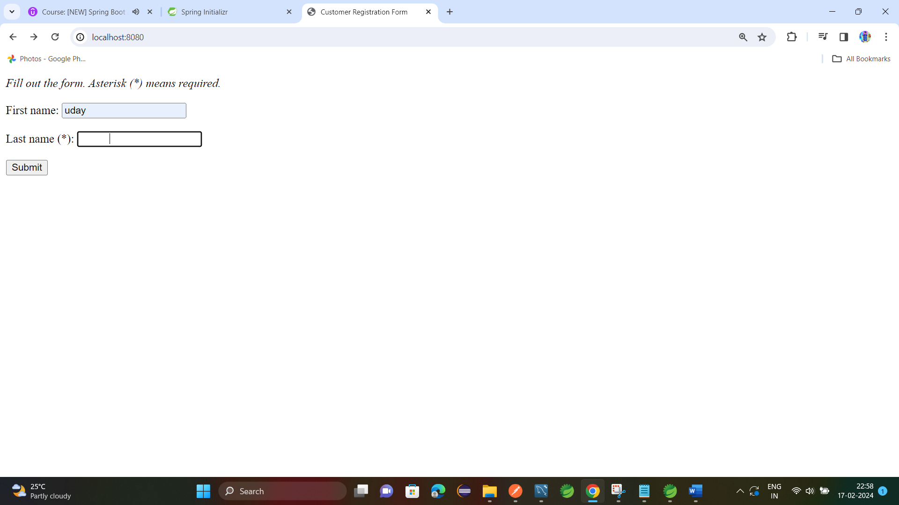 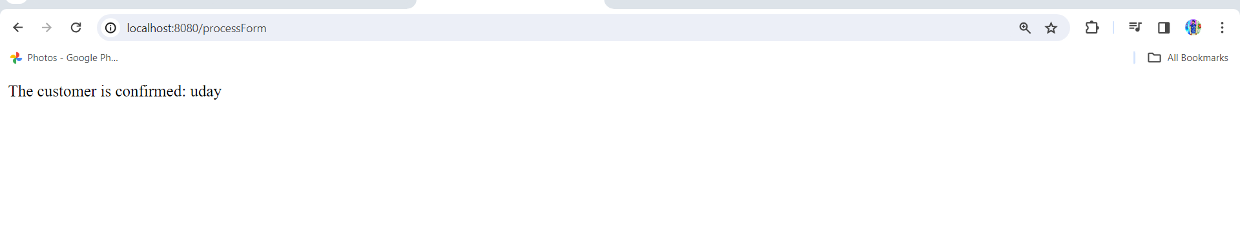

To overcome this issue follow as in **CustomerController.java**

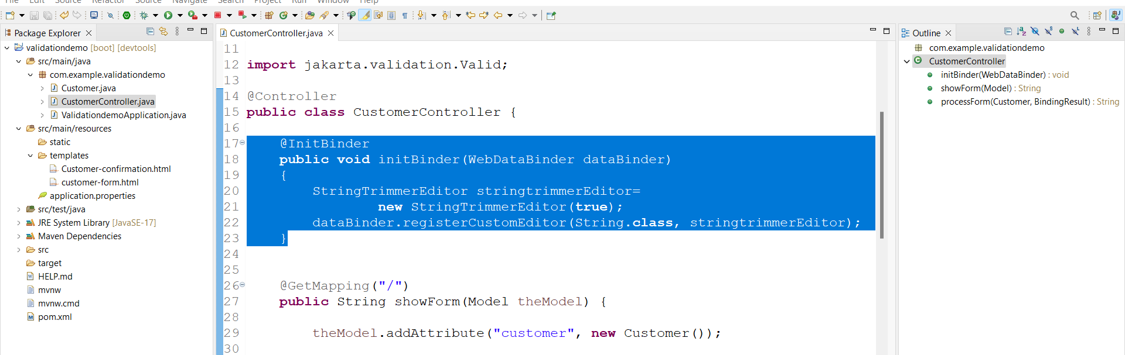

This code not allows empty spaces

Validation Number Range:-

1.add new field freePasses to **Customer.java** and generate getter and setter

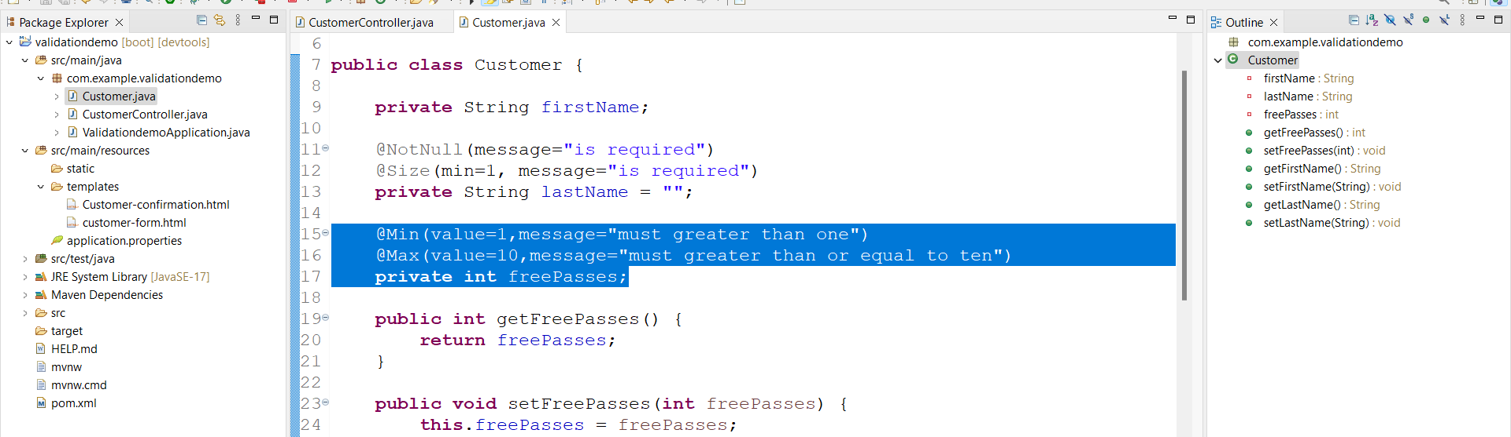

2.add field to **customer-form.html**

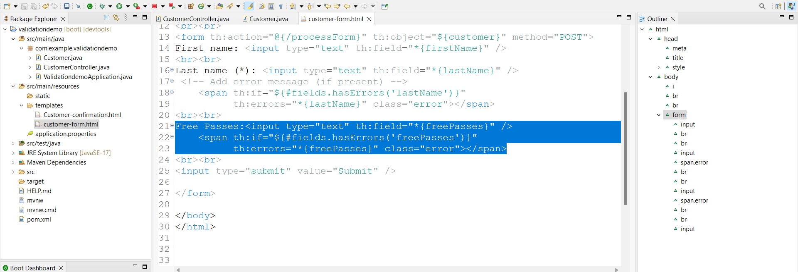

3.perform validation in controller

No deed to change code keep it as it is

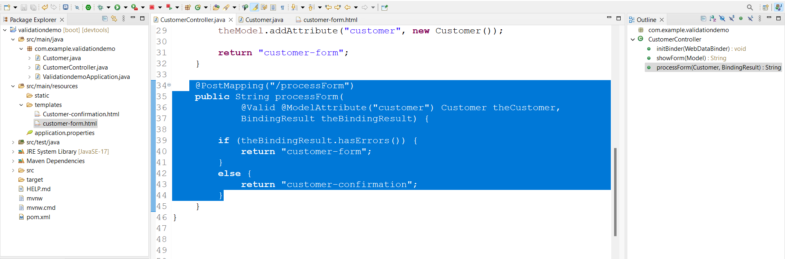

4.customer-confirmation.html

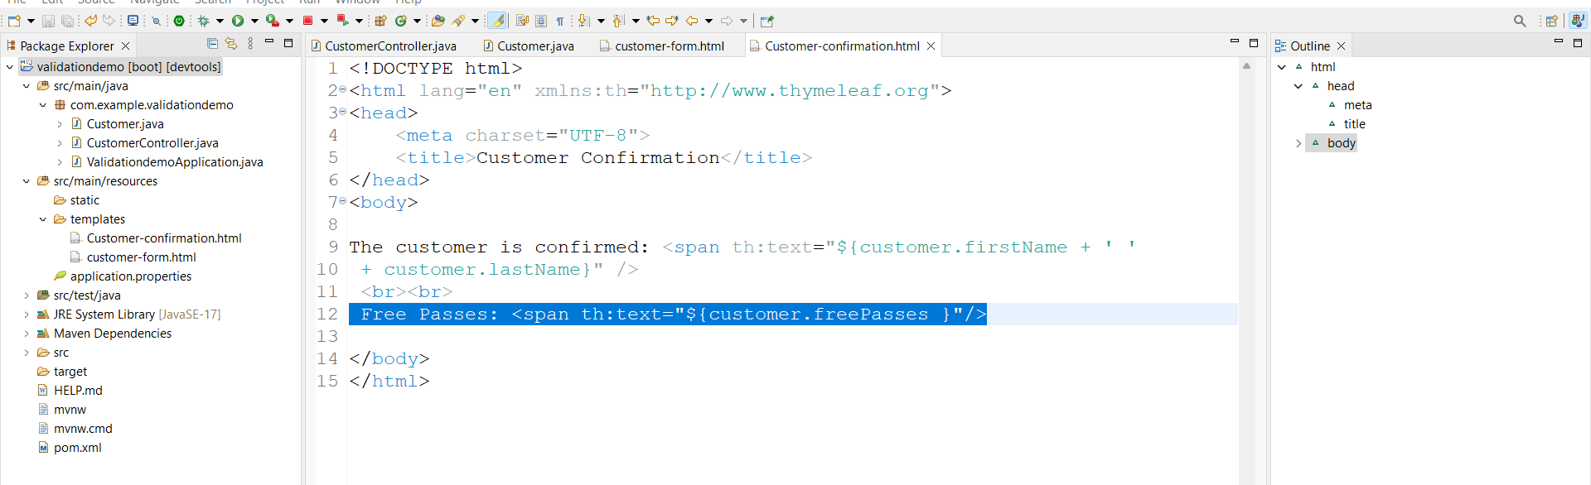

Run appn

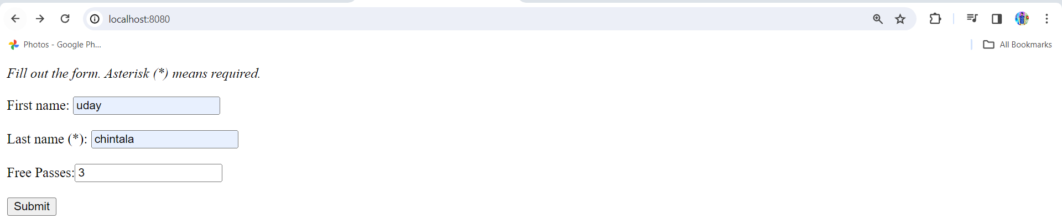

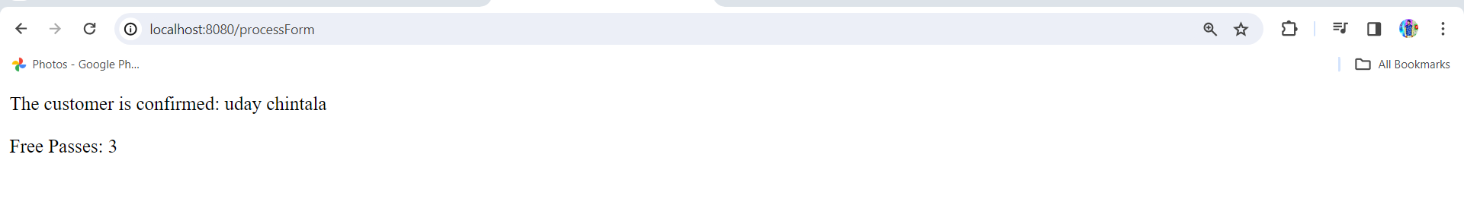

MVC Regular Expressions:-

1.Customer.java add postalCode field and setters and getteres

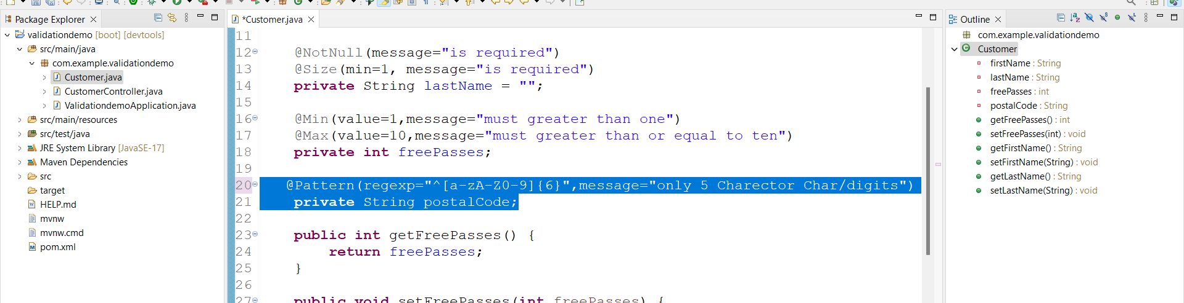

2.customer-form.html

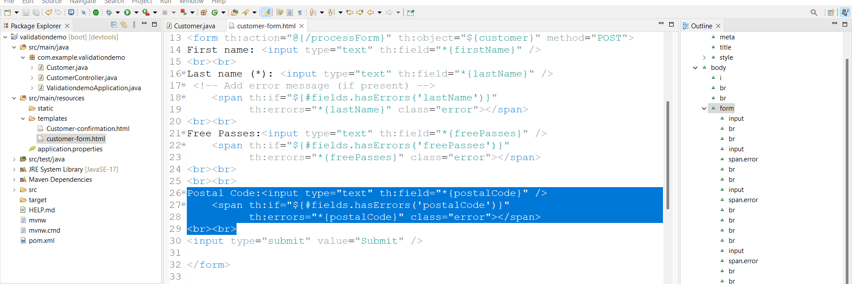

3.customer-confirmation.html

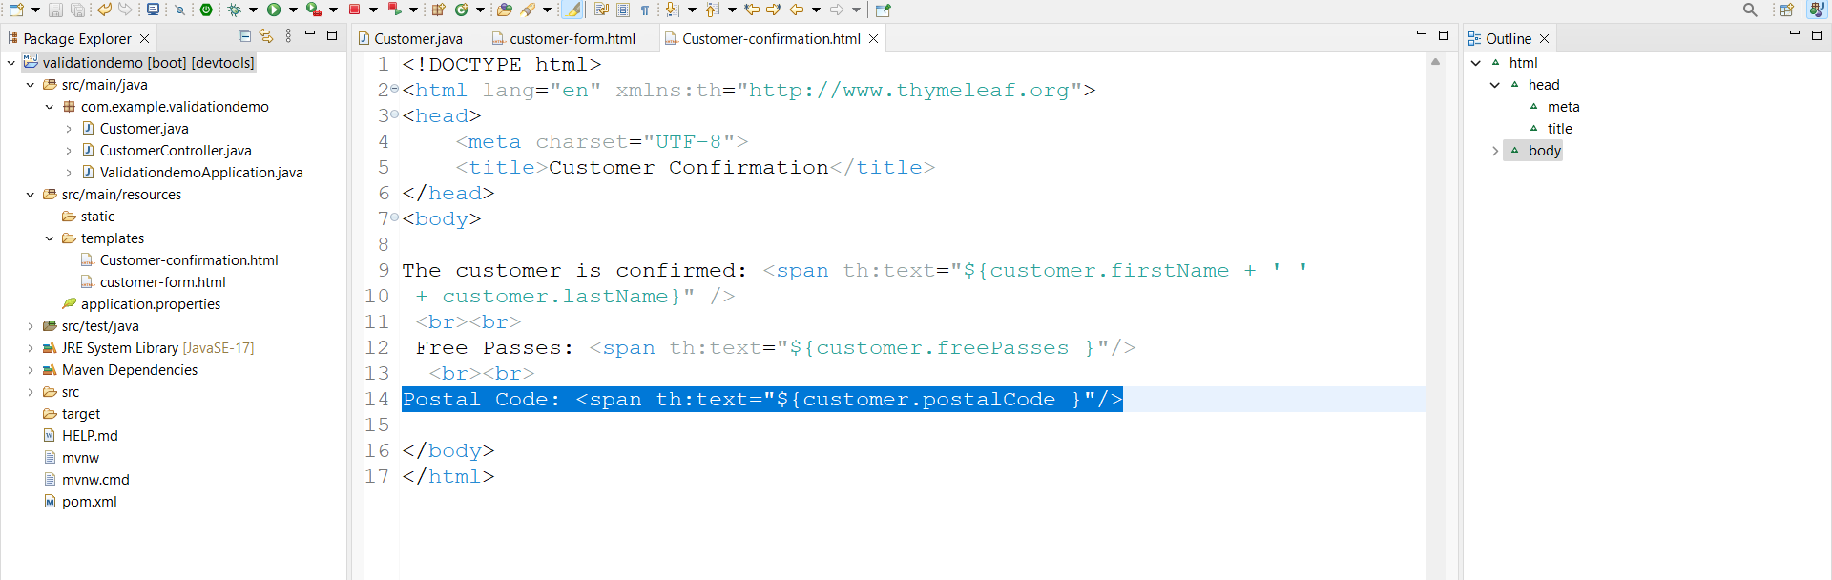

Run appn link:- <http://localhost:8080/>

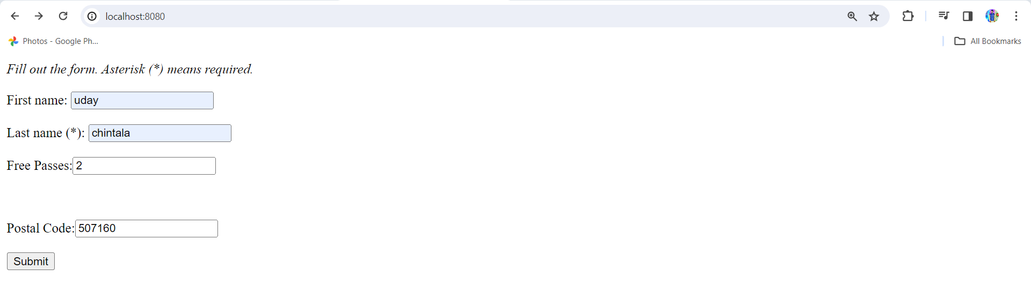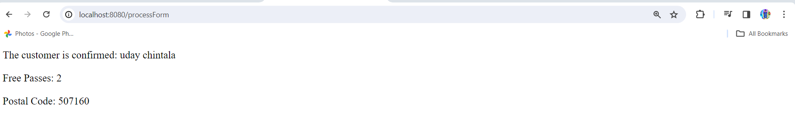

In our appn freePasses is declared as int type if we declared this field with @NOtNUll then it will give you big message as follows

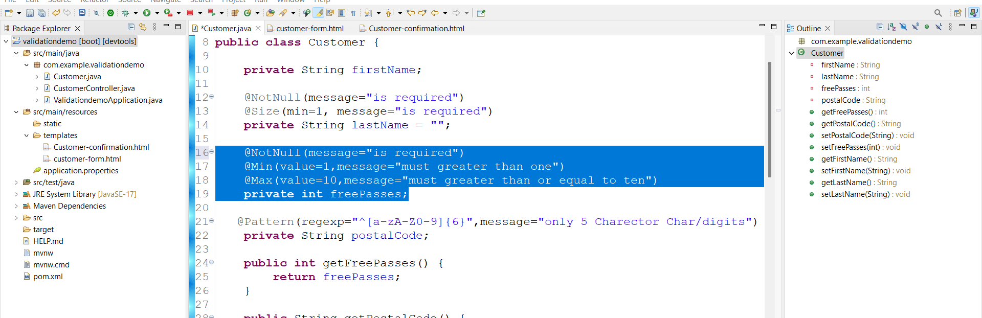

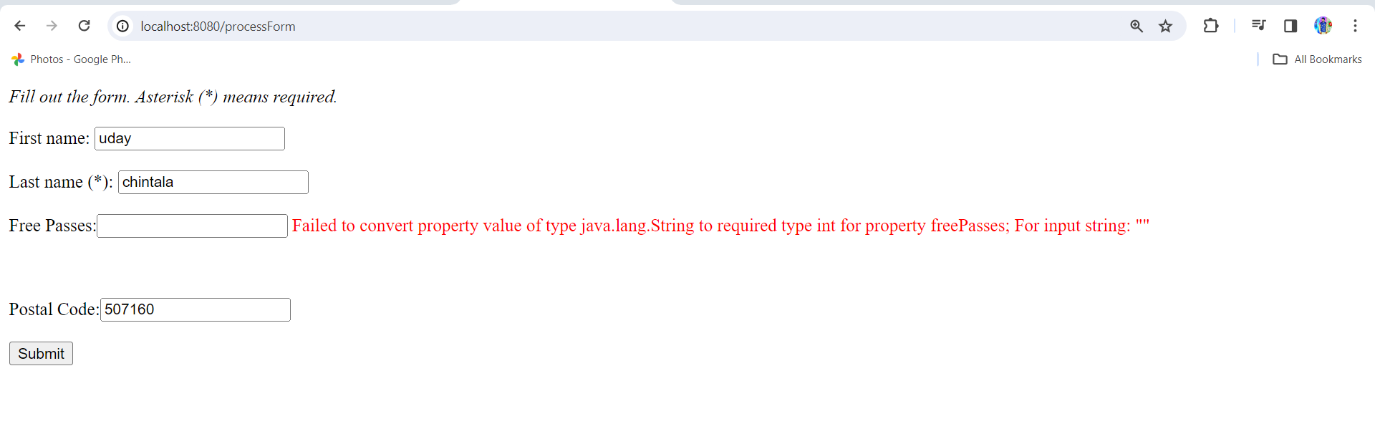

To overcome this field type will convert to int to Integer then it works fine

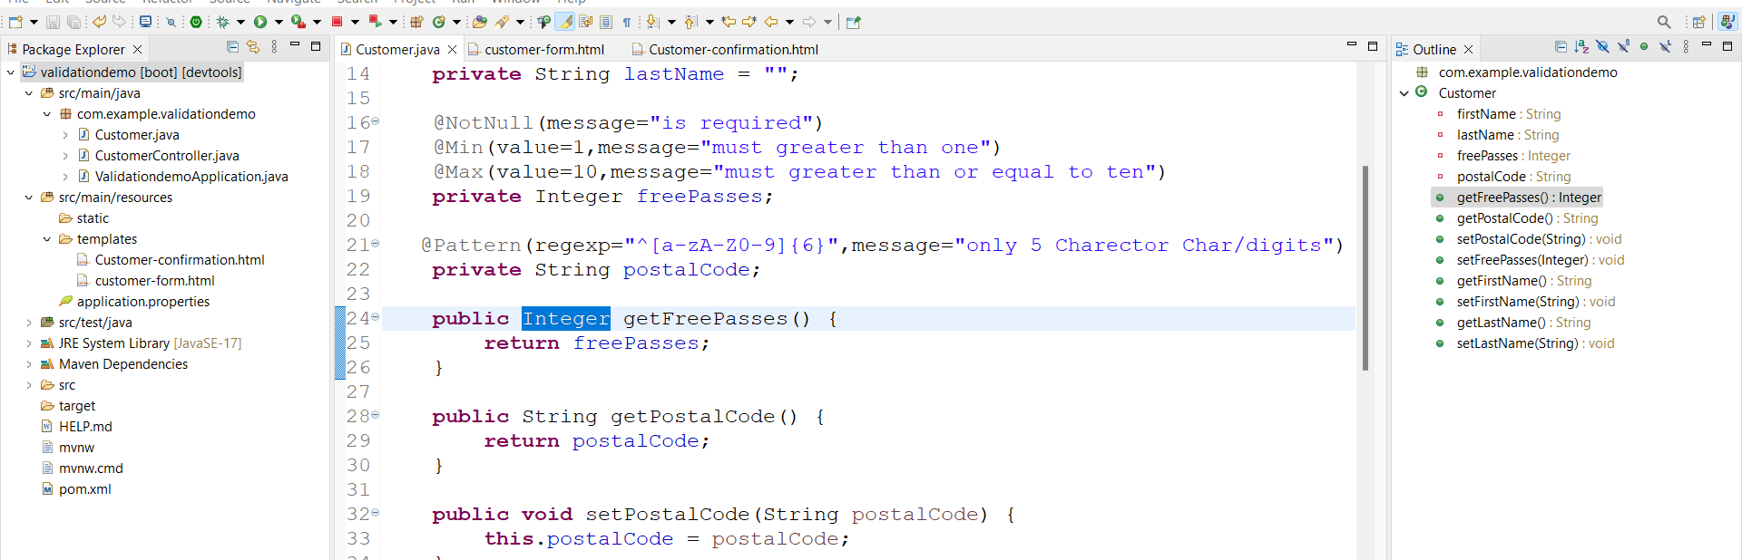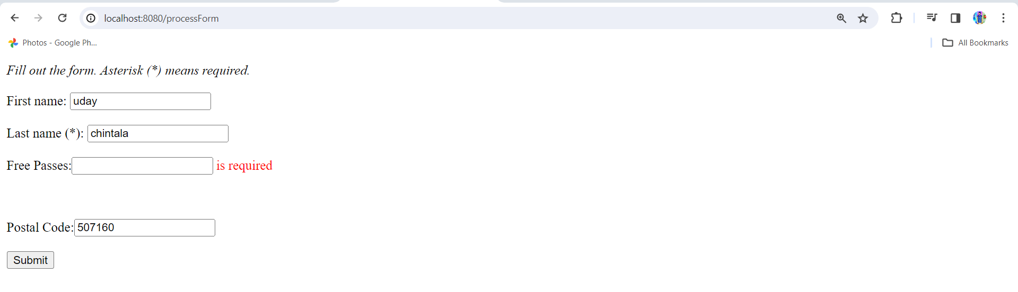

Custom Error Message:-

If we give char value to freePasses it gives you a long error message to overcome this follow as

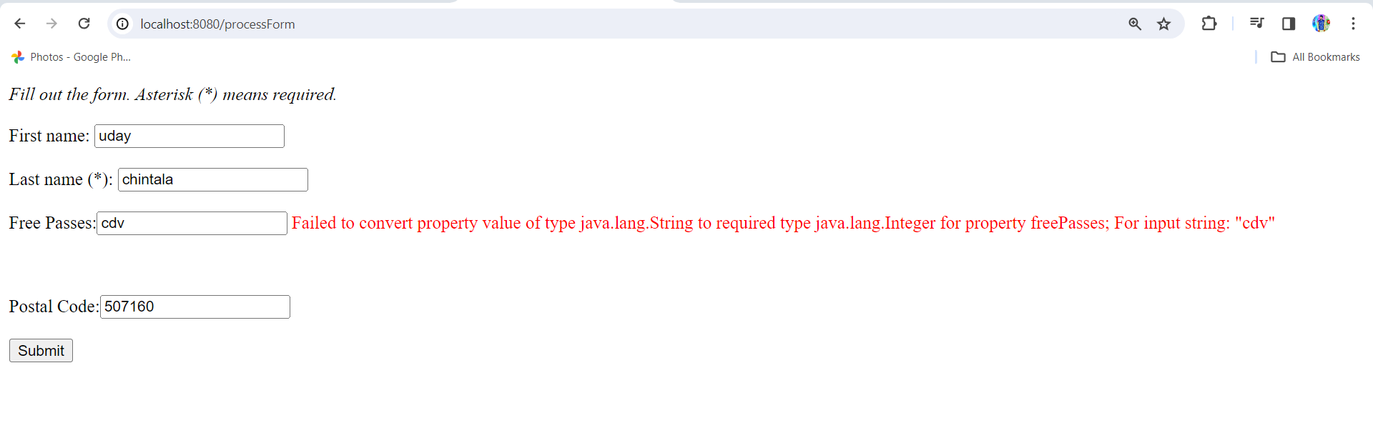

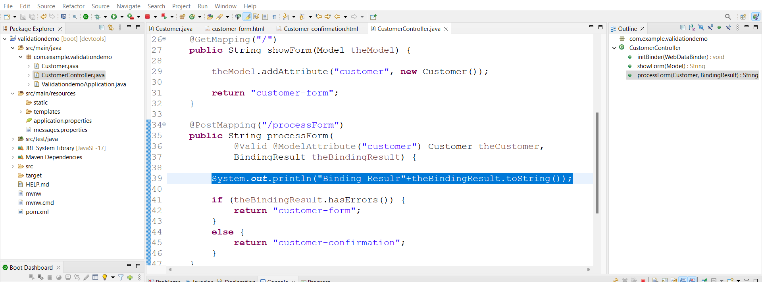

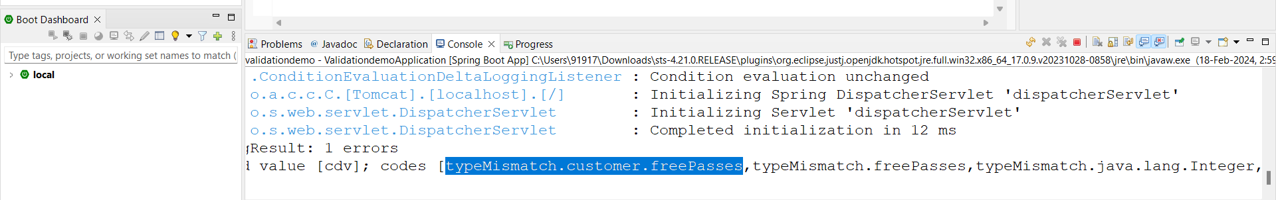

1.create message.properties under resources and add highlighted message to avoid long error message

This line will give you typeof error

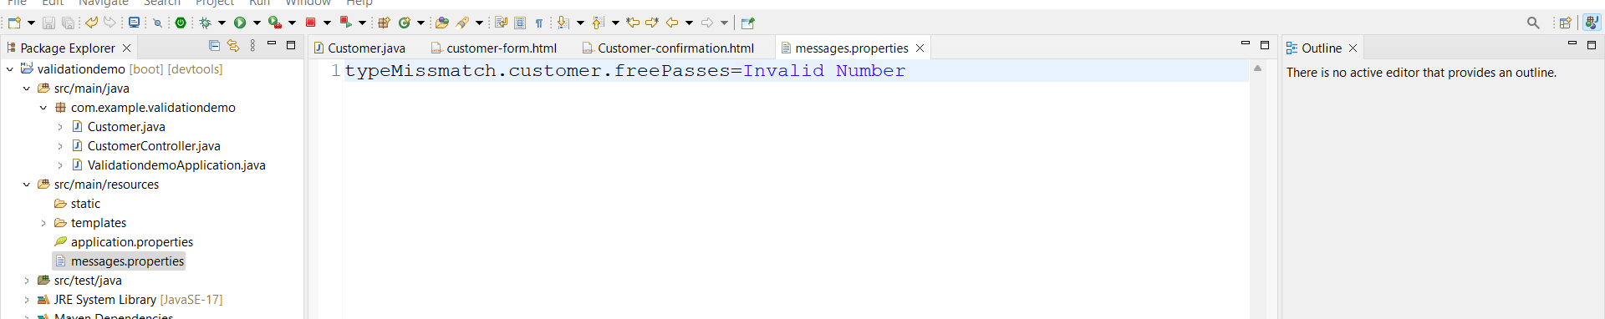

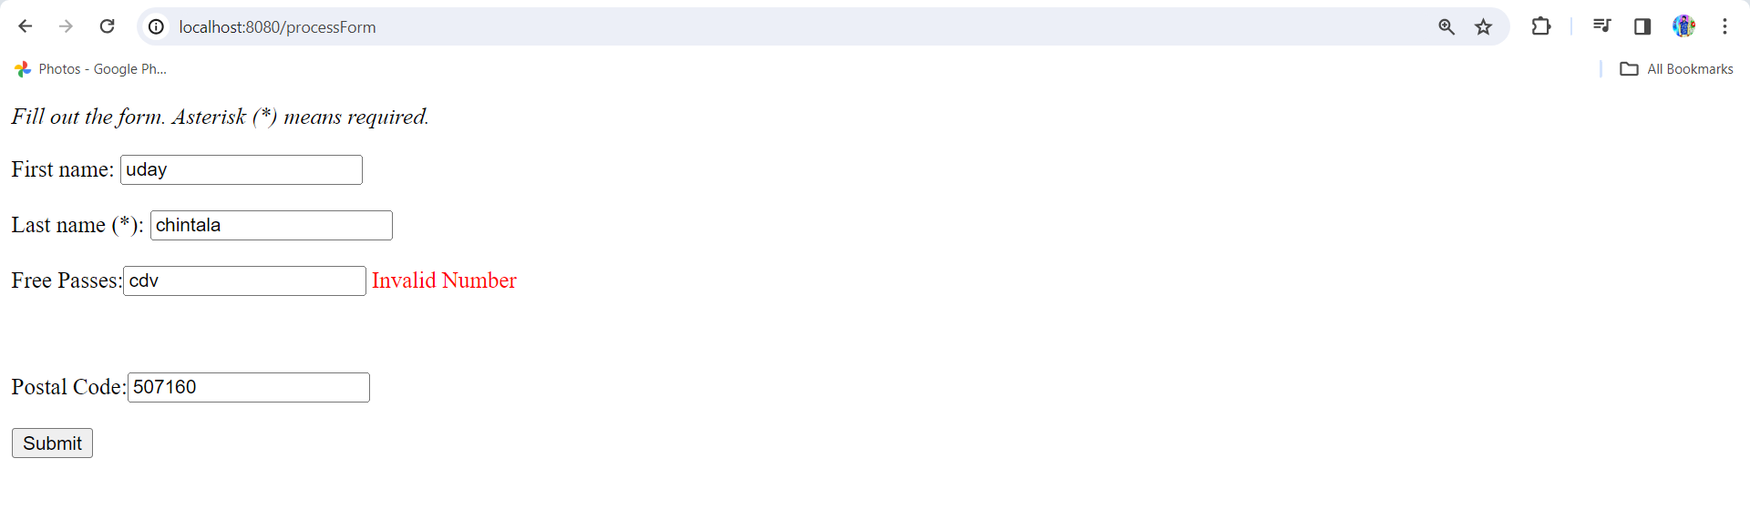

Custom Annotations:-

Requirement is course code is strat with Luv

1.create @CourseCode Annotation

Create package validation and create CourseCode annotation under this folder

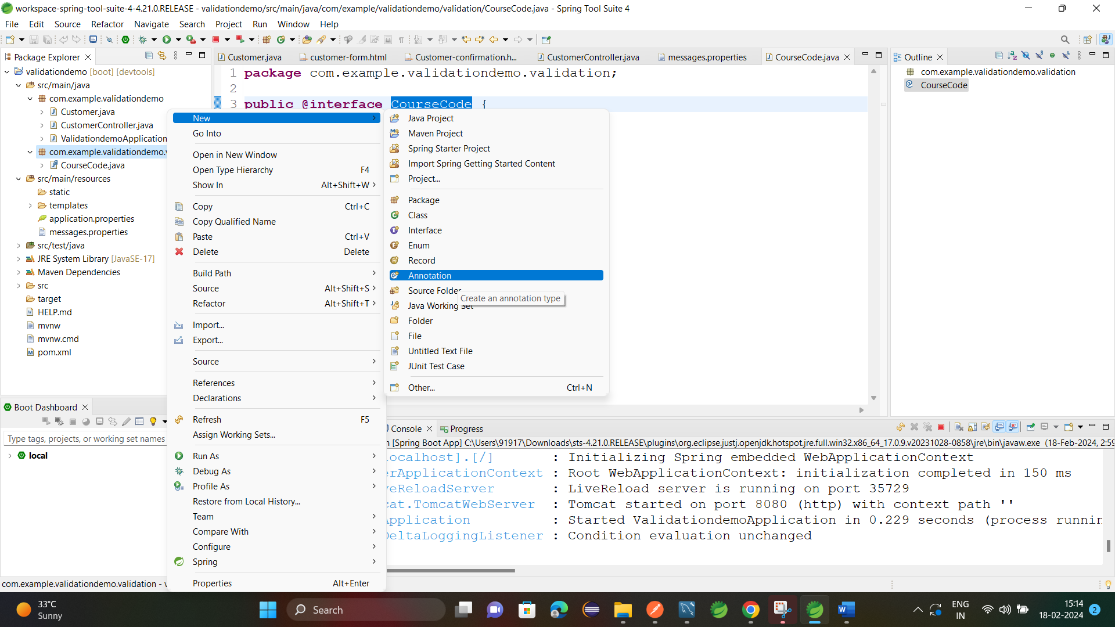

And create new class CourseCodeConstraintValidator.java under validation package

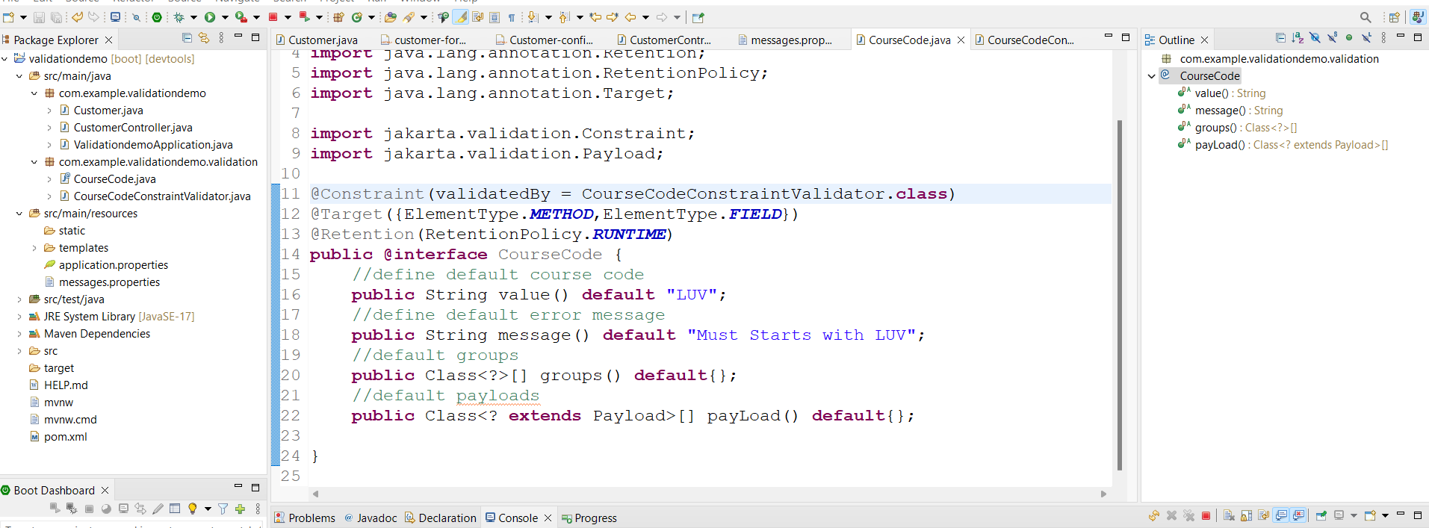

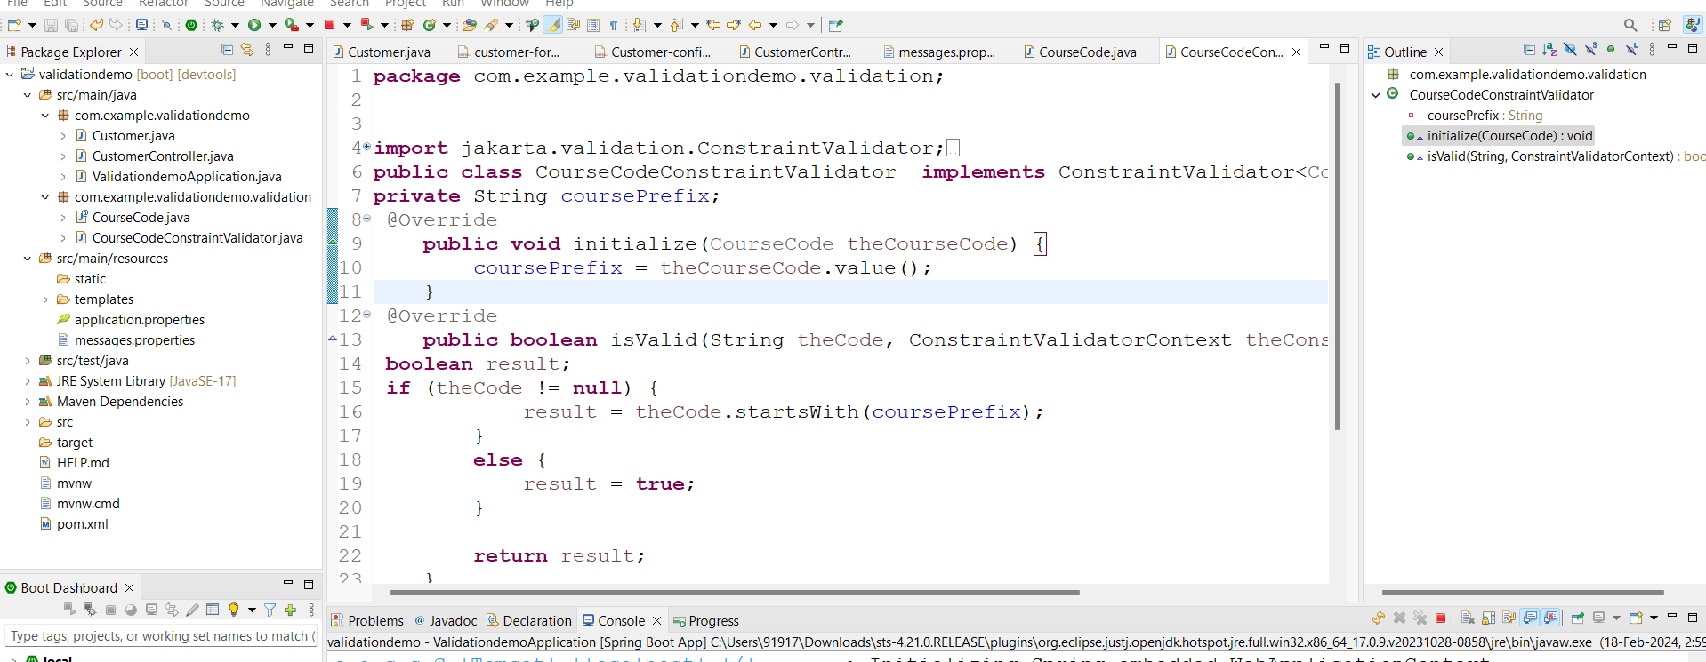

2.create field in Customer.java and add @CourseCode

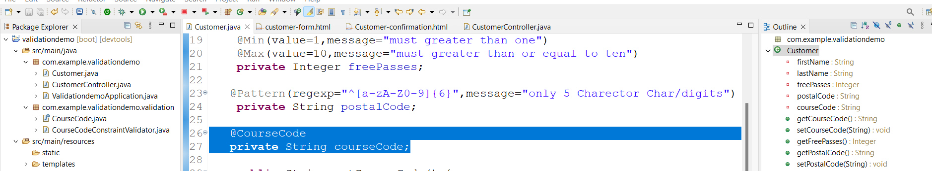

3.customer-form.html

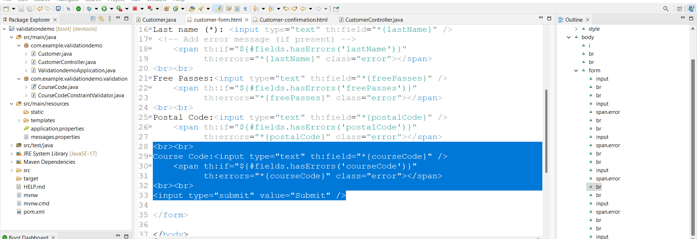

3.customer-confirmation.html

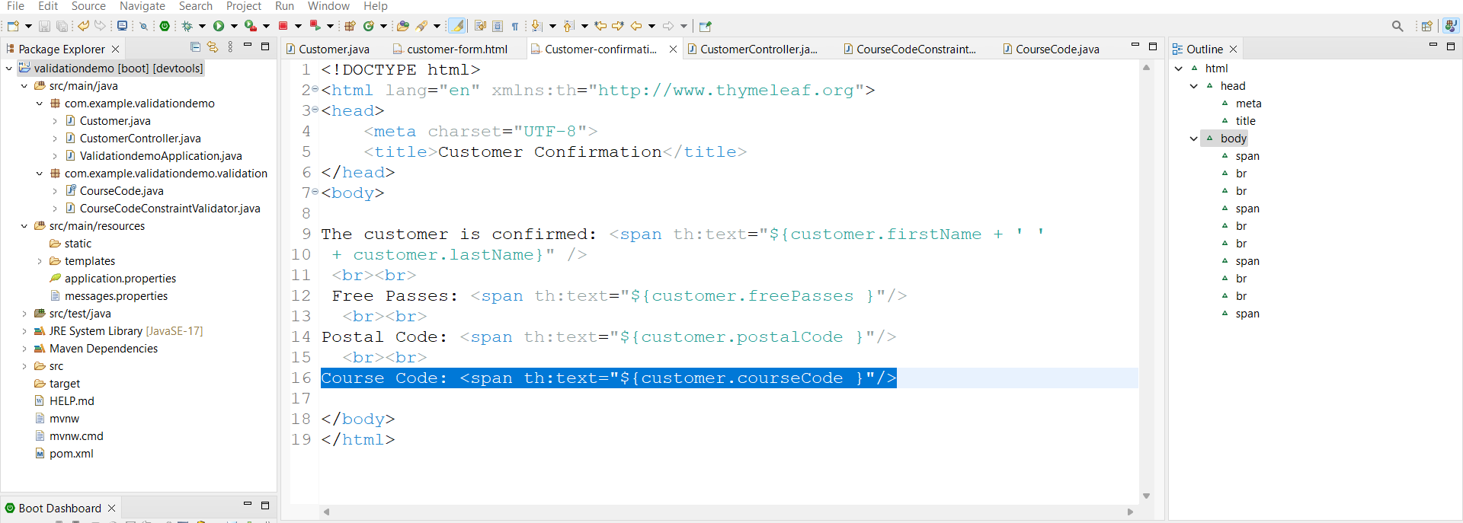

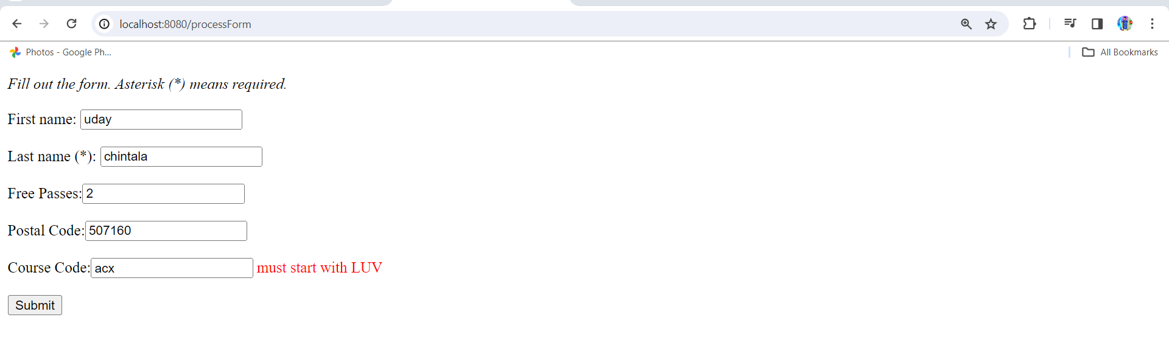

Now course code default start is LUV will change that to our wish as follows

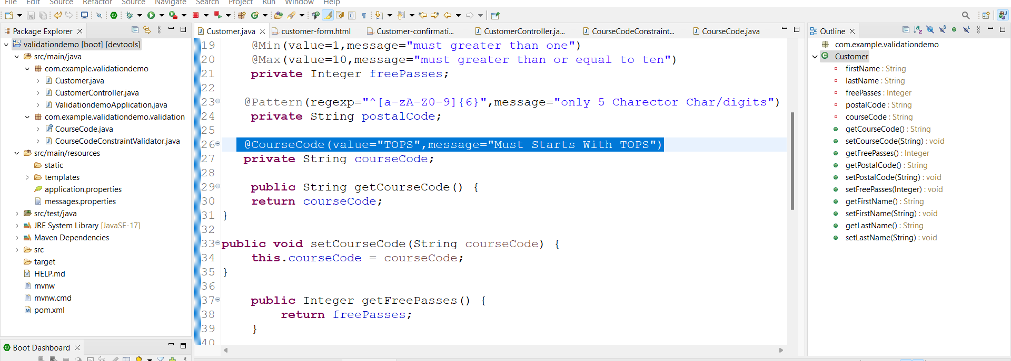 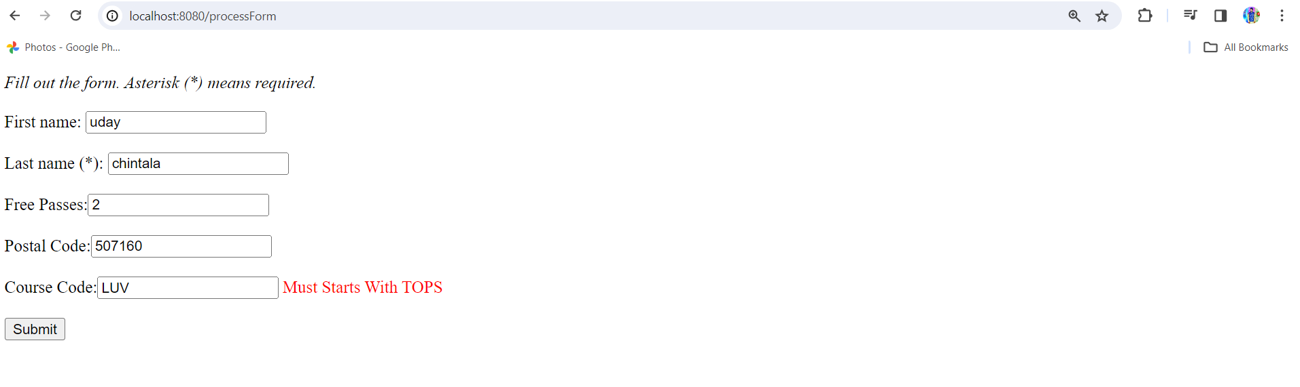

**Topic- 7. MVC CRUD :-**

Download project video and run **link:-** [**http://localhost:8080/api/employees**](http://localhost:8080/api/employees)

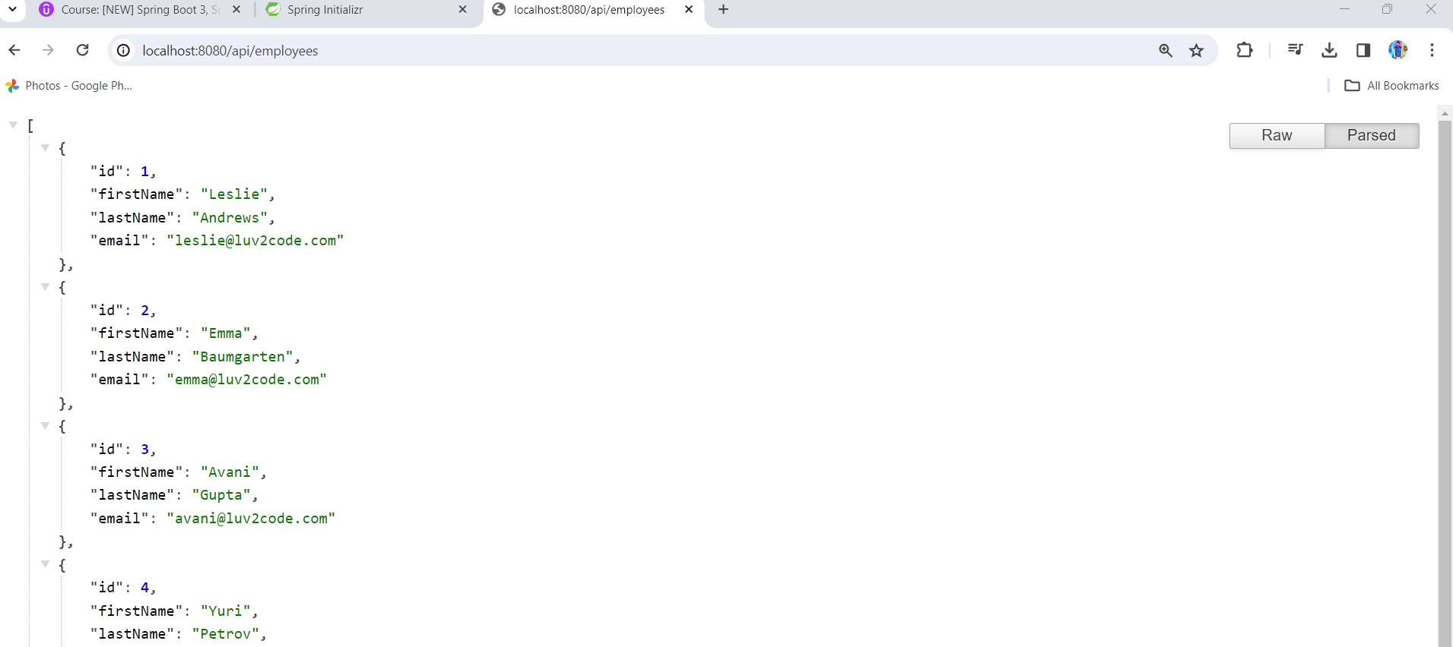

Remove package rest and create new package controller and create new class **EmployeeController.java** under Controller

1. **EmployeeController.java**

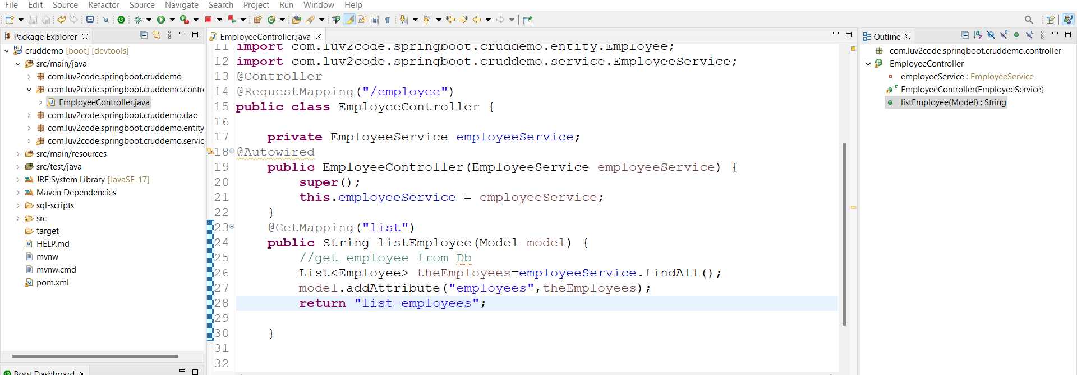

2. create list-employee.html under templates

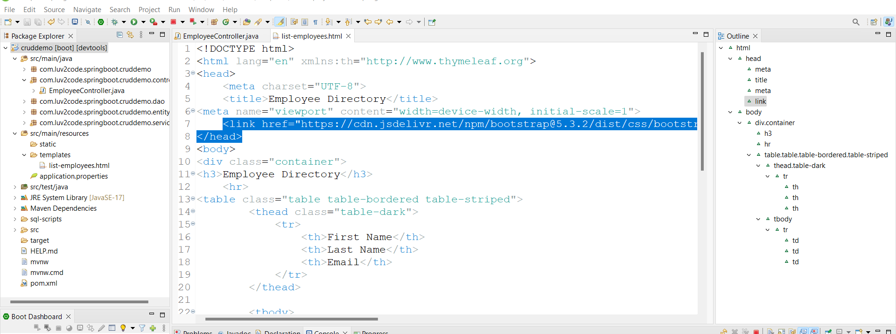

Highlighted is boot strap

Boot Strap code:

<link href="https://cdn.jsdelivr.net/npm/bootstrap@5.3.2/dist/css/bootstrap.min.css" rel="stylesheet" integrity="sha384-T3c6CoIi6uLrA9TneNEoa7RxnatzjcDSCmG1MXxSR1GAsXEV/Dwwykc2MPK8M2HN" crossorigin="anonymous">

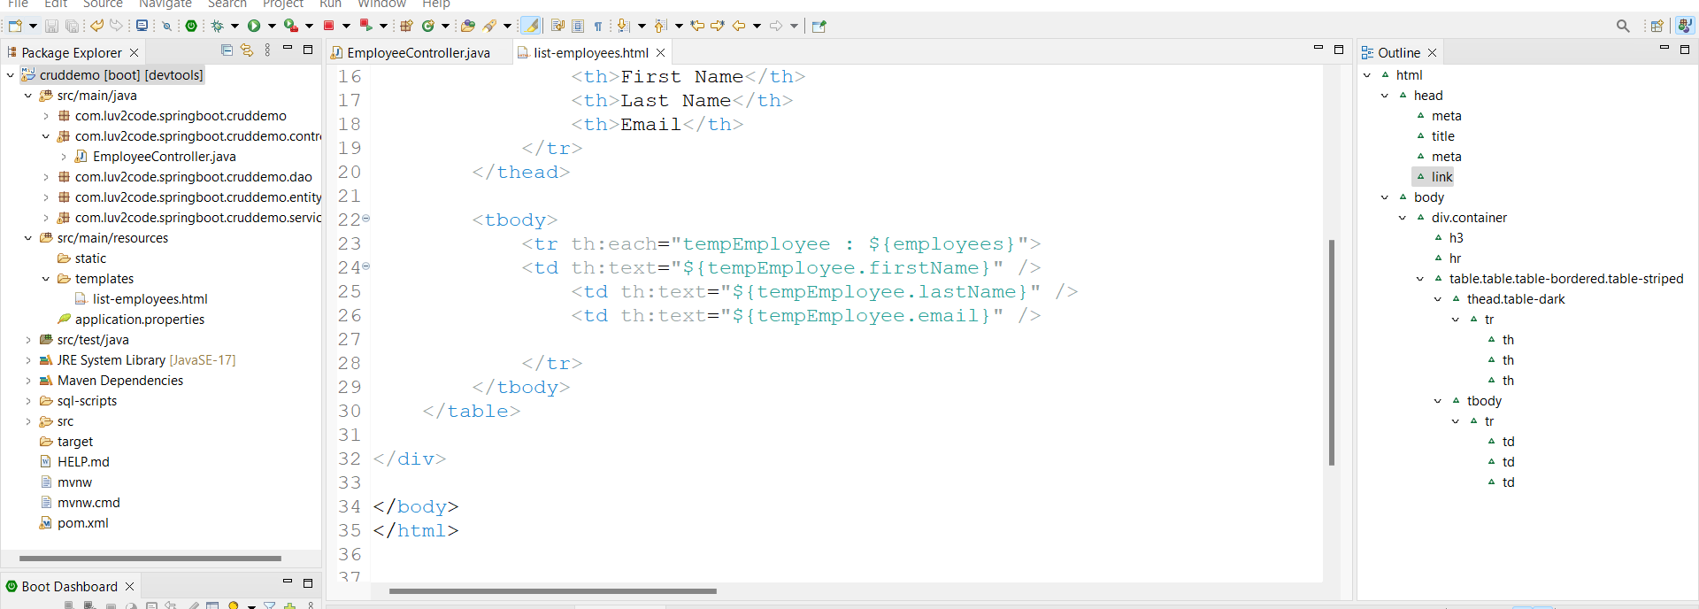

Run appn Link:- <http://localhost:8080/employee/list>

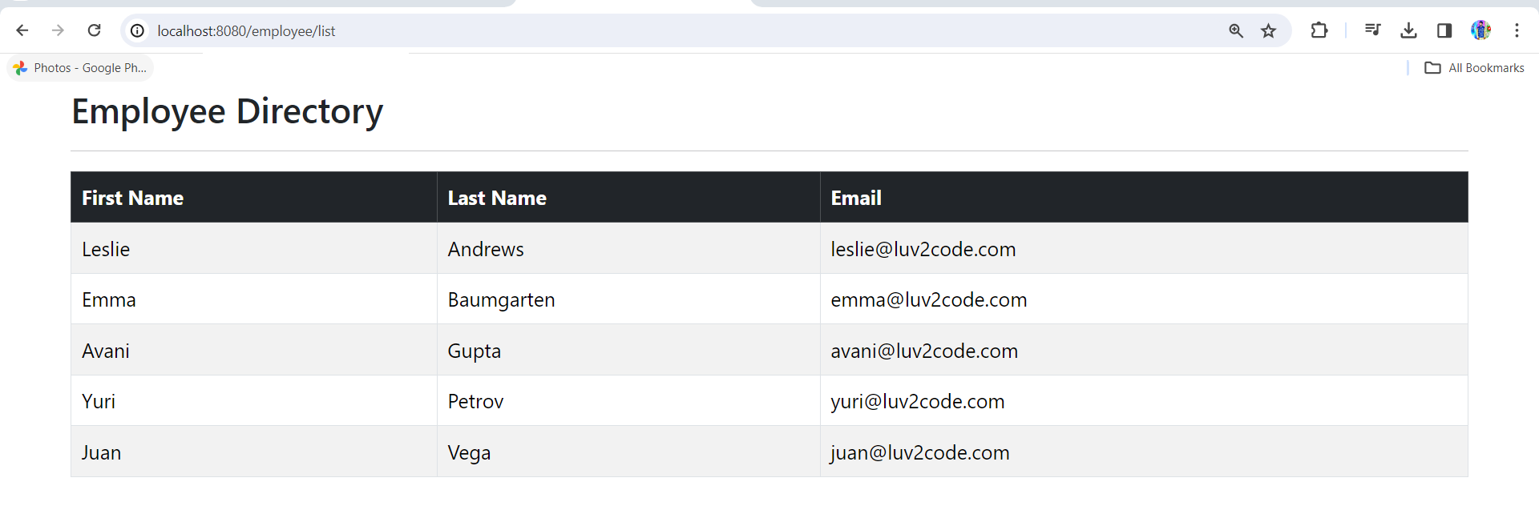

If we giving wrong url will get error so to avoid this follow as

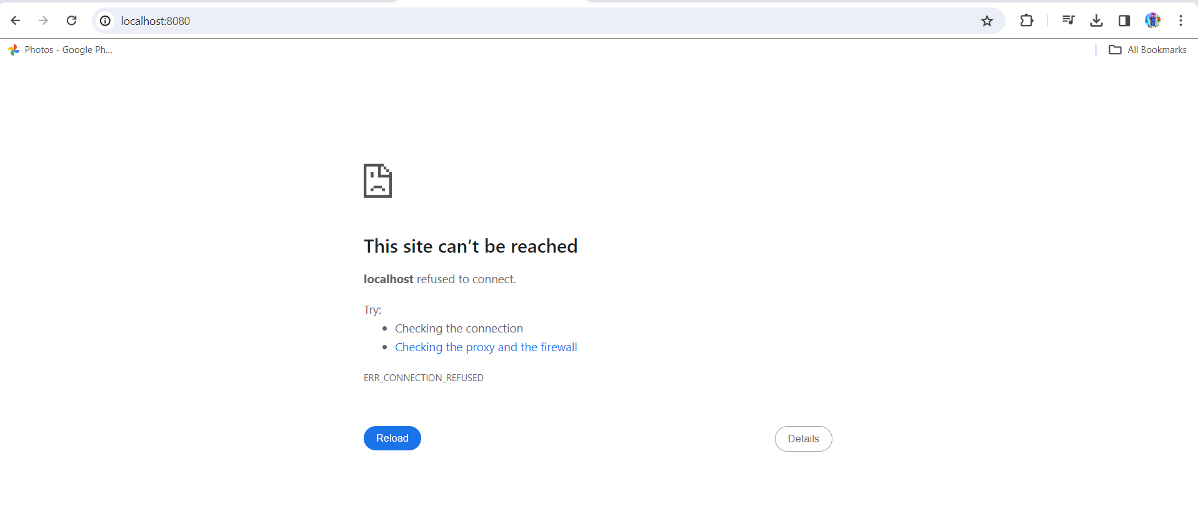

1.create **index.html** under resources/static

This will automatically loads if no page path given

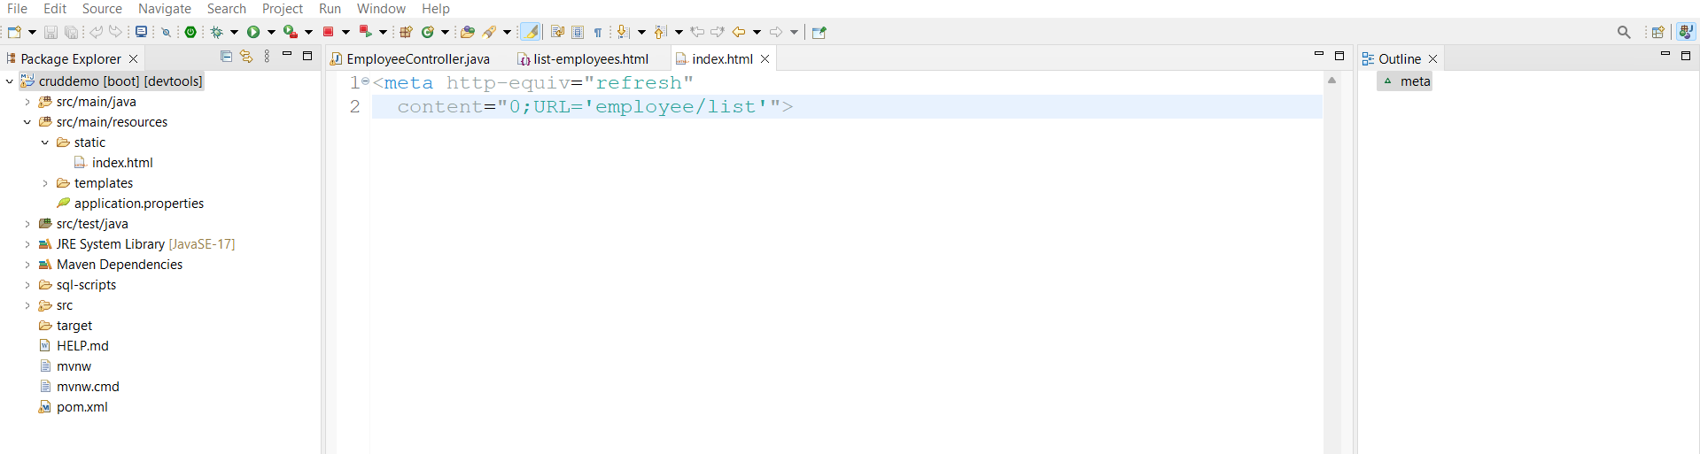

Run appn if you giving wrong url also it will redirect to our appn path

Given <http://localhost:8080>

It rediresct to <http://localhost:8080/employees/list>

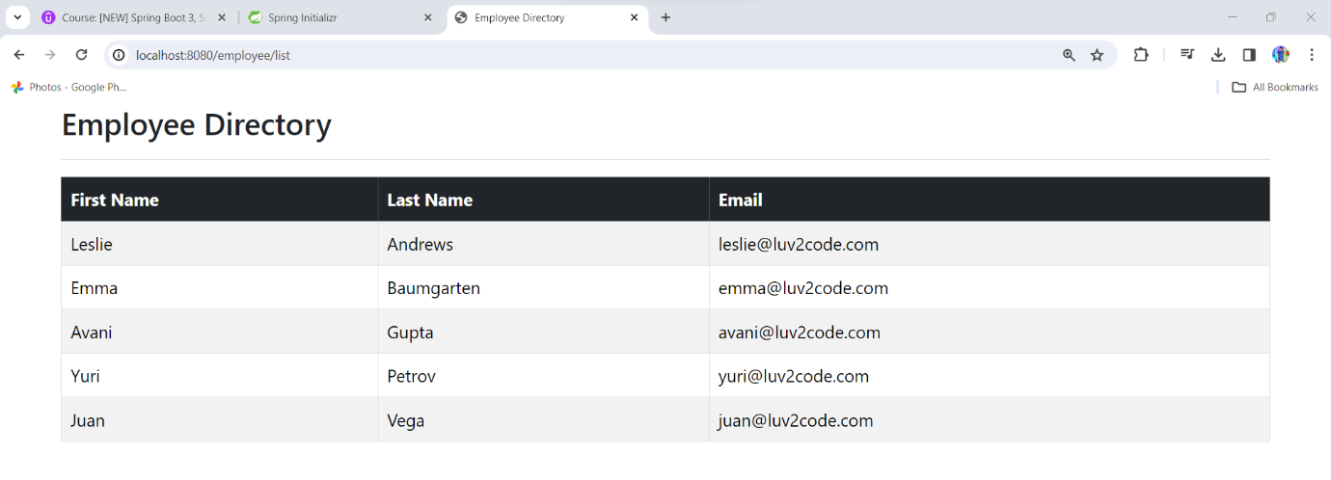

Refactor code as follows for understanding purpose.

Create employees folder under templates and move list-employee.html under that.

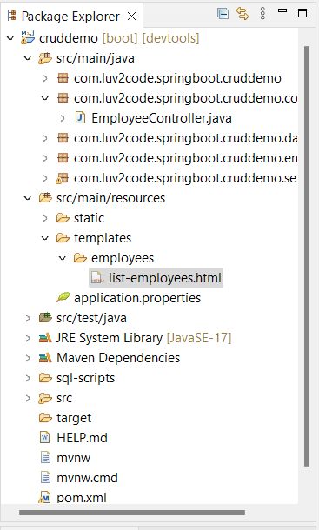

And open EmployeeController.java and change return type as follows

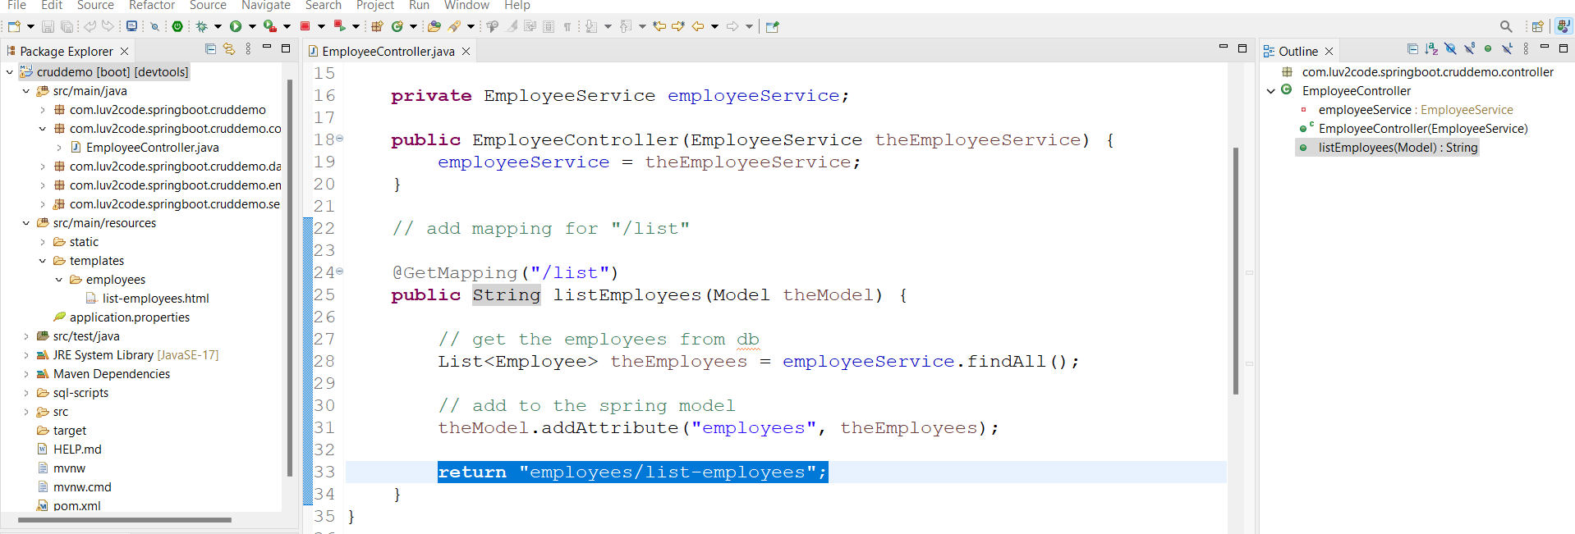

Run appn it works fine.

Add Employee:-

1.list-employee.html

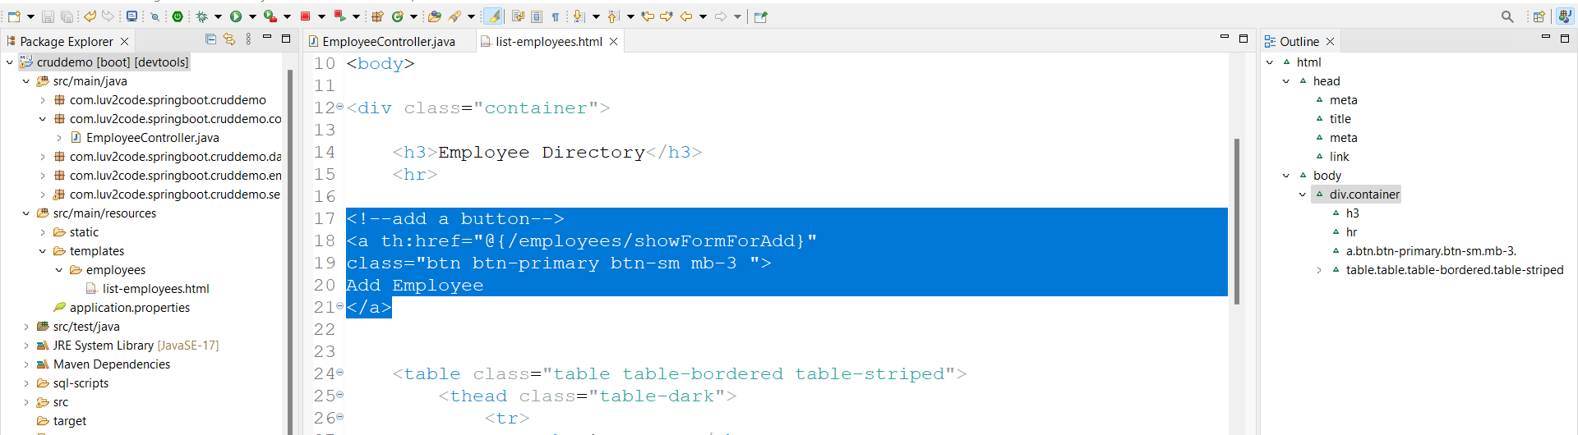

Run appn

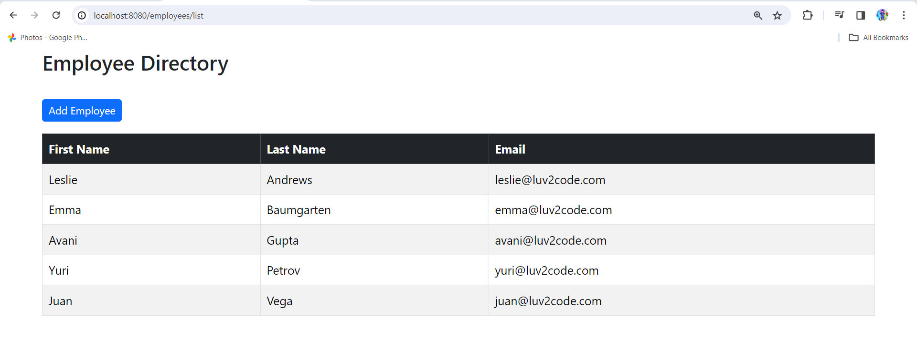

2.controller code to show form

**EmployeeController.java**

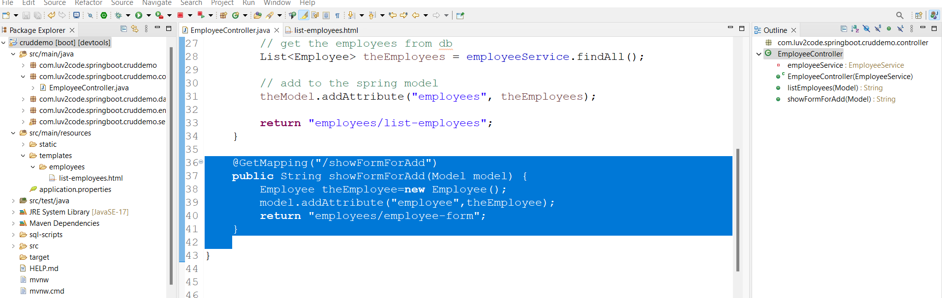

3.creating employee-form.html under templats/employees

Copy from list-employee.html upto head tag to get boot strap

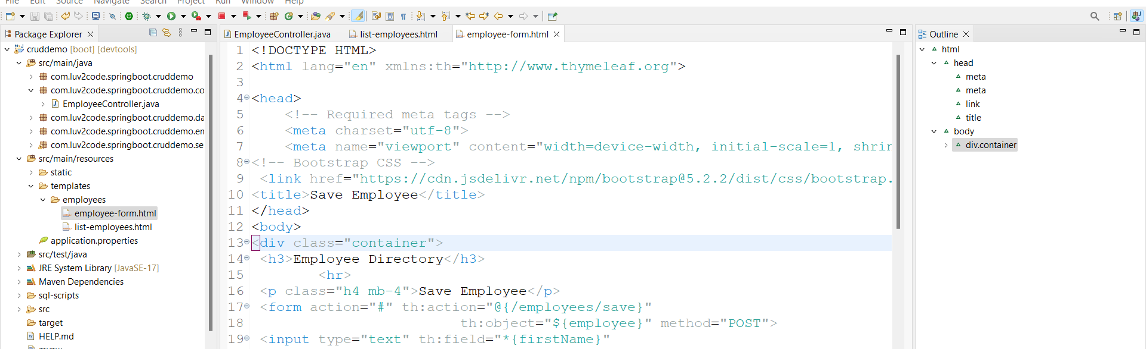

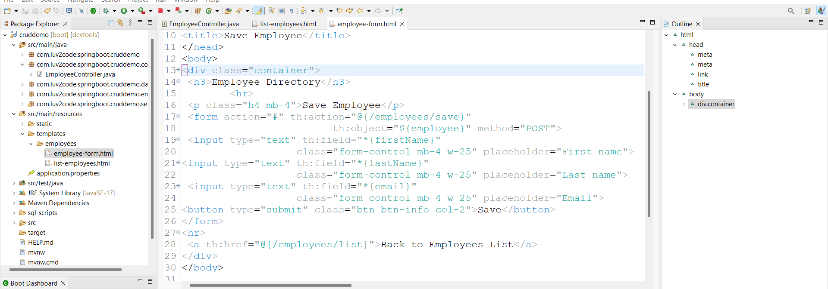

4.EmployeeController.java

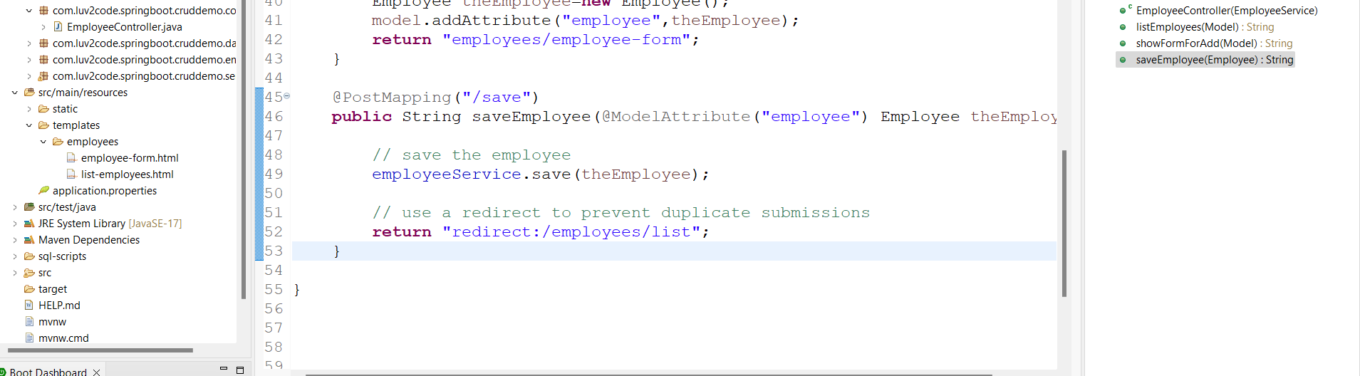

Run appn link:- <http://localhost:8080/employees/list>

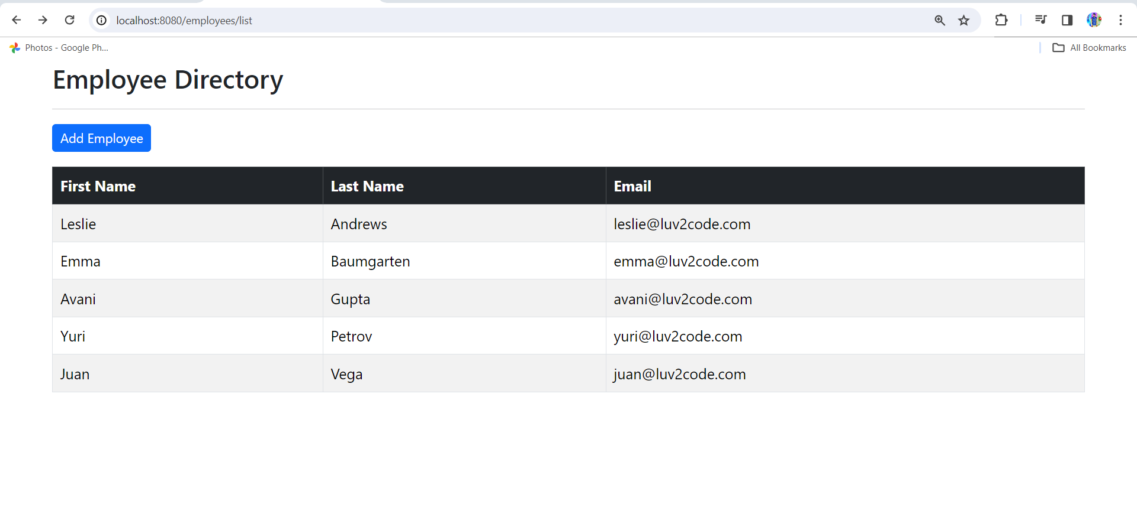

Click on Add Employee button

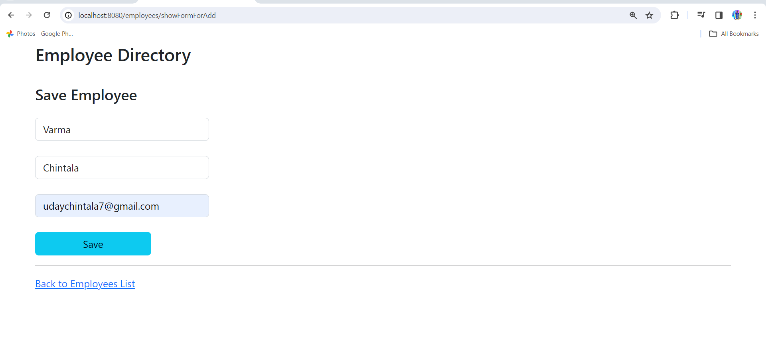

Click on save

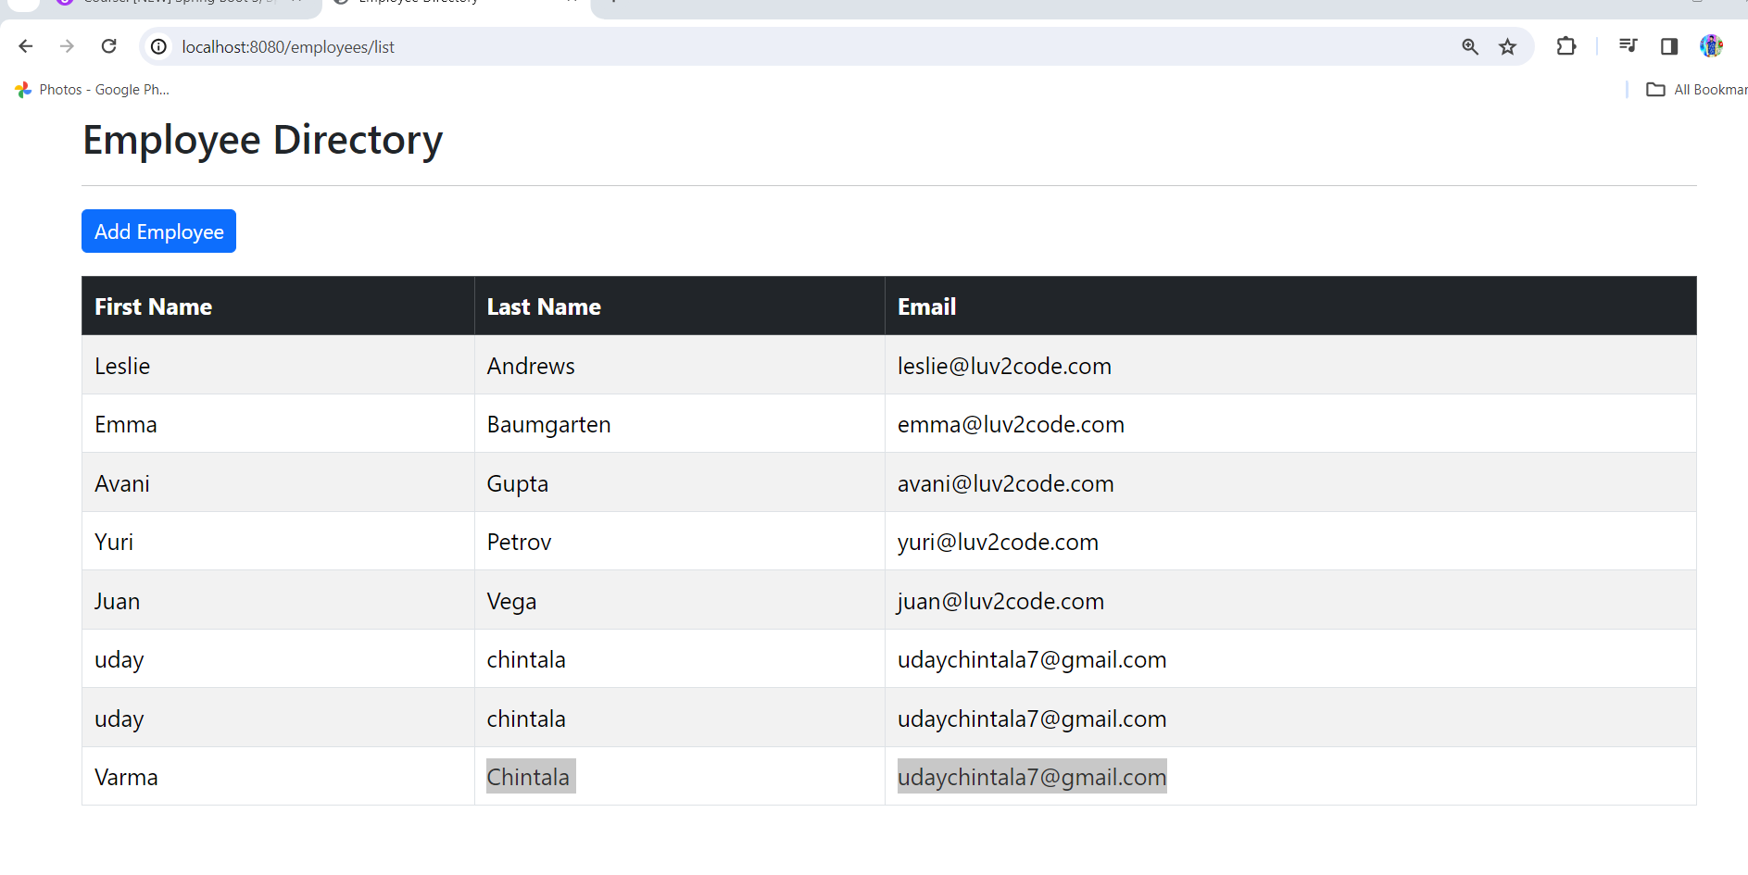

Employee added successfully

To see employees in sorting order

1.EmployeeRepository.java

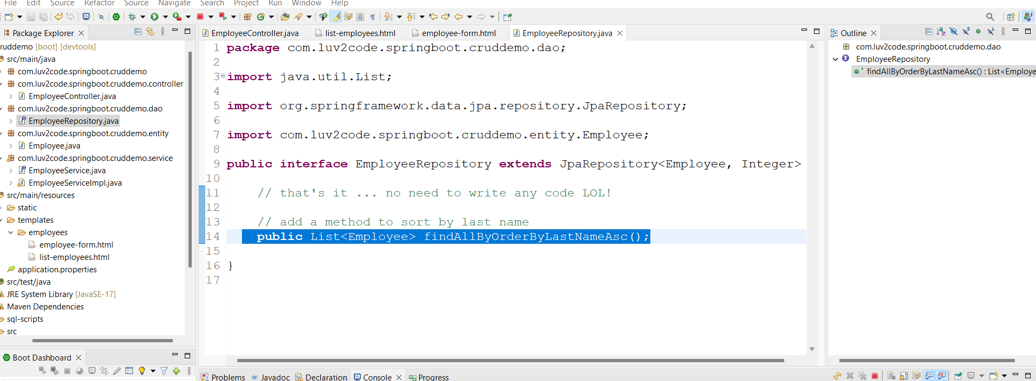

2.EmployeeServiceImpll.java

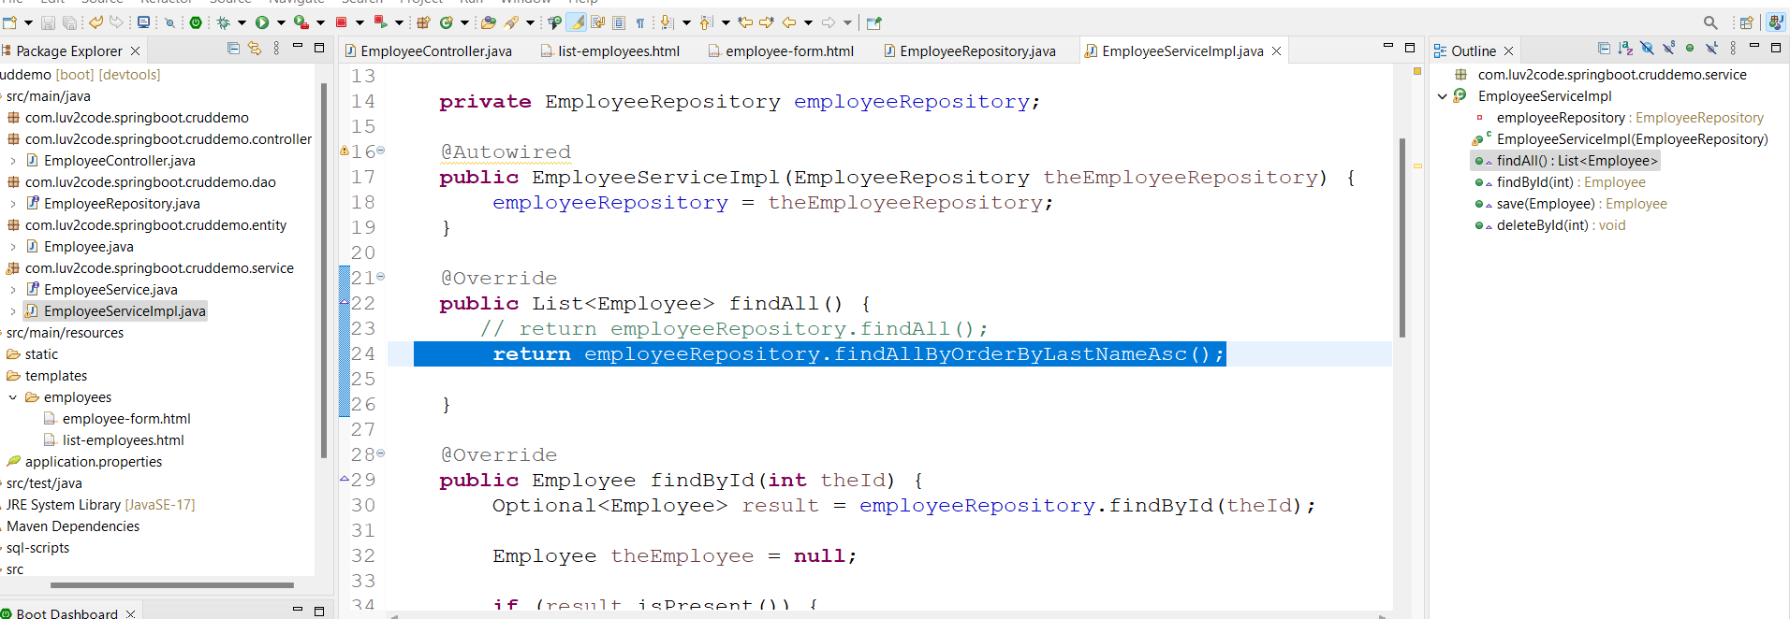

Run appn then see employees arranged in sorting order by lastName

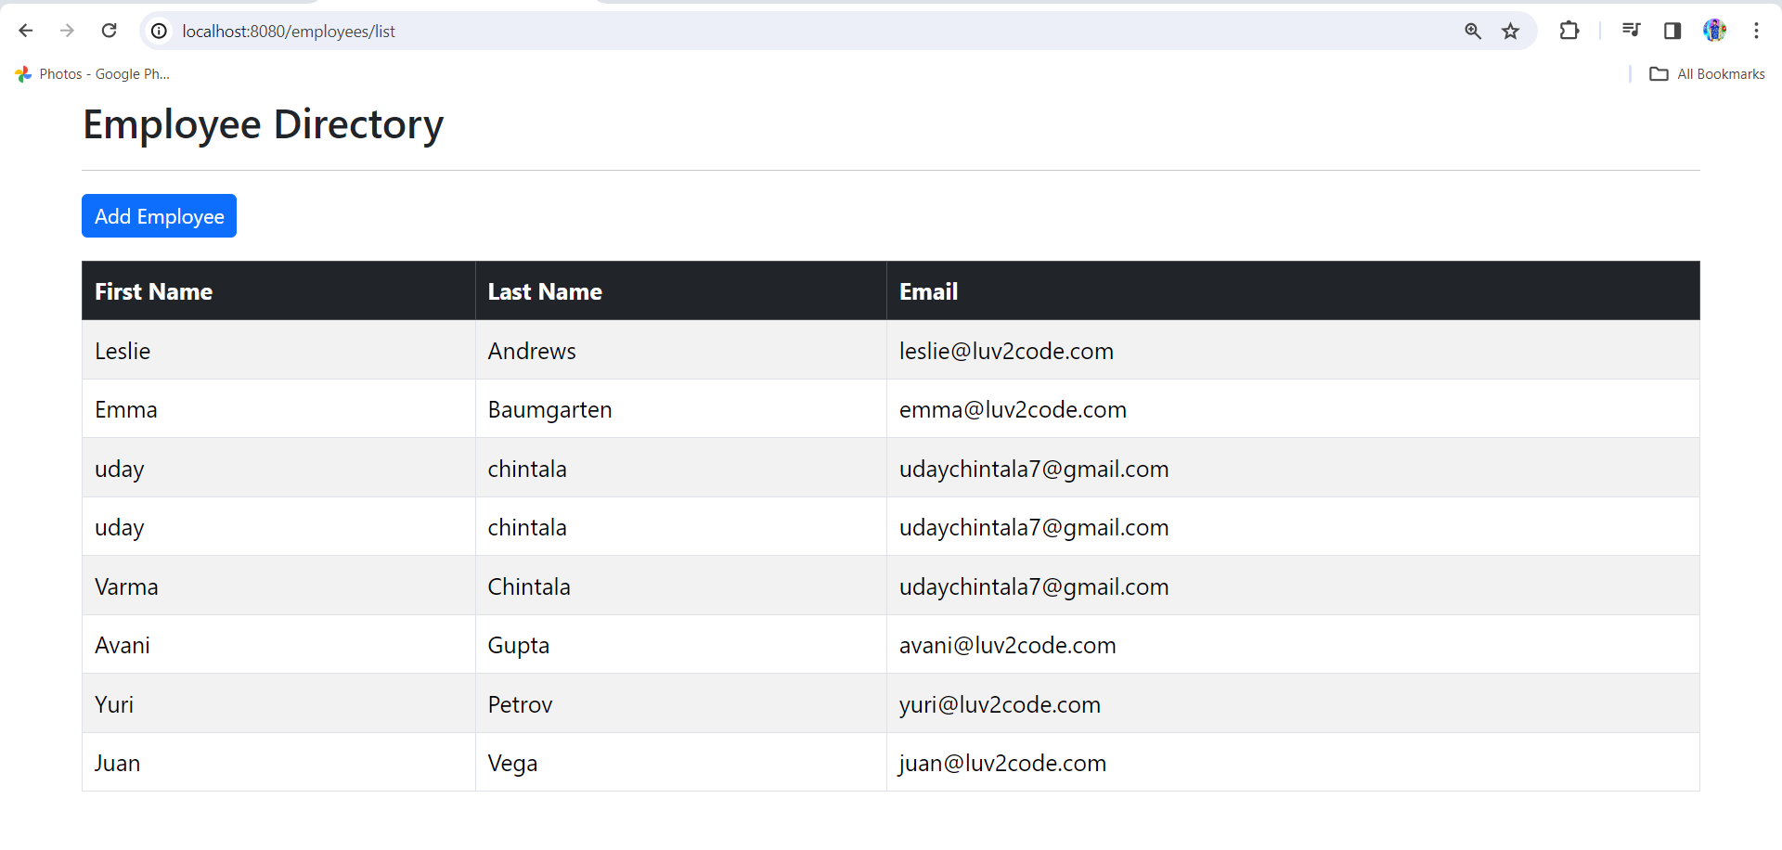

Update Employee:-

1.add Update button

List-employee.html

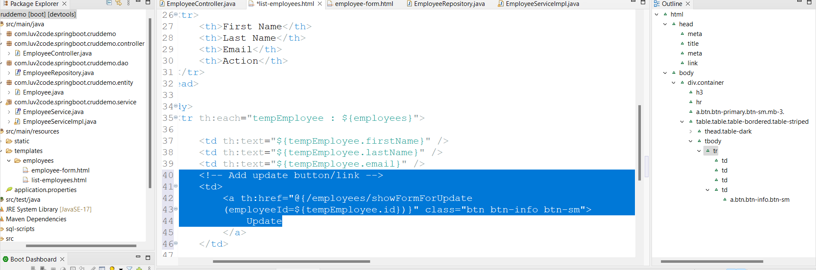

2.EmployeeController.java

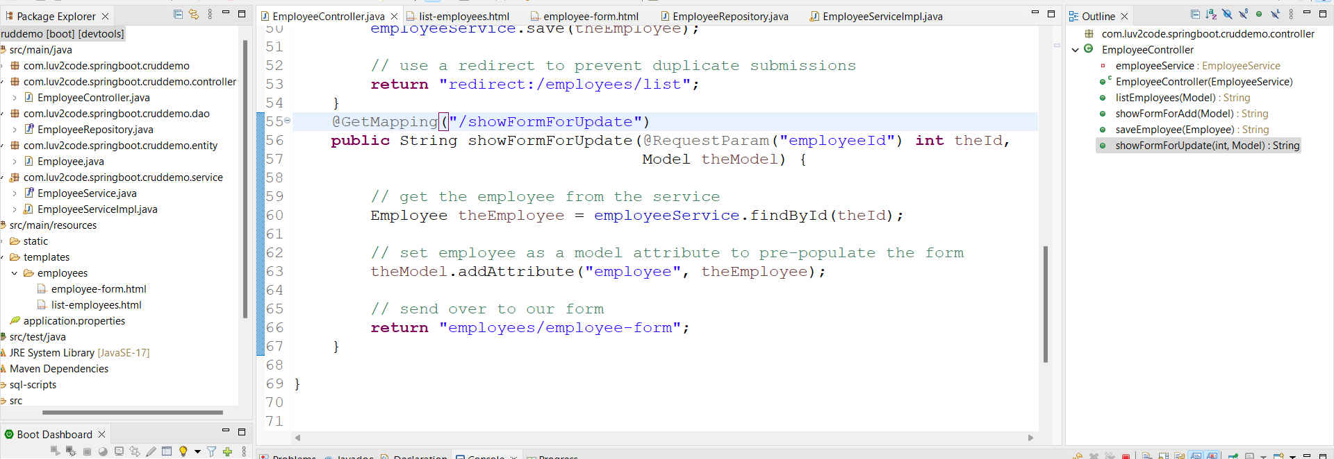

3.employee-form.html

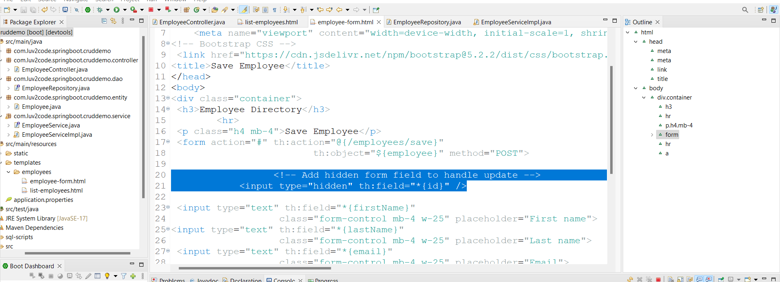

Run appn

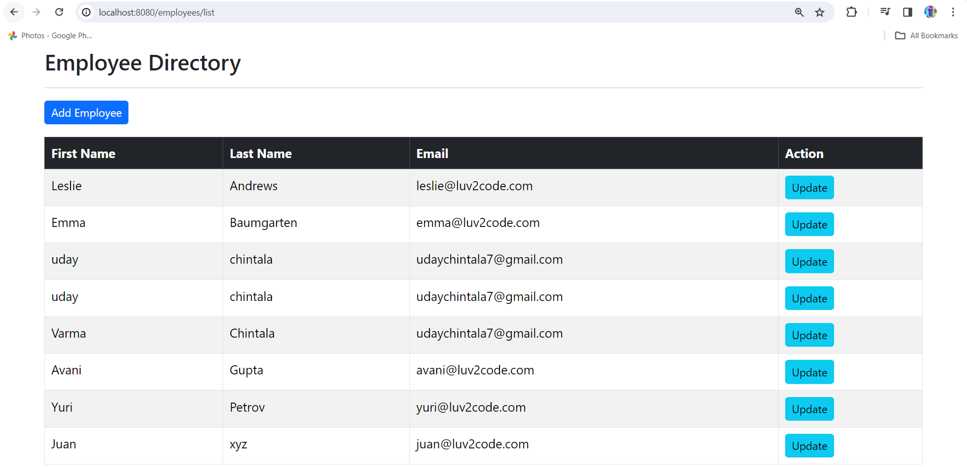

Click on update button and save

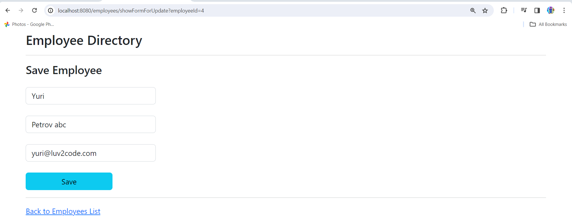

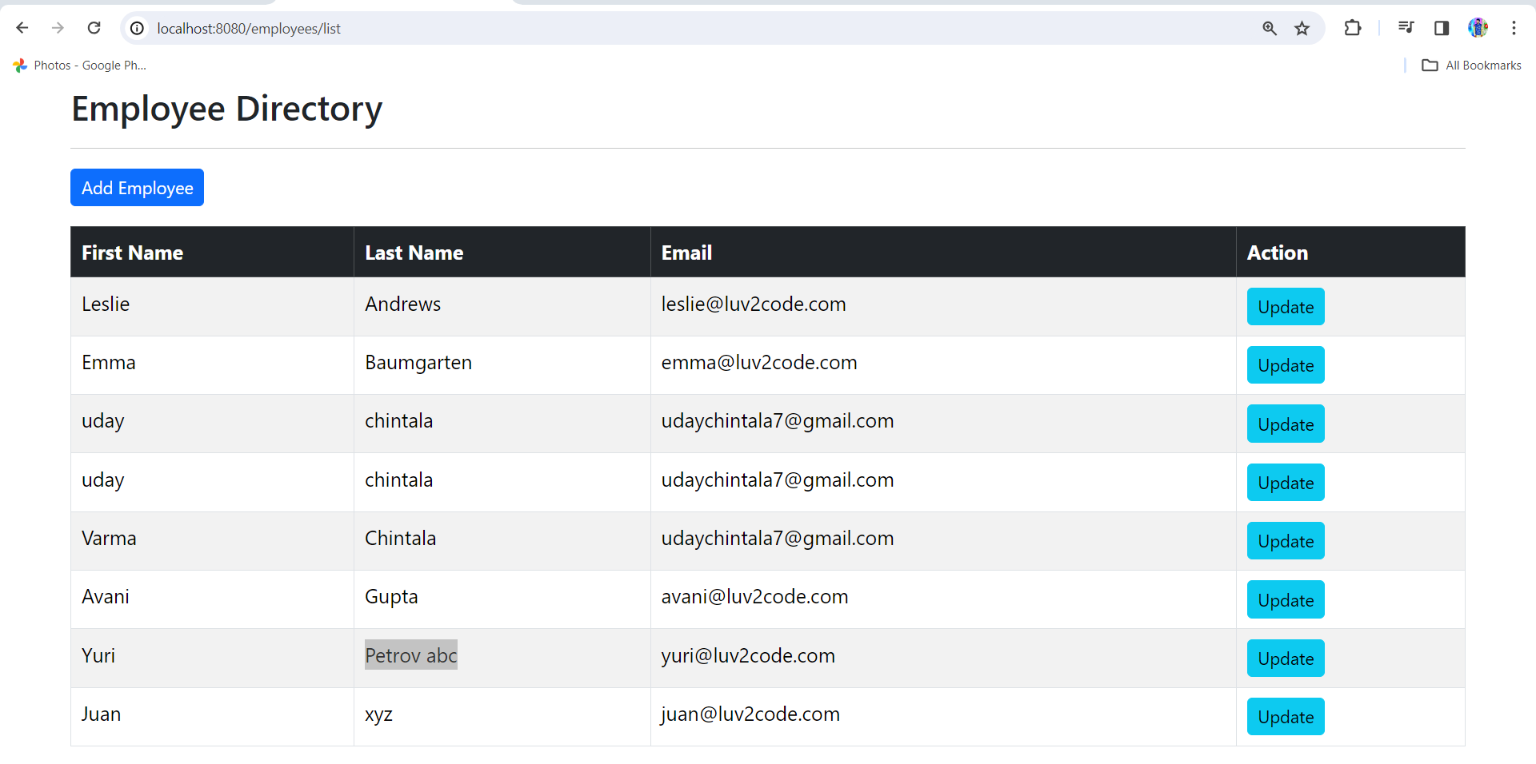

Delete Employee:-

1.list-employee.html

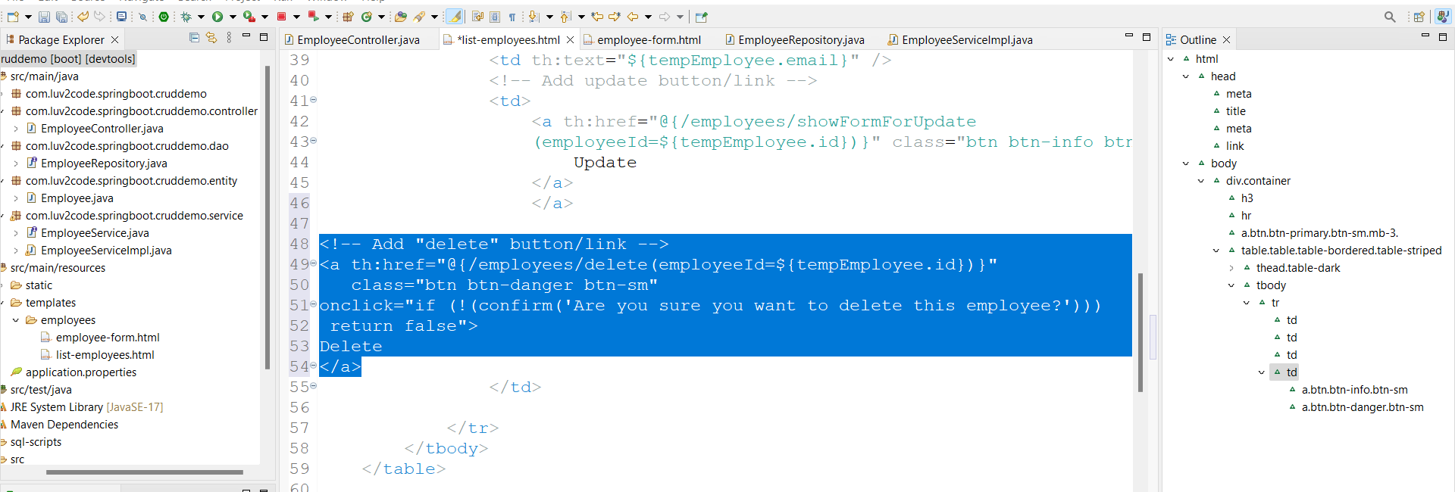

2.EmployeeController.java

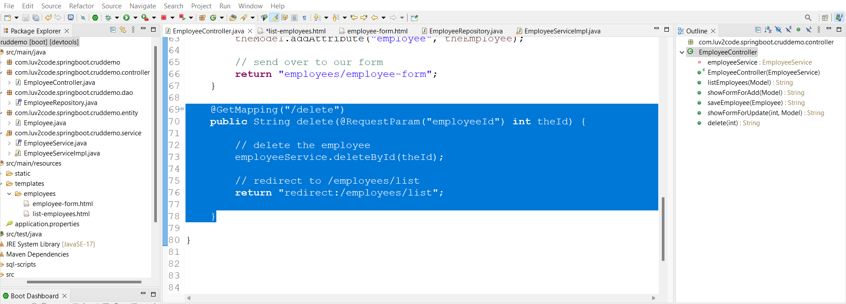

Run appn

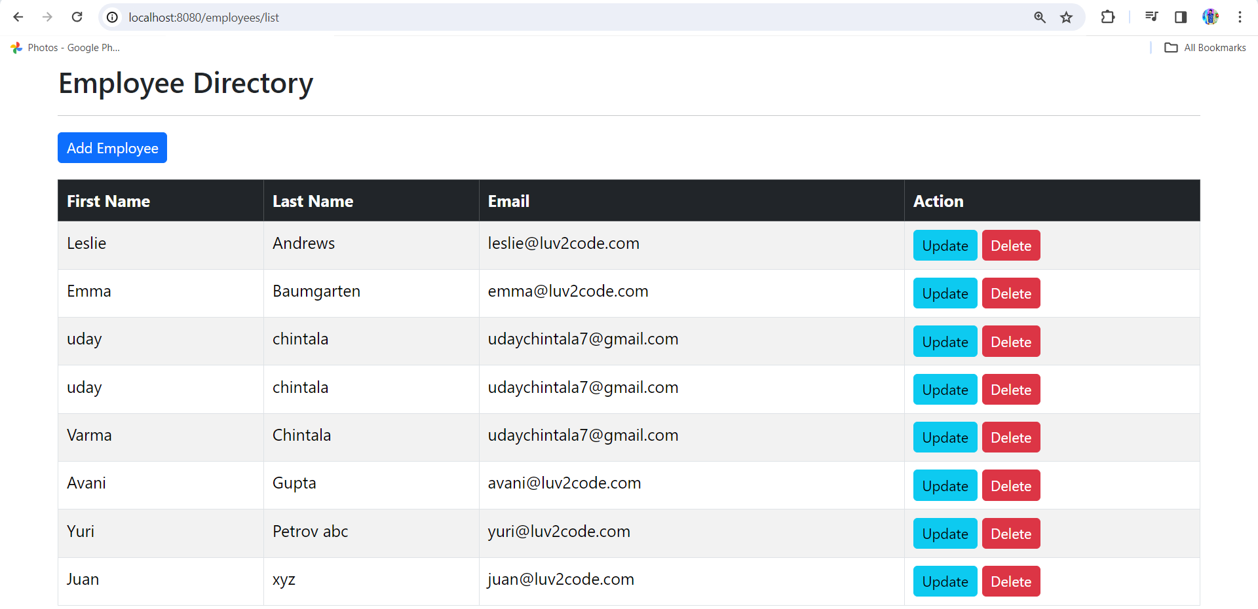

Click on delete

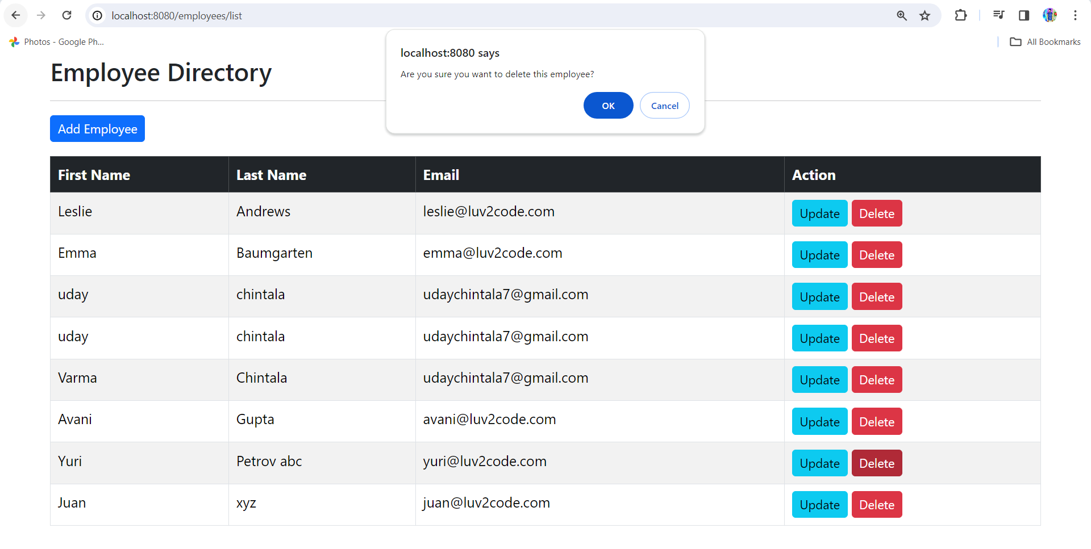

Employee deleted successfully